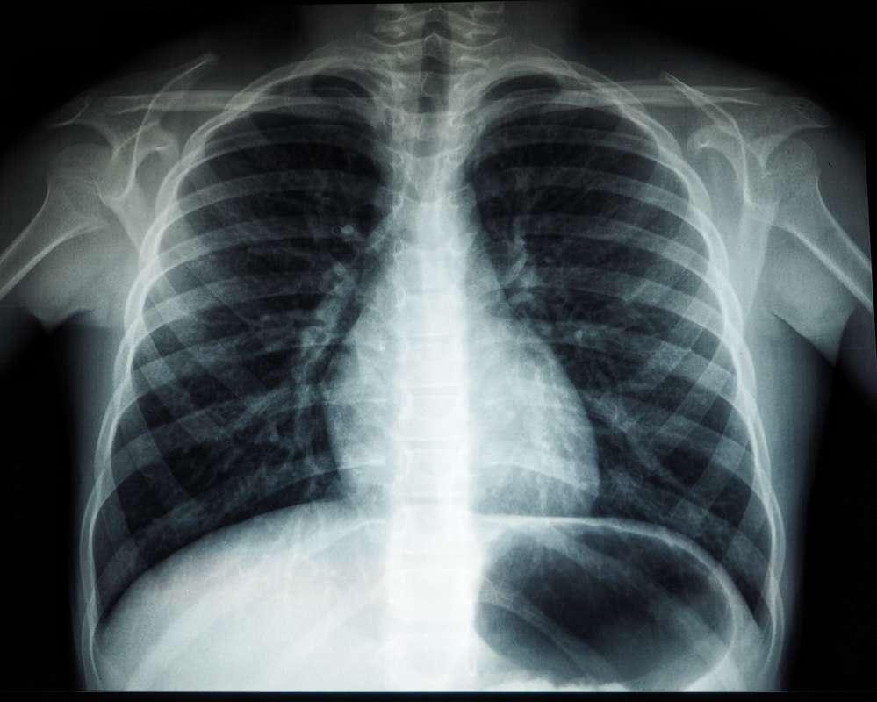

# Indications

The patient had a persistent cough for the past two weeks, with no fever, chest pain or shortness of breath. Chest X-ray was ordered to evaluate for any underlying pulmonary pathology.

# Findings

The chest X-ray shows mild hyperinflation with increased retrosternal airspace opacity, which is concerning for early bronchitis or pneumonia. No evidence of pleural effusion or significant lymphadenopathy. The heart and mediastinum are within normal limits.

# Impression

1. Early bronchitis or pneumonia, based on the chest X-ray findings.  
  
2. Clinical correlation and further evaluation are recommended.

# Recommendations

1. Consider clinical correlation and further evaluation, such as sputum culture, bronchoscopy, or CT scan of the chest.  
  
2. Follow-up chest X-ray in 2-4 weeks to evaluate for resolution of the findings.