mentoring_chatbot

*by* Amit Kumar

**Submission date:** 16-Nov-2022 10:56AM (UTC+0530)

**Submission ID:** 1955546471

**File name:** MENTORING_CHATBOT.docx (77.85K)

**Word count:** 2530

**Character count:** 13368

7755 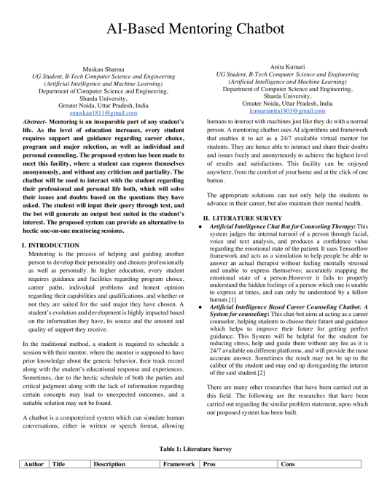

4

2

2

2 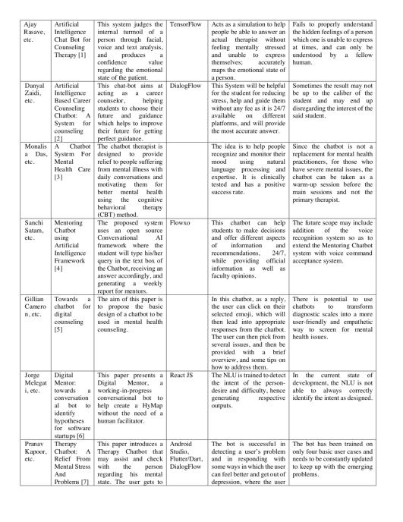

2

1

1

4

10

3

11

1 1

9

6

3

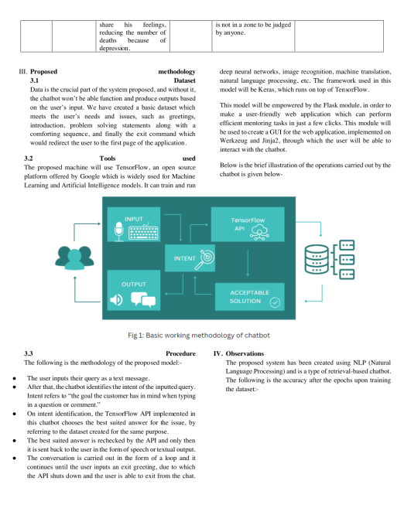8

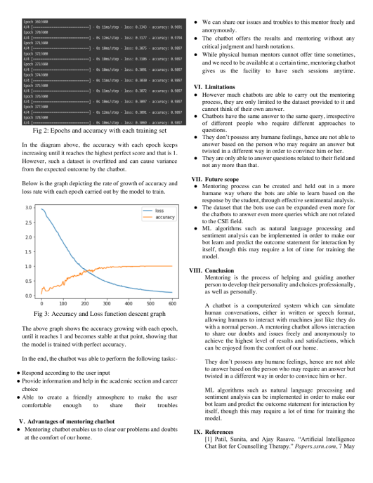

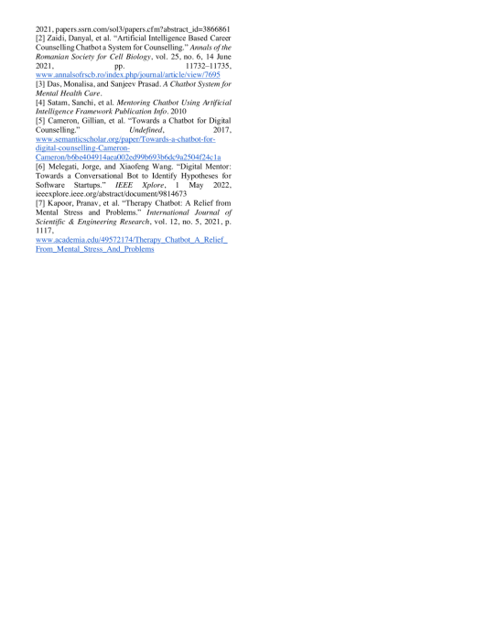

mentoring_chatbot ORIGINALITY REPORT

14% SIMILARITY INDEX

PRIMARY SOURCES

11%

INTERNET SOURCES

4%

PUBLICATIONS

2%

STUDENT PAPERS

1 4%

ijcrt.org

Internet Source

2 2%

annalsofrscb.ro

Internet Source

3 2%

Jorge Melegati, Xiaofeng Wang. "Digital

mentor", Proceedings of the Fourth

International Workshop on Bots in Software

Engineering, 2022

Publication

4 1%

www.myresearchjournals.com

Internet Source

5 1%

www.ijitee.org

Internet Source

6 1%

Submitted to Asia Pacific University College of Technology and Innovation (UCTI)

Student Paper

7 1%

www.gitam.edu

Internet Source

8 1%

www.mdpi.com

Internet Source

9 1%

Submitted to University of Oxford

Student Paper

10 <1%

arxiv.org

Internet Source

11 <1%

Ashlin Deepa R N, Prathyusha Karlapati,

Mrunhaalhini Reddy Mulagondla, Pavitra

Amaranayani, Anika Pranavi Toram. "An

Innovative Emotion Recognition and Solution Recommendation Chatbot", 2022 8th

International Conference on Advanced

Computing and Communication Systems

(ICACCS), 2022

Publication

Exclude quotes Off Exclude bibliography On

Exclude matches Off