HW 04

Due Friday Oct 18, 2019

Submit your solution in MS Word document format.

Apply the data visualization design principles to update the graph you generated for Q1 from Homework 01 (reattached below for your reference).

Informed decision making is slowly but surely gaining traction in healthcare. In order to investigate the potential of educational training material (brochures, pamphlets, CDs) etc., five patients were asked to participate in a study. The patients had to answer questions related to the disease before and after undergoing the educational training. The pre and post test scores of the five patients are provided in the excel sheet and shown below. Draw a graph of the pre and post test scores of the patients that conveys the message on whether the educational materials were effective or not.

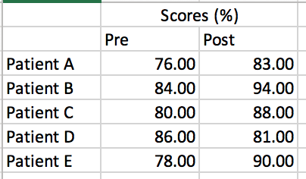

1. Reattach the plot from HW01 solution. Do not redo the graph from HW01, just submit the same graph you submitted in HW01. Critique this graph by provide a thorough description of how your graph MEETS or DOES NOT MEET the guidelines set by data visualization design principles.
2. Update your graph using data visualization design principles and briefly discuss the ones you used in redesigning your graph. If you had no changes, i.e. if your graph from HW01 did not need any updates. Justify why?