**CRUD Operations:**

**Task 1 Insert New Feedback:**

Input: Adding feedback for a customer and loan, capturing sentiments and details about the loan process.

**Step 1:** In order to insert a collection, we need to go to **ADD** **DATA** tab under it we have option of **Insert** **document** click on it.

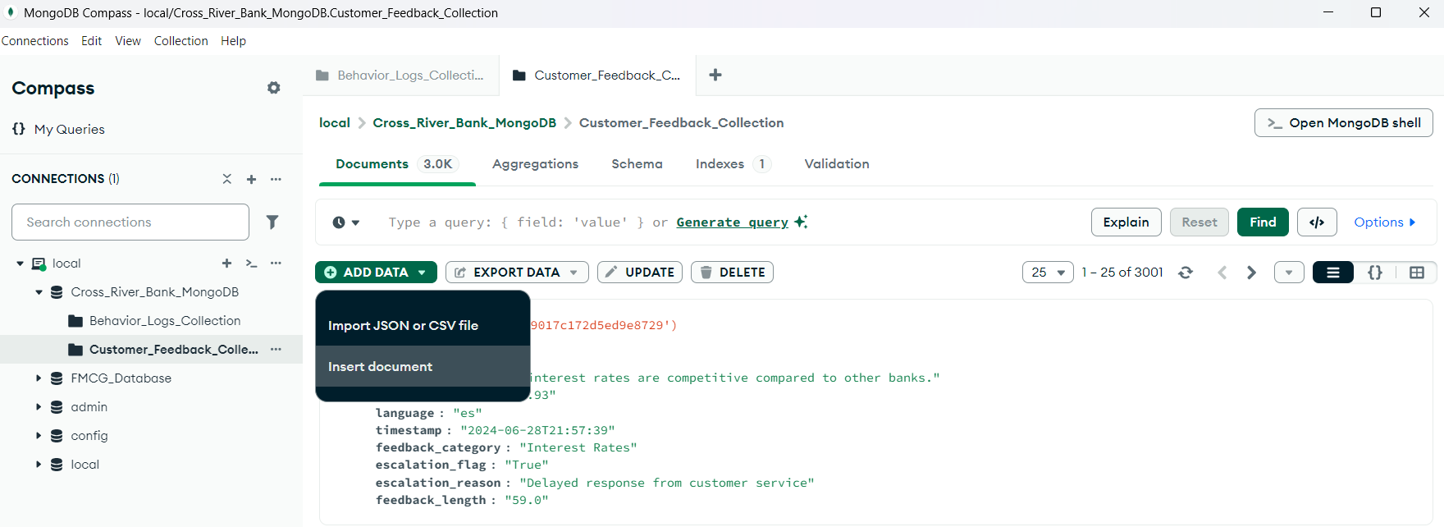

**Step 2:** It will open a blank data where we have input the documents as what we want to insert.

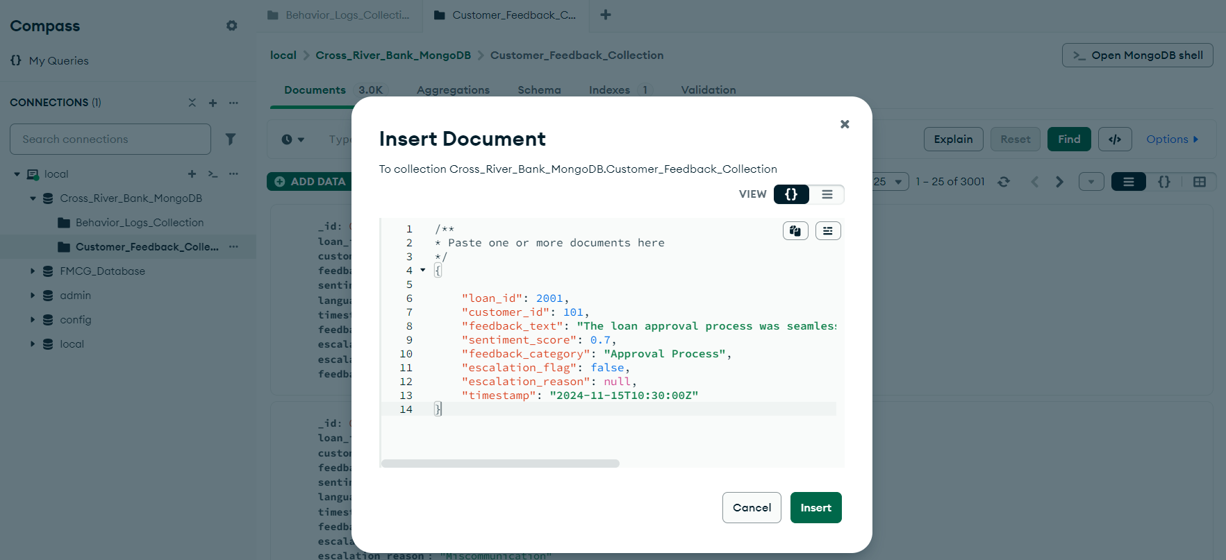

**Output**:

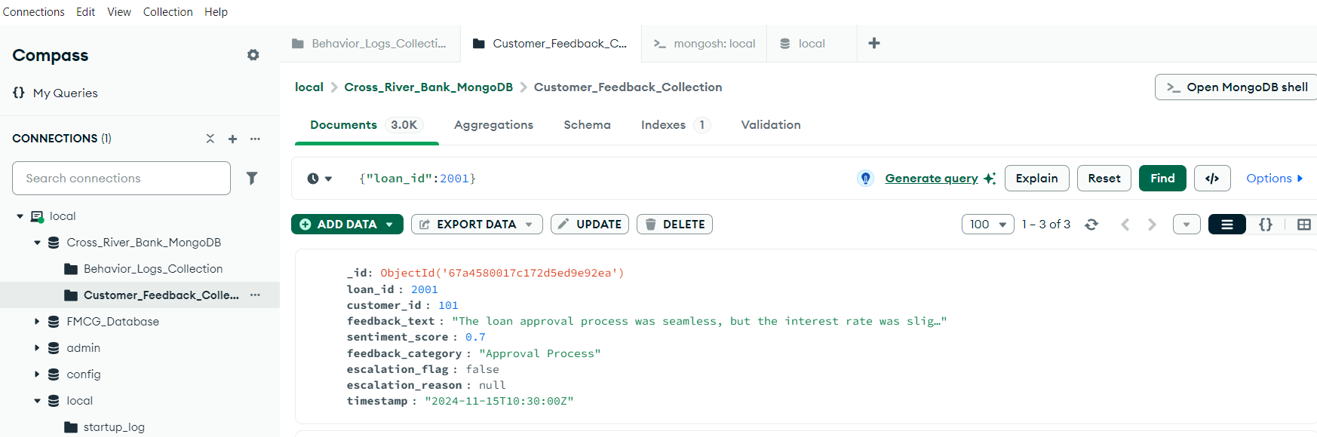

**Task 2 Update Escalation Flags: No Completed**

Update escalation flags in feedback to include specific reasons for unresolved customer complaints.

**Step 1:**  In order to update the escalation flags, firstly we need to identify the customers where escalation flag is True and escalation reason is null.

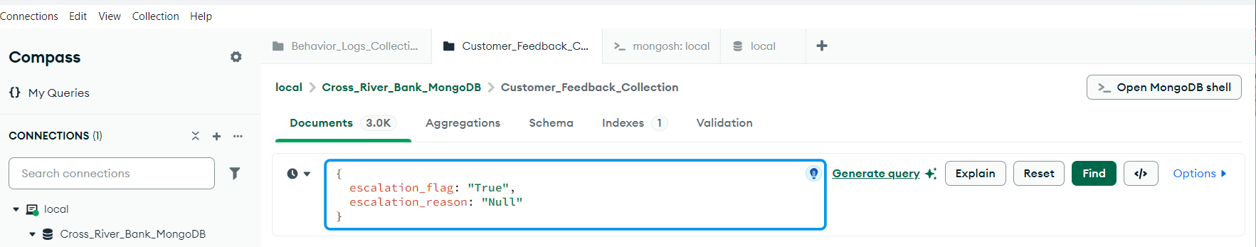

**Step2:** Now, we can update the documents as if found to update the reason for unresolved customer complaints.

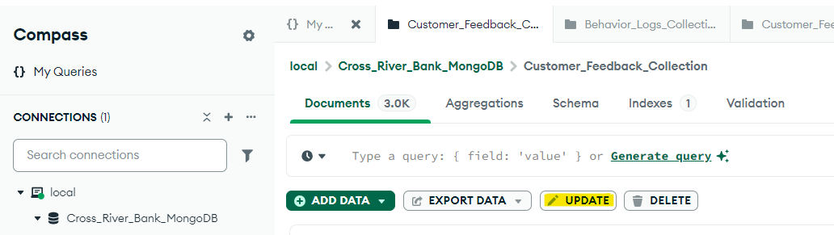

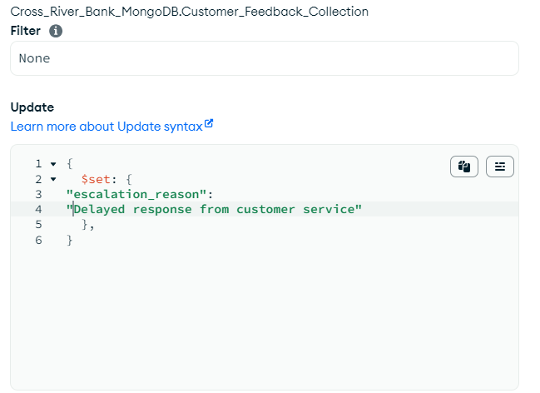

**Task 3 Remove Duplicate Behavior Logs:**

Remove duplicate entries with the same customer_id and timestamp.

There is no duplicate in behavior logs data to remove.

**4. Retrieve Positive Feedback**

Retrieve feedback entries with sentiment scores greater than 0.5

Output

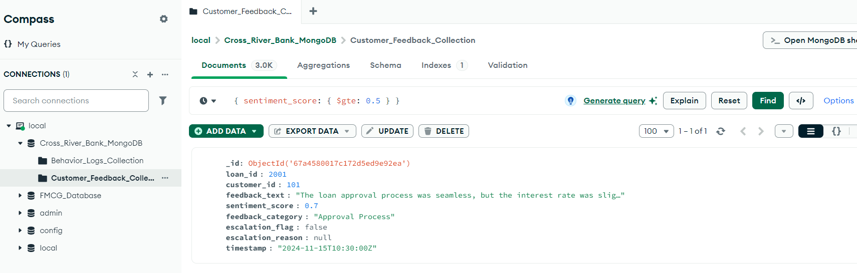

**Task 5. Fetch Logs for 'Missed Payment' Actions:**

 Retrieve behavior logs where the action is "Missed Payment."

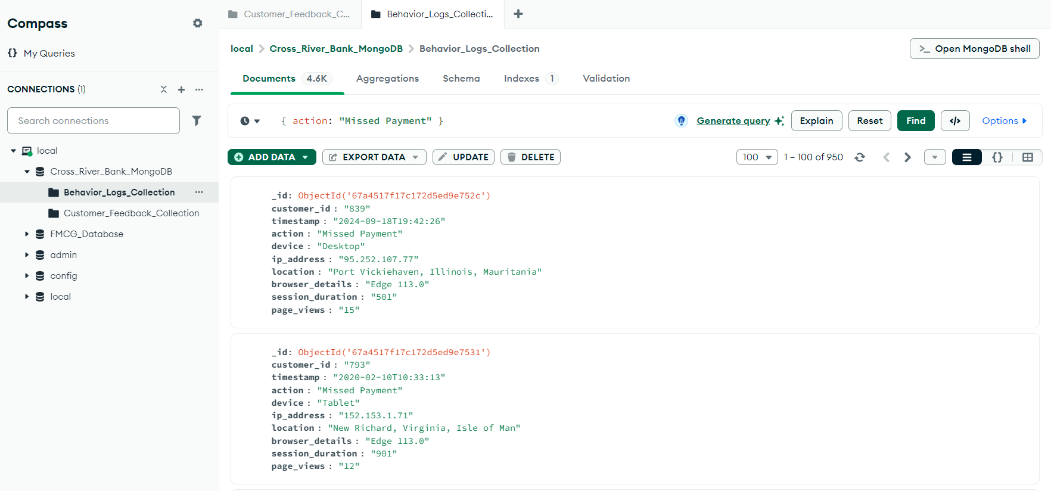

**Aggregate Pipeline task:**

1. **Join Feedback and Behavior Log - In Customer_Feedback**

Use the $lookup stage to combine feedback from the customer_feedback collection with behavior logs from the behavior_logs collection, matching on customer_id.

** It will join 2 collection based on one common field.

**Output:**

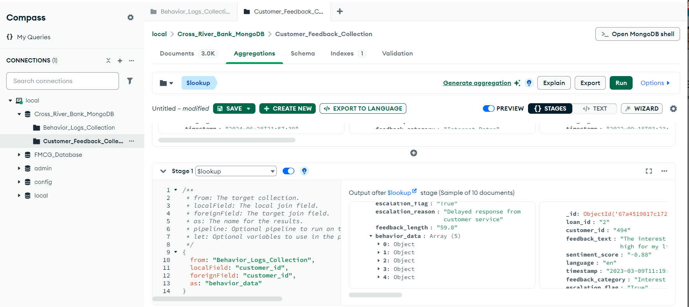

**2. Flatten Joined Data - In Customer_Feedback**

Apply $unwind to flatten the nested array created by $lookup. This ensures a clean structure for subsequent aggregation stages.

** It will convert the array into individual document to reaqd properly

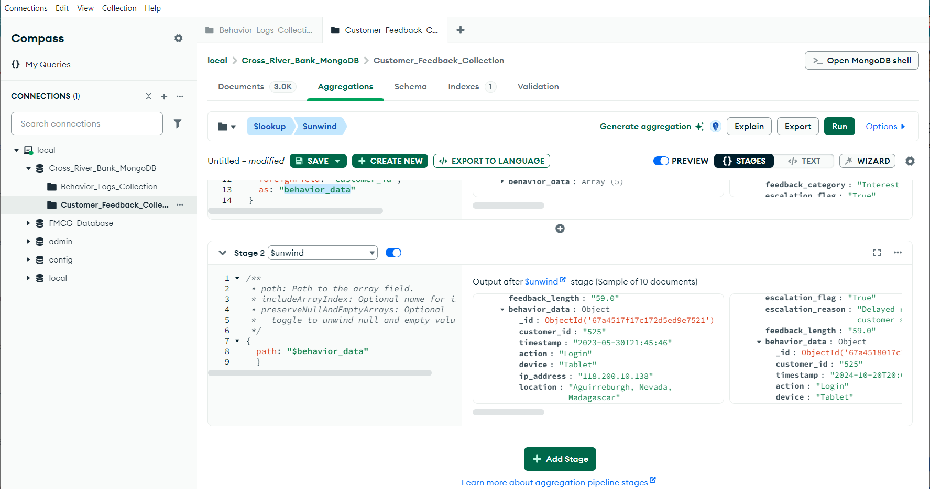

**3. Aggregate Feedback and Behavioral Metrics - In Customer_Feedback**

Group the combined data by customer_id to compute:

* Average sentiment scores.
* Total missed payments.
* Total session durations.
* Count of unresolved escalations

**Codes: {**

_id: "$behavior_data.customer_id",

avg_sentiment_score:

{"$avg": {"$toDouble":"$sentiment_score"} },

Total_missed_payments:{"$sum":{"$cond":

[{"$eq":["$behavior_data.action", "Missed Payment"] }, 1, 0]}},

Total_session_durations:{"$sum":

{$toDouble:"$behavior_data.session_duration"}},

Total_unresponsive_escalations: {"$sum":{

"$cond":

[{"$eq":

["$escalation_reason", "Unresponsive Service"]}, 1, 0]}}

}

**Output:**

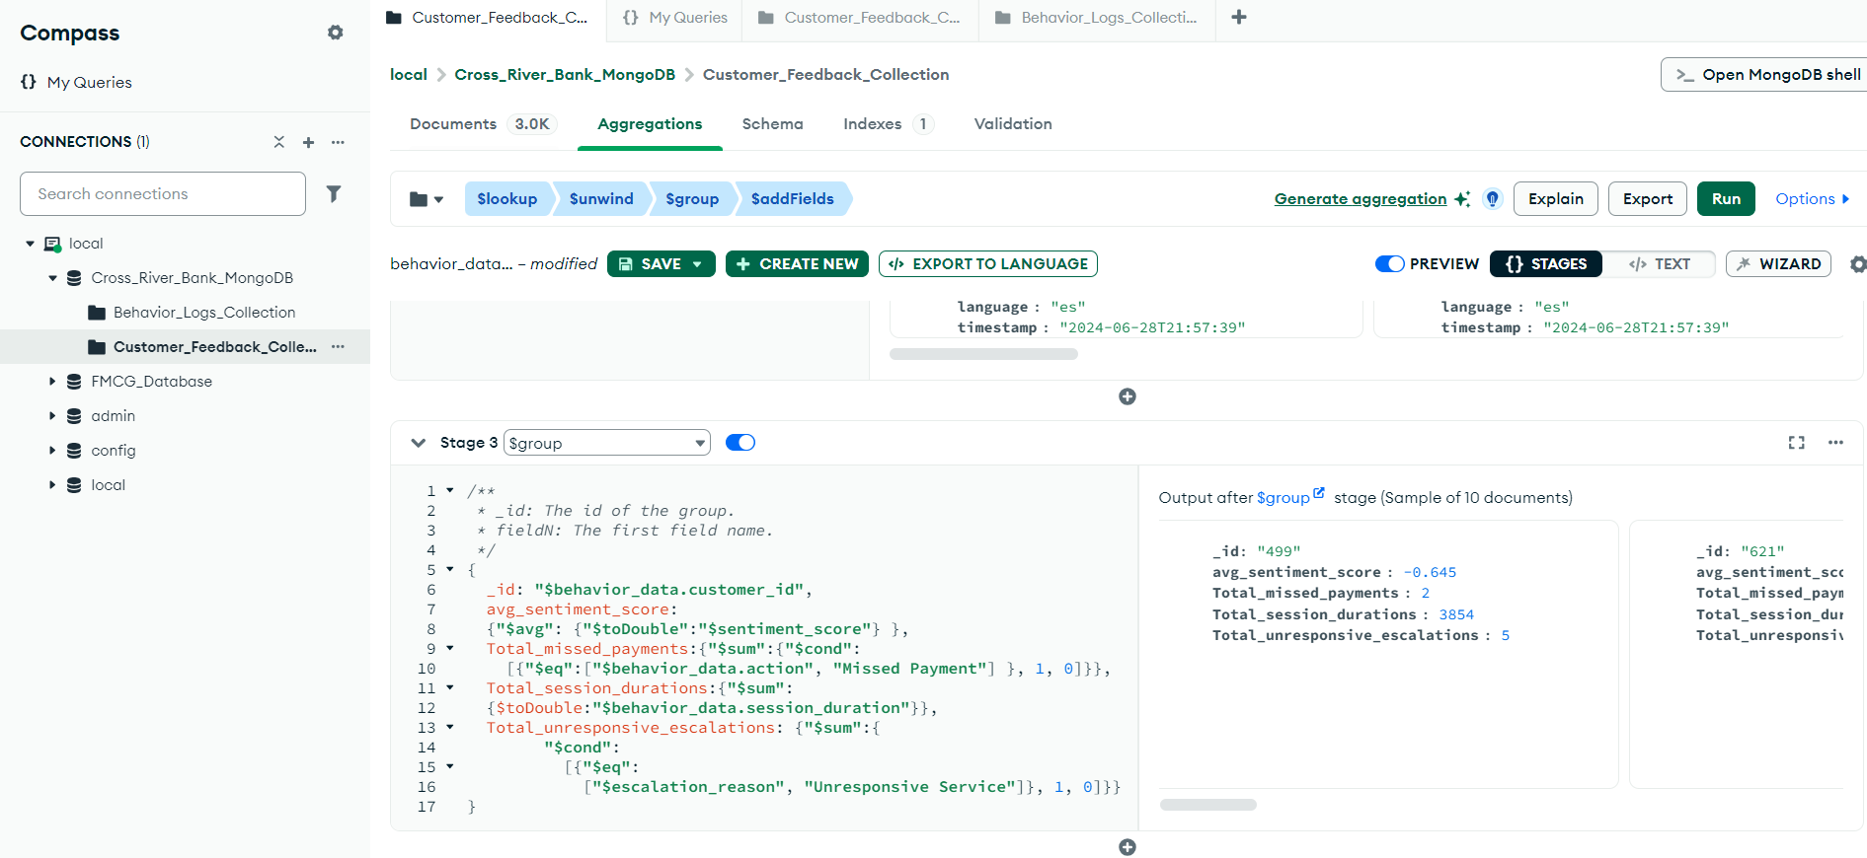

**4. Calculate Risk Scores – In Customer_Feedback**

Add a composite risk score using $addFields, incorporating:

* Missed payments (weighted heavily as an indicator of risk).
* Negative sentiment (calculated as 1 - avgSentiment).
* Total session durations (scaled if necessary).
* Escalation counts.

**Codes:**

{

"composite_risk_score": {

$add: [

{$multiply: [{"$ifNull": ["$Total_missed_payments", 0] }, 5] },

{$multiply: [{$subtract: [1, {"$ifNull": ["$avg_sentiment_score", 1] }] },

3]},

{$multiply: [{$divide: [{"$ifNull": ["$Total_session_durations", 0] }, 1000] },

1]},

{$multiply: [{"$ifNull": ["$Total_unresponsive_escalations", 0] }, 2] }

]

}

}

**Output:**

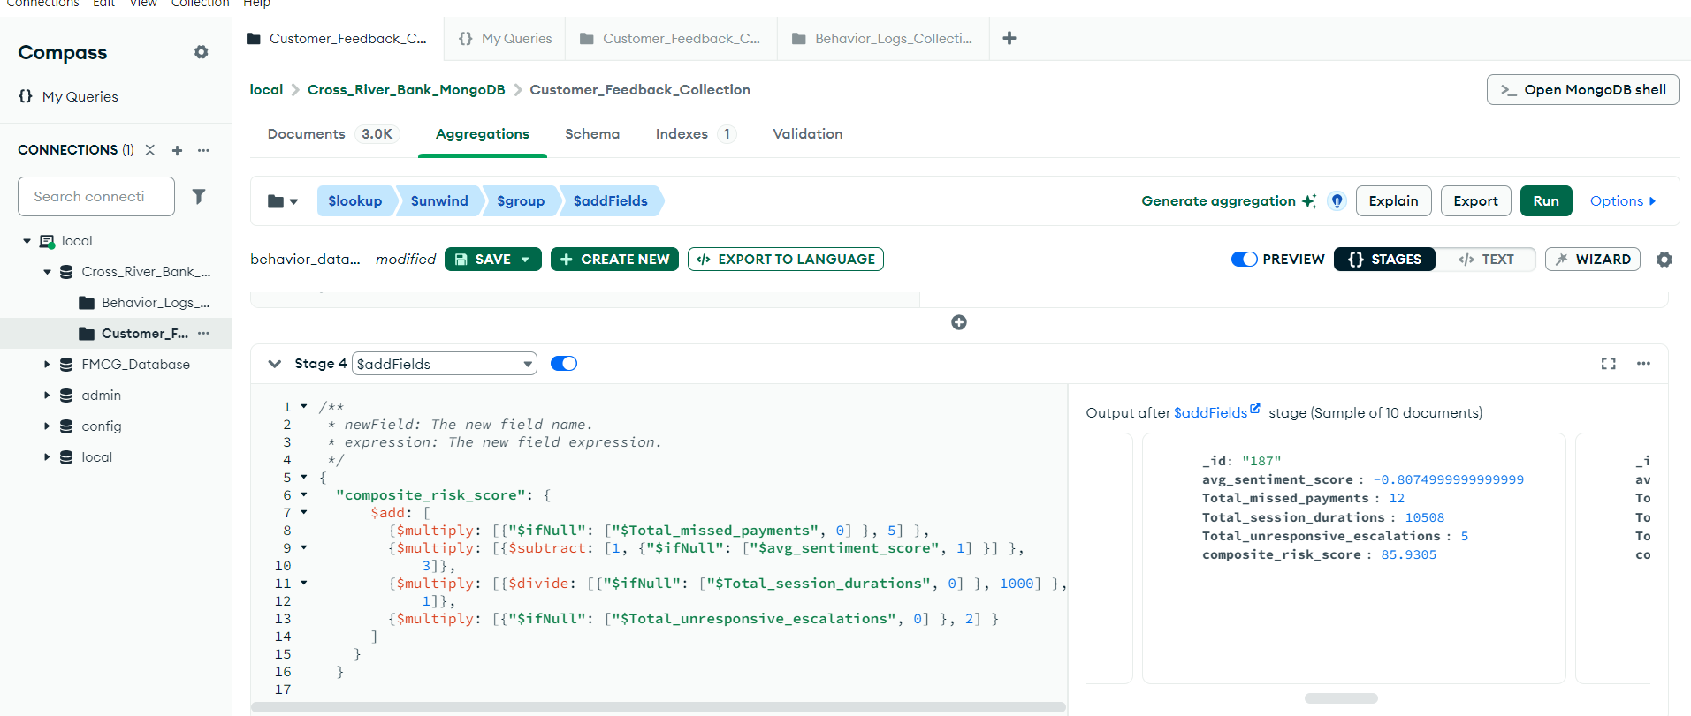

**5. Identify Device Usage Trends – In Behavior_Log**

Group behavior logs by device to detect preferences and anomalies in usage patterns, especially for high-risk actions like "Missed Payment."

**Code:**

{

_id: "$device",

Missed_payment_counts: {$sum:{$cond:[{"$eq":["$action", "Missed Payment"] },1,0]}}

}

**Output:**

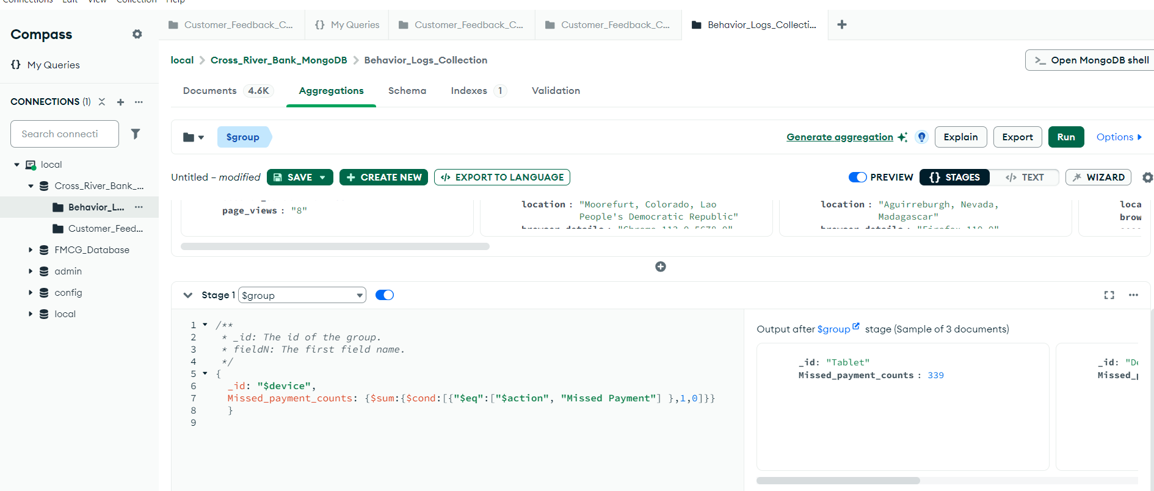

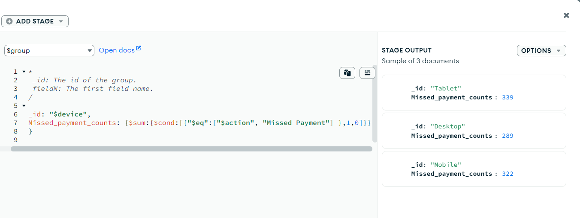

**6. Detect Session Outliers**

Use the $bucket to identify customers with session durations that fall into extreme ranges (e.g., above the 90th percentile or below the 10th percentile).

**Code:**

{

groupBy: "$session_duration",

boundaries: [0,300, 600,900,1200,1500,1800],

"default": "Outliers",

"output": {

customer_count: {"$sum": 1},

customers: { $addToSet: {$toDouble: "$customer_id" }}

}

}

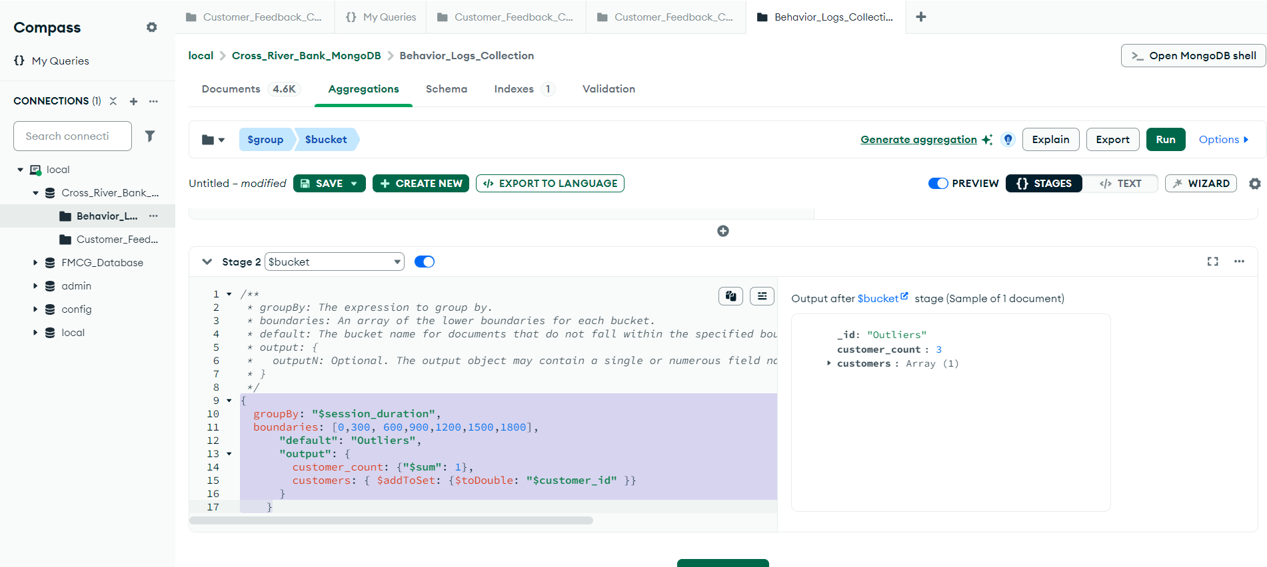

**7. Escalation Analysis**

* Filter for customers with:
* Non-zero escalation counts.
* High composite risk scores.
* Highlight these customers for immediate follow-up and prioritization.
* **Code:**
  1. **Match**

{

Total_unresponsive_escalations:{$gt:0},

composite_risk_score:{$gt:30}

}

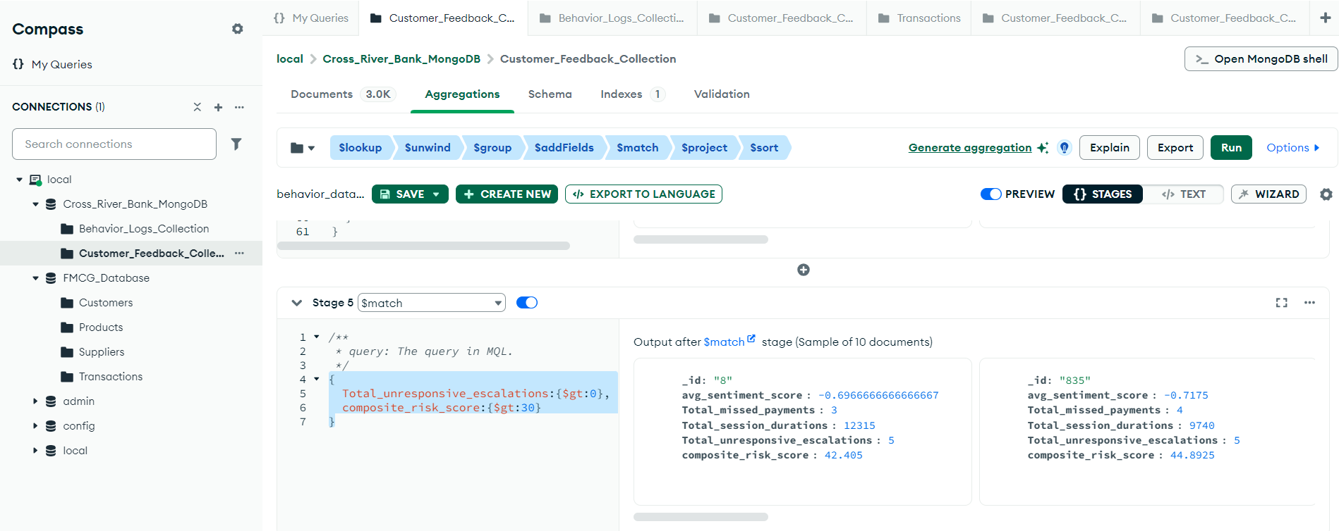

* 1. **Project**

{

_id:0,

customer_id:{$ifNull:["$customer_id", "$_id"]},

Total_unresponsive_escalations:1,

composite_risk_score:1

}

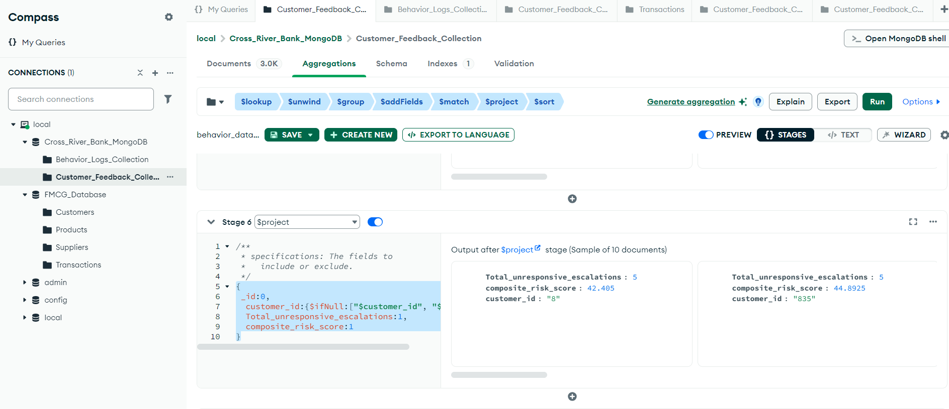

* 1. **Sort**

{

composite_risk_score: -1

}

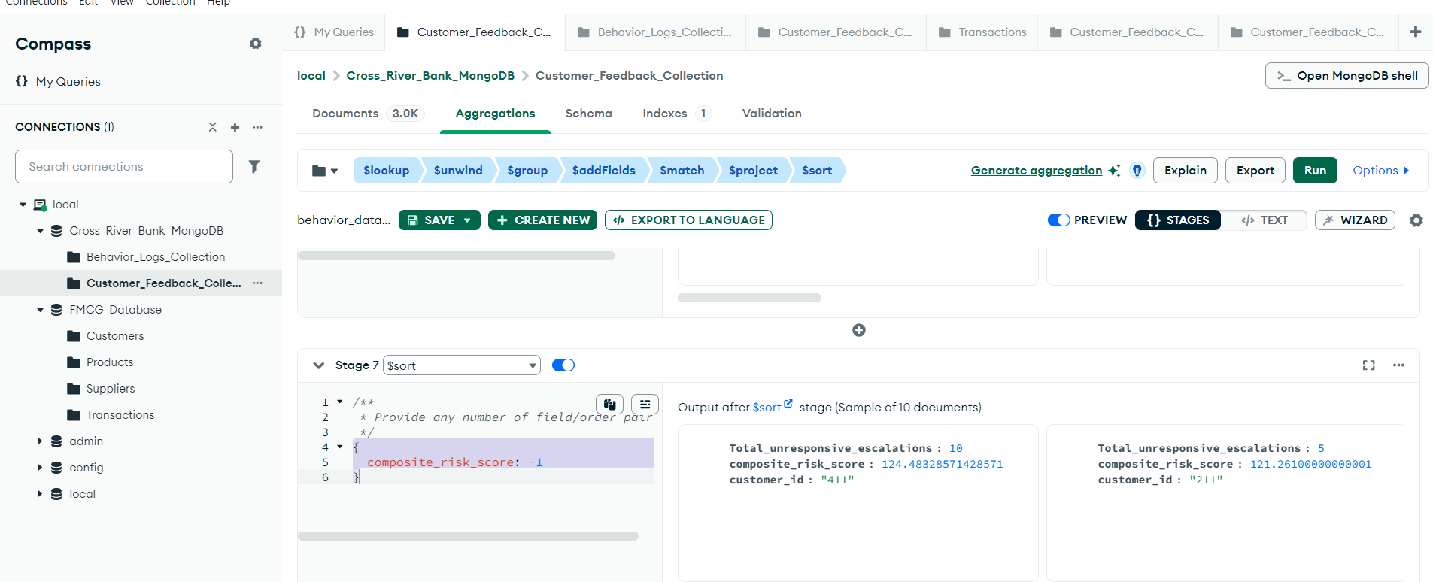

**Final Output of Aggregation Pipeline:**

