FeedPulse
Project: ARTNEST – Personal Museum Memory & Wishlist
Course: IN-SDE-EN-CMK
Student: Anita Ivanova

1. Introduction
In this document I included screenshots of two feedback moments from FeedPulse. Since the screenshots already show the written feedback, the text below each checkpoint focuses mainly on how I used that feedback in my work. The purpose of this document is to show how teacher feedback helped me improve both my project and the way I document my progress.

2. Checkpoint 1
After this feedback, I updated my project slide to improve the balance between visual design and content. I reduced the amount of text, made the layout cleaner, and then adjusted it again so that the most important information was still included. This helped me understand that a presentation slide should be visually clear, but it also still needs to communicate the idea, the users, and the main functionality of the project.

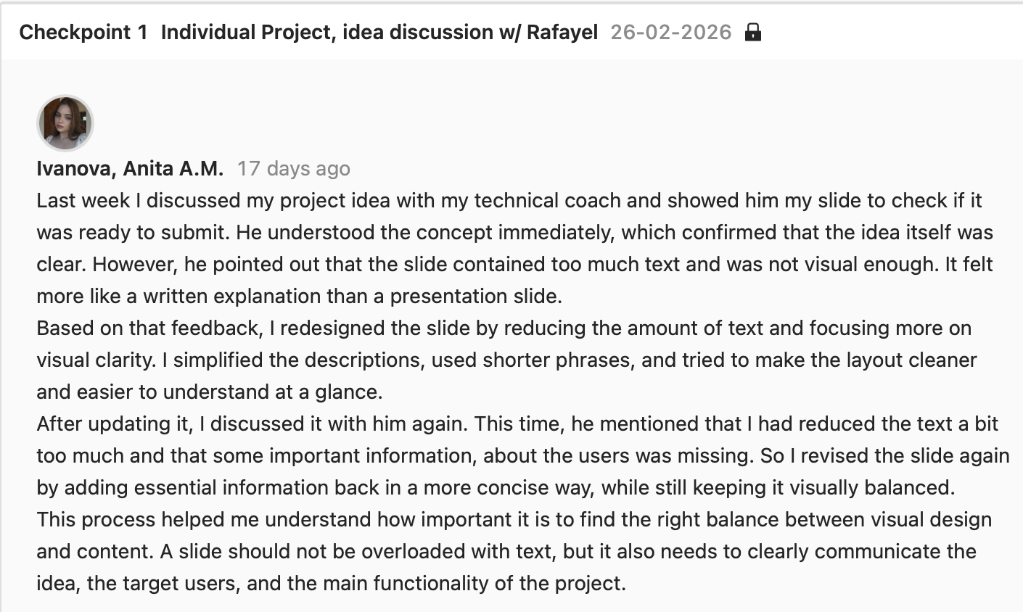

3. Checkpoint 2
After this feedback, I became more careful about how I structure my portfolio and divide information between different documents. I understood that each document should have its own purpose and that I should avoid repeating the same content across multiple artifacts. I also improved the way I think about evidence descriptions by focusing more on explaining what I did, why I did it, and what I learned from it. This feedback helped me better understand how to make my portfolio clearer, more organized, and more reflective.

