Customer Segmentation for E-Commerce using k-Means Clustering

Objectives
To segment customers based on their purchasing behavior using Recency, Frequency, and Monetary (RFM) features and apply K-Means Clustering to group similar customers for targeted marketing strategies.

1. Data Loading and Cleaning
- Source: data.csv
- Encoding: ISO-8859-1
- Cleaning Steps:
  - Dropped rows with missing CustomerID or Description.
  - Filtered only positive values for Quantity and UnitPrice.
  - Converted InvoiceDate to datetime format.
  - Created a new feature TotalAmount = Quantity × UnitPrice.

2. RFM Feature Engineering
- Reference Date: One day after the latest InvoiceDate in the dataset.
- RFM Metrics:
  - Recency: Days since the customer's most recent purchase.
  - Frequency: Number of unique invoices (transactions).
  - Monetary: Total amount spent.
These metrics were grouped by CustomerID to profile each customer.

3. Feature Scaling
- Tool Used: StandardScaler from sklearn
- Reason: To normalize the RFM features so that each contributes equally to distance calculations in clustering.

4. Finding Optimal Number of Clusters (k)
- Method Used: Elbow Method
- Metric: SSE (Sum of Squared Errors/Inertia)
- Range Tested: 1 to 10 clusters
- Observation: A bend (elbow) around k=4, suggesting 4 is the optimal number of clusters.

5. K-Means Clustering
- Chosen k: 4
- Model: KMeans with random_state=42 for reproducibility
- Assignment: Each customer was assigned to one of the 4 clusters.

6. Cluster Analysis
Summary Table:
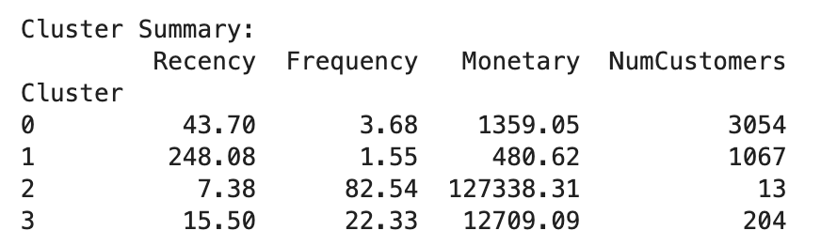
Interpretation Tips:
- Lower Recency = More recent customers.
- Higher Frequency and Monetary = More valuable and loyal customers.
- This analysis helps in understanding customer segments like:
  - Loyal customers
  - High spenders
  - At-risk customers
  - New customers

7. Visualization
- Tool Used: Seaborn PairPlot
- Dimensions: Recency, Frequency, and Monetary
- Colored by: Cluster
- Purpose: To visually explore the separation and distribution of customers across clusters.

Complete Code / Program
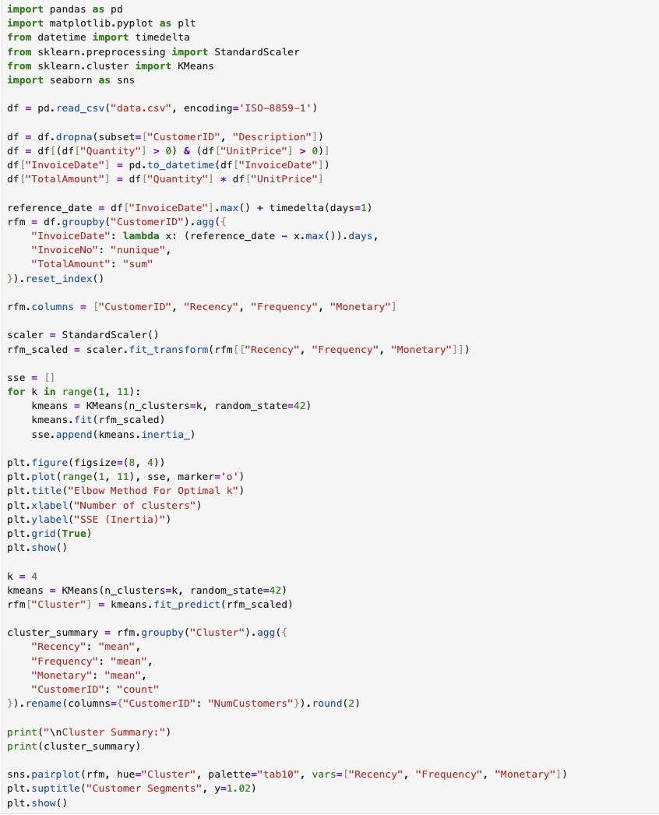
Result
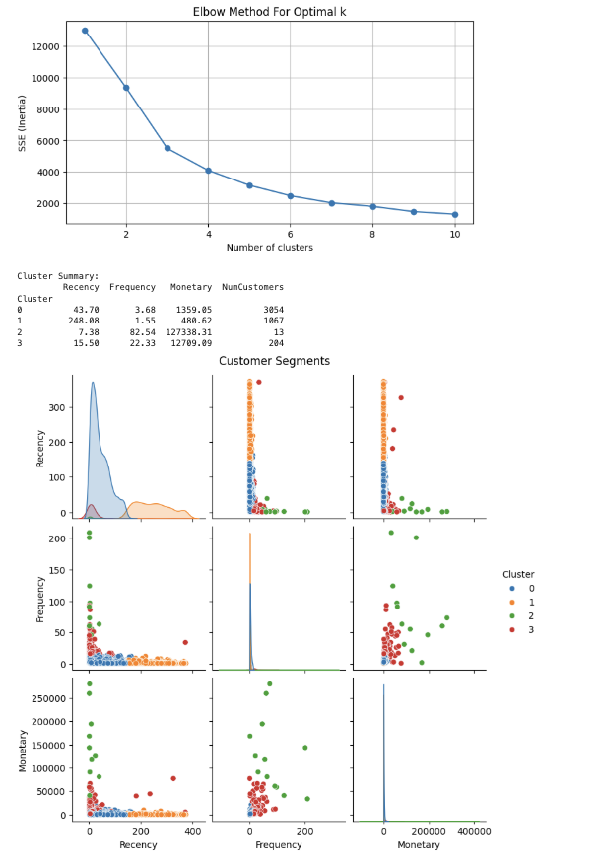

Conclusion
This project successfully performed customer segmentation using the RFM model and k-means clustering. The insights derived from the cluster profiles can help businesses:
- Tailor marketing strategies
- Prioritize high-value customers
- Re-engage inactive customers
- Optimize customer service efforts

