Spark 3.5.3 & Scala 2.12.18 Configuration & Commands

Installation in Windows 10

Step 1: Make sure that you have installed Java 11 or 8
Step 2: Download Spark 3.5.3 and install
Step 3: Download IntelliJ IDE and install

To install Spark and IntelliJ (Community Edition), follow the below YouTube video:
https://www.youtube.com/watch?v=ipw-Sv_jkeY

In case if you get any errors, go through the following video:
https://www.youtube.com/watch?v=UGwgsbY0JA4

Spark home is: C:\spark-3.5.3
Open the command prompt and type: C:\spark-3.5.3\bin>spark-submit –version

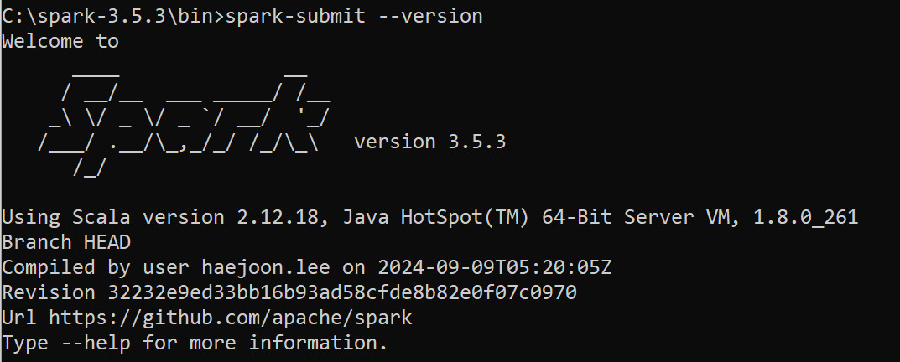
After installing and editing the configuarion of IntelliJ, you must see the IDE as,
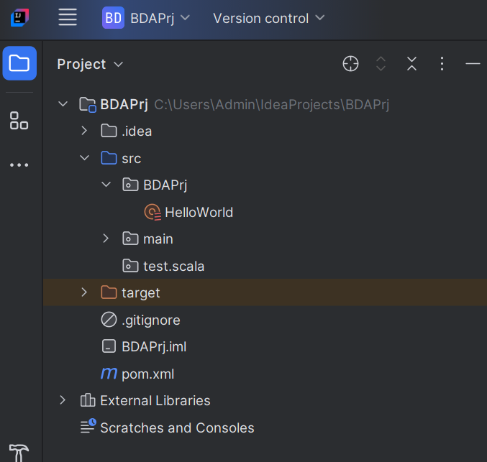

Note that we are using Maven project for this exercise. Maven is an open-source tool that helps manage and build projects.

Make sure that the project folder structure is as mentioned in the above screenshot.
Your scala program should be in this folder:
C:\Users\Admin\IdeaProjects\BDAPrj\src\BDAPrj\HelloWorld.scala

Step 4: To test the Spark-Scala, type the below code in IntelliJ IDE:
// Basic Spark Scala Program
package BDAPrj
import org.apache.spark.sql.SparkSession

object HelloWorld{
def main (args:Array[String]):Unit={
val spark = SparkSession.builder()
.master(master = "local[1]")
.appName(name = "MFU")
.getOrCreate()

println("App name = " + spark.sparkContext.appName)
println("Deployment Mode = " + spark.sparkContext.deployMode)
println("Master = " + spark.sparkContext.master)

spark.stop()
}
}

POM File:
<?xml version="1.0" encoding="UTF-8"?>
<project xmlns="http://maven.apache.org/POM/4.0.0"
xmlns:xsi="http://www.w3.org/2001/XMLSchema-instance"
xsi:schemaLocation="http://maven.apache.org/POM/4.0.0 http://maven.apache.org/xsd/maven-4.0.0.xsd">
<modelVersion>4.0.0</modelVersion>

<groupId>MFU.Spark</groupId>
<artifactId>SparkDemoNew</artifactId>
<version>1.0-SNAPSHOT</version>

<properties>
<maven.compiler.source>11</maven.compiler.source>
<maven.compiler.target>11</maven.compiler.target>
<project.build.sourceEncoding>UTF-8</project.build.sourceEncoding>
<spark.version>3.5.3</spark.version>
<scala.version>2.12.18</scala.version>
</properties>
<dependencies>
<!-- https://mvnrepository.com/artifact/org.apache.spark/spark-core -->
<dependency>
<groupId>org.apache.spark</groupId>
<artifactId>spark-core_2.12</artifactId>
<version>3.5.3</version>

</dependency>
<!-- https://mvnrepository.com/artifact/org.apache.spark/spark-sql -->
<dependency>
<groupId>org.apache.spark</groupId>
<artifactId>spark-sql_2.12</artifactId>
<version>3.5.3</version>
<scope>provided</scope>
</dependency>

<!-- https://mvnrepository.com/artifact/org.scala-lang/scala-library -->
<dependency>
<groupId>org.scala-lang</groupId>
<artifactId>scala-library</artifactId>
<version>2.12.18</version>
</dependency>

</dependencies>
</project>

Output:
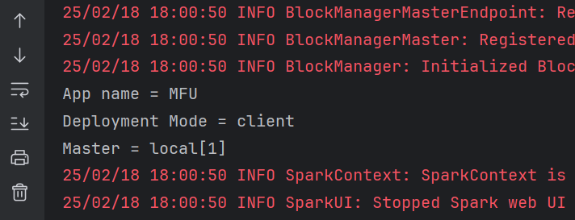

Working with SQL (without MySQL Database)

Type the following code in IntelliJ IDE:
// Demo Scala program to show the working of SQL
package BDAPrj
import org.apache.spark.sql.SparkSession

object ScalaDemo {
def main(args: Array[String]): Unit = {
val spark = SparkSession.builder()
.master(master = "local[1]")
.appName(name = "ScalaDemo")
.getOrCreate()

println("App name = " + spark.sparkContext.appName)
println("Deployment Mode = " + spark.sparkContext.deployMode)
println("Master = " + spark.sparkContext.master)

// Necessary for dataframe creation
import spark.implicits._

// create spark dataframe
val spark_df = Seq(
(1, "Patrick", 10),
(2, "Lisbon", 10),
(3, "Cho", 20),
(4, "Rigsby", 20),
(5, "Scott", 10)).toDF("sno", "name", "deptid")

// create temp view (database Table) for the spark dataframe
spark_df.createOrReplaceTempView("My_Spark_Table")

// select from the temp view using spark sql
spark.sql("Select * from My_Spark_Table").show()

// Get count of employees in each department using spark sql
spark.sql("Select deptid, count(*) from My_Spark_Table group by deptid").show()

spark.stop()
}
}

Output:

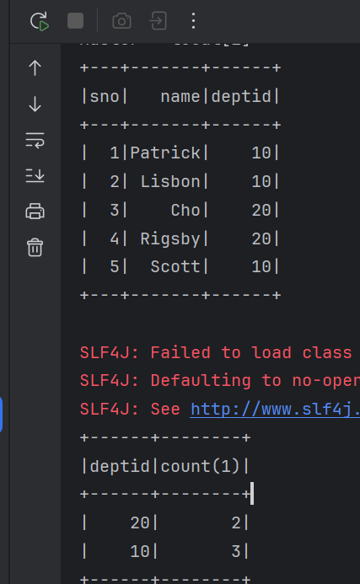

Working with JDBC-MySQL

Step 1: Create a new File: File→New→File. Name it as JDBCDemo.scala
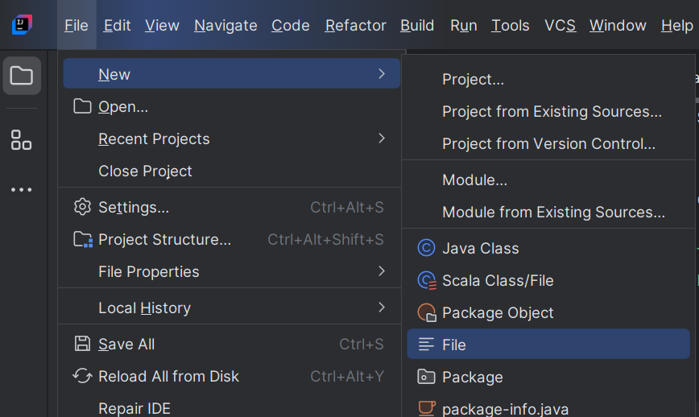

Step 2: Make sure that you have the database and Table created in MySQL Workbench.
Database name : mydatabase
Table Name : Customers
User name : root
Password : admin
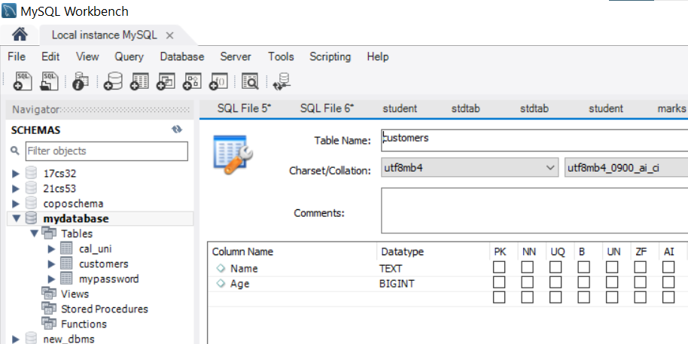

Step 3: Add the JDBC Connector jar files to the external Library
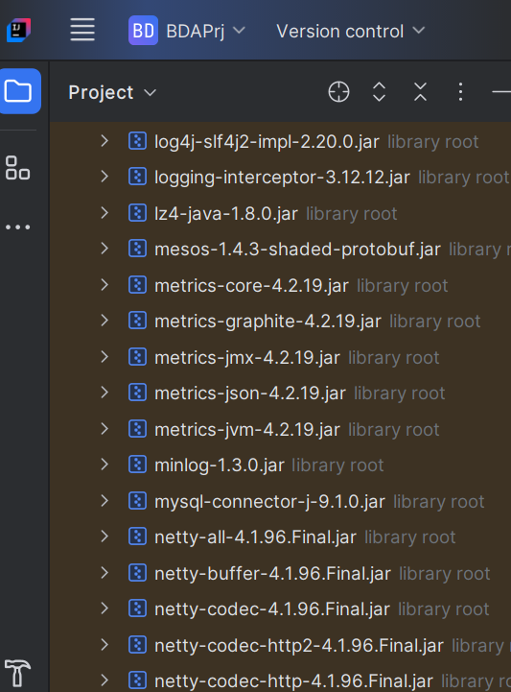

To add the JDBC driver folder, click
File→Project Structure→Modules→Dependencies→+
Download the connector: https://dev.mysql.com/downloads/connector/j/?os=26

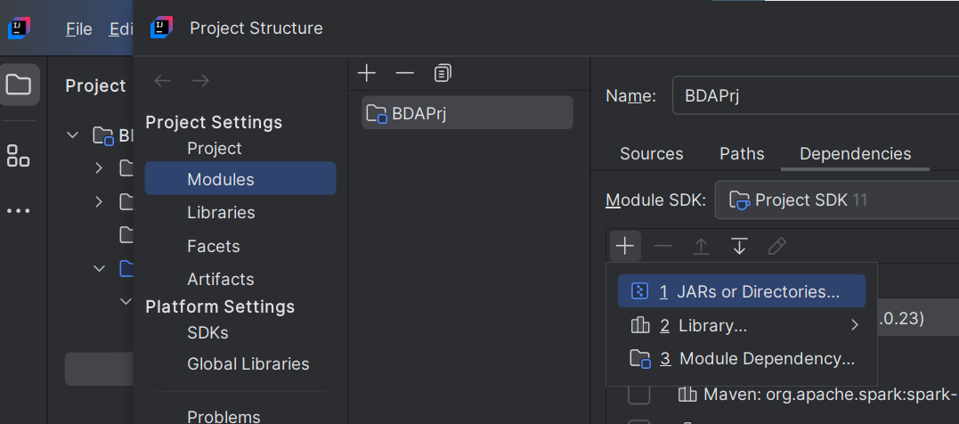

Step 4: Type the below scala program in the file JDBCDemo.scala:

// Program to demonstrate the connection between
// MySQL DB and Scala Program via JDBC
package BDAPrj
import org.apache.spark.sql.SparkSession

object JDBCDemo {
def main(args: Array[String]): Unit = {
val spark = SparkSession.builder()
.master(master = "local[1]")
.appName(name = "ScalaDemo")
.enableHiveSupport()
.getOrCreate()

// Connection String
val jdbcUrl ="jdbc:mysql://127.0.0.1:3306/mydatabase"
val tableName = "customers"
val user = "root"
val password = "admin"

// Read Data from MySQL Table
val df = spark.read
.format("jdbc")
.option("url", jdbcUrl)
.option("dbtable", tableName) // Replace with your table name
.option("user", user)
.option("password", password)
.option("driver", "com.mysql.cj.jdbc.Driver")
.load()

// Display the table data
df.show()

// create temp view (database Table) for the spark dataframe
df.createOrReplaceTempView("My_Spark_Table")

// select only customers who's is Age > 30
println("Customers with Age > 30:")
spark.sql("Select Name, Age From My_Spark_Table Where age > 30").show()

spark.stop()
}
}

Output:
