Data Structures and Algorithms Laboratory | 
Laboratory 1: Review of Object-Oriented Programming with Java | School of Information Technology
Name: | ID: | Section:
Date: | Due date: on the LMS

Objective
- To review fundamental object-oriented programming. Note that the red boxes indicate the inputs.
- Upload your completed pdf format to LMS system.
File name: DSA_lab01_[yourID]_[yourSec].pdf
Due date: 1 week after assigned date.

Exercise 1: (in-class) The below program creates 3 instances of class: “Student” in array and print out all students first name. Complete the missing codes of class: “Student” and “Classroom”

Sample result after running program
Enter score for Student 1: 9
Enter score for Student 2: 7

---Summary---
John: 9 points
Michael: 7 point
Max score = 9 points

// Student Class
public class Student {

private int ID;
private String firstName;
private String lastName;
private int score;

public Student(int id, String firstname, String lastname){
__________ = id;
__________ = firstname;
__________ = lastname;
}

public int getId() {
return _______;
}

public String getFirstName() {
return ___________;
}

public String getLastName() {
return ___________;
}

public void setScore(int s){

}
public int getScore(){

}
}
// Classroom class
import java.util.Scanner;

public class Classroom {

public static void main(String[] args) {
//Variables
Student students[] = new Student[2];
int score, max;

students[_] = new Student(54100001,"John","Nuvo");
students[_] = new Student(54100003,"Michael","Paang");

//Input
Scanner keyboard = new Scanner(System.in);
System.out.print("Enter score for Student 1: ");
score = ______.nextInt();
students[_].setScore(______);

System.out.print("Enter score for Student 2: ");
score = ______.nextInt();
students[_].setScore(______);
//Process
if(____>_____){
max=________;
}else{
max=________;
}
//Output
System.out.println("\n---Summary---");

for(int i=0;____;___){
System.out.println(students[__]._________+ ": " +students[__].getScore()+" points");
}

System.out.println("Max score = "+max+" points");
}
}

Exercise 2: (Homework) Complete missing codes to simulate a shopping system. Assume there are only three shopping items. The red boxes indicate the inputs.

The initial interface of the program is:
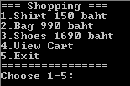

If we try to view the cart, there will be nothing.
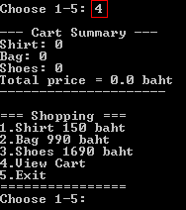

Then choose to by a shirt and see the updated cart.
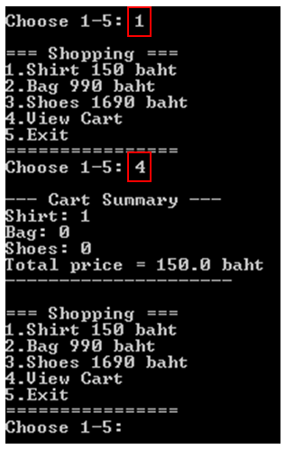

Next add a bag and view the cart again.
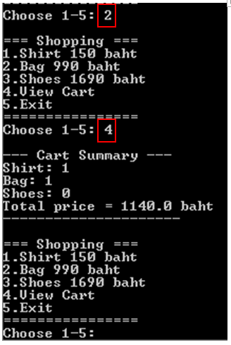

Finally select shoes and observe the cart.
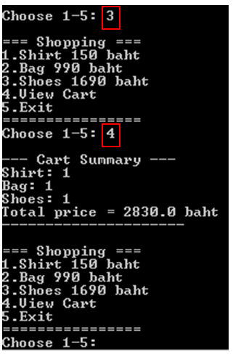

A class diagram is as follows.

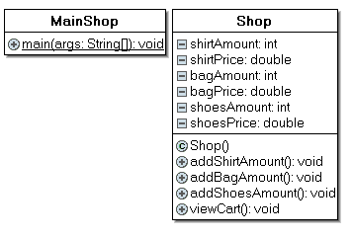

// Shop class
public class Shop {
private int shirtAmount;
private double shirtPrice;
___________________
___________________
___________________
___________________

public Shop() {
shirtAmount = 0;
shirtPrice = 150.0;
bagAmount = ______
bagPrice = ______
______
______
}

public void addShirtAmount() {
______________;
}
public void addBagAmount() {
_____________;
}
public void addShoesAmount() {
_____________;
}
public void viewCart() {
System.out.println("--- Cart Summary ---");
System.out.println("Shirt: "+ __________);
System.out.println("Bag: "+ __________);
System.out.println("Shoes: "+ __________);
System.out.println("Total price = "+ (__________) + " baht");
System.out.println("--------------------");
}

}

// MainShop class
import java.util.Scanner;

public class MainShop {

public static void main(String[] args) {
// TODO Auto-generated method stub
Shop shop = new _______();
while(true) {
int menu;
System.out.println("===Shopping===");
System.out.println("1.Shirt 150 baht");
System.out.println("2.Bag 990 baht");
System.out.println("3.Shoes 1690 baht");
System.out.println("4.view Cart");
System.out.println("5.Exit");
System.out.println("==============");

Scanner keyboard = new Scanner(System.in);
System.out.print("Choose 1-5: ");
menu = _________.nextInt();

if(menu==4) {
shop.viewCart();
}else if(menu==1) {
_____________________

}else if(menu==2) {
_____________________

}else if(menu==3) {
_____________________

}else{
System.exit(0);
}

}
}

}

