Data Structures and Algorithms Laboratory | 
Laboratory 2: Arrays | School of Information Technology
Name: | ID: | Section:
Date: | Due date: on LMS

Objective
- To create, access and modify arrays
- To apply arrays to be data structure for solving problems

Exercise 1 (In-class): Using arrays to be data structure of a Blackjack game and complete the missing codes to get results below.

Game conditions
- 2 players: you and computer
- Card values are from 1-11
- Two random cards for each player
  - If any player get 11 and 11, change the second card to 1
- Winning conditions
  - Sum of card values is higher
  - If both player get the same sum, computer wins

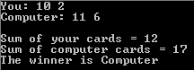

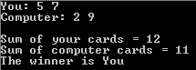

Paste your code here.

import java.util.Random;

public class Blackjack{
private int[] cardYou = new;
private int[] cardComputer;
private int =0;

public Blackjack(){
//Initialize game data
Random rand = new Random();
//Player
cardYou[0] =;

//Dealer
cardComputer[0];

//Sum

//Check both 11
if(sumYou==){

}
if(==){

cardComputer[1] = 1;
}
}

public void showPlayerCard(){

}

public void showComputerCard(){

}

public void showSumCard(){

}

public void checkWinner(){
if(____){
winner = "You";
}
else {

}

}

public String ___Winner(){

}

public _________ void main(___________){
_____ bj = new Blackjack();

bj.showPlayerCard();
bj.showComputerCard();
System.out.println();
____.showSumCard();
bj.checkWinner();
system.out.println(“ ”+bj.___Winner());
}
}

Exercise 2 (Homework): Modify exercise 1 to get more functions as follows.

- You can ask for another card but max total number of cards is 5
- If you do not want more card, the game will end and the winner is the one who gets the higher sum
- Anytime if sum of values of your cards is greater than 21, the game ends and the winner is computer
- If sum of card values of any player is 21, the game ends and that player wins
- If both players get 21 at the beginning, computer wins

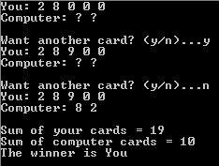 | 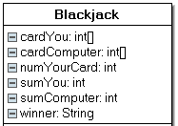
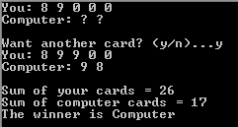 | 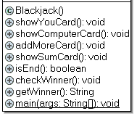
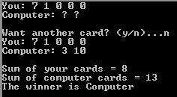
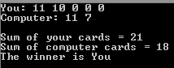
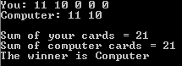
Paste your code here.

