Data Structures and Algorithms Laboratory | 
Laboratory 3: Linked Lists | School of Information Technology
Name: | ID: | Section:
Date: | Due date: on the LMS

Objective
- To create, access and modify linked lists
- To implement singly linked lists

Exercise 1: (In-class) From the given class diagram, create a singly linked list and complete the program to get the results as shown. Assume that elements in all nodes are integer.
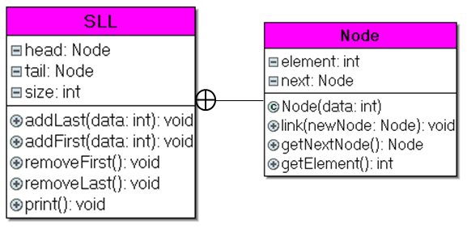
Expected result
1->2->3->null
2->3->null
2->null

Complete the codes below.
class SLL {
// ----------------------- Node --------------------
private class Node {
private int element;
private Node next;

// constructor
public Node(int data) {
element = data;
next = null;
}

// link a new node to this node
public void link(Node newNode) {
next = newNode;
}

// return next node
public Node getNextNode() {
return next;
}

// return element of this node
public int getElement() {
return element;
}
}
// --------------------- End Node --------------------

// SLL properties and methods
private Node head = null;
private Node tail = null;
private int size = 0; // SLL's size

public void addLast(int data) {
// create new node
Node newNode = new Node(data);
if (size == 0) {
head = newNode;
} else {
tail.link(newNode);
}
tail = newNode;
size++;
}

public void addFirst(int data) {

}

public void removeFirst() {

}

public void removeLast() {

}

public void print() {
if (size == 0) {
System.out.println("Empty linked list");
} else {
for (Node p = head; p != null; p = p.getNextNode()) {
System.out.print(p.getElement() + "->");
}
System.out.println("null");
}
}
}

//======================== Main Class ========================
public class MainSLL {
public static void main(String[] args) {
SLL sll = new SLL();
sll.addFirst(2);
sll.addLast(3);
sll.addFirst(1);
sll.print();
sll.removeFirst();
sll.print();
sll.removeLast();
sll.print();
}
}

Exercise 2: (In-class) From the previous exercise, create four new methods as follows:
- int getSize() return size of SLL
- boolean isEmpty() return true if SLL is empty
- element get(index) return element at specified position
- void clear() remove all elements

For example, if we have a SLL.
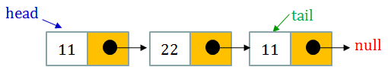

Expected result
=== Empty SLL ===
Size = 0
Empty = true

=== After adding elements ===
Size = 3
Empty = false
Element 0 = 11
Element 1 = 22
Element 2 = 11

=== After clearing elements ===
Size = 0
Empty = true

class SLL{

}

public class MainSLL{
public static void main(String[] args){
SLL sll = new SLL();
System.out.println("=== Empty SLL ===");
System.out.println("Size = "+ sll.size());
System.out.println("Empty = " + sll.isEmpty());
System.out.println();

//add elements
sll.addLast(11);
sll.addLast(22);
sll.addLast(11);
System.out.println("=== After adding elements ===");
System.out.println("Size = "+ sll.size());
System.out.println("Empty = " + sll.isEmpty());
System.out.println("Element 0 = " + sll.get(0));
System.out.println("Element 1 = " + sll.get(1));
System.out.println("Element 2 = " + sll.get(2));
System.out.println();

//clear
sll.clear();
System.out.println("=== After clearing elements ===");
System.out.println("Size = "+ sll.size());
System.out.println("Empty = " + sll.isEmpty());
}
}

Exercise 3 (Homework): From the previous exercise, create three new methods as follows:
- findElement(element) to find whether a number is in a SLL and return true or false when found and not found respectively
- countElement(element) to count nodes whose elements are equal to a number
- sumElement() to find summation of all numeric elements of nodes

For example, if we have a SLL.
- findElement(11) will return true but findElement(33) will return false
- countElement(11) will return 2, countElement(22) will return 1 and countElement(33) will return 0
- sumElement() will return 44

Expected result

11->22->11->null

Find element 11: true
Find element 22: true
Find element 33: false
Count element 11: 2
Count element 22: 1
Count element 33: 0
Sum of all elements: 44

class SLL{

}

public class MainSLL{
public static void main(String[] args){
SLL sll = new SLL();
sll.addFirst(11);
sll.addLast(22);
sll.addLast(11);
sll.print();

System.out.println();
System.out.println("Find element 11: "+sll.findElement(11));
System.out.println("Find element 22: "+sll.findElement(22));
System.out.println("Find element 33: "+sll.findElement(33));
System.out.println("Count element 11: "+sll.countElement(11));
System.out.println("Count element 22: "+sll.countElement(22));
System.out.println("Count element 33: "+sll.countElement(33));
System.out.println("Sum of all elements: "+sll.sumElement());
}
}

Example (Optional): Implementation of SLL using ArrayList

JAVA provides a class ArrayList which is one type of SLL with several built-in methods. Try to observe the following codes.

Be careful that the data to store in ArrayList must be objects not the primitive variables.

import java.util.ArrayList;

public class MainArrayList {

public static void main(String[] args) {
//create an Integer ArrayList with default size of 10
ArrayList<Integer> sll = new ArrayList<Integer>();

//add first
sll.add(0, new Integer(2)); //[2]
//add last
sll.add(new Integer(3)); //[2,3]
//add first
sll.add(0, new Integer(1)); //[1,2,3]
//print
System.out.println(sll);

//remove first
sll.remove(0); //[2,3]
//remove last
sll.remove(sll.size() - 1); //[2]
//print
System.out.println(sll);

//find element
System.out.println(sll.contains(new Integer(2))); //true
System.out.println(sll.contains(new Integer(1))); //false
}
}

To see more details and functionality of ArrayList, please visit https://docs.oracle.com/javase/8/docs/api/java/util/ArrayList.html

Exercise 4 (Optional): Use the ArrayList and its functions above to get the following result.

Assume that we want to create a back-end of a shopping system for the administrator. This system allows to add, delete and show products. Suppose that we use two SLL to store product name and product price.

Expected result

=== Shopping Backend ===
1. Show product
2. Add product
3. Delete product
4. Exit
Choose 1-4...1
--- Product ---
No product

=== Shopping Backend ===
1. Show product
2. Add product
3. Delete product
4. Exit
Choose 1-4...2
Enter product name: Shirt
Enter product price: 199

=== Shopping Backend ===
1. Show product
2. Add product
3. Delete product
4. Exit
Choose 1-4...2
Enter product name: Shoes
Enter product price: 299

=== Shopping Backend ===
1. Show product
2. Add product
3. Delete product
4. Exit
Choose 1-4...1
--- Product ---
1. Shirt 199 baht
2. Shoes 299 baht

=== Shopping Backend ===
1. Show product
2. Add product
3. Delete product
4. Exit
Choose 1-4...3
1. Shirt 199 baht
2. Shoes 299 baht
Enter the number of product to delete...1

=== Shopping Backend ===
1. Show product
2. Add product
3. Delete product
4. Exit
Choose 1-4...1
--- Product ---
1. Shoes 299 baht

=== Shopping Backend ===
1. Show product
2. Add product
3. Delete product
4. Exit
Choose 1-4...4
Good bye

Paste your code here.

