**LAPORAN GRAFIKA KOMPUTER**

**PERTEMUAN 2**

**Nama : Anita Putri**

**NIM : 21104410008**

**Kelas : TI 4A**

**Tugas**

1. Background warna ukuran jendela 640, 480

|  |
| --- |
| function setup() {  createCanvas(640, 480);  }  function draw() {  background(255,160,122);  } |

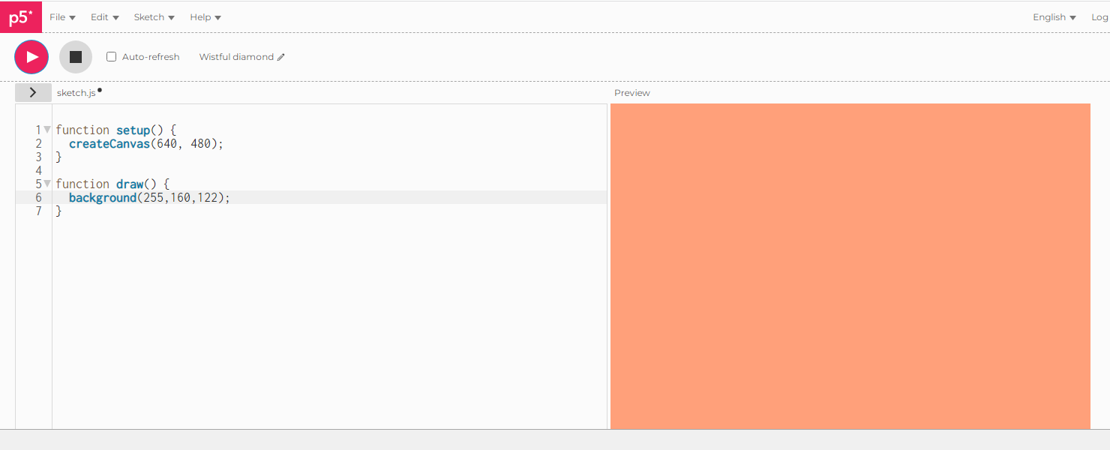

1. Membuat bentuk

|  |
| --- |
| function setup() {  createCanvas(640, 480);  }  function draw() {  background(139, 69, 19);    fill(254, 228, 181);  triangle(100, 200, 150, 100, 200, 200);  fill(210, 180, 140);  triangle(200, 200, 250, 100, 300, 200);  fill(254, 228, 181);  triangle(300, 200, 350, 100, 400, 200);    fill(222, 184, 135);  rect(100, 200, 300, 80);  fill(160, 82, 45);  rect(100, 270, 300, 30);    fill(0, 0, 0);  ellipse(150, 90, 25, 25);  fill(255, 250, 250);  ellipse(250, 90, 25, 25);  fill(0, 0, 0);  ellipse(350, 90, 25, 25);  } |

