**Objective Questions**:

1. What is the total no. of tables present in the data?

**Ans.**

There are 2 tables in the final excel file. One is inside the raw data sheet (original table) and second one is inside Table 1 sheet (a dynamic table created using power query editor, so that it doesn’t affect the original data, with some new added columns according to the requirement).

1. What is the total no. of attributes present in the data?

**Ans.** Raw Data Tabel=21 & Table 1 = 26

1. How many categorical columns are there in the data?

**Ans.** 15

4.

The data consists of some inconsistent and missing values so ensure that the data used for further analysis is cleaned.

Answer::

Missing values were there for cuisines of USA, which is filled up by maximum occurrence of cuisines in USA by using a pivot table and then drawing out the max using LOOKUP function.

Approch:: The missing values can be found out by filtering out the blank values using proper filter option. Or by looking the “Column Quality” option inside View Tab of Power Query Editor

Added “American” to Cuisines Column for missing values because missing values was there for USA country only. And also added year column to find no. of restaurants opened each year using =LEFT(W2,4) function.

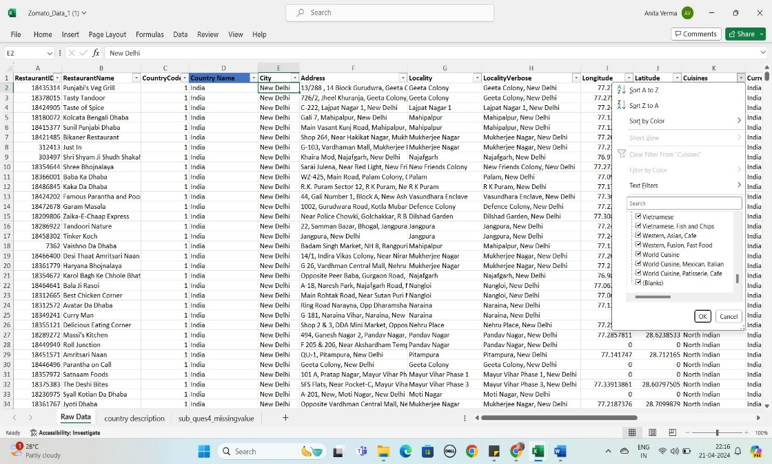

1. Using the LookUp functions, fill up the countries in the original data using the country code.

Ans:

**APPROACH -** Used XLOOKUP Function in Raw data sheet for fetching the country name from the Country description sheet.

* Inserted a Country column next to the country code column in the raw data sheet for accurate analysis, Using XLOOKUP Function **=VLOOKUP(C2,'country description'!A$2:B$16,2,0).**
* 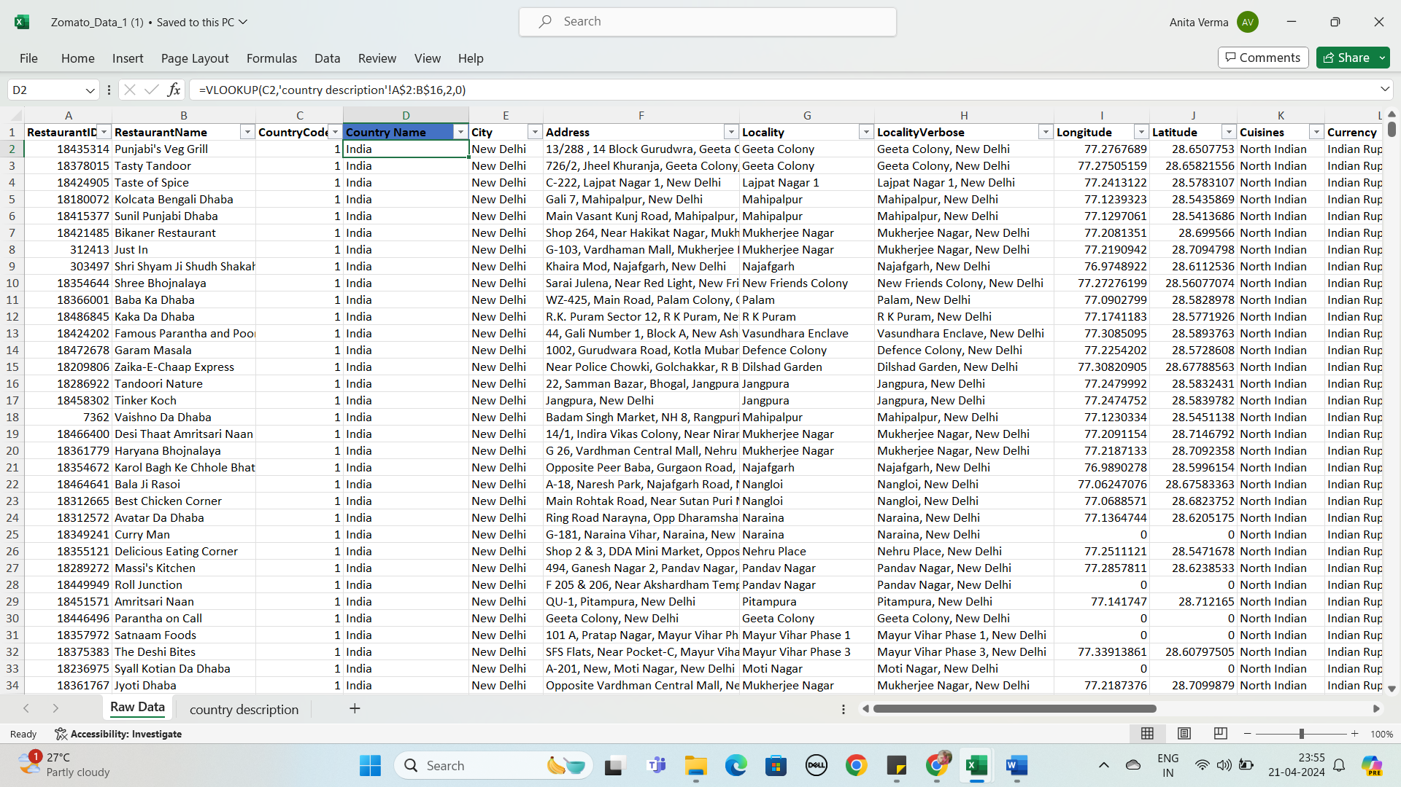

6.Create a table to represent the number of restaurants opened in each country.

ANS::

|  |  |  |
| --- | --- | --- |
| 6.Number of resturant each country   |  | | --- | |  | |  |
|  |  |
| **Row Labels** | **Count of RestaurantName** |
| Australia | 24 |
| Brazil | 60 |
| Canada | 4 |
| India | 8652 |
| Indonesia | 21 |
| New Zealand | 40 |
| Philippines | 22 |
| Qatar | 20 |
| Singapore | 20 |
| South Africa | 60 |
| Sri Lanka | 20 |
| Turkey | 34 |
| United Arab Emirates | 60 |
| United Kingdom | 80 |
| United States of America | 434 |
| **Grand Total** | **9551** |

* **APPROACH -** Created a pivot table using Raw Data, in row added the country and in value added the Restaurant Name and summaries by count function.
* **FINDINGS -** The total number of restaurants in the given data set is **9551.** India has the highest number of restaurants among all countries around **8652** restaurants and Canada and Austria has the least number of restaurants, that is **4**

**Question no .7:** Also, the management wants to look at the number of restaurants opened each year, so provide them with something here.

ANSWER::

|  |  |  |  |  |
| --- | --- | --- | --- | --- |
| number of resturant open each year   |  | | --- | |  | |  |  |  |
|  |  |  |  |
|  |  |  |  |
|  | **Row Labels** | **Count of RestaurantName** |  |
|  | 2010 | 1080 |  |
|  | 2011 | 1098 |  |
|  | 2012 | 1022 |  |
|  | 2013 | 1061 |  |
|  | 2014 | 1051 |  |
|  | 2015 | 1024 |  |
|  | 2016 | 1027 |  |
|  | 2017 | 1086 |  |
|  | 2018 | 1102 |  |
|  | **Grand Total** | **9551** |  |
|  |  |  |  |

* To answer this we need a Year column. For this, have Inserted columns next to the Datekey_Opening column in the raw data sheet and then applied **‘split text to the column’** on the column, and then separated them using delimiters of ‘_’. With this, I have extracted the Year, Month & Date from the Datekey_Opening and **labeled it as Opening Year, Opening Month & Opening date.**
* **APPROACH -** Created a pivot table using Raw Data, add Year in row and Restaurant Name in value and summaries by count function. Along with this, I’ve also created a Bar chart for the better representation of data on how many restaurants have opened in each year.
* **FINDINGS -** This data confirms that more than 1000 restaurants are opened each year.
* As per the analysis, the maximum number of restaurants open in **2018 (i.e. 1102)** and the minimum number of restaurants open in **2012 (i.e. 1022)**.

**Question 8:** What is the total number of restaurants in India in the price range of 4?

**Answer:**:

|  |  |
| --- | --- |
| *Country Name* | COUNTA of Restaurant Name |
| India | 388 |
|  |  |

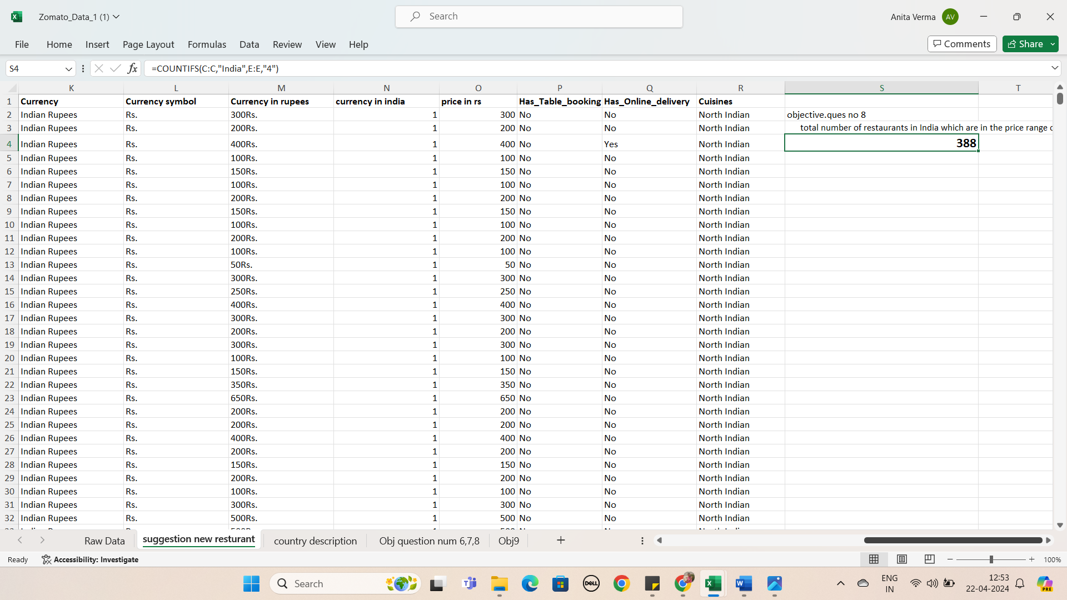

**Approach: -** Using conditional aggregation function COUNTIFS we can achieve this, because we have to look for 2 criteria here, first one is where country is “India” and second one is having “price range” is equals to 4. So, I’ve putted the country name column range in criteria_range_1 (first parameter of COUNTIFS function), “India” in criteria1 (second parameter of COUNTIFS function), Price Range column range in criteria_range_2 (third parameter of COUNTIFS function) and “4” in criteria2 (fourth parameter of COUNTIFS function), to get the desired result as shown above.

**Question 9:**

What is the average number of voters for the restaurants in each country according to the data?

Answer: **Approach: -** For this I have used the pivot table. In which “Country Name” column is putted in the rows and “Voters” is putted in value field and changed the field setting to average of “Restaurant Id” of pivot table, so that we can get average number of voters for the restaurants in each country.

|  |  |  |  |  |
| --- | --- | --- | --- | --- |
| average number of voters for the restaurants in each country according to the data   |  | | --- | |  | |  |  |  |
|  |  |  |  |
|  |  |  |  |
|  | **Row Labels** | **Average of Votes** |  |
|  | Australia | 111.4166667 |  |
|  | Brazil | 19.61666667 |  |
|  | Canada | 103 |  |
|  | India | 137.212552 |  |
|  | Indonesia | 772.0952381 |  |
|  | New Zealand | 243.025 |  |
|  | Philippines | 407.4090909 |  |
|  | Qatar | 163.8 |  |
|  | Singapore | 31.9 |  |
|  | South Africa | 315.1666667 |  |
|  | Sri Lanka | 146.45 |  |
|  | Turkey | 431.4705882 |  |
|  | United Arab Emirates | 493.5166667 |  |
|  | United Kingdom | 205.4875 |  |
|  | United States of America | 428.2211982 |  |
|  | **Grand Total** | **156.9097477** |  |
|  |  |  |  |

10. Calculate the average rating for all the restaurants that have price_range < 4 and provide online delivery. Use only the “IF” function, Logical Operators, and Aggregation functions to solve this problem. **[Note: Don’t use Conditional aggregation in this question.]**

ANS:: **Approach: -** Instead of using conditional aggregation function “AVERAGEIF”, I’ve done this using Average and If condition in a nested way. Firstly, IF condition will look for cells which have Price_range less than 4 and simultaneously having “Yes” in the Has_Online_delivery. Then, AVERAGE function will calculate the average of Ratings column for those values which we get from the IF condition.

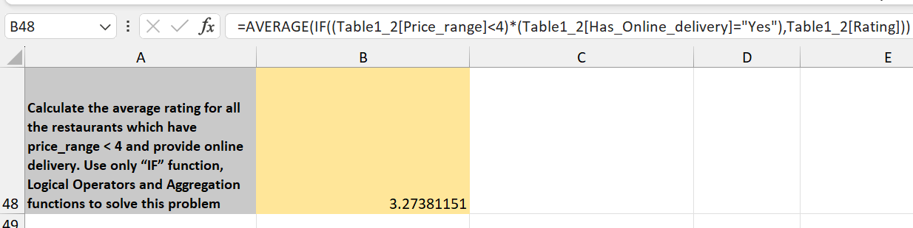

**11.**Using Conditional formatting highlight the rows of restaurants that are located in the countries or cities that you’ve suggested to the management for opening new restaurants.

Ans:

**Heiglighte row in sheet (suggestion_new_resturant)**

* **Country with less restaurant than 200**
* **Restaturnt in that country which has rating >=3**
* **resturant in that coutry which has avg_cost_for_two <=800 and not 0(after converting each avg_cost_for_two to any one currency)**
* **Votes (number of persion visited)>100 in that restaurant**

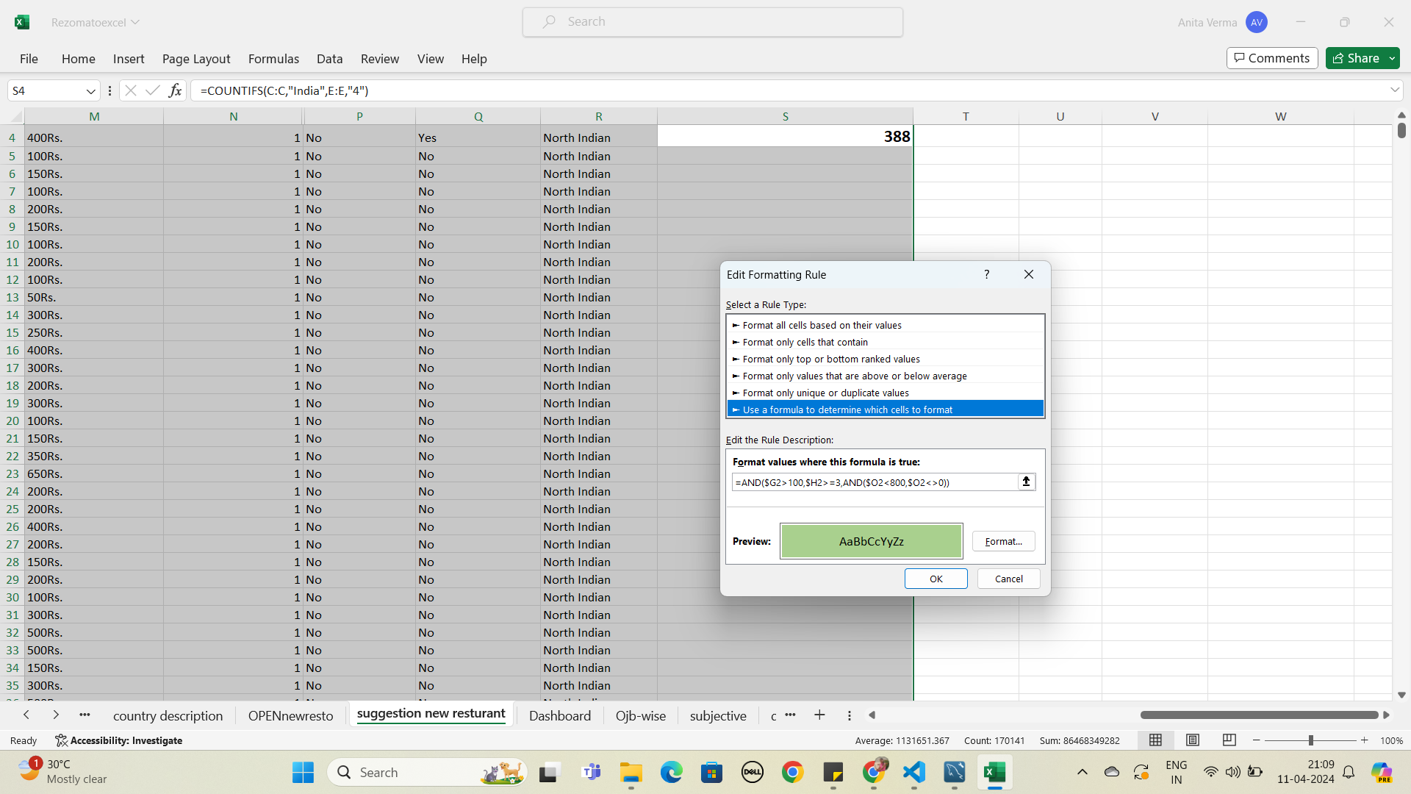

**12.ques::**

Create a new customized price column that consists of the abbreviation/symbol of the currency along with the Average_cost_for_two values. [Use string operations to do this task]

ans:: go to suggestion_new _resturant sheet ,we used concat(o2,L2) formula and put value in column M

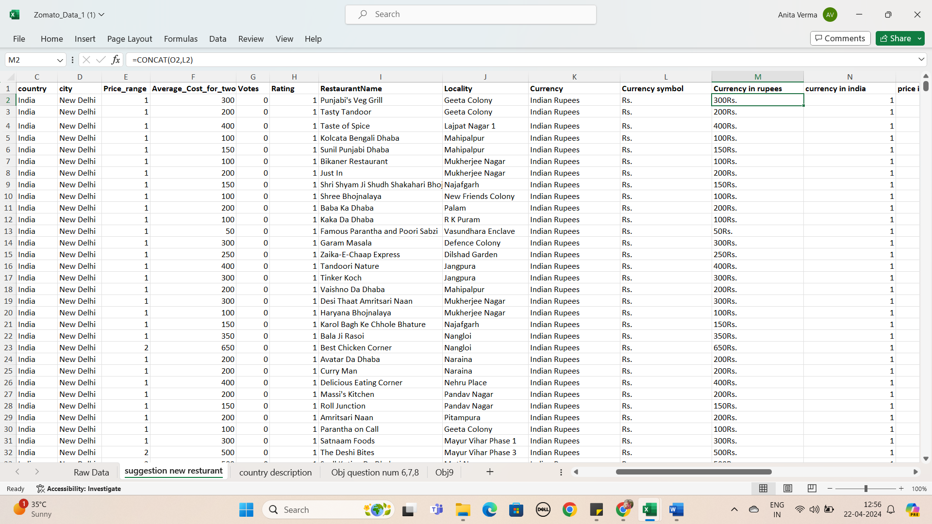

**13.** How can you create an array formula in Excel or Google Sheets to count the number of restaurants listed that do not offer online delivery, are in the lowest price range, and have an average cost for two people less than or equal to 250 Indian Rupees?

**Ans:** ans: ={=COUNTIFS(D2:D9552, "No", B2:B9552, 1, C2:C9552, "<=250")}

**Approach: -** As there is no restriction mentioned in this question so I’ve used the conditional aggregation formula COUNTIFS to solve it, because we have to look for multiple criteria here, first one is where has_online_delivery is “No”, second one is having “price range” is equals to 1 (i.e. lowest price_range), third one is having an average_cost_for_two people less than or equal to 250 Indian Rupees i.e Price_Imputed less than equals to 250 rupees. So, I’ve putted the has_online_delivery column range in criteria_range_1 (first parameter of COUNTIFS function), “No” in criteria1 (second parameter of COUNTIFS function), Price Range column range in criteria_range_2 (third parameter of COUNTIFS function) and “1” in criteria2 (fourth parameter of COUNTIFS function), average_cost_for_two column range in criteria_range_3, Price_Imputed less than equals to Rs. 250 in criteria3 to get the desired result

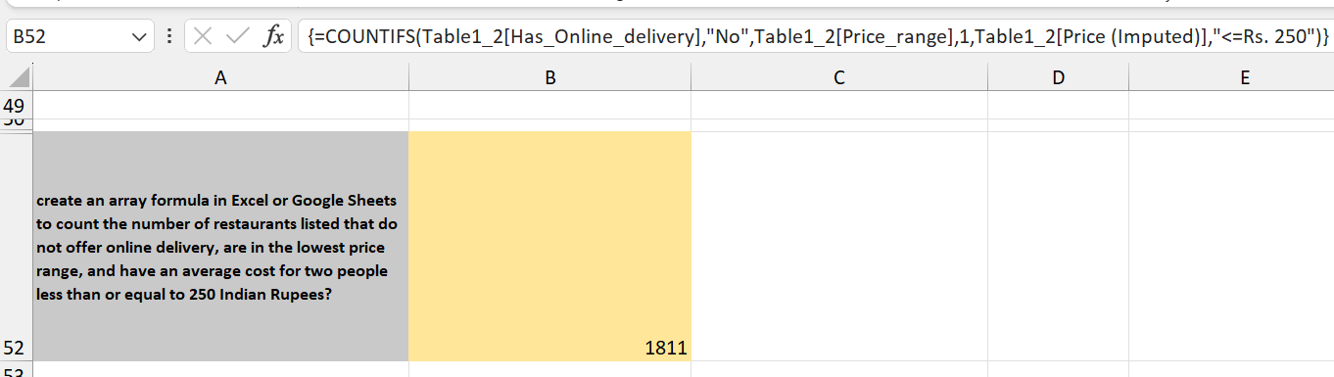

**Subjective**

**1.Suggest a few countries where the team can open newer restaurants with lesser competition.**

**Answer:**

|  |  |  |  |  |
| --- | --- | --- | --- | --- |
| **1.Suggest a few countries where the team can open newer restaurants with lesser competition**   |  | | --- | |  | |  |  |  |
|  |  |  |  |
|  |  |  |  |
|  |  |  |  |
|  |  |  |  |
|  | **Row Labels** | **Average of Rating** | **Count of RestaurantID** |
|  | Australia | 3.658333333 | 24 |
|  | Canada | 3.575 | 4 |
|  | Singapore | 3.575 | 20 |
|  | Sri Lanka | 3.87 | 20 |
|  |  |  |  |

**Approach: -** We can analyse it by keeping following criteria in mind

1. Country with less restaurants than 200.

2. Restaurants in that country which has rating>=3.

3. Restaurants in that country which has avg_cost_for_two <= Rs 1600 and not 0 (after converting each avg_cost_for_two to any one currency). The average cost for two person to eat food in Indian Rupee ranges from Rs 800-Rs2000, therefore, Rs 1600 (a middle value is taken) for the analyses.

4. Votes (number of persons visited) >150 in that restaurant

**Visualization: -** We can use conditional formatting to fetch lesser competition countries and a dashboard to visualize the analyses.

**Ques2: : Come up with the names of States and cities in the suggested countries suitable for opening restaurants and What is the current quality regarding ratings for restaurants that are open in suggested countries ?**

**Ans:**

**names of States and cities in the suggested countries suitable for opening restaurants and What is the current quality regarding ratings for restaurants that are open in suggested countries**

**ques**

|  |  |  |
| --- | --- | --- |
| **country** | **city** | **Average of Rating** |
| **Australia** | Armidale | 3.5 |
|  | Balingup | 3.2 |
|  | Beechworth | 4.6 |
|  | East Ballina | 4.1 |
|  | Forrest | 3.7 |
|  | Macedon | 3.5 |
|  | Mayfield | 2.9 |
|  | Middleton Beach | 3.8 |
|  | Palm Cove | 4.4 |
|  | Penola | 3.4 |
|  | Phillip Island | 3.7 |
| **Canada** | Chatham-Kent | 3.7 |
|  | Consort | 3 |
|  | Yorkton | 3.3 |
| **Sri Lanka** | Colombo | 3.87 |
| **Grand Total** |  | **3.691176471** |

**APPROACH -** Firstly, Listed down all the cities in the selected countries along with the number of Restaurants along with the average rating for the city. In that Pivot table, added the country column in row and restaurants name in value, summaries by count function.

* **FINDINGS -** Arranged all of the data in ascending order of Rating and then filter out only cities having less than 3 .7 ratings for lesser competition. and as a result, we have **few** cities ,where we open new restaurants

**Ques 3.**

**According to the countries you suggested, what is the current quality regarding ratings for restaurants that are open there?**

Ans: all detail in 2 number 2 plz check it

Ques.4:

**Also, what is the current expenditure on food in the suggested countries, so we can keep our financial expenditure in control?**

**Ans:**

* For this, created a separate sheet “**Currency Conversion**” and listed down the current conversion rate for all the different Currency types in the Raw Data. After that, inserted a new column next to the “Average_Cost_for_two” column with the name of the column as **“Average_Cost_for_two_in_Dollars”.** In this column, converted all the values in Ruppes by using the VLOOKUP formula**“=VLOOKUP(L2,CURRENCY!$A:$B,2,0) *S2”** from the Currency conversion.
* **APPROACH -** Created a Pivot Table added Country in Rows and Average of Average_Cost_for_two_in_Dollars in Values and then filtered only the selected countries. Apart from this, Created the visualization with the column Chart where we can see what is the average cost for two in Dollars in the restaurants in the selected countries.
* **FINDINGS -** In Sri Lanka we spend an average amount like 7.36$ and in Singapore we need to spend 155.75 $ as the financial expenditure.

|  |  |
| --- | --- |
| **Row Labels** | **Average of price in rs** |
| Australia | 1315.190833 |
| Canada | 2221.0375 |
| Singapore | 9648.7125 |
| Sri Lanka | 641.25 |

* We must keep our financial expenditure in control and have a balanced expenditure on food.

**Ques 5:**

**Come up with the names of restaurants from the recommended states that are our biggest competitors and also those that are rated in the lower brackets, i.e. 1-2 or 2-3.**

**Ans:**

|  |  |  |  |  |
| --- | --- | --- | --- | --- |
|  | Ques 5 bigg compatitor   |  | | --- | |  | |  |  |
|  |  |  |  |
|  |  |  |  |
|  |  |  |  |
|  | **country** | **city** | **Average of Rating** |
|  | **Australia** | Beechworth | 4.6 |
|  |  | East Ballina | 4.1 |
|  |  | Huskisson | 4.1 |
|  |  | Palm Cove | 4.4 |
|  |  | Tanunda | 4.4 |
|  |  | Trentham East | 4.1 |
|  | **Canada** | Vineland Station | 4.3 |
|  | **Sri Lanka** | Colombo | 3.87 |

**APPROACH -** Created the pivot table and used a rating filter in both cases, more than 3.8 for Biggest Competitors & less than 3 .7 for no competition. Also used filter on cities. For better visualization, used the column chart to display this data.

* **FINDINGS -** As per the given data, Australia is the only country where we have 6 high competition cities **(Beechworth, East Ballina, Huskisson, Palm Cove, Tanunda, Trentham East.**We can start from low competition cities and after that once we get a good grip on the Australian market then we can start with high competition cities.
* We have 3cities suitable for opening our new restaurants with negligible competition. Those 3 cities are **Mayfield, Montville, Paynesville, Consort ,canada and colabo** Please refer to the column charts given below -

|  |
| --- |
|  |

|  |  |  |  |
| --- | --- | --- | --- |
| ques no 5 :less compatitor |  |  |  |
|  |  |  |  |
|  |  |  |  |
|  |  |  |  |
|  |  |  |  |
|  | **country** | **city** | **Average of Rating** |
|  | **Australia** |  | 3.254545455 |
|  | **Canada** | Consort | 3 |
|  |  | Yorkton | 3.3 |
|  | **Singapore** | Singapore | 3.575 |
|  |  |  |  |

**Ques6.**

**Which cuisines should we focus on in the newer restaurants to get better feedback? Does the choice of cuisines affect the restaurant ratings?**

**Ans:**

* **APPROACH -** To determine Rating, we add cuisines in row, rate in value and summaries by Average function in the pivot table.
* Firstly, listed all the Cuisines which are getting served in the selected country along with the average of Rating and the total votes through which the rating has been decided and arranged the data into ascending order of average of rating. With this dataset, we will get to know the cuisines which are rated by a large number of people.
* **INSIGHTS -** we must know the cuisine is currently in demand. Now, we have taken the cuisines where the rating are below 3.8 rating. If the rating of any cuisine is above 3.8 rating then we should avoid the cuisines as there is a high chance of tough competition.
* the choices of cuisines do affect the rating of the restaurant because if we provide the customer with the type of food which is generally bad in the country with the good quality then there are high chances that they will like the food and give the restaurant higher ratings. But if we serve food which is already highly rated, then the smallest of the mistakes will lead to a bad rating.
* **FINDINGS -** In our newer restaurants, we should focus majorly on American food, Italian food and Continental food. Plotted a line chart for better visuals.

ques no 6.Which cuisines should we focus on in the newer restaurants to get better feedback? Does the choice of cuisines affect the restaurant ratings?

|  |  |
| --- | --- |
| **Row Labels** | **Average of Rating** |
| Chinese | 2.409322034 |
| Desserts | 2.960377358 |
| Cafe | 3.048160535 |
| Continental | 3.614285714 |
| Italian | 3.731481481 |

**Ques 7.**

**According to our current data, should we go for online delivery and table booking? Does that affect the customer’s ratings?**

**Ans:**

* **APPROACH -** In Pivot chart, table booking in row and added average of rating in values. same with online delivery and created pie charts for better visualization.
* **INSIGHTS - Yes**. As per the survey, we must opt for online delivery and table booking, It affects the customer’s ratings.
* Restaurants offering more services (online delivery and table booking)tend to have higher ratings because customers enjoy additional ease & convenience in their dining experience. Refer to the pie charts for better clarity.
* We can offer the current high rating Restaurants to tie up with us. We can approach them.

**Booking Table**

|  |  |
| --- | --- |
| **Row Labels** | **Average of Rating** |
| No | 2.809686644 |
| Yes | 3.482556131 |
| **Grand Total** | **2.89126793** |

**Online Table**

|  |  |
| --- | --- |
| **Row Labels** | **Average of Rating** |
| No | 2.754309859 |
| Yes | 3.288004896 |
| **Grand Total** | **2.89126793** |

**Ques.8::**

**subShould the team keep the rate of cuisines higher? Will that affect the feedback? According to our data are the rates of cuisines and ratings, correlated?**

**Ans:**

* **APPROACH -** Created Pivot chart, as cuisines in row, added average of rating and price range in value.
* **INSIGHTS -** According to our data, the rates of cuisines and ratings are not directly correlated. But the quality and ratings are directly related. To get a higher rating, We must keep the rate of cuisines in the middle range and keep high quality cuisines in our newer Restaurants.
* **Plz check** In excel ques no.7,8 and 9:

**Should the team keep the rate of cuisines higher? Will that affect the feedback? According to our data are the rates of cuisines and ratings, correlated?**

|  |  |  |
| --- | --- | --- |
| **Row Labels** | **Sum of Price_range** | **Average of Rating** |
| American | 95 | 3.7625 |
| Cafe | 517 | 3.048160535 |
| Chinese | 525 | 2.409322034 |
| Continental | 63 | 3.614285714 |
| Desserts | 61 | 2.960377358 |
| Italian | 161 | 3.731481481 |
| **Grand Total** | **1422** | **2.861266748** |

**Ques.9: What is the distribution of several restaurants of different price ranges in all the countries?**

**Ans:**

|  |  |  |
| --- | --- | --- |
| **Row Labels** | **Count of RestaurantID** | **Count of City** |
| 1 | 4444 | 4444 |
| 2 | 3113 | 3113 |
| 3 | 1408 | 1408 |
| 4 | 586 | 586 |
| **Grand Total** | **9551** | **9551** |

* **APPROACH -** Used a pivot table to fetch the different price range of restaurants of all the countries, add Price range in row and Restaurants Name in value and summaries by Count function.
* **FINDINGS -** As a result, we can see that there are less number of restaurants having higher price range.

1. **.Explain your approach in brief for suggesting countries/cities in order to open new restaurants, if the objective and subjective questions would have not been given to assist you.** **[you have to give bullet pointers in order to answer this question]**

**Ans:: Answer :: 1.Country with less restaurant than 200.**

**2.Restaturnt in that country which has rating >=3**

**3.resturant in that coutry which has avg_cost_for_two <=800 and not 0(after converting each avg_cost_for_two to any one currency)**

**4.Votes (number of persion visited)>100 in that restaurant**

**Plz check sheet number :suggestion new resturant.**

DASHBOARD

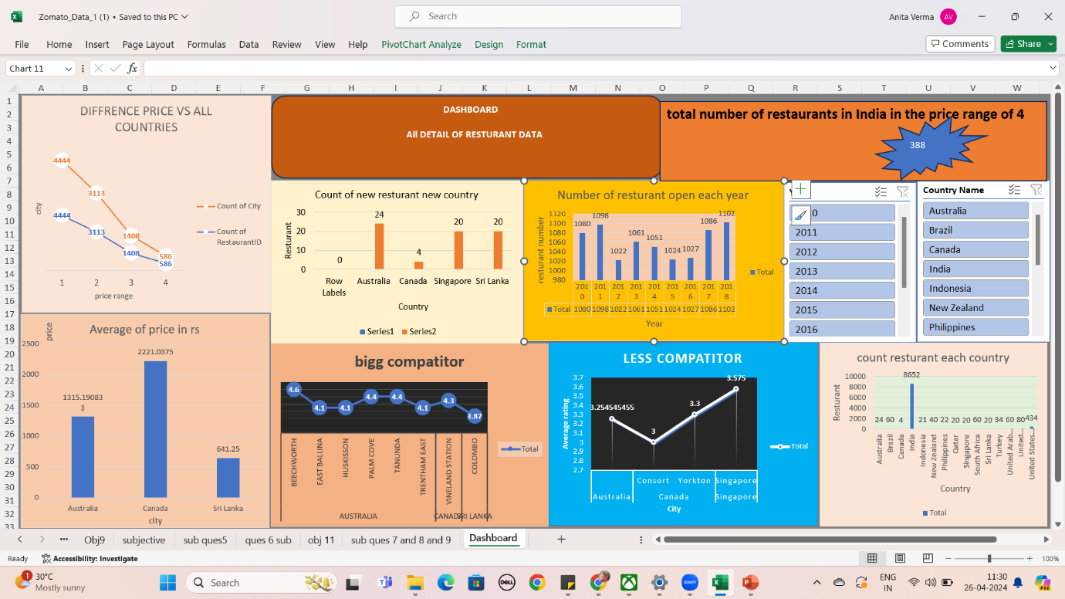

**Conclusion**

1. Top 4 selected countries for our expansion are Australia, Canada, Singapore, Sri Lanka.
2. Most suitable 6 cities for opening our new Restaurants are as follows - Mayfield, Montville, Paynesville, Consort, Singapore, Colombo. Our Major Focus will be on Australia, As this Country has 3 most suitable cities.
3. In our newer restaurants, we should focus majorly on American food, Italian food and Continental food. The Choice and variety of Cuisines affects the restaurantratings.
4. get a higher rating, We must keep the rate of cuisines in the middle range and keep high quality cuisines in our newer Restaurants.
5. We must offer more services like online delivery and table booking to increase the customer’s ratings because customers enjoy additional ease & convenience in their dining experience.