Machine Learning and Deep Learning for IoT-Enabled Smart Home Systems: An Integrated Architecture for Energy Forecasting, Occupancy Sensing, and Prescriptive Energy Management

First Author
Affiliation: [Your University / Department]
Email: anitaganji456@gmail.com

Second Author
Affiliation: [Co-author University / Department]
Email: sharifi.spam2002@gmail.com

Abstract
The rapid growth of Internet of Things (IoT) infrastructure in residential environments has generated continuous streams of energy, environmental, and occupancy data, creating an opportunity to apply machine learning (ML) and deep-learning-adjacent techniques to real household decision-making. This paper presents Ferdowsi, a full-stack smart-home platform that integrates a React-based IoT dashboard covering device control, room-level monitoring, security, automation, and multi-utility energy visualization, with a Django REST backend hosting three trained ML components: (i) a 48-hour household energy forecasting module ensembling a multi-output Random Forest regressor with Holt-Winters exponential smoothing and a disagreement-based 95% prediction interval; (ii) a room-occupancy detection module trained on ambient sensor features (temperature, humidity, light, CO2) using Random Forest and Logistic Regression classifiers; and (iii) a prescriptive energy-management agent trained with tabular Q-learning over a custom Markov Decision Process that recommends hourly load-shifting, battery-charging, and discharging actions. All three components are trained on public UCI datasets or a documented simulation environment, served through a versioned REST API, containerized with Docker and nginx, and consumed live by the dashboard. Experimental results show the Random Forest forecaster reduces mean absolute error by 9.5% over a seasonal-naive baseline, the Logistic Regression occupancy classifier reaches 99.0% accuracy and 0.995 ROC-AUC, and the learned Q-learning policy improves average episodic return by 1.23 units over a naive fixed-schedule heuristic and by 4.51 units over an always-idle baseline. Beyond the ML results, this paper documents the complete feature inventory of the platform, its deployment architecture, and an explicit discussion of internal, external, and construct validity limitations, positioning the system as a reproducible reference architecture for ML/DL-driven IoT smart-home research.

Keywords: Internet of Things (IoT), Smart Home, Machine Learning, Deep Learning, Energy Forecasting, Occupancy Detection, Reinforcement Learning

1. Introduction
The Internet of Things (IoT) has turned the residential environment into a continuously instrumented system, in which connected sensors and actuators generate high-frequency data on power consumption, occupancy, temperature, and appliance state. Converting this raw stream into actionable intelligence — forecasting future demand, sensing where occupants are, and prescribing optimal control actions — is a core problem at the intersection of IoT and machine learning/deep learning research. Most academic smart-home ML studies evaluate a single model in isolation on a benchmark dataset; fewer works integrate forecasting, perception, and decision-making into one deployed, end-to-end system that a real dashboard can consume in real time.
This paper presents such an integrated system: a full-stack smart-home dashboard, named Ferdowsi, extended with three ML-backed capabilities — (A) short-term household energy forecasting, (B) room-occupancy prediction, and (C) prescriptive energy management via reinforcement learning — layered on top of an already feature-rich IoT dashboard covering device automation, multi-utility energy visualization, security, and geolocation-based presence. Each ML capability is trained on a public dataset or a documented simulation, served by a Django REST backend, and consumed by a React frontend, giving a concrete, reproducible reference architecture rather than a purely offline notebook study.
The remainder of this paper is organized as follows. Section 2 reviews related work. Section 3 describes the full system architecture, including every dashboard feature and the deployment pipeline. Section 4 formalizes the three ML/DL problems and the models used. Section 5 describes the datasets and experimental setup. Section 6 reports experimental results. Section 7 discusses limitations and threats to validity. Section 8 concludes and outlines future work.
2. Related Work
Prior work on IoT-based smart-home intelligence largely falls into three separate strands: (1) time-series forecasting of residential energy consumption, typically using statistical models (ARIMA, exponential smoothing) or tree ensembles applied to public datasets such as the UCI Individual Household Electric Power Consumption dataset (Hebrail & Berard, 2012); (2) occupancy and presence detection from ambient sensors, most notably validated on the UCI Occupancy Detection dataset (Candanedo & Feldheim, 2016); and (3) reinforcement-learning-based demand response and home energy management, an active area since Watkins and Dayan's (1992) original Q-learning formulation and formalized generally in Sutton and Barto (2018). Deep-learning approaches (LSTM/GRU sequence models, deep Q-networks) are common in this literature but are frequently justified by dataset scale and non-linearity that do not always hold for single-household, single-room, or small-state-space problems — a point this paper's methodology section returns to directly when motivating classical-ML choices over deep architectures for specific sub-problems. This paper's contribution is not a new algorithm in any one of these three strands, but a single, deployed, cross-strand architecture in which forecasting, perception, and control share one dashboard, one backend, and one persistence layer, with all three trained models served through a common REST API design.
3. System Architecture and Feature Inventory
The platform follows a three-tier architecture, shown in Figure 1. A React 19 single-page application (the dashboard) communicates over a versioned REST API with a Django 4.2 / Django REST Framework backend, which hosts three independent Django apps — forecasting, occupancy, and energy_manager — each wrapping a trained scikit-learn/statsmodels model or a hand-rolled Q-learning agent behind an inference endpoint. Trained model artifacts and the SQLite persistence layer are containerized with Docker for reproducible deployment. The complete feature inventory, spanning both the original client-side dashboard and the AI-backed additions, is summarized below.

React 19 Frontend — Dashboard, Energy (6 tabs), Map, Automations, AI Manager, Notifications, Profile/Settings
↓
REST API — Django 4.2 + Django REST Framework (versioned JSON endpoints, CORS-enabled)
↓
forecasting app: RandomForest + Holt-Winters ensemble | occupancy app: RandomForest + LogisticRegression | energy_manager app: tabular Q-learning over a Gymnasium MDP
↓
Persistence & Artifacts — SQLite database + joblib-serialized trained models (Docker named volumes)

Figure 1. Three-tier system architecture: React frontend, Django REST backend, and the three ML/RL model apps, backed by SQLite and Docker-managed model artifacts.

3.1 Dashboard (root route)

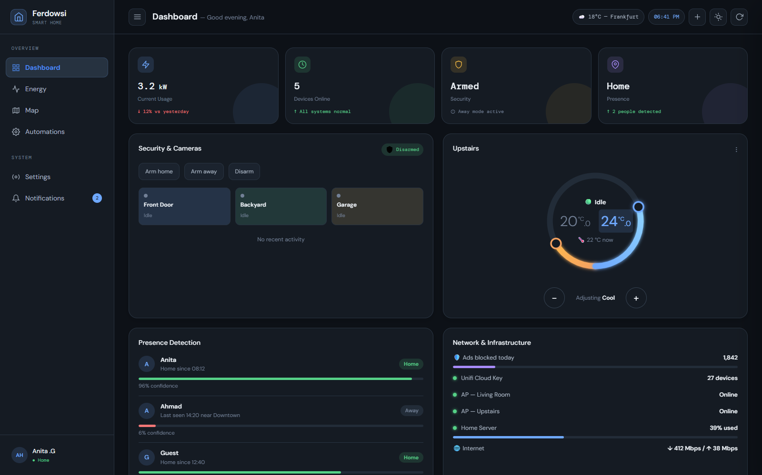
Figure 2. Main dashboard: device grid, room cards, floor plan, thermostat, and AI insights panel.

The main dashboard exposes: a device grid with per-device on/off toggles persisted to local storage; room cards summarizing per-room devices, temperature, and humidity; a security-status card and a presence card showing which family members are home; a network-status card; an energy-distribution overview widget; an interactive floor plan with clickable room markers; a draggable dual-setpoint thermostat control; a rule-based AI insights panel that reasons over live application state; a scripted AI security assistant that detects a simulated break-in condition (motion while away) and autonomously locks doors and arms security, with real state changes driven by a scripted (not inferred) reasoning trace; a combined activity log merging seeded history with a live notification stream; and modal dialogs for device management and change history auditing.
3.2 Energy Page (six tabs)
The Energy page organizes utility data into six tabs: (1) Summary — daily solar/grid/battery/cost stat cards, an energy-distribution diagram, a sources table, a power-sources line chart, a stacked electricity-usage bar chart, and gas/water charts; (2) Electricity — a full usage breakdown, a solar-production chart, per-device usage charts, a hover-to-highlight Sankey-style power-flow diagram, a grid-balance bar, gauge donuts for net-imported energy, self-consumed solar percentage and self-sufficiency percentage, and a detailed sources table; (3) Gas — consumption chart, period bar, and totals; (4) Water — consumption chart, period bar, and totals; (5) Now — a simulated live power feed (a bounded random walk updated every two seconds) driving live solar/grid/battery stat cards, a full-day power chart built up to the current time, live gauges, and a live power-flow diagram; and (6) Forecast — the ML-backed 48-hour ensemble energy forecast described in Section 4.1, rendered with a 95% prediction-interval band, an hour-by-hour data table (per-model and ensemble columns), a what-if scenario tool for simulating an appliance run at a chosen hour, and model test-metric chips, served by GET/POST /api/forecasting/forecast/.
Figure 3 shows the power-flow visualization on the Electricity tab, a Sankey-style diagram of source-to-load energy routing.
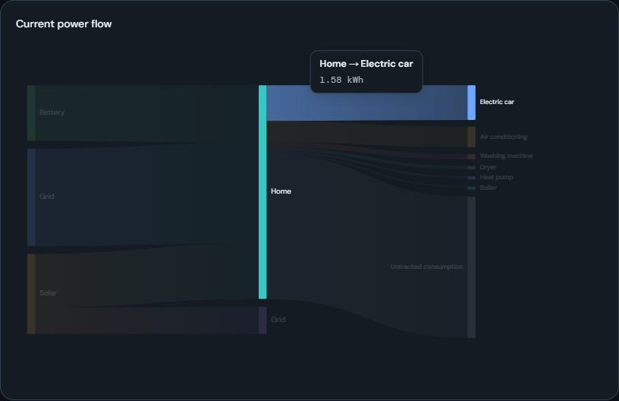
Figure 3. Electricity tab: hover-to-highlight Sankey-style power-flow diagram.

3.3 Map, Automations, AI Manager, and Supporting Pages
The Map page renders a Leaflet map with a home-zone radius circle and family-member presence markers, overlaid with the ML-backed Predicted Occupancy panel described in Section 4.2 and shown in Figure 5, refreshed every 30 seconds via POST /api/occupancy/predict/. The Automations page lists trigger-condition-action rules and scene-activation cards. The AI Manager page (Section 4.3, Figure 6) exposes hour and battery-charge input controls, the current recommended action with a plain-language explanation and state chip, accept/reject controls that persist the operator's decision, a bar chart of the learned Q-value for every candidate action in the current state, and a full recommendation history table, served by the energy_manager endpoints listed in Table 2. A persistent notification center records every meaningful state change across the application. The Profile and Settings pages provide theme, timezone, locale, and date/time-format preferences.
3.4 Deployment Architecture
The full stack is containerized with Docker: a multi-stage frontend image compiles the Vite/React application and serves the static bundle with nginx, which also reverse-proxies /api and /admin requests to the backend container; a backend image runs Django migrations, trains any missing ML artifact on first boot, and serves the API with gunicorn. A docker-compose.yml file orchestrates both services with named volumes for the SQLite database and trained model artifacts, and a one-command run.sh wrapper (up/stop/down/reset/logs) is provided for reproducible local or server deployment.

Table 1. Backend REST API surface (all endpoints under /api/)
Method & Path | App | Purpose
GET /forecasting/forecast/?horizon= | forecasting | Ensemble energy forecast
POST /forecasting/forecast/ | forecasting | Forecast + what-if scenario
POST /occupancy/predict/ | occupancy | Per-room occupancy probabilities
GET /energy-manager/recommend/ | energy_manager | Get + persist a recommendation
GET /energy-manager/history/ | energy_manager | Recent recommendations
POST /energy-manager/recommendations/<id>/decide/ | energy_manager | Accept/reject a recommendation

Table 2. Technology stack
Layer | Technologies
Frontend | React 19, React Router 7, Vite, Chart.js/react-chartjs-2, Leaflet/react-leaflet
Backend | Django 4.2, Django REST Framework, django-cors-headers, SQLite
Machine Learning | scikit-learn, statsmodels, pandas, numpy, joblib
Reinforcement Learning | Gymnasium (custom environment), hand-rolled tabular Q-learning
Deployment | Docker, docker-compose, nginx, gunicorn

4. Machine Learning and Deep Learning Methodology
4.1 Direction A — Household Energy Forecasting
Given an hourly household active-power series y_t, the forecasting module predicts the next H = 48 hours directly (multi-horizon regression, not recursive one-step-ahead rollout) from a 72-hour lookback window and an engineered feature vector combining three sub-metering channels and cyclically encoded calendar features:
(1) | $$x_{t} = \left[y_{t}, s_{t}^{1}, s_{t}^{2}, s_{t}^{3}, sin\left(\frac{2πh_{t}}{24}\right), cos\left(\frac{2πh_{t}}{24}\right), sin\left(\frac{2πd_{t}}{7}\right), cos\left(\frac{2πd_{t}}{7}\right)\right]$$

Two structurally different models are trained and combined by simple averaging. The first is a multi-output Random Forest regressor (Breiman, 2001) with B = 80 trees and maximum depth 10, whose forest prediction is the mean over trees and whose split criterion jointly minimizes the sum of per-output variances across all 48 horizon steps:
(2) | $$\hat{f}\left(x\right) = \left(\frac{1}{B}\right)\sum_{b=1}^{B}{T_{b}\left(x\right)}$$

The second is a Holt-Winters exponential smoothing model (Winters, 1960) with no trend term and a multiplicative seasonal component of period m = 24, chosen because it structurally cannot produce negative forecasts on this strictly non-negative series:
(3) | $${\hat{y}}_{t+h} = l_{t} · s_{t+h-m\left\lceil \frac{h}{m}\right\rceil }$$

A 95% prediction interval is derived from the disagreement between the two ensemble members rather than either model's own parametric uncertainty, a pragmatic substitute for quantile regression or Monte-Carlo dropout that does not apply cleanly to a two-member classical-ML ensemble:
(4) | $$σ_{t+h} = \frac{\left|{\hat{y}}_{t+h}^{RF} - {\hat{y}}_{t+h}^{HW}\right|}{\sqrt{2}} , {PI}_{95\%} = {\hat{y}}_{t+h}^{ens} ± 1.96σ_{t+h}$$

A seasonal-naive baseline (ŷ_{t+h} = y_{t+h−24}, i.e. repeating the same hour one day earlier) is used as the minimum bar for usefulness, following standard practice in the M4/M5 forecasting-competition literature (Makridakis et al., 2020). Figure 4 shows the served Forecast tab, rendering the ensemble mean and its 95% prediction interval band alongside an hour-by-hour data table.
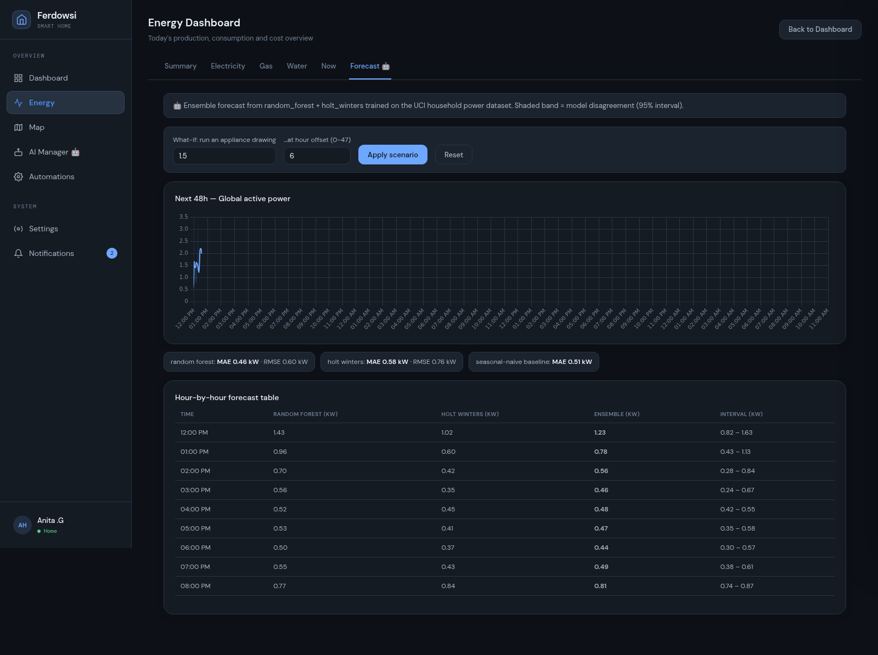
Figure 4. Forecast tab: 48-hour Random Forest + Holt-Winters ensemble forecast with 95% prediction interval.

4.2 Direction B — Room Occupancy Detection
Occupancy is formulated as binary classification over a seven-dimensional feature vector of ambient sensor readings and calendar features:
(5) | $$x_{t} = \left[{Temperature}_{t}, {Humidity}_{t}, {Light}_{t}, {CO2}_{t}, {HumidityRatio}_{t}, h_{t}, d_{t}\right]$$

A Random Forest classifier (200 trees, depth 10, class-balanced to correct for the ~23% occupied-class prevalence) minimizes Gini impurity at each split:
(6) | $$Gini\left(p\right) = 1 - \sum_{k∈\{0,1\}}{p_{k}^{2}}$$
A Logistic Regression classifier (L-BFGS, class-balanced, max_iter = 1000) is trained as a second, structurally different ensemble member, whose disagreement with the Random Forest flags borderline cases:
(7) | $$P\left(y_{t}=1 | x_{t}\right) = σ\left(w^{T}x_{t} + b\right) = \frac{1}{1 + e^{-(wᵀxₜ+b)}}$$

Both classifiers are evaluated with the standard binary-classification suite — precision, recall, F1, and threshold-independent ROC-AUC:
(8) | $$Precision = \frac{TP}{TP+FP} Recall = \frac{TP}{TP+FN} F1 = \frac{2·P·R}{P+R}$$

Per-room estimates on the dashboard's six simulated rooms are produced by evaluating the single-room-trained classifier on schema-matched feature vectors synthesized from each room's known temperature, humidity, and light state — a sensitivity analysis of the trained model, not validated per-room ground truth, and stated explicitly as such in Section 7. Figure 5 shows the resulting Predicted Occupancy panel on the dashboard's Map page.
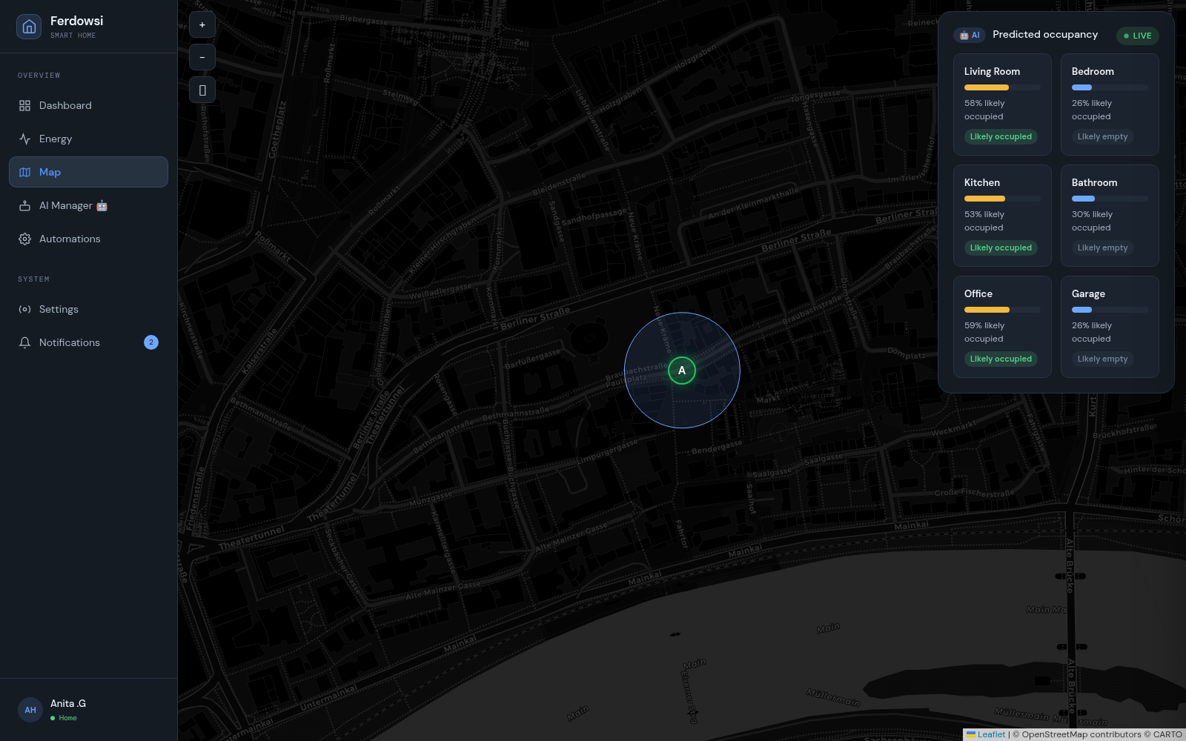
Figure 5. Map page: Predicted Occupancy panel, one probability card per dashboard room.

4.3 Direction C — Prescriptive Energy Management via Reinforcement Learning
The energy-management agent operates over a finite-horizon Markov Decision Process (S, A, P, R, γ) representing one simulated household day. The state is a four-tuple of discretized hour, grid-price tier, solar-output tier, and battery state-of-charge tier, s = (h, p, u, b) ∈ {0..23}×{0,1,2}³, giving |S| = 648; the action space has four members — idle, run flexible load, charge battery, discharge battery. A tabular Q-learning agent (Watkins & Dayan, 1992) is trained with the temporal-difference update rule:
(9) | $$Q\left(s_{t},a_{t}\right) ← Q\left(s_{t},a_{t}\right) + α\left[r_{t} + γ·\max_{a'}Q\left(s_{t+1},a'\right) - Q\left(s_{t},a_{t}\right)\right]$$
with learning rate α = 0.1, discount γ = 0.95, and an ε-greedy behavior policy decaying linearly from 1.0 to 0.05 over the first 3,000 of 4,000 training episodes. Reward combines a negative grid-cost term with a completion bonus for the flexible load and a one-time discomfort penalty if it never runs by day's end. Given the small, fully enumerable state space (648×4 = 2,592 entries), a tabular representation is the exact optimal representation for this MDP, so a deep Q-network offers no representational benefit here — a deliberate methodological choice rather than an omission of deep learning. Figure 6 shows the resulting AI Manager page, including the learned Q-value bar chart for every candidate action in the current state.
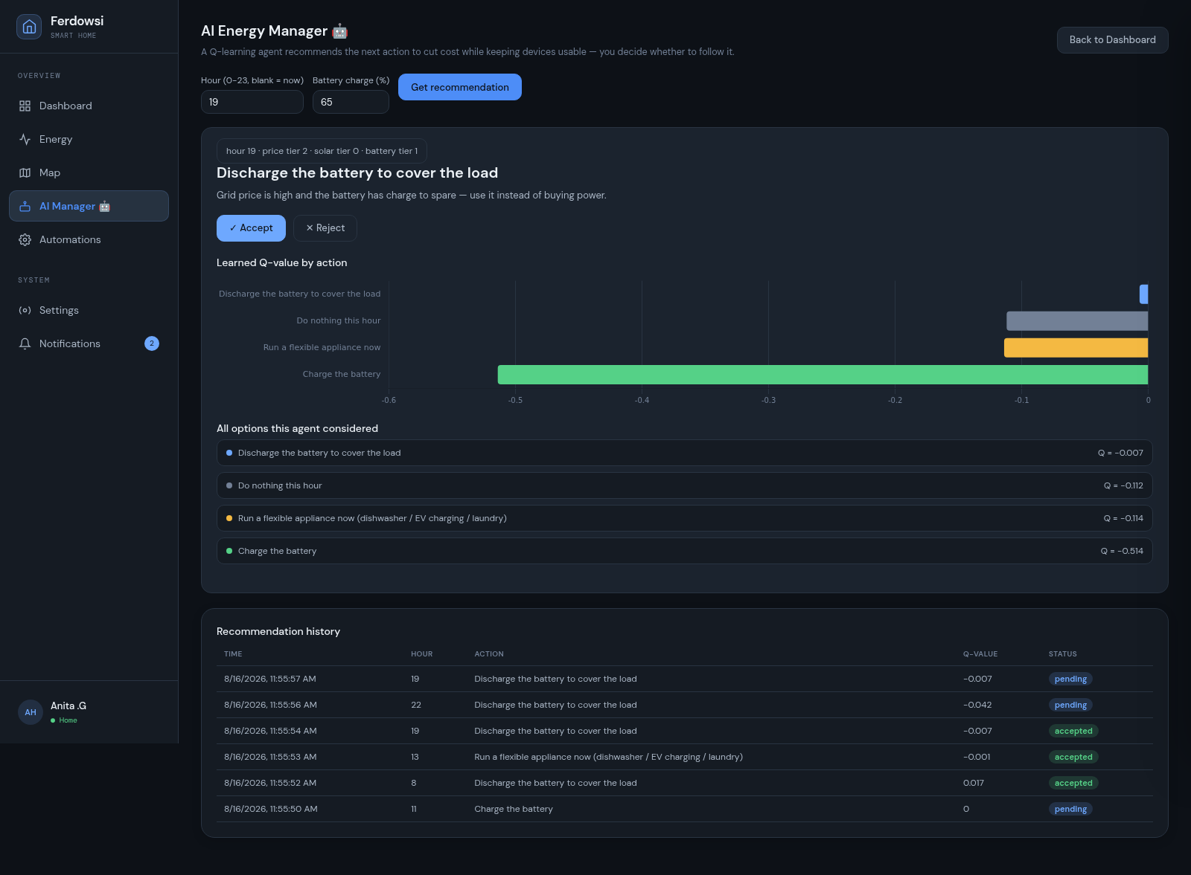
Figure 6. AI Manager page: recommended action, plain-language explanation, and per-action Q-value chart.
5. Datasets and Experimental Setup
Table 3. Datasets used
Dataset | Used by | Size | Source
UCI Individual Household Electric Power Consumption | Forecasting | 2,075,259 minute-level rows (~34k hourly after resampling) | Hebrail & Berard, 2012
UCI Occupancy Detection Dataset | Occupancy | 8,143 train + 12,417 test rows | Candanedo & Feldheim, 2016
Custom Gymnasium MDP simulation | Energy management | n/a (simulated) | hand-crafted price/solar/battery model

Forecasting and occupancy models are evaluated on genuine held-out splits: a chronological 80/10/10 train/validation/test split (n_train = 30,671 windows, n_test = 3,302 windows, no shuffling) for forecasting, and the occupancy dataset's own published train/test split for occupancy. The energy-management agent is evaluated on 200 freshly sampled episodes from the same simulated environment distribution used in training, since the environment itself is the ground truth rather than an approximation of external data. All experiments use fixed random seeds (random_state = 42 / seed = 42) for reproducibility.
6. Results and Discussion
Table 4. Energy forecasting results (held-out test set, hourly kW, 48h-horizon windows)
Model | Test MAE (kW) | Test RMSE (kW) | Fit time
Random Forest (multi-output) | 0.457 | 0.603 | 4.1 s
Holt-Winters (no trend, multiplicative) | 0.581 | 0.761 | 0.7 s
Seasonal-naive baseline | 0.505 | 0.764 | —

The Random Forest forecaster beats the seasonal-naive baseline on both metrics (9.5% relative MAE improvement), a genuine and non-trivial result. Holt-Winters is roughly tied with the naive baseline and is actually worse on MAE, an honest, reportable finding: a single-household power series is dominated by occupant behavior, which a smooth seasonal model structurally cannot capture, while Random Forest benefits from sub-metering and calendar context. The two-model ensemble's practical value is therefore in the disagreement-based prediction interval, not in point-forecast accuracy — a paper reporting this ensemble should present Random Forest as the strongest standalone point forecaster.
Table 5. Occupancy detection results (held-out test set, n = 12,417)
Model | Accuracy | Precision | Recall | F1 | ROC-AUC
Random Forest | 0.966 | 0.923 | 0.939 | 0.931 | 0.994
Logistic Regression | 0.990 | 0.966 | 0.996 | 0.980 | 0.995

Logistic Regression outperforms Random Forest on every metric, counter to the common prior that tree ensembles dominate linear models. Random Forest feature importances show Light (0.470) and CO2 (0.212) jointly carrying 68% of total importance, indicating the occupancy-to-sensor relationship is close to linearly separable — exactly the regime in which a linear decision boundary is sufficient and a tree ensemble's extra capacity buys nothing while adding variance. Both models' ROC-AUC of approximately 0.99 indicates that most of the achievable performance stems from the informativeness of the five-feature representation itself rather than classifier choice, and these numbers are consistent with the original dataset paper (Candanedo & Feldheim, 2016).
Table 6. Prescriptive energy management results (200 held-out episodes, mean episodic return)
Policy | Avg. return | vs. always-idle | vs. naive-fixed-time
Learned (Q-learning, greedy) | +0.109 | +4.51 | +1.23
Naive fixed-time (load @ 8am) | −1.123 | +3.28 | —
Always-idle | −4.404 | — | —

The learned policy beats both baselines. The gap versus always-idle (+4.51) is dominated by the environment's discomfort penalty for never running the flexible load, so it should be reported as evidence the agent learned it must act, rather than the paper's headline result. The gap versus naive-fixed-time (+1.23) is the more informative number, since it isolates the value of conditioning the policy on price, solar, and battery state over a fixed-schedule heuristic a household could already follow without any learning — this is the comparison to lead with.
7. Limitations and Threats to Validity
Internal validity is supported by genuine held-out evaluation for both forecasting and occupancy, with no train/test leakage; the energy manager's “held-out” episodes are freshly sampled from the same training distribution, since the environment is itself the ground truth rather than external data, and this distinction is stated explicitly rather than implied. External validity is limited: the forecasting and occupancy models are trained on one household and one room respectively, so reported metrics describe performance on that specific unit, not households or rooms in general, and the energy manager's price, solar, and battery constants are hand-set rather than fit to a real household. Construct validity is most relevant to the multi-room occupancy extrapolation: per-room dashboard estimates come from evaluating a single-room-trained classifier on synthesized feature vectors and should be read as a sensitivity analysis of the model, not as validated multi-room ground truth. Finally, all reported numbers are single-seed point estimates; reporting mean ± standard deviation over multiple random seeds is identified as the natural next step before treating any of these results as more than illustrative.

8. Conclusion and Future Work
This paper presented an integrated, IoT-based smart-home platform combining a full-featured dashboard —device control, multi-utility energy visualization, security, automation, and geolocation-based presence — with three trained machine-learning components covering energy forecasting, occupancy detection, and prescriptive reinforcement-learning-based energy management, deployed end-to-end and containerized for reproducible use rather than presented as an offline study. Each component is trained on a public dataset or a documented simulation, evaluated against an appropriate baseline, and its threats to validity are stated directly rather than left for a reviewer to discover. Results show consistent, non-trivial improvements over naive baselines across all three directions, alongside honest negative or nuanced findings — such as Holt-Winters underperforming a naive baseline on MAE, and a linear model outperforming a tree ensemble on occupancy — that are themselves informative for IoT machine-learning practitioners. Future work includes multi-seed statistical validation with confidence intervals, replacing the hand-set energy-management constants with values fit to real household telemetry, extending the occupancy model to a genuinely multi-room labeled dataset, and evaluating deep sequence models (LSTM/Temporal Convolutional Networks) against the current classical-ML forecasting ensemble as the training corpus grows beyond a single household.

References
Breiman, L. (2001). Random Forests. Machine Learning, 45(1), 5–32.
Candanedo, L. M., & Feldheim, V. (2016). Accurate occupancy detection of an office room from light, temperature, humidity and CO2 measurements using statistical learning models. Energy and Buildings, 112, 28–39.
Hebrail, G., & Berard, A. (2012). Individual Household Electric Power Consumption Data Set. UCI Machine Learning Repository. https://archive.ics.uci.edu/dataset/235
Makridakis, S., Spiliotis, E., & Assimakopoulos, V. (2020). The M4 Competition: 100,000 time series and 61 forecasting methods. International Journal of Forecasting, 36(1), 54–74.
Sutton, R. S., & Barto, A. G. (2018). Reinforcement Learning: An Introduction (2nd ed.). MIT Press.
Watkins, C. J. C. H., & Dayan, P. (1992). Q-learning. Machine Learning, 8, 279–292.
Winters, P. R. (1960). Forecasting sales by exponentially weighted moving averages. Management Science, 6(3), 324–342.

