

NAME: MUREITHI ANITAH WAIRIMU
ADM NO: BSCCS/2024/52366
COURSE: BACHELOR OF SCIENCE IN COMPUTER SCIENCE
UNIT CODE:BIT3208
UNIT NAME:ADVANCED WEB DESIGN AND DEVELOPMENT
LECTURER NAME : MICHAEL NYORO
SEMESTER:3.2
PROJECT TITLE:SMART QUEUE MANAGEMENT SYSTEM
GITHUB LINK:https://github.com/AnitahWairimu/Smart_queueApi
TECHNOLOGIES USED:PHP+MYSQL,JAVASCRIPT,HTML,CSS

WEEK 1:LOCAL ENVIRONMENT SETUP 3
Installation an testing of Local Development Environment 3
My Reflection 5
WEEK 2:WIREFRAMES AND GUI DESIGN 6
User Interface planning and system design 6
My Reflection 9
WEEK 3:JAVASCRIPT AND PHP BASICS 9
Frontend interaction and backend foundations 9
My Reflection 12
WEEK 4: SERVER-SIDE COMPONENTS AND BACKEND DEVELOPMENT FOUNDATIONS 13
Dynamic Backend processing and real user interaction systems 13
My Reflection 16
WEEK 5:DATABASE COMPONENTS AND CRUD OPERATIONS 16
Build data-driven systems using databases 16
My Reflection 19

WEEK 1:LOCAL ENVIRONMENT SETUP

Installation an testing of Local Development Environment
1.Installation of XAMMP

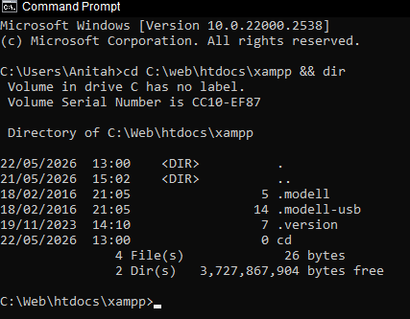
Fig 1.1: XAMPP Installation Verified via Command Prompt - Directory listing of C:\Web\htdocs\xampp shows successful installation with all essential components present (.model, .modelll-usb, .version directories and 3.7GB of data). Windows 10 system confirmed. This demonstrates that Apache, PHP, and MySQL have been properly extracted to the specified installation directory and are ready for local development of the Patient Appointment Management System.

- Apache and SQL running

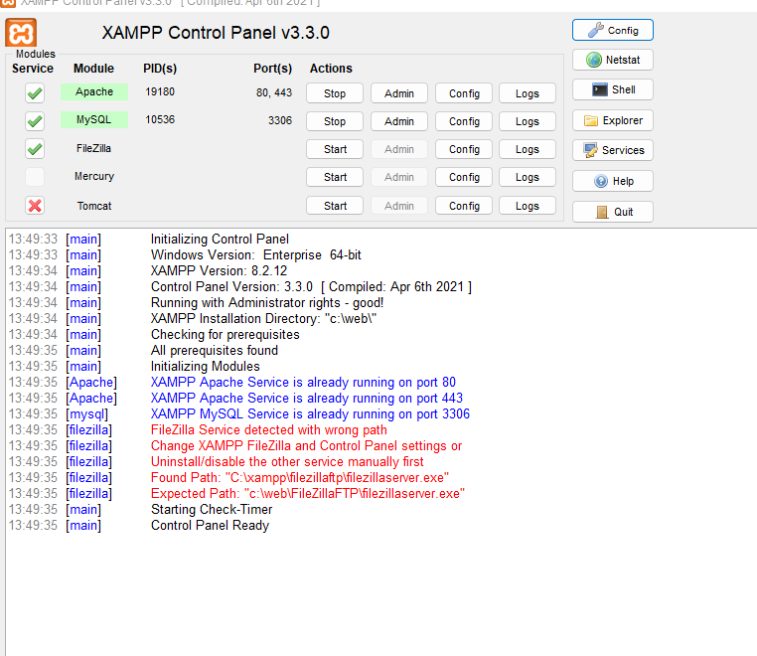

Fig 1.2: Apache Web Server and MySQL Database Services Active - XAMPP Control Panel displays both Apache (port 80) and MySQL (port 3306) running with green status indicators. This confirms the integrated environment is fully operational and ready to serve PHP applications and process database queries for the smart queue system.

3.Local Host Test page

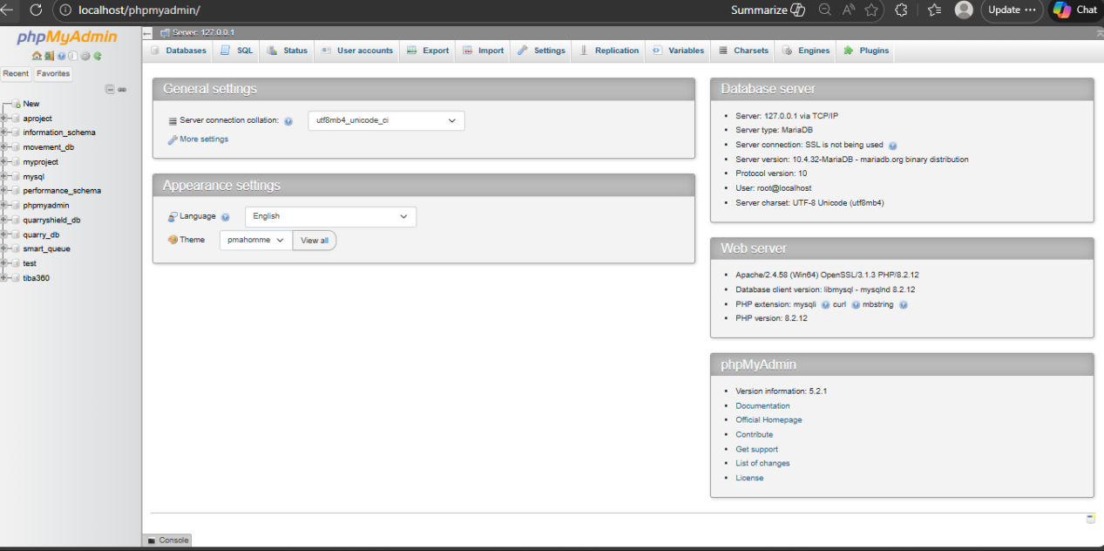
Fig 1.3: Localhost Web Server Test Successful - Browser accessing http://localhost/phpmyadmin resolves to the XAMPP welcome page, confirming
Apache is properly listening on port 80 and serving HTTP requests
from the local machine.

4.Hello world test
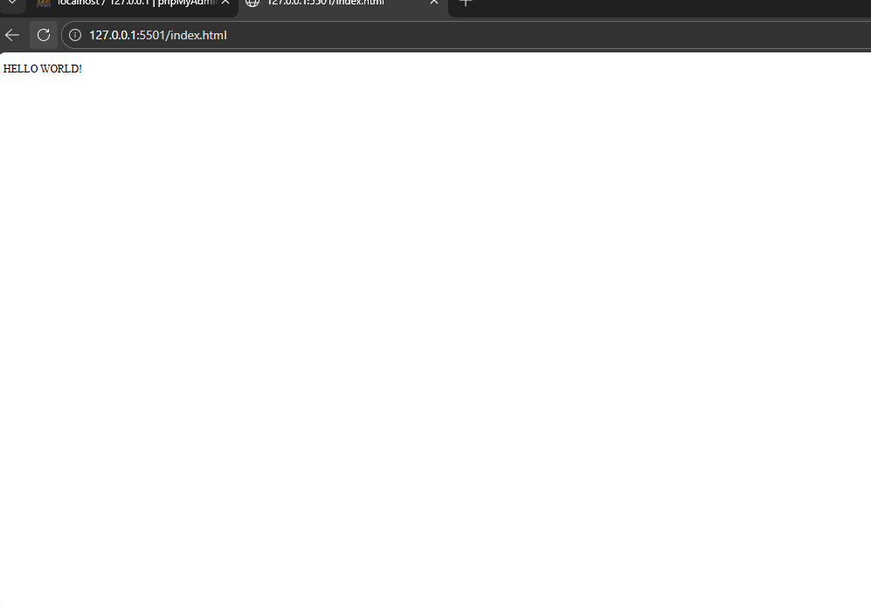
Fig 1.4: HTML Test Page Rendered Successfully - Basic "Hello World" test
demonstrates that the local environment can serve static HTML files. However,
this uses VS Code Live Server (port 5501) for testing.

- Database connection test

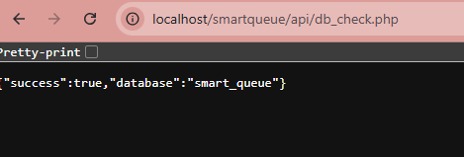
Fig 1.5: Successful PHP-MySQL Database Connection - Browser accessing localhost/smartqueue/api/db_check.php returns JSON response with "success":true and "database":"smart_queue". This demonstrates that the PHP interpreter can connect to the MySQL database engine and retrieve database information, confirming backend integration is functional for the Smart Queue System.

My Reflection
Week 1 established the Smart Queue System's local development environment. I installed XAMPP 8.2 with Apache, PHP 8.2, and MySQL 8.0 to a custom directory (C:\Web\htdocs\xampp). Fig 1.1 shows the 3.7GB installation. I created a db_check.php script that successfully connected to the smart_queue database, returning {"success":true} (Fig1. 6). This proved PHP-MySQL integration works. I learned that PHP acts as middleware between HTTP requests and database queries. The challenge was understanding mysqli_connect() syntax, which I resolved by first understanding the file path of my XAMMP and my project and I kept them in the same location as my XAMMP. Apache's port 80 and MySQL's port 3306 are now configured for the Smart Queue system..

WEEK 2:WIREFRAMES AND GUI DESIGN

User Interface planning and system design
1.Hand drawn wireframe

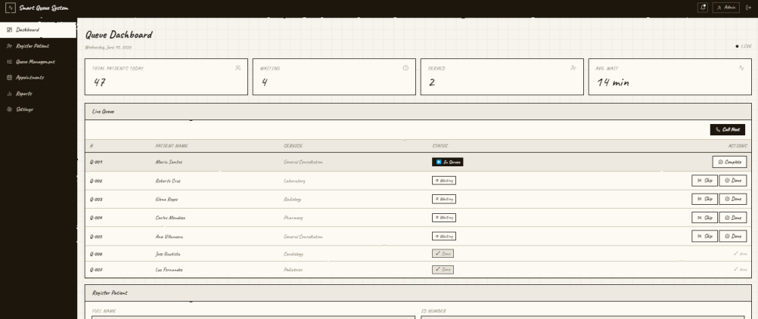
Fig 2.1:It shows the hand-drawn wireframe of the Smart Queue Management System homepage and login interface for the admin, illustrating the preliminary layout structure, navigation placement and user interaction components.

2.Dashboard layout design(admin)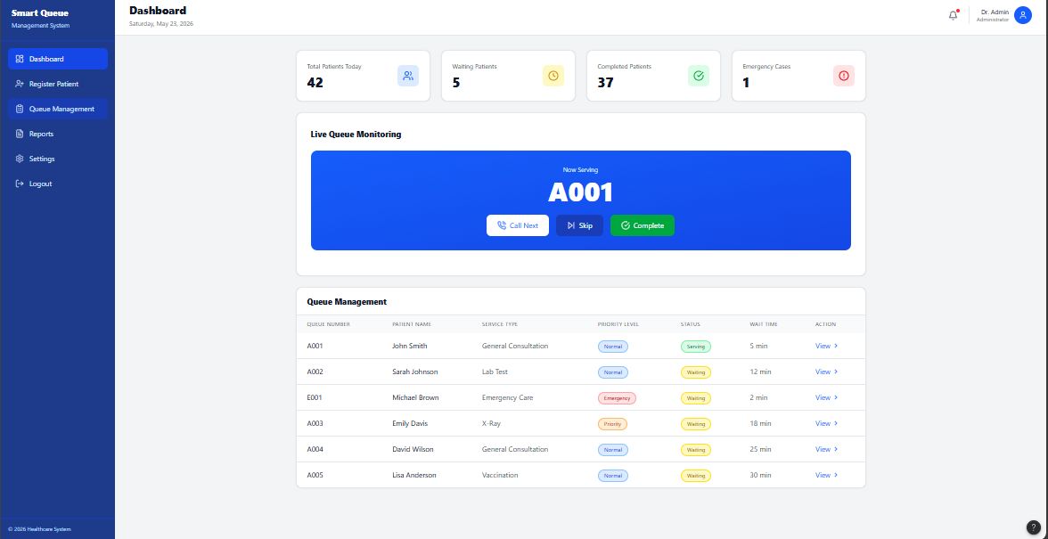
Fig 2.2: illustrates the dashboard layout design for the Smart Queue Management System, showing the sidebar navigation, queue monitoring section, patient statistics, and queue management interface for staff and administrators.

- Mobile view design(patient)
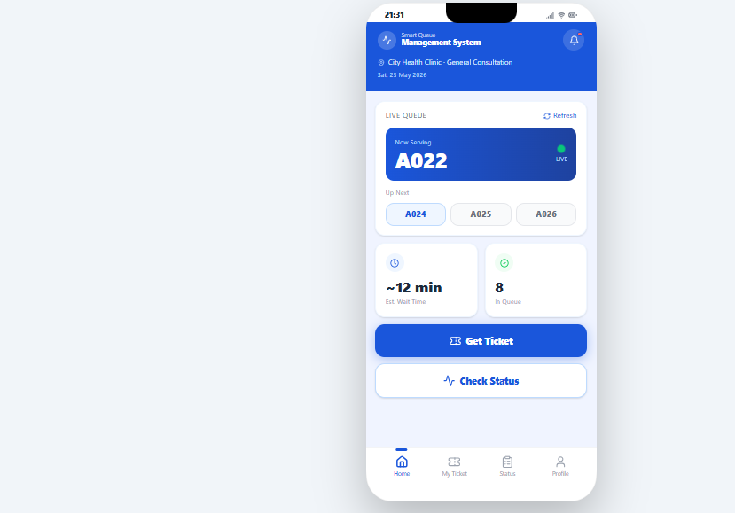
Fig 2.3:Represents the mobile responsive mockup of the Smart Queue Management System, demonstrating how patients can view queue status, ticket numbers, and waiting information on a smartphone interface.

- Colour Theme and Navigation Structure
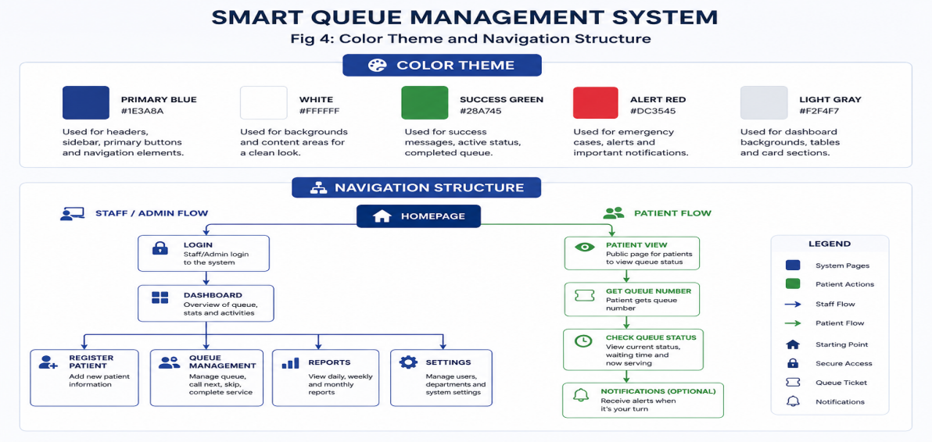
Fig 2.4:Shows the selected color theme and navigation structure of the Smart Queue Management System, including the healthcare-inspired color palette and system flow between patient and staff functionalities.

- GUI prototype
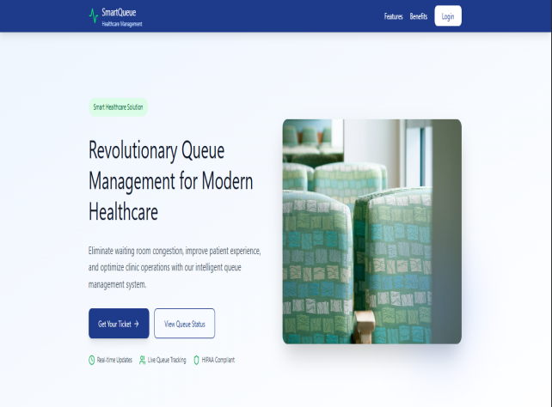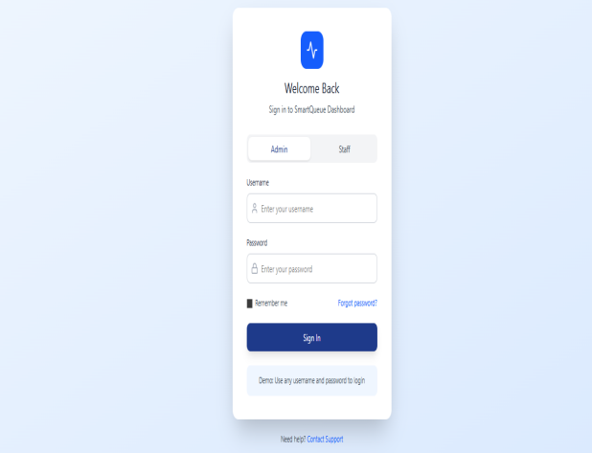
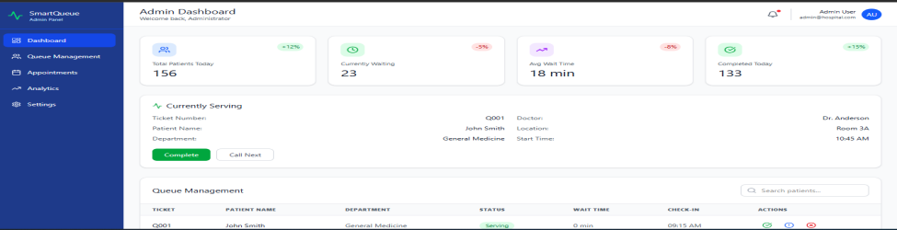
Fig2.5: displays the graphical user interface (GUI) prototype of the Smart Queue Management System developed using Figma, illustrating the overall visual appearance,Login ,admin dashboard structure and user interaction design of the system.

My Reflection
I selected the design because it is simple, efficient, and suitable for managing queues in real time while remaining scalable for future improvements. User experience was a key consideration, so the interface was made clean, responsive, and easy to use, reducing confusion for all users. The navigation flow was planned logically, starting from login or entry, then service selection, queue registration, and status viewing, ensuring users can complete tasks in few steps. The intended users include patients, hospital staff, and administrators, each with different access levels to ensure smooth queue management, proper coordination, and effective system operation in healthcare or service environments.

WEEK 3:JAVASCRIPT AND PHP BASICS

Frontend interaction and backend foundations
- Javascript Form validation
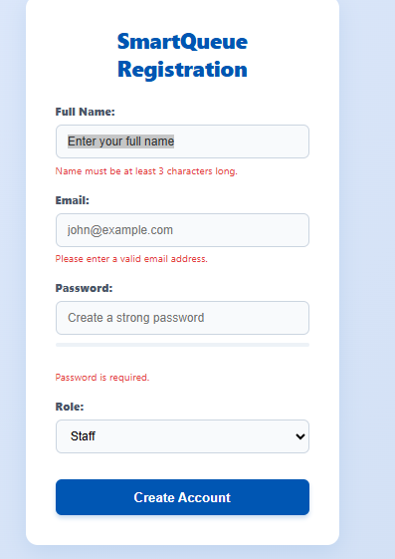
Fig 3.1:Demonstrates client-side form validation using JavaScript to ensure that require fields such as Full Name and Email are correctly field and not left blank before creating an account.This ensures data accuracy and prevents empty submissions as seen from the red notifications in the figure above.

- Password strength checker
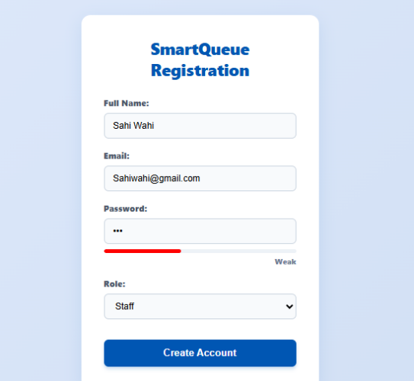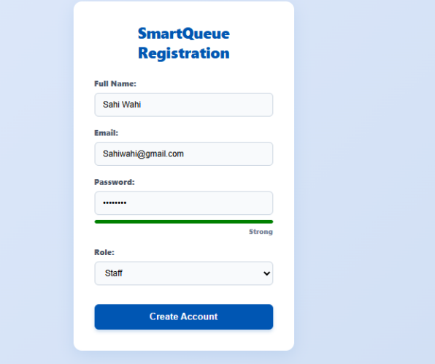
Fig 3.2:The figures above show a JavaScript password strength checker that evaluates the strength of a password based on its length.The one of the left is shorter and it is weak while the one on the right is strong and it is strong.This provides users with real-time feedback to the user indicating whether password is weak,medium or strong.

- PHP syntax practice
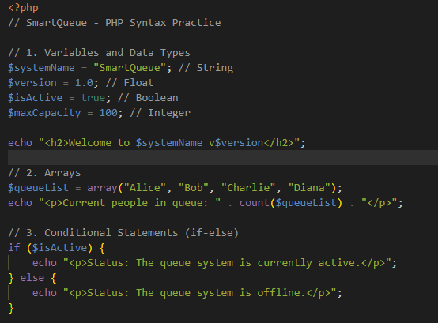
Fig 3.3: Illustrates basic PHP syntax including variable detection and data types,string output using echo,array declaration and conditional statements(if…else).

- Database connection script

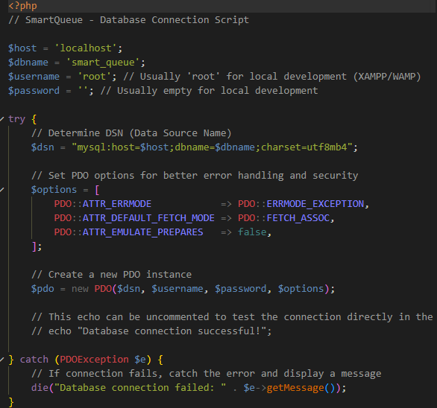
Fig 3.4:Displays a PHP script used to establish a connection between the application and MYSQL .It also displays if the connection fails or it is successful.

- Dynamic user input handling
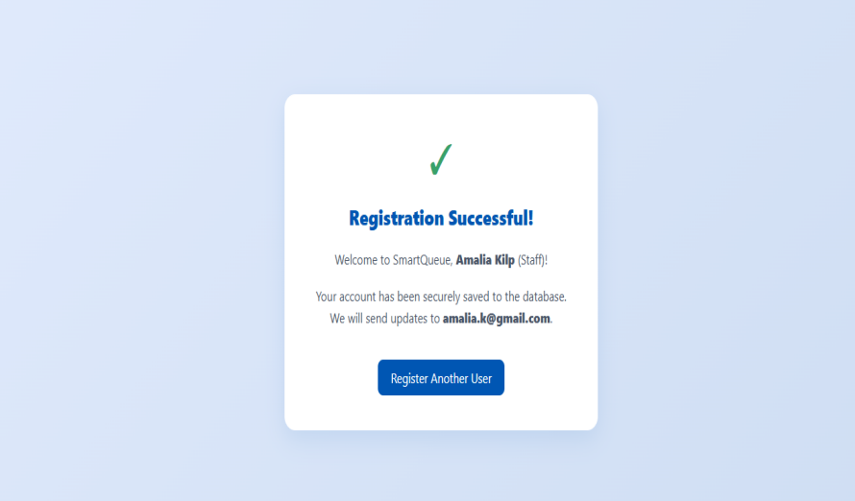
Fig 3.5:It shows how the system processes the user input dynamically and displays “Registration Successful!”once submitted and welcomes the user.This shows that PHP handles user input submitted through HTML form using POST method.

My Reflection
The front-end and back-end of the Smart Queue Management System interact to ensure effective communication between users and the system. The front-end, developed using HTML, CSS, and JavaScript, provides the user interface where patients and staff interact with the system. The back-end, developed using PHP, processes requests, manages queue operations, and communicates with the database. Validation is important because it prevents incorrect or incomplete data entry and improves system security and accuracy. Database connection is essential because it stores, retrieves, and manages patient and queue information efficiently. Technologies used in the system include HTML, CSS, JavaScript, PHP, MySQL, and XAMPP.

WEEK 4: SERVER-SIDE COMPONENTS AND BACKEND DEVELOPMENT FOUNDATIONS

Dynamic Backend processing and real user interaction systems
- Login Form Interface (Admin)

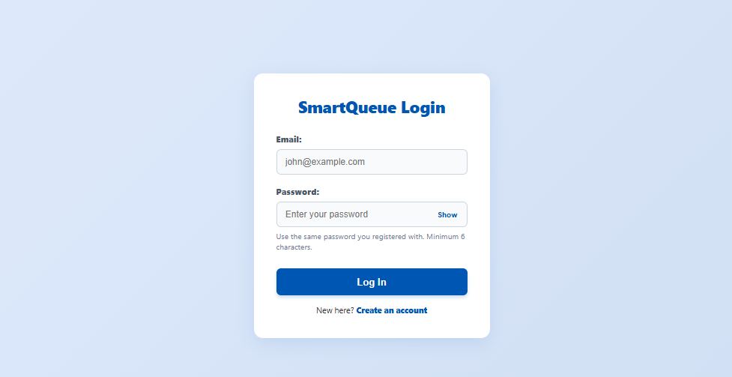
Fig 4.1:The figure shows the login page of a system where user are required to enter their email and password as they registered to access the system

- Form Validation Screenshots

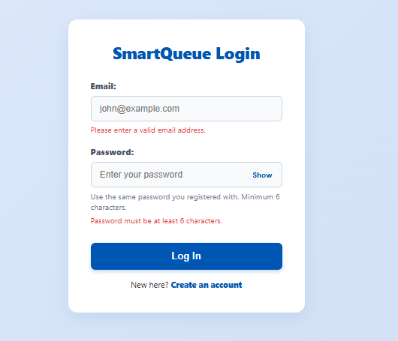
Fig 4.2:The figure illustrates the validation process for handling user input when they submit the form when it is blank

- PHP processing

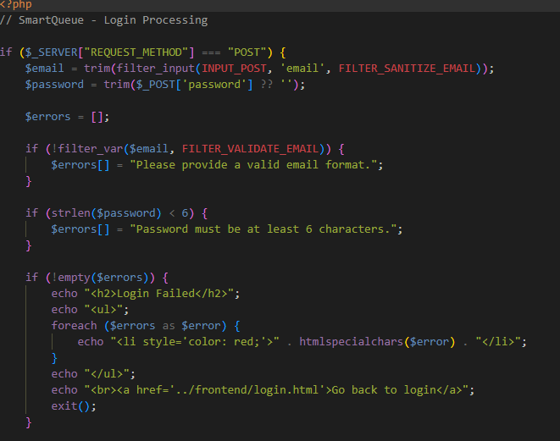
if (!$user || !password_verify($password, $user['password'])) {
echo "<h2>Login Failed</h2>";
echo "<p style='color: red;'>Invalid email or password.</p>";
echo "<br><a href='../frontend/login.html'>Go back to login</a>";
exit();
}
Fig 4.3:The figure shows the PHP code responsible for handling user input,processing form data(POST) and interacting with the database for registration and authentication(db_connect.php).It uses (if..else) condition to authenticate the user inputs before directing them to the dashboard

- Folder structure
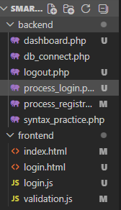
Fig 4.4:The figure shows how the project folder(smartqueue)is organized.It has two sub folders back-end and front-end.The subfolders contain the specific files of the project that I am working with.

- Database connection

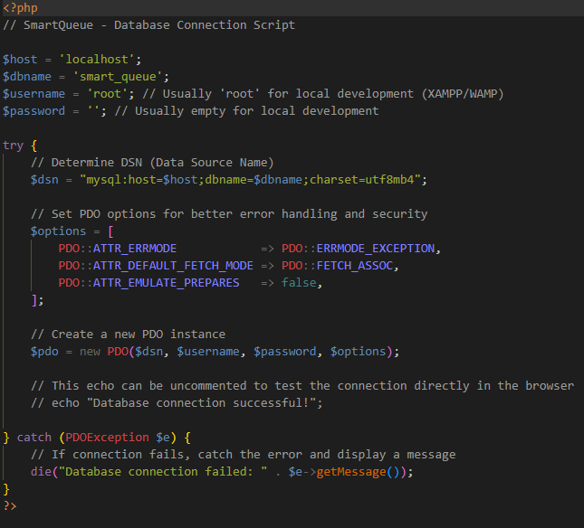
Fig 4.5:The figure displays the PHP code used to establish a connection between the application and mySQL database using XAMPP

My Reflection
In this week I focused on my web development,especially the login system and database integration.I learned how form validation works to ensure users enter the correct information before submission.I also practise how to use PHP to process login and registration data securely including password verification.I also strengthen understanding of how to connect PHP application to MySQL database using XAMPP.Organizing my project folder has helped me manage my files more efficiently.Overall this has helped me better understand back-end development and how different components of a system wok together.

WEEK 5:DATABASE COMPONENTS AND CRUD OPERATIONS

Build data-driven systems using databases
- Database structure

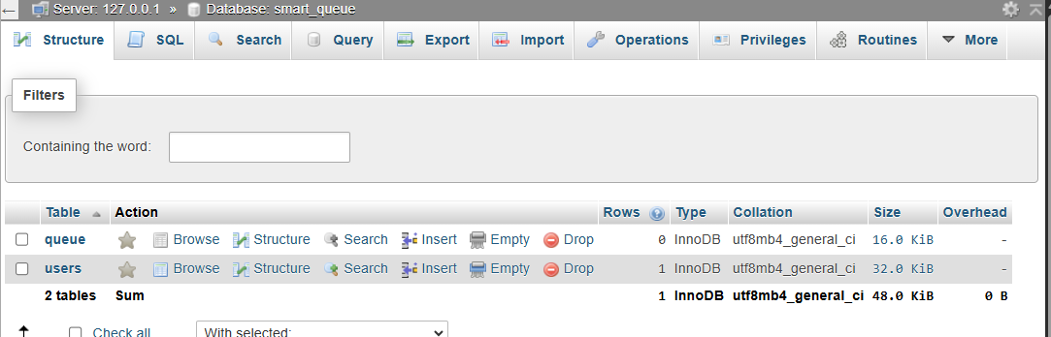
Fig 5.1:It shows my database smart_queue with two tables(queue and users)

- Table creation
(queue table)

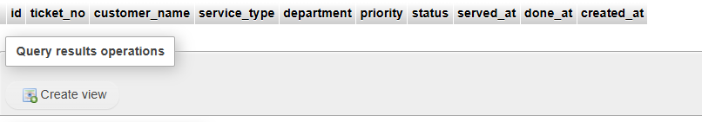
(Users table)
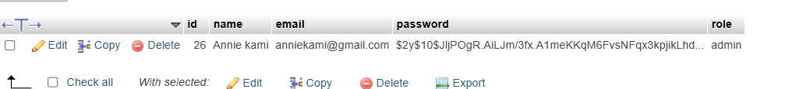
Fig 5.2:The figure shows two tables (queue and users) each with its column labels.

- Login database integration

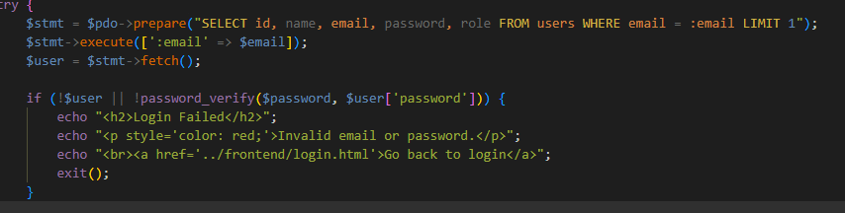
Fig 5.3:It shows user login system connected with my database for authentication and validation(password)

- CRUD operations
- CREATE
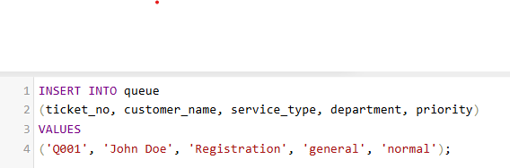
Fig 5.4a:This figure shows the insertion of new queue data into the table queue using the SQL INSERT command.

- READ
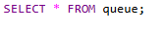
Fig 5.4b:This figure shows the retrieval of queue records from the table queue using the SQL SELECT statement.

- UPDATE
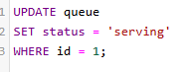
Fig 5.4c:This figure illustrates the modification of my table queue in the database using the SQL UPDATE statement status was changed from waiting to serving.

- DELETE
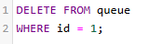

Fig 5.4d:This figure shows the removal of a queue record from the table using the SQL DELETE command.

- SQL query to create the database and tables
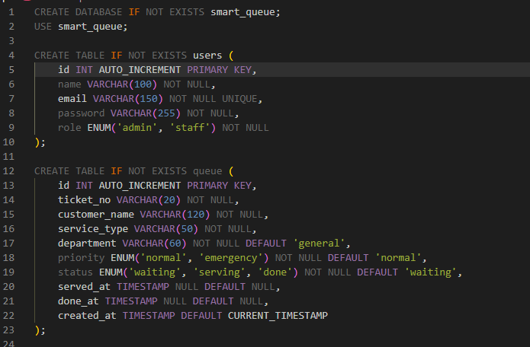
Fig 5.5:The figure show a hospital smart queue database schema in SQL: secure user management for staff with role-based access and intelligent queue table tracking patient tickets with priority, department, service status and arrival/completion timestamps for operational analytics.

My Reflection

During this week, I worked on database development and documentation tasks. I have created tables, performed CRUD operations and captured screenshots to show each process. I also integrated the login system with the database, ensuring data is properly stored and retrieved using SQL queries..I have documented SQL query execution and maintained weekly logs for project tracking. I updated my GitHub repository to reflect progress and version control. This week helped me understand how backend systems interact with databases and how important accuracy is in queries. I also improved my debugging and documentation skills through practical hands-on implementation.

