

Name of the course: Computer Tools
Name of the Teacher: Dear Zohreh Moeini

Name of the student: Anita Torki Harchegani
Student ID: 2211985
Winter 2022

The graph to show the Sale:

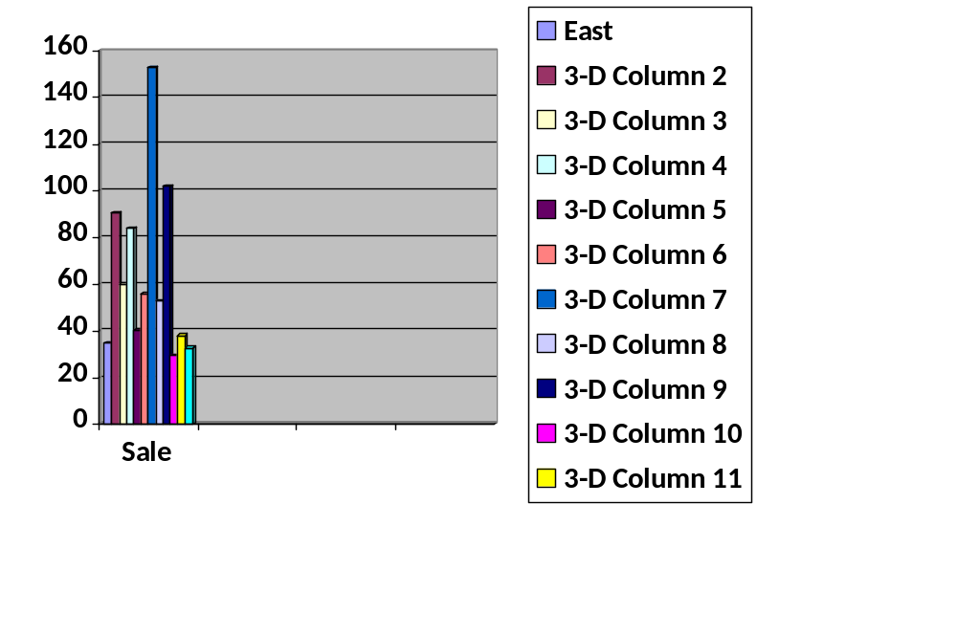

The graph for each category sales results:

