1. Given the following binary search tree data what is the inorder Predecessor and Successor of node 40?

50, 40, 60, 70, 55, 58, 52, 45, 30, 35, 42, 47, 20, 65, 80

Ans:

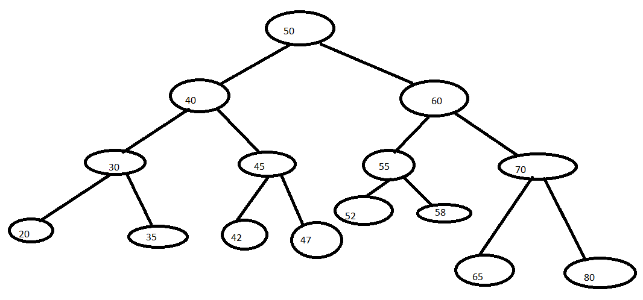

Inorder traversal: 20, 30, 35, 40, 42, 45, 47, 50, 52, 55, 58, 60, 65, 70, 80

Inorder Predecessor: 35

Inorder Successor: 42

If a node has 2 children its inorder predecessor is the maximum value in its left subtree and its inorder successor is the minimum value in its right subtree.

If a node doesn’t have a left child, then a node’s inorder predecessor is its first left ancestor.

Preorder traversal: 50 40 30 20 35 45 42 47 60 55 52 58 70 65 80

Preorder Predecessor: 50

Preorder Successor: 30

Postorder traversal: 20 35 30 42 47 45 40 52 58 55 65 80 70 60 50

Postorder Predecessor: 45

Postorder Successor: 52