

P R O J E C T H A N D B O O K

**Project: Wound Analysis Based On Image Processing**

Course: Information Engineering and Computer Science

Semester: 2

Teacher: Dr. Timo Kahl

Project leader:

Project members: Qurratul Ain Abid (Matriculation no. 21037)

**3. Project Organization**

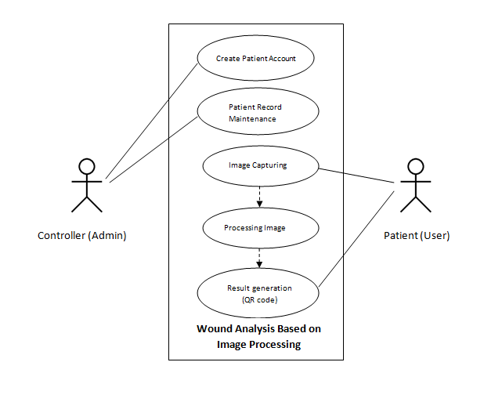 *Fig: Use Case Diagram*

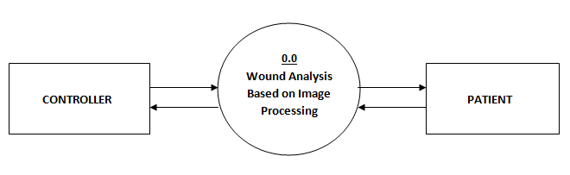 *Fig: Level 0 DFD*

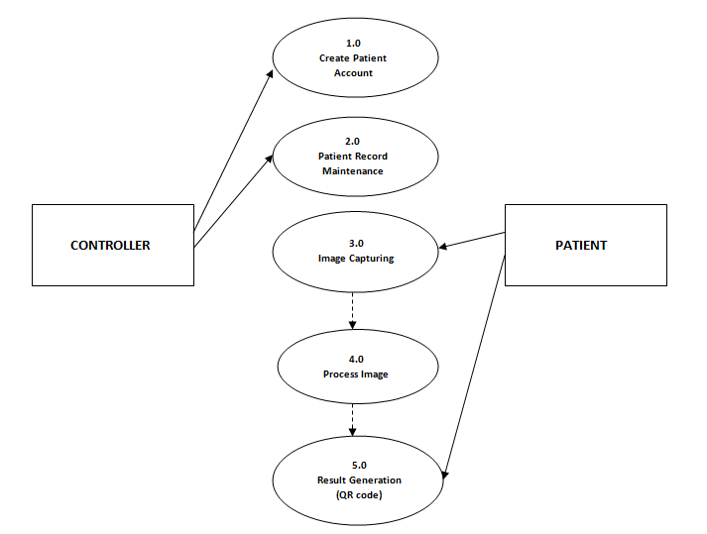

*Fig: Level 1 DFD*



1. **WSP Specification/ Description**

Describe the most important work packages of your WSP.

|  |  |  |
| --- | --- | --- |
|  |  | **WP Specification** |
| **Work Package:** 1.0 Research | |  |
| WP Content / Results: |  |  Research on image processing algorithm, hardware, types of |
|  |  | wound, design and development tools. |
|  |  |  |
| Responsible Person: |  | All group members |
|  |  |  |
| Progress since last status |  | Image processing algorithms research: Anith, Qurratul-Ain and Arun. |
| report: |  | Types of Wound: Mayuri and Jeff. |
|  |  | Hardware: Amir. |
|  |  |  |
| Open issues: |  | <Description> |
|  |  |  |

|  |  |
| --- | --- |
|  | **WP Specification** |
| **Work Package:** 2.0 User Interface Design and Development | |
| WP Content / Results: |  User Interface Design and Coding |
|  |  |
| Responsible Person: | Anith and Amir |
|  |  |
| Progress since last status | <Description> |
| report: |  |
|  |  |
| Open issues: | <Description> |
|  |  |

|  |  |
| --- | --- |
|  | **WP Specification** |
| **Work Package:** 3.0 Image Processing and Hardware Integration | |
| WP Content / Results: |  Implementation of image processing algorithm and hardware. |
|  |  |
| Responsible Person: | Qurratul Ain and Arun |
|  |  |
| Progress since last status | <Description> |
| report: |  |
|  |  |
| Open issues: | <Description> |
|  |  |

|  |  |  |
| --- | --- | --- |
|  | **WP Specification** |  |
| **Work Package:** 4.0 Databases | |  |
| WP Content / Results: |  Database designing and development |  |
|  |  |  |
| Responsible Person: | Jeff and Mayuri |  |
|  |  |  |
| Progress since last status | <Description> |  |
| report: |  |  |
|  |  |  |
| Open issues: | <Description> |  |
|  |  |  |
| IP_Project-Handbook_V001_KN.doc | 05.11.2017 | !8 |



|  |  |
| --- | --- |
|  | **WP Specification** |
| **Work Package:** 5.0 Testing and Deployment | |
| WP Content / Results: |  Testing and Final Deployment |
| Responsible Person: | All group members |
|  |  |
| Progress since last status | <Description> |
| report: |  |
|  |  |
| Open issues: | <Description> |
|  |  |

|  |  |  |
| --- | --- | --- |
| IP_Project-Handbook_V001_KN.doc | 05.11.2017 | !9 |



1. **Project Milestones**



**Milestones**

|  |  |  |  |  |  |  |  |
| --- | --- | --- | --- | --- | --- | --- | --- |
|  | **WSP-Code** | **Milestone-** |  | **PLANNED-DATE** |  | **IS-DATE** |  |
|  | **Name** |  |  |  |
|  |  |  |  |  |  |  |
| 1.0 | Initial Research | Research | 16 | October | 4 November | |  |
|  | |  |  | |  |  |  |
| 2.0 Analysis/Software | | Software Requirement | 4 November | | 14 | November |  |
| Requirements | | Specification |  |  |  |  |  |
|  |  |  |  |  |  |  |  |
| 3.0 | Design | UI Design and Code | 20 | November | 15 | December |  |
|  |  |  |  | |  |  |  |
| 4.0 | Development | Image processing and | 5 December | | 10 | January |  |
| (Phase 1) | | hardware integration |  |  |  |  |  |
|  |  |  |  | |  | |  |
| 4.0 | Development | Databases | 5 December | | 5 January | |  |
| (Phase 2) | |  |  |  |  |  |  |
|  |  |  |  |  |  |  |  |
| 5.0 | Deployment | Deployment and | 12 | January | 24 | January |  |
|  |  | Testing |  |  |  |  |  |
|  |  |  |  |  |  |  |  |

1. **Project Schedule Plan**

|  |  |  |  |
| --- | --- | --- | --- |
| **Task** | **Start Date** | **Days to Complete** | **Task Names as in WBS** |
| T_1.0 | 16-Oct | 18 | Research |
| T_2.0 | 04-Nov | 2 | Analysis/Software Requirements |
| T_2.1 | 06-Nov | 2 | Conduct needs analysis |
| T_2.2 | 10-Nov | 4 | Draft preliminary software specifications |
| T_2.3 | 14-Nov | 4 | Secure required Resources |
| T_3.0 | 20-Nov | 3 | Design |
| T_3.1 | 24-Nov | 6 | Basic Prototype Design |
| T_3.2 | 01-Dec | 6 | Develop functional specifications |
| T_4.0 | 10-Dec | 5 | Development |
| T_4.1 | 16-Dec | 18 | Develop code/Algorithm |
| T_4.2 | 05-Jan | 7 | Hardware Integration |
| T_5.0 | 12-Jan | 6 | Deployment/Testing |
| T_5.1 | 18-Jan | 4 | Testing |
| T_5.2 | 22-Jan | 4 | Determine final deployment strategy |
|  |  |  |  |
|  | Task schedule based on WBS |  |  |

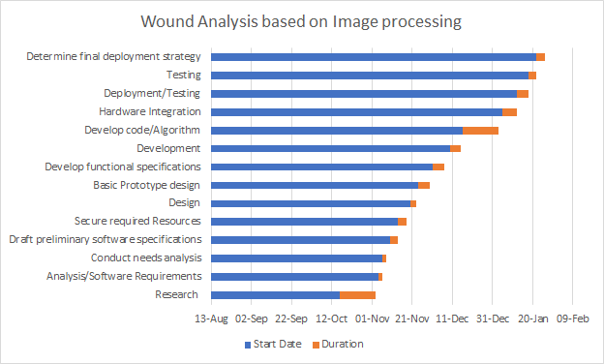

*Fig: Gantt Chart*

1. **Project Costs and Risks**

|  |  |  |
| --- | --- | --- |
| *Work Package / Milestone* | *Type of Costs* | *Amount/Effort* |
| *Name* | *e.g Personal, material* | *e.g 5 hours* |
| **Barcode scanner** | **material** | **15 hours** |
| **camera** | **material** | **5 hours** |
| **Clouding system** | **material** | **15 hours** |

|  |  |  |  |
| --- | --- | --- | --- |
| *Risk* | *Event risk* | *Impact* | *measures* |
| *NAME AND DISCRIPTION* | *e.g in %* | *e.g quality cost date* | *Wbs code name* |
| **Integration of hardware and software** | **20%** | **Barcode scanner** |  |
| **Software specifications** | **20%** | **R coding / phython** |  |
| **Camera of choice** | **10%** | **Digital camera/ msart phone camera** |  |
| **Integration of database to cloud** | **30%** | **Azure/ docker cloud** |  |
| **Accurate image detector** | **20%** |  |  |

!

|  |  |  |
| --- | --- | --- |
| IP_Project-Handbook_V001_KN.doc | 05.11.2017 | 10! |