

PROJECT HANDBOOK

**Project: Wound Analysis based on Image processing**

Course: Information Engineering and Computer Science

Semester: 2

Teacher: Prof. Dr. Timo Kahl

Project leader: Arun Kumar Holla Bommanabillu Raghavendra (24349)

Project members: Amir Abdullah Md Faruk (24350)

Anith Shaji (22914)

Jefferson .o. Akhigbe (21603)

Qurratul-Ain Abid (21037)

Mayuri Jain (24499)

**Index**

1 Document History 3

2 Project Charter 5

3 Project Aims 5

4 Project Organisation 6

5 Work Breakdown Structure (WSP) 8

6 WSP Specification/ Description 10

7 Project Milestones 11

8 Project Schedule Plan 12

9 Project Costs & Time Tracking 13

10 Project Risk 13

11 Miscellaneous............................................................................................................................... 14

# Document History

|  |  |  |  |
| --- | --- | --- | --- |
| **Change History** | | | |
| **Version-Number** | **Date** | **Changes** | **Author** |
| 0.1 | 04/11/17 | Handbook initial version | Arun Holla |
|  |  |  |  |
|  |  |  |  |

# Project Charter

|  |  |
| --- | --- |
| **Project Charter** | |
| **Project Aim** (Output):  Introducing a system that implements:   * The concept of AI and image comparison algorithm. * Focusing on wound detection and healing using a web platform. * Automated system for the detection and diagnosis of wounds in early stages. * Generate Medical prescription with QR code.   Enhancement of existing ‘E-Welfare ‘project, by addition of above mentioned features. | **Non-Aims / Non-Content**:   * Scope can be expanded to a variety of disease treatment. * In a distant future, this project can be implemented on a standalone machine Ex : A robot, which would eliminate the need for human intervention. |
| **Project Achievements** (Outcome):  Early detection and diagnosis of wound and treatment to the patient with limited assistance from a medical professional. | |
| **Project Client**: | **Project Leader**: |
| **Project Members**:   * Arun Kumar Holla Bommanabillu   Raghavendra   * Amir Abdullah Md Faruk * Anith Shaji * Jefferson .o. Akhigbe * Qurratul-Ain Abid * Mayuri Jain | **Other Stakeholders**:   * Patients. * Medical Personals. |
| **Major Activities / Project Phases**:   * Website development. * Hardware Integration. * Integration and Deployment on azure platform. | **Milestones**:   * First month * Second month * Third month   (More detailed information is in page 7) |
| **Project Start**: 21 October,2017 | **Project End**: 29 January,2018 |
| **Project Costs / - Efforts**:   * Research on Comparison algorthm. * Website coding and design . * Image processing. * Simulation tools. * Data storage. | **Project Risks**:   * Tight timeframe: for data collection and research. * Project team: we have complete confidence in the project team but also realize that the individuals on the team have other demands on their time that might, at times, take priority. * Techniacal Risk : Security of collected data,algorithm implementation for image comparison. * Cost : Cost of hardware devices. |
| ……………………………………………..  <Date>, Signature Project Leader | ……………………………………………..  <Date>, Signature Project Supervisor (Teacher) |

# 

# 3 Project Aims

|  |  |  |
| --- | --- | --- |
| **Plan of Project Aims** | | |
| **Type of Aim** | **Project Aims** | **Adapted Aims (incl.** **<Date>)** |
| **Project Aim (Output):** | To introduce a system that implements the concept of AI and image comparison algorithm, focusing on wound detection and healing using a web platform, Automated system for the detection and diagnosis of wounds in early stages. Also to generate medical prescription with scan code. |  |
| **Sub-Goals:** | **Software Phase:**  Coding, designing and data storage management.  **Hardware Phase:**  Image scanner and camera (smart phone). |  |
| **Non-Aims / Non-Content:** | * Scope can be expanded to a variety of disease treatment. * In a distant future, this project can be implemented on a standalone machine Ex: A robot, which would eliminate the need for human intervention. |  |

# Project Organisation

|  |  |  |
| --- | --- | --- |
| **Project Organisation** | | |
| **Role** | **Role Description** | **Name** |
| Project Client | * Treating patients and prescribing medicines | * Doctors and Pharmacist |
| Project Leader | * Hardware Interfacing and Algorithm implementation. | * Arun Kumar Holla Bommanabillu Raghavendra |
| Project Member | * Web development * Web development * Database * Processing Algorithm * Database | * Amir Abdullah Md Faruk, * Anith Shaji , * Jefferson .o. Akhigbe, * Qurratul-Ain Abid * Mayuri Jain |

Mayuri Jain

Arun Kumar Holla BommanabilluRaghavendra

Jefferson .o. Akhigbe

Qurratul-Ain Abid

Anith Shaji

Amir Abdullah MdFaruk

Patients, Medical personnel

# . Work Breakdown Structure

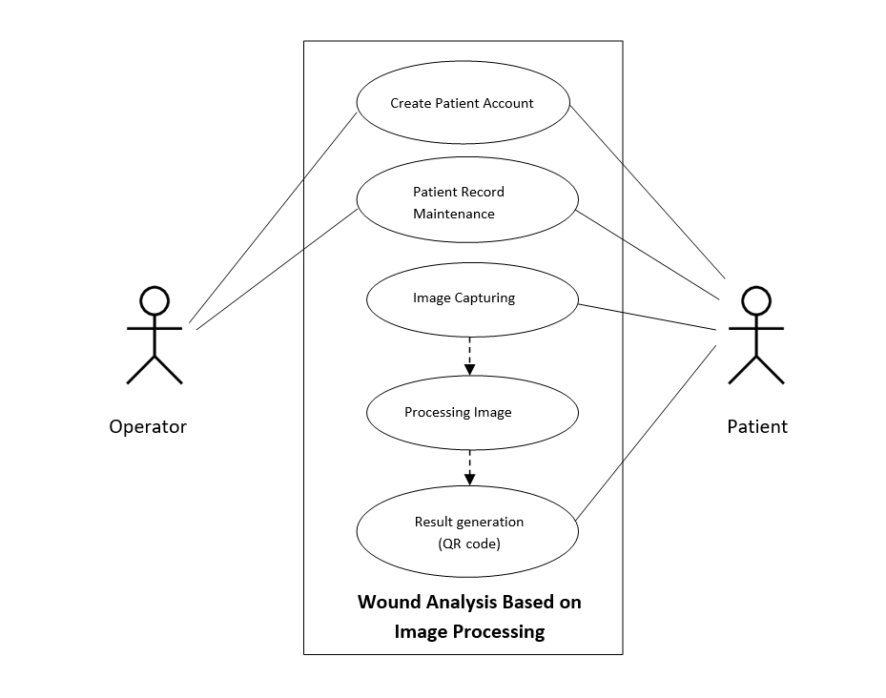

*Fig: Use Case Diagram*

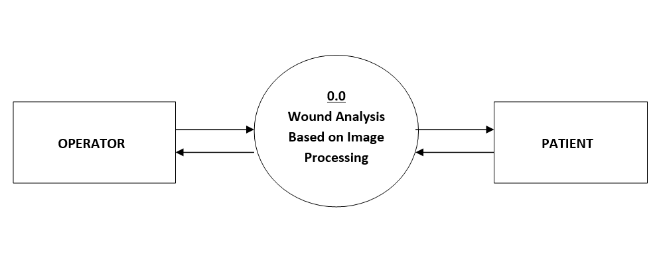

*Fig: Level 0 DFD*

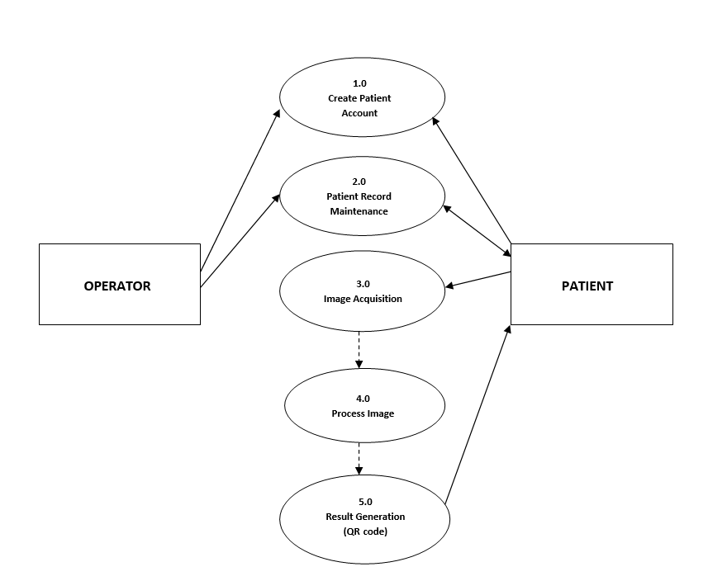

*Fig: Level 1 DFD*

1. **WSP Specification/ Description**

Describe the most important work packages of your WSP.

|  |  |  |
| --- | --- | --- |
|  |  | **WP Specification** |
| **Work Package:** 1.0 Research | |  |
| WP Content / Results: |  | Research on image processing algorithm, hardware, types of |
|  |  | wound, design and development tools. |
|  |  |  |
| Responsible Person: |  | All group members |
|  |  |  |
| Progress since last status |  | Research on Image processing algorithms : Anith, Qurratul-Ain and Arun. |
| report: |  | Research on Types of Wound: Mayuri and Jefferson. |
|  |  | Research on Hardware: Amir. |
|  |  |  |
| Open issues: |  | <Description> |
|  |  |  |

|  |  |
| --- | --- |
|  | **WP Specification** |
| **Work Package:** 2.0 User Interface Design and Development | |
| WP Content / Results: | User Interface Design and Coding |
|  |  |
| Responsible Person: | Anith and Amir |
|  |  |
| Progress since last status | <Description> |
| report: |  |
|  |  |
| Open issues: | <Description> |
|  |  |

|  |  |
| --- | --- |
|  | **WP Specification** |
| **Work Package:** 3.0 Image Processing and Hardware Integration | |
| WP Content / Results: | Implementation of image processing algorithm and hardware. |
|  |  |
| Responsible Person: | Qurratul Ain and Arun |
|  |  |
| Progress since last status | <Description> |
| report: |  |
|  |  |
| Open issues: | <Description> |
|  |  |

|  |  |  |
| --- | --- | --- |
|  | **WP Specification** |  |
| **Work Package:** 4.0 Databases | |  |
| WP Content / Results: | Database designing and development |  |
|  |  |  |
| Responsible Person: | Jefferson and Mayuri |  |
|  |  |  |
| Progress since last status | <Description> |  |
| report: |  |  |
|  |  |  |
| Open issues: | <Description> |  |
|  |  |  |

|  |  |
| --- | --- |
|  | **WP Specification** |
| **Work Package:** 5.0 Testing and Deployment | |
| WP Content / Results: | Testing and Final Deployment |
| Responsible Person: | All group members |
|  |  |
| Progress since last status | <Description> |
| report: |  |
|  |  |
| Open issues: | <Description> |
|  |  |

1. **Project Milestones**



**Milestones**

|  |  |  |  |  |  |  |  |
| --- | --- | --- | --- | --- | --- | --- | --- |
|  | **WSP-Code** | **Milestone-** |  | **START-DATE** |  | **END-DATE** |  |
|  | **Name** |  |  |  |
|  |  |  |  |  |  |  |
| 1.0 | Initial Research | Research | 16 | October | 4 November | |  |
|  | |  |  | |  |  |  |
| 2.0 Analysis/Software | | Software Requirement | 4 November | | 14 | November |  |
| Requirements | | Specification |  |  |  |  |  |
|  |  |  |  |  |  |  |  |
| 3.0 | Design | UI Design and Code | 20 | November | 15 | December |  |
|  |  |  |  | |  |  |  |
| 4.0 | Development | Image processing and | 5 December | | 10 | January |  |
| (Phase 1) | | hardware integration |  |  |  |  |  |
|  |  |  |  | |  | |  |
| 4.0 | Development | Databases | 5 December | | 5 January | |  |
| (Phase 2) | |  |  |  |  |  |  |
|  |  |  |  |  |  |  |  |
| 5.0 | Deployment | Deployment and | 12 | January | 24 | January |  |
|  |  | Testing |  |  |  |  |  |
|  |  |  |  |  |  |  |  |

1. **Project Schedule Plan**

|  |  |  |  |
| --- | --- | --- | --- |
| **S.I No.** | **Start Date** | **Duration** | **Task Names as in WBS** |
| T_1.0 | 16-Oct | 18 | Research |
| T_2.0 | 04-Nov | 2 | Analysis/Software Requirements |
| T_2.1 | 06-Nov | 2 | Conduct needs analysis |
| T_2.2 | 10-Nov | 4 | Draft preliminary software specifications |
| T_2.3 | 14-Nov | 4 | Secure required Resources |
| T_3.0 | 20-Nov | 3 | Design |
| T_3.1 | 24-Nov | 6 | Basic Prototype Design |
| T_3.2 | 01-Dec | 6 | Develop functional specifications |
| T_4.0 | 10-Dec | 5 | Development |
| T_4.1 | 16-Dec | 18 | Develop code/Algorithm |
| T_4.2 | 05-Jan | 7 | Hardware Integration |
| T_5.0 | 12-Jan | 6 | Deployment/Testing |
| T_5.1 | 18-Jan | 4 | Testing |
| T_5.2 | 22-Jan | 4 | Determine final deployment strategy |

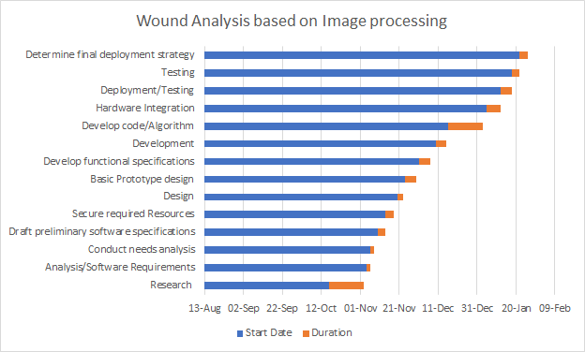

*Fig: Gantt Chart*

1. **Project Costs and Time Tracking**

|  |  |  |
| --- | --- | --- |
| **Work Package / Milestone** | **Type of Costs** | **Amount/Effort** |
| **Name** | **Ex: Personal, material** | **Ex: 5 hours** |
| Barcode scanner | material | 15 hours |
| Camera | material | 5 hours |
| Clouding system | material | 15 hours |

**10.Project Risks**

|  |  |  |  |
| --- | --- | --- | --- |
| **Risk** | **Event risk** | **Impact** | **measures** |
| **NAME AND DISCRIPTION** | **in %** | **Type of object** | **Wbs code name** |
| Integration of hardware and software | 30% | Barcode scanner |  |
| Software specifications | 30% | R coding / Python |  |
| Camera of choice | 10% | Digital camera/ smart phone camera |  |
| Integration of database to cloud | 30% | Azure/ docker cloud |  |

**11) Miscellaneous :**

**1. Research Topics Detail**

|  |  |  |
| --- | --- | --- |
| 1. | Anith | Research on different types of Image comparison Algorithms |
| 2. | Qurratul Ain | Research on different types of Image comparison Algorithms |
| 3. | Arun | Research on different types of Image comparison Algorithms |
| 4. | Jeff | Searching types of Wounds |
| 5. | Mayuri | Searching types of Wounds |
| 6. | Amir | Research on hardware device for Images |

**2. Task Distribution List**

1. Architecture design.
2. Layering the system.
3. Front end design.
4. Back end design.
5. Algorithm integration.
6. Code testing in R, Python, C#, MAT lab.
7. Wound Image collection for training the system.
8. Hardware integration.
9. Entity search and finalisation.
10. Database SQL server set up and implementation(primary publishing)
11. IBM cloud set up and implementation (secondary publishing)
12. Testing.

|  |  |  |
| --- | --- | --- |
| # | Tasks | Assigned to |
| 1 | Architecture design. | Anith |
| 2 | Layering the system. | Anith |
| 3 | Front end design. | Qurratul Ain |
| 4 | Back end design. | Amir |
| 5 | Algorithm integration methods. | Arun, Qurratul Ain |
| 6 | Image comparison Code testing in R. | Anith |
| 7 | Image comparison Code testing in Python | Arun |
| 8 | Image comparison Code testing in C# | Amir |
| 9 | Image comparison Code testing in MAT lab | Mayuri, Qurratul Ain |
| 10 | Wound Image collection for training the system. | Jeff,Mayuri |
| 11 | Entity search and finalisation. | Qurratul Ain,Arun |
| 12 | Hardware integration. | Amir,Arun |
| 13 | Database sql server set up and implementation(primary publishing) | Anith,Amir |
| 14 | IBM cloud set up and implementation (secondary publishing) | Jeff,Arun |
| 15 | Testing . | Mayuri, Jeff |

**3. Flow chart (Function flow)**

1. **PATIENT :**



1. **OPERATOR :**

Start

Send email with rejection reason

Send email with account details

End

Verify Patient details

View Patient Details

Delete Patient Record

Requested Patient List

Enrolled Patient List

Website Tab 2

Website Tab 1

Operator Login