Hochschule Rhein-Waal

Rhine-Waal University of Applied Sciences

Faculty of Communication and Environment

Prof. Dr.-Ing. Rolf Becker

GeoInformatics- 2018/2019 Winter

Land Quality Analysis System

By Group M

Aishwarya: xxxx

Anith: xxxx

Bitty: xxxx

Submission Date:

Day Month Year

**Abstract**

**-------------------------------------------to update later------------------------------------------------------**

**Statement of Authorship**

This report is the result of our own work. Material from published or unpublished work of others, which is referred to in the report, is credited to the author in the text.

Anith Shaji(MN)

Aishwarya(MN)

Bitty(MN)

**TABLE OF CONTENT**

1 Introduction 6

2 Background 7

2.1 NDVI 8

2.2 Geo data , clipping, mosaicking all papers we used ieee here 8

3 Research Methodology, System Investigation and Analysis 8

3.1 Research Methodology 8

3.1.1 Data Collection 8

3.1.2 Data Analysis 8

3.1.4 Result of Analysis and Interpretation 8

3.2 System Analysis 8

3.2.1 Problems of Existing System 9

3.2.2 Proposal of a New System 9

3.2.3 Benefits of The Proposed System 9

4 System Design and Implementation 9

4.1 Design Phase 9

4.1.1 Functional Requirements 9

4.1.2 Non-Functional Requirements 10

4.1.6 Database Design 10

4.2 Preparation Phase 10

4.3 Implementation Phase 10

4.3.1 Data preparation for ndvi 10

5 Results and Discussion 10

6 Conclusion, Evaluation and Recommendations 11

6.1 Conclusion 11

6.2 Evaluation of the System 11

6.3 Recommendation for Further Research 11

References 12

Appendix 12

1 sdfdsfsdffssd 12

**LIST OF FIGURES:**

Figure 1: Project outline and work outline 9

**LIST OF TABLES:**

Table 2: Basic Application Functionalities 11

# 1 Introduction

The modern era of the Internet has opened the means for the web applications for instant information broadcasting and various other transactions, including those having financial repercussions. Currently, a large number of web applications are developed using two major technologies, Object Oriented Programming (OOP) and Relational Database Management Systems (RDBMSs). These two technologies even being uneven, best suits each other (Armas et al. 2017, p.500).

The mainstream web application that interface with databases needs to work with both object-oriented and relational data models (Mehra et al. 2007, p.283). Java and C# are the two major object-oriented programming languages for writing the business logic of an application whereas relational databases like SQL Server and MySQL control the continuous storage of data.

………………………………………….

-------------------------------------------------------

Stored procedures are blocks of code in the database server, which is precompiled[1] ; it provides faster execution and reduces the network traffic (C-sharpcorner.com, 2018). This work will consist of using the SQL Server stored procedure in Code First Approach of Entity Framework in MVC 5 web application, for faster data transformation and modelling.

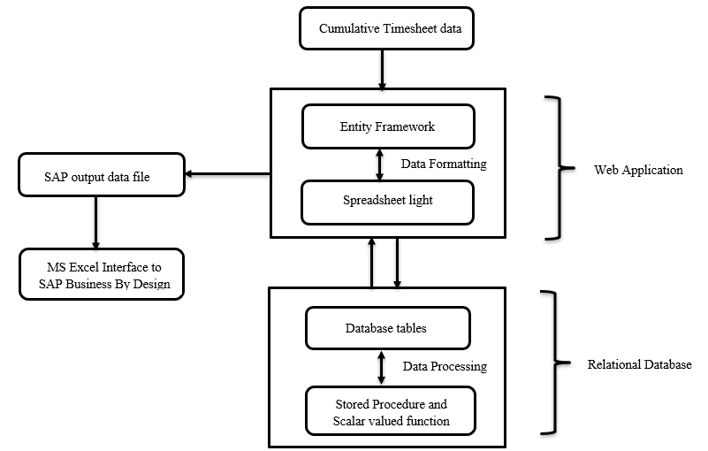

Figure 1: Project outline and work outline

The work done in this project consists of three ………………….

Chapter 2 covers Background information on the theoretical part of different techniques used throughout this work.

Chapter 3 discusses existing.

Chapter 4 presents the results of the proposed system and discuss these results.

Chapter 5 concludes and gives some possible future improvements to our solution.

# 2 Background

This section will serve as the baseline information for the central concepts used throughout this project. Firstly, we will give an overview about the concepts used in system, then processing mechanism and finally about the with our approach.

## 2.1 NDVI

## 2.2 Geo data , clipping, mosaicking all papers we used ieee here

# 3 Research Methodology, System Investigation and Analysis

In this chapter first, we will see the research methodology adopted for data collection and review the studies carried out on the ……………………..

## 3.1 Research Methodology

Research is the process of arriving at a reliable solution to a given problem through the systematic collection, analysis and interpretation of data. In this project ……………………..

### 3.1.1 Data Collection

There are the number of data collection methods depending on the nature of the research determines the approach of data collection. ----------------------------------------------------

< -------------------type of data its format and detailing ------------------------->

### 3.1.2 Data Analysis

The data collected

### 3.1.4 Result of Analysis and Interpretation

The results obtained from the analysis of the data includes:

1. The company, and transformation of data files during the intermediate stages of the process.

## 3.2 System Analysis

The investigation conducted

### 3.2.1 Problems of Existing System

From the system analysis made above, the issues identified in the current operating system are:

1. submission of the resultant booking data file.

### 3.2.2 Proposal of a New System

The proposed system is an intranet[2] that is available for the company employees and any authorized persons within the company.

### 3.2.3 Benefits of The Proposed System

The new system implemented within the company has enhanced the timesheet management process in the following manner:

1. mechanism with improved timeliness and accuracy.

# 4 System Design and Implementation

This chapter will describe the proposed web application system design and its implementation based final SAP timesheet booking data file.

## 4.1 Design Phase

The initial phase the functional and non-functional requirements of the customer.

### 4.1.1 Functional Requirements

Functional requirements capture

Table 2: Basic Application Functionalities

|  |  |  |
| --- | --- | --- |
| **FUNCTION** | **DESCRIPTION** | **ACCESS** |
| Login | Allow the registered employees to sign in. | Admin, Employee. |
|  |  |  |
|  |  |  |
|  |  |  |
|  |  |  |

The significant application functionalities (see Table 2), the SAP booking timesheet file.

### 4.1.2 Non-Functional Requirements

“Requirements which are not particularly concerned with the functionality of a system and place restrictions on the product under development and the development process, and they specify external constraints that the product must meet.”

They are usually the non-behavioral aspects of the system

**==============================================================**

### 4.1.6 Database Design

In the project we use *Entity Framework (EF) Code-First*

## 4.2 Preparation Phase

The initial phase focus on setting up of the EF development environment in Visual Studio IDE and then using EF Code First Migration for creating and updating the database schema.

## 4.3 Implementation Phase

After analyzing the client are chosen to describe the scenarios along with the C#.NET code and SQL Stored Procedure (SP).

### 4.3.1 Data preparation for ndvi

### 

# 5 Results and Discussion

In this chapter the results of the study are presented and discussed in accordance with the aim of the project, which was to

# 6 Conclusion, Evaluation and Recommendations

In this chapter the closing comments on the proposed application system is presented providing an overview and conclusion on the research methodology. The proposed system

## 6.1 Conclusion

The dependency on web applications is

## 6.2 Evaluation of the System

The main strengths of the application system are:

The limitations of the system:

1. Lack of direct submission of the final booking data

## 6.3 Recommendation for Further Research

Some of the aspects for further studies are:

1. The developers can

# References

1. J. Armas, P. Navas, T. Mayorga, P. Rengifo and B. Arévalo, "Optimization of code lines and time of access to information through object-relational mapping (ORM) using alternative tools of connection to database management systems (DBMS)," 2017 2nd International Conference on System Reliability and Safety (ICSRS), Milan, 2017, pp. 500-504.

# Appendix

## 1 sdfdsfsdffssd

1. compiled initially to be used again and again.
2. An internal organization computer network built on internet technology.