Hochschule Rhein-Waal

Rhine-Waal University of Applied Sciences

Faculty of Communication and Environment

Prof. Dr.-Ing. Rolf Becker

GeoInformatics- 2018/2019 Winter

Land Quality Analysis System

By Group M

Aishwarya Narkar: xxxx

Anith Shaji: xxxx

Bitty Samuel Varghese: 24873

Submission Date:

17.02.2019

# Abstract

**-------------------------------------------to update later------------------------------------------------------**

**Statement of Authorship**

This report is the result of our own work. Material from published or unpublished work of others, which is referred to in the report, is credited to the author in the text.

Aishwarya Narkar (MN)

Anith Shaji (MN)

Bitty Samuel Varghese (24873)

**TABLE OF CONTENT**

1 Introduction 6

2 Background 7

2.1 NDVI 8

2.2 Geo data , clipping, mosaicking all papers we used ieee here 8

3 Research Methodology, System Investigation and Analysis 8

3.1 Research Methodology 8

3.1.1 Data Collection 8

3.1.2 Data Analysis 8

3.1.3 Result of Analysis and Interpretation 8

3.2 System Analysis 8

3.2.1 Problems of Existing System 9

3.2.2 Proposal of a New System 9

3.2.3 Benefits of The Proposed System 9

4 System Design and Implementation 9

4.1 Design Phase 9

4.1.1 Functional Requirements 9

4.1.2 Non-Functional Requirements 10

4.1.3 Database Design 10

4.2 Preparation Phase 10

4.3 Implementation Phase 10

4.3.1 Data preparation for ndvi 10

5 Results and Discussion 10

6 Conclusion, Evaluation and Recommendations 11

6.1 Conclusion 11

6.2 Evaluation of the System 11

6.3 Recommendation for Further Research 11

References 12

Appendix 12

1 sdfdsfsdffssd 12

**LIST OF FIGURES:**

Figure 1: Project outline and work outline 9

Figure. Footprints for Tulare county

Figure. Merging operation

Figure. Merged output of Tulare County

Figure. Shapefile for Tulare County

Figure. Clipped output for Tulare county

**LIST OF TABLES:**

Table 2: Basic Application Functionalities 11

**LIST OF ABBREVIATION:**

LST Land Surface Temperature

NDVI Normalized Difference Vegetation index

OLI Operational Land Imager

TIRS Thermal Infrared Sensor

USDA United States Department of Agriculture

# Introduction

The modern era of the Internet has opened the means for the web applications for instant information broadcasting and various other transactions, including those having financial repercussions. Currently, a large number of web applications are developed using two major technologies, Object Oriented Programming (OOP) and Relational Database Management Systems (RDBMSs). These two technologies even being uneven, best suits each other (Armas et al. 2017, p.500).

The mainstream web application that interface with databases needs to work with both object-oriented and relational data models (Mehra et al. 2007, p.283). Java and C# are the two major object-oriented programming languages for writing the business logic of an application whereas relational databases like SQL Server and MySQL control the continuous storage of data.

………………………………………….

-------------------------------------------------------

Stored procedures are blocks of code in the database server, which is precompiled[1] ; it provides faster execution and reduces the network traffic (C-sharpcorner.com, 2018). This work will consist of using the SQL Server stored procedure in Code First Approach of Entity Framework in MVC 5 web application, for faster data transformation and modelling.

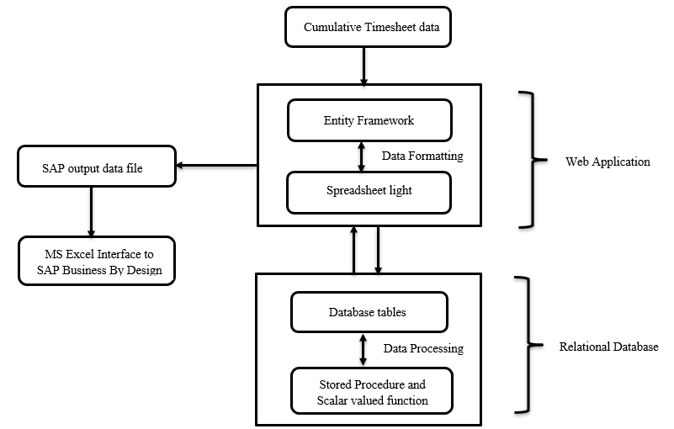

Figure 1: Project outline and work outline

The work done in this project consists of three ………………….

Chapter 2 covers Background information on the theoretical part of different techniques used throughout this work.

Chapter 3 discusses existing.

Chapter 4 presents the results of the proposed system and discuss these results.

Chapter 5 concludes and gives some possible future improvements to our solution.

# Background

This section will serve as the baseline information for the central concepts used throughout this project. Firstly, we will give an overview about the concepts used in system, then processing mechanism and finally about the with our approach.

## NDVI

The Normalized Difference Vegetation Index (NDVI) is an indicator for the presence of live green vegetation present on the remote sensing images such as Landsat satellite images. NDVI is a numeric value calculated as the arithmetic ratio of visible light band and near-infra red band present in the Landsat dataset (Reddy, 2016, abstract). While classifying the land cover into crop land, low vegetation area, bare soil, and water bodies, vegetation index has a vital role.

## Geo Data

In Geographic Information System (GIS), the data of geographical locations should be in a specified form for processing. That means geo data is the data stored in a format for GIS applications. The geo data is available in databases, geodatabases, shapefiles, raster image or even in Microsoft Excel sheets (Desktop.arcgis.com, n.d.). Landsat 8 images are kind of geodata for geographical processing. The Operational Land Imager (OLI) and the Thermal Infrared Sensor (TIRS) are two main sensors for Landsat 8 images with improved signal-to-noise ratio (Landsat.usgs.gov, n.d.).

## Mosaicing and Clipping

Mosaicing is the process to generate a mosaic which will be covering the entire geographical region of the interested area (J. Firl, 2010). Mosaicing is required when there are more than one satellite image tile are required for covering the area of interest (AOI). There are algorithms in QGIS like GDAL merge for mosaicing the available raster image tiles.

According to J. Firl (2010) clipping process clips the raster image by using a boundary shape file of AOI as mask layer.

## ~~2.2 Geo data , clipping, mosaicking all papers we used ieee here~~

# Research Methodology, System Investigation and Analysis

In this chapter first, we will see the research methodology adopted for data collection and review the studies carried out on the ……………………..

## Research Methodology

Research is the process of arriving at a reliable solution to a given problem through the systematic collection, analysis and interpretation of data. In this project ……………………..

### Data Collection

The data required for the project are data for two counties of California State of the United States of America (USA) such as Kern and Tulare. According to recent reports, in USA’s agricultural state California, Kern is having first place in agricultural ranking while Tulare shares second. Both counties’ climate and geography favor the productive yielding of crops. To analyses the cropping in both the counties it is required to find the presence of vegetation and land surface temperature. According to USDA National Agricultural Statistics Service’s Cropland Data Layer, both counties have some majorly growing crops, crops having variations in each year of production (Nassgeodata.gmu.edu, 2019).

The geodata, Landsat 8 images, for processing is collected from the official website of U.S Geological Survey. The required Landsat 8 OLI/TIRS Level-1 TP images or tiles covering the entire geographic location of Kern and Tulare counties between 2013 and 2017 having less cloud coverage (less than 10%) are downloaded.

### Data Analysis

The collected data analysed to find the major crops in the counties to decide which one should be suggested for purchasing. The data available with USDA provides Almonds, Pistachio are major contributions to production.

### Result of Analysis and Interpretation

The results obtained from the analysis of the data includes:

1. The company, and transformation of data files during the intermediate stages of the process.

## System Analysis

The investigation conducted

### Problems of Existing System

The existing system of QGIS provides processing and results which is not a simpler platform for a common person who has less technological background.

~~From the system analysis made above, the issues identified in the current operating system are:~~

1. ~~submission of the resultant booking data file.~~

### Proposal of a New System

The proposed system is an intranet[2] that is available for the company employees and any authorized persons within the company.

### Benefits of the Proposed System

The new system implemented within the company has enhanced the timesheet management process in the following manner:

1. mechanism with improved timeliness and accuracy.

# System Design and Implementation

This chapter will describe the proposed web application system design and its implementation based final SAP timesheet booking data file.

## Design Phase

The initial phase the functional and non-functional requirements of the customer.

### Functional Requirements

Functional requirements capture

Table 2: Basic Application Functionalities

|  |  |  |
| --- | --- | --- |
| **FUNCTION** | **DESCRIPTION** | **ACCESS** |
| Login | Allow the registered employees to sign in. | Admin, Employee. |
|  |  |  |
|  |  |  |
|  |  |  |
|  |  |  |

The significant application functionalities (see Table 2), the SAP booking timesheet file.

### Non-Functional Requirements

“Requirements which are not particularly concerned with the functionality of a system and place restrictions on the product under development and the development process, and they specify external constraints that the product must meet.”

They are usually the non-behavioral aspects of the system

**==============================================================**

### Database Design

In the project we use *Entity Framework (EF) Code-First*

## Preparation Phase

The initial phase focuses on preprocessing of the collected data. Since the entire county region is covered by one or more Landsat 8 image sets (see Figure.), the candidate images are downloaded by specifying criterion as similar. As Landsat 8 has collection of 11 bands including visible light and near-infrared bands, band 4, band 5 and band 10 are important for NDVI and LST calculation.

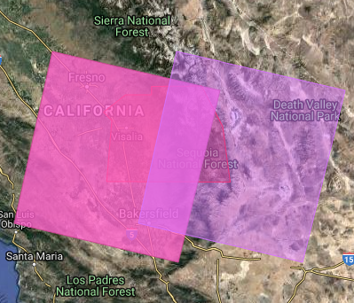

*Figure. Footprints for Tulare county (Source: Landsat.usgs.gov, n.d.)*

It is required to combine or stitch the corresponding bands together to make it as a representative band which containing the entire county area. This is done by GDAL Merge algorithm in QGIS by inputting the bands to be merged (see Figure.).

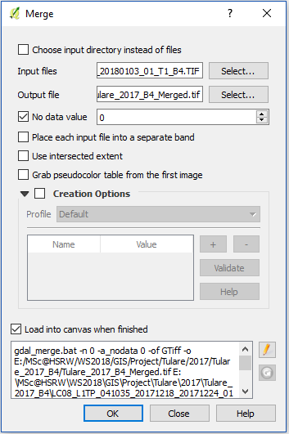

*Figure. Merging operation*

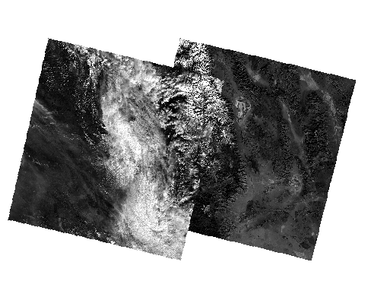

*Figure. Merged output of Tulare County*

Next preprocessing step is to clip the merged output with masking layer as boundary shape file (see Figure.) of the corresponding county. The shapefile of the corresponding county is selected from the shapefile of the entire state California (downloaded from https://geodata.lib.berkeley.edu/catalog/ark28722-s7vp4m) by using QGIS.

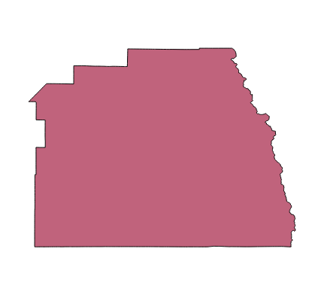

*Figure. Shapefile for Tulare County*

The mosaic image is the input for clipping and clipping mode is changed to mask layer by including boundary shapefile as a mask (see Figure ).

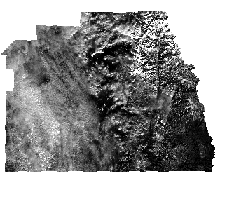

*Figure. Clipped output for Tulare county*

## Implementation Phase

After analyzing the client are chosen to describe the scenarios along with the C#.NET code and SQL Stored Procedure (SP).

### Data preparation for NDVI

### 

# Results and Discussion

In this chapter the results of the study are presented and discussed in accordance with the aim of the project, which was to

# Conclusion, Evaluation and Recommendations

In this chapter the closing comments on the proposed application system is presented providing an overview and conclusion on the research methodology. The proposed system

## Conclusion

The dependency on web applications is

## Evaluation of the System

The main strengths of the application system are:

The limitations of the system:

1. Lack of direct submission of the final booking data

## Recommendation for Further Research

Some of the aspects for further studies are:

1. The developers can

# References

J. Armas, P. Navas, T. Mayorga, P. Rengifo and B. Arévalo, "Optimization of code lines and time of access to information through object-relational mapping (ORM) using alternative tools of connection to database management systems (DBMS)," 2017 2nd International Conference on System Reliability and Safety (ICSRS), Milan, 2017, pp. 500-504.

Reddy, S. (2016). *Land cover classification based on NDVI using LANDSAT8 time series: A case study Tirupati region - IEEE Conference Publication*. [online] Ieeexplore.ieee.org. Available at: http://ieeexplore.ieee.org/document/7754369/ [Accessed 7 Feb. 2019].

Desktop.arcgis.com. (n.d.). *What is geodata?—Help | ArcGIS for Desktop*. [online] Available at: http://desktop.arcgis.com/en/arcmap/10.3/main/manage-data/what-is-geodata.htm [Accessed 8 Feb. 2019].

J. Firl, G. (2010). *Lesson 8 : Mosaicking and Clipping Landsat Data*. [online] Coloradoview.org. Available at: https://www.coloradoview.org/wp-content/coloradoviewData/trainingData/co-rs-tutorial8.pdf [Accessed 8 Feb. 2019].

Nassgeodata.gmu.edu. (2019). *CropScape - Cropland Data Layer*. [online] Available at: https://nassgeodata.gmu.edu/CropScape/ [Accessed 8 Feb. 2019].

Landsat.usgs.gov. (n.d.). *Landsat 8 | Landsat Missions*. [online] Available at: https://landsat.usgs.gov/landsat-8 [Accessed 8 Feb. 2019].

# Appendix

## 1 sdfdsfsdffssd

1. compiled initially to be used again and again.
2. An internal organization computer network built on internet technology.