
Software Requirements Specification
For
Suspect Detection System (SDS)

Anith Shaji(22914)
Arun Kumar(24349)
Sanwar(22747)
Qurratul-Ain Abid (21037)

November 3, 2017

Submitted in partial fulfillment
Of the requirements of
M-IE CS.03 Advanced Software Engineering, WS 2017/18

Table of Contents

Table of Contents i
List of Figures ii
1.0. Introduction 1
1.1. Purpose 1
1.2. Scope of Project 1
1.3. Glossary 2
1.4. References 2
2.0. Overall Description 4
2.1 System Environment 4
2.2 Functional Requirements Specification 5
2.3 User Characteristics 15
2.4 Non-Functional Requirements 15
3.0. System Specification 17
3.1 System Requirements 17
3.2 Table Design 17
4.0. Conclusion 17

List of Figures

Figure 1 - System Environment 4
Figure 2 – Contex Level DFD 6
Figure 3 – Level 0 DFD 8
Figure 4 – Level 1 DFD 23
Figure 4 – Level 2 DFD(Admin) 23
Figure 4 – Level 2 DFD 23

1.0. Introduction

1.1. Purpose
The main objective of the system is to help the cops in determining the suspect’s details and in taking appropriate actions against the crime performed. It also gives the criminal status and support in faster identification of criminals.
The website basically provides a platform for easy and efficient storage and retrieval of details of the suspect. This system also helps the judiciary system to evaluate the suspect and give appropriate punishment to him/her.

1.2. Scope of Project
This software system will be a Website for the police officers of a regional area of a country. This system will be designed in order to maintain the details of the suspect in an online manner rather than maintaining hardcopy files. By maximizing the editor’s work efficiency in searching criminal background details while remaining easy to understand and use.
More specifically, this system is designed to allow an officer to search and create criminal record. It forms a platform for criminal record keeping system. The system provides different access permission based on the rank of the officers in the department. It provides a grid listing view of the entire criminals who is currently present in the database. The system also contains a relational database containing a list of Officers at different ranking level and the criminals.

1.3. Glossary
Term | Definition
SDS | The web site for maintaining the criminal record.
Admin | The high Ranked officer in the Police department.
SI | Police Sub Inspector.
User | The officers having rank lower than Police Sub Inspector.
ASI | Assistant Police Sub Inspector.
HC | Head Constable.
C | Constable.
SRS | Software Requirements Specification is a document that completely describes all of the functions of a proposed system and the constraints under which it must operate. For example, this document.

References
- www.w3schools.com
- Asp.Net complete reference
- www.codeproject.com

2.0 Overall Description

2.1 System Environment


Web Interface
Admin(SI)
Database store
Scanned data
Suspect
User(ASI/HC/C)
Fingerprint scanner
Suspect Detection System

Figure 1 - System Environment

The Web System has two active actors .i.e. the Admin(Police Sub Inspector(SI)) and User(Assistant Police Sub Inspector(ASI),Head Constable(HC),Constable(C)).The Admin have more access permission than the other users who are the low ranked officers.
Here when a suspect is caught, the officers with the help of Fingerprint Scanning Module (FSM) take the finger print from him/her and check with those present in the SDS data store. If a match is found then the record is fetched, this give the officer more information related to the suspect and take further action based on it. If no match is found then new record is created based on the offence that currently done by the person.

2.2 Functional Requirements Specification
This section outlines the data flow diagrams (dfd) for the admin and users of the system. It explains the interaction of the users with the system.

2.2.1 Context Level DFD

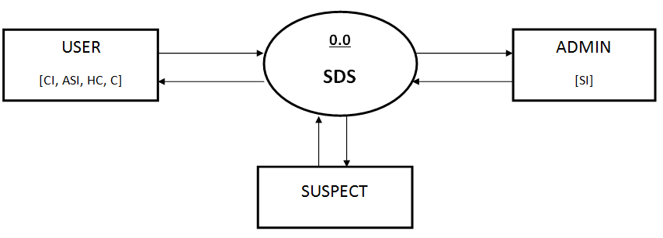

Figure 2 – Context Level DFD

2.2.2 Level 0 DFD

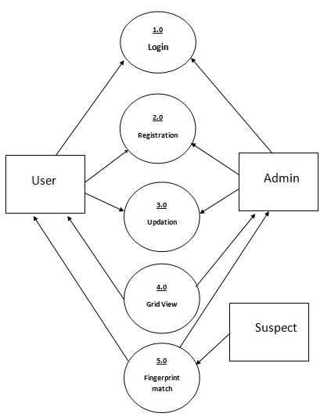

Figure 3 – Level 0 DFD

2.2.3 Level 1 DFD

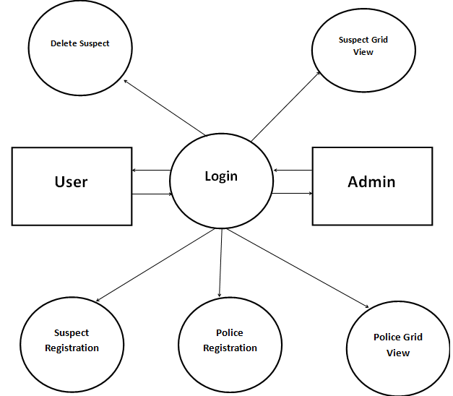

Figure 4 – Level 1 DFD

2.2.4 Level 2 DFD (Admin)

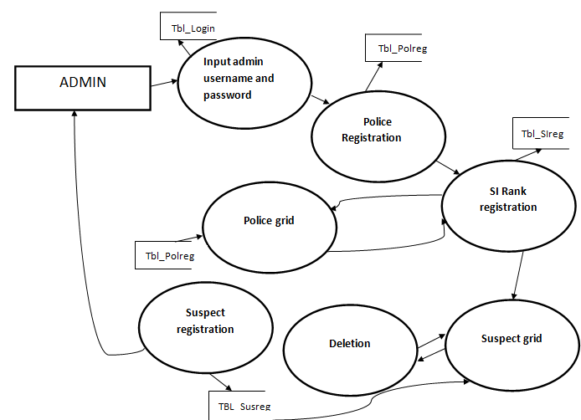

Figure 5- Level 2 DFD Admin

2.2.4 Level 2 DFD (Suspect)

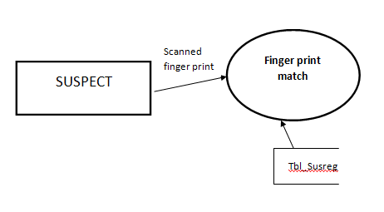
Figure 6 - Level 2 DFD Suspect

2.3 User Characteristics
The Admin is the highest ranked officer of the department .i.e. SI and can register new criminal record and view the user in the system. He can also add or delete the user in the system.
Whereas the low ranked officers like (ASI, HC, C) can register the suspect and view their details.
The system has a hardware interface .i.e. a fingerprint scanner that scans the fingerprint of the captured suspect and compare with the available criminal record in the database of the system. This makes easy identification of the suspect and gets their previous criminal background details.

2.4 Non-Functional Requirements
When the user types in the URL of the site in the address field of the browser, a web server is contacted to get the requested information. In the MVC .Net framework,
IIS (Internet Information Service) act as a web server. The sole task of a web server is to accept the incoming HTTP request and to return the requested resource in an HTTP response.

3.0. System Specification

3.1 System Requirements
For implementing the system there is a set of hardware and software requirements. These requirements have to be satisfied for the successful implementation of the website. The hardware and software requirements are specified below:

3.1.1 Hardware Requirements
- PROCESSOR : INTEL I3
- RAM : 2.00 GB
- MONITOR : 15” COLOR
- HARD DISK : 500GB
- KEY BOARD : STANDARD 102 KEYS
- MOUSE : 3 BUTTONS
- SCANNER : FINGERPRINT SCANNER

3.1.2 Software Requirements

- OPERATING SYSTEM : WINDOWS 10
- ENVIRONMENT : VISUAL STUDIO .NET 2017
- MVC .NET FRAMEWORK : VERSION 1.1
- LANGUAGE : C# .NET
- WEB TECHNOLOGY : MVC .NET 3.5
- BACKEND : SQL SERVER 2014

3.2 Table Design

The logical structure of the data to be stored in the database is given below.

The data descriptions of some of the basic data entities are as follows:

Police Data Entity
Data Item | Type | Description
User name | Varchar(50) | Cops name
Password | Varchar(50) | Unique password
RollId | Int | Rank

Suspect Data Entity
Data Item | Type | Description
Name | Varchar(50) | Name of principle author
Gender | Varchar(50) | ID number of Historical Society member
Age | Int | Internet address
State | Varchar(50) | Article entity of
Station | Varchar(50) | Review entity
Image | Bytes | Comments on past performance
Description | Varchar | Area of expertise

Roll Data Entity
Data Item | Type | Description
Roll_id | Int | Primary key
Roll Name | Varchar(50) | Rank Level Name

4.0. Conclusion

Computer as we know have become an important part of our daily life. The knowledge and information around glob is available within a moment due to internet and its facilities. All sectors of life has been affected by the advancement in technology.

This site is helpful in identifying various suspects with criminal background .It helps to search suspects online and also provide entire background details.

