Exploratory Data Analysis of Liquid Waste Management Data Using Python

1. Introduction
Liquid waste management is an important part of environmental sanitation and public health. Wastewater generated by households and communities needs suitable collection, drainage and management arrangements to reduce environmental contamination and health risks.
This project, titled “Exploratory Data Analysis of Liquid Waste Management Data Using Python”, analyses a sample dataset containing village-level records about liquid-waste-management assets and related administrative locations. The project uses Python to inspect, clean, summarise and visualise the dataset and to generate evidence-based insights.

2. Project Objectives
- Load the Liquid Waste Management sample dataset and inspect its structure.
- Identify missing values, duplicate records and data-type issues.
- Clean and prepare the data for analysis while retaining original household-coverage observations for comparison.
- Perform univariate, bivariate and multivariate exploratory data analysis.
- Use group-by summaries, a pivot/cross-tabulation and correlation analysis.
- Create at least ten visualizations and interpret the results.
- Present at least five insights supported by the actual dataset output.

3. Dataset Description
The dataset used is “Liquid Waste Management_Sample_Data(1).csv”, hosted in the GitHub repository associated with this project. The original dataset contains 500 rows and 17 columns.
The columns cover State Name and State Code; District Name and District Code; Block Name and Block Code; Gram Panchayat Name and Gram Panchayat Code; Village Name and Village Code; LGD hierarchy exact-mapping status; Asset; Sbm; Mgnrega; Mopr; Shared With Other Village (SBM-G); and Households Covered (%).
The dataset represents sample records. Record counts describe the rows available in this sample and do not independently measure the quality, completeness or effectiveness of liquid-waste-management services.

4. Tools and Technologies
Python: programming language used for the analysis.
Pandas: data loading, inspection, cleaning, grouping and summarisation.
NumPy: numerical operations and correlation calculations.
Matplotlib: chart creation and formatting.
Seaborn: statistical plots and heatmaps.
Google Colab: cloud notebook platform used to execute the project.

5. Data Loading and Initial Inspection
The notebook imports Pandas, NumPy, Matplotlib and Seaborn, and uses IPython display utilities to show tabular results. The CSV file is loaded from the GitHub raw-file URL using pandas.read_csv().
The raw dataframe is retained as df_raw and a working copy named df is created. The notebook prints the number of rows and columns and displays the first five records. The initial source contains 500 rows and 17 columns.

6. Data Cleaning and Preprocessing
The notebook standardises column names to make them easier to reference in Python. It checks for duplicate records and removes duplicates before continuing the analysis. The executed insight output confirms that 500 records remain after duplicate removal and preprocessing.
The field for shared arrangements with another village (SBM-G) is reviewed because it contains substantial missing information and is excluded from the cleaned analysis workflow. The household-coverage field is retained in its original form for observed-value analysis; a separate analysis field is used where imputation is needed. A missingness indicator is also retained so that missing values are not hidden.
Text fields are cleaned by trimming unnecessary whitespace. Numeric fields used for analysis are converted to numeric values safely. The notebook uses observed household-coverage values, excluding missing observations, for the household-coverage distribution and summary statistics.
Data-quality caution: the household-coverage field is labelled as a percentage, but the notebook's descriptive output shows a maximum observed value of 313.0. Values above 100% require validation against the source definition before being interpreted as valid percentages. They should not be silently changed.

7. Exploratory Data Analysis
Univariate analysis reviews the distribution of individual variables, including asset categories, state and district record counts, and numerical summaries of household coverage.
Bivariate analysis compares asset categories with geographical locations and examines household coverage by asset type. A cross-tabulation is used to compare asset-type counts across states.
Multivariate analysis uses a correlation matrix for selected numeric fields. Correlation describes statistical association and does not establish a cause-and-effect relationship. Administrative code fields are identifiers; a high correlation between codes should not be interpreted as a meaningful operational relationship.

8. Data Visualizations
The notebook contains ten visualization plots. Insert the corresponding actual chart image exported from the completed Google Colab notebook in each space below. The plot descriptions here follow the actual chart code in the linked notebook.

Figure 1 – Asset Category Bar Chart
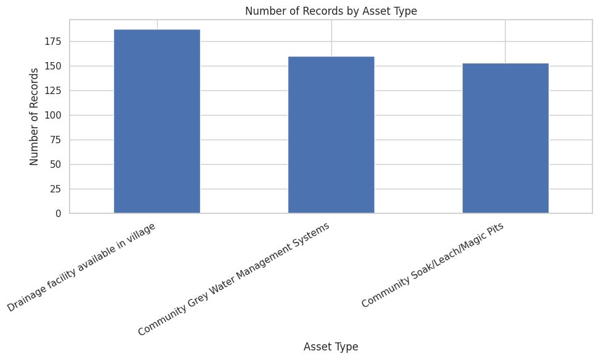

Displays the number of records for each liquid-waste-management asset category. It helps compare the frequency of the recorded asset types.

Figure 2 – State-wise Horizontal Bar Chart
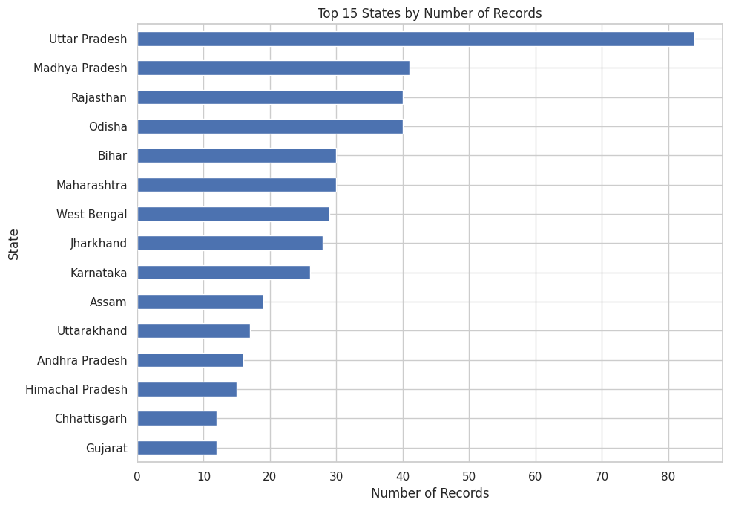

Displays the 15 states with the highest record counts in the sample. Counts represent dataset records and should not be interpreted as a performance ranking.

Figure 3 – Household Coverage Histogram
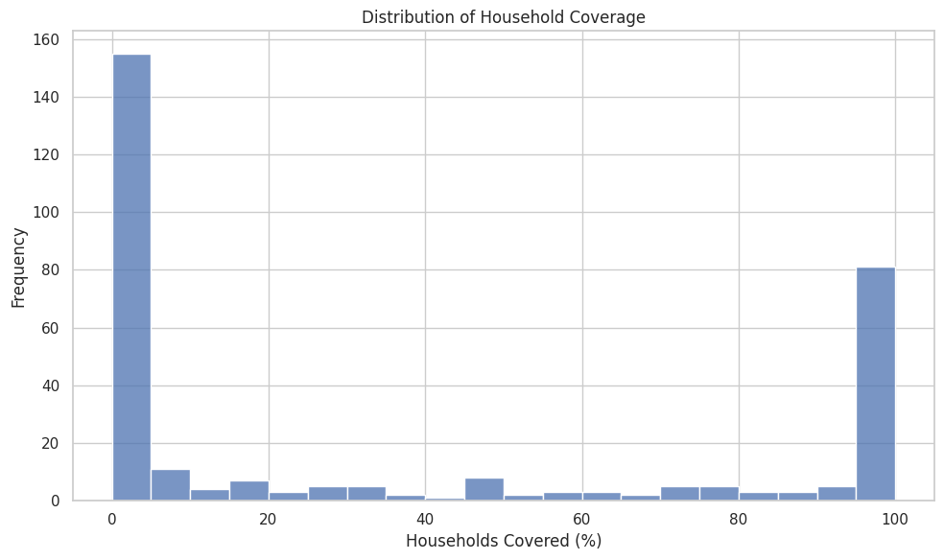

Shows the frequency distribution of observed household-coverage percentages. Missing values are excluded.

Figure 4 – Household Coverage Box Plot

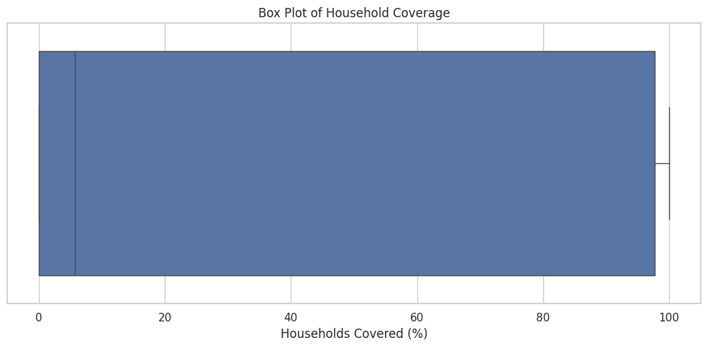

Summarises the median, quartiles, spread and potential outliers in observed household coverage.

Figure 5 – Asset Category Pie Chart
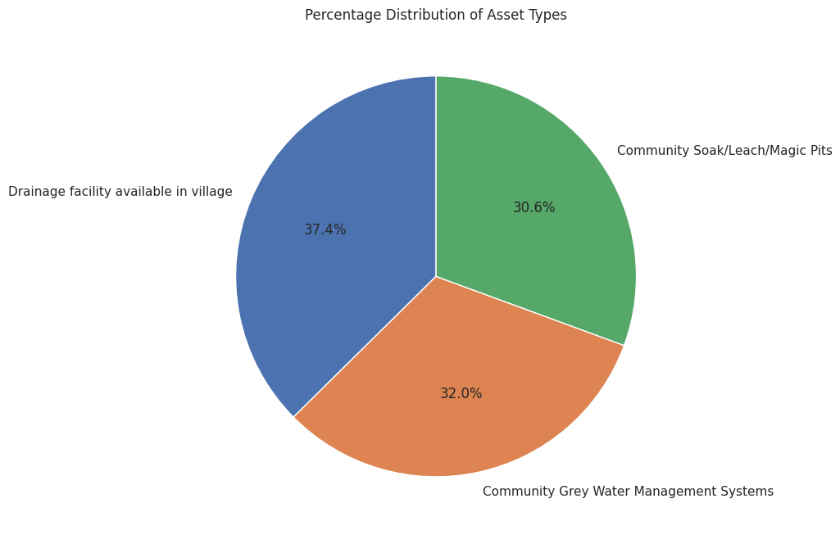

Shows each asset category's share of all recorded asset rows.

Figure 6 – Top 10 Districts Horizontal Bar Chart
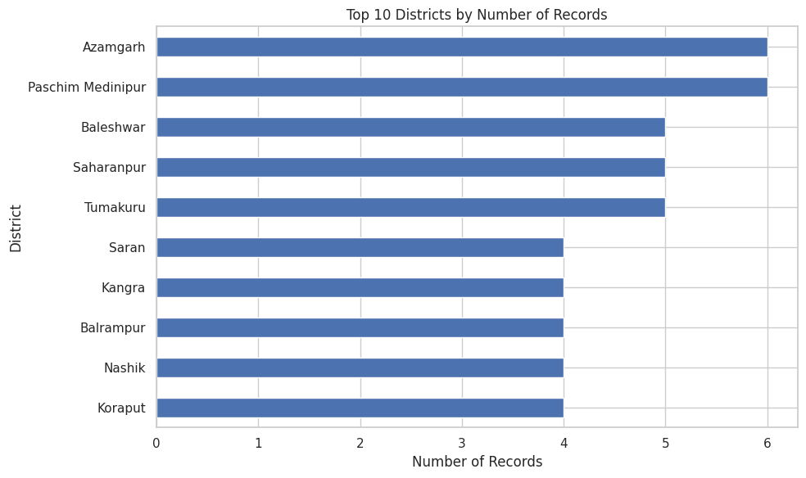

Compares the ten districts with the highest number of records.

Figure 7 – Household Coverage by Asset Type Box Plot

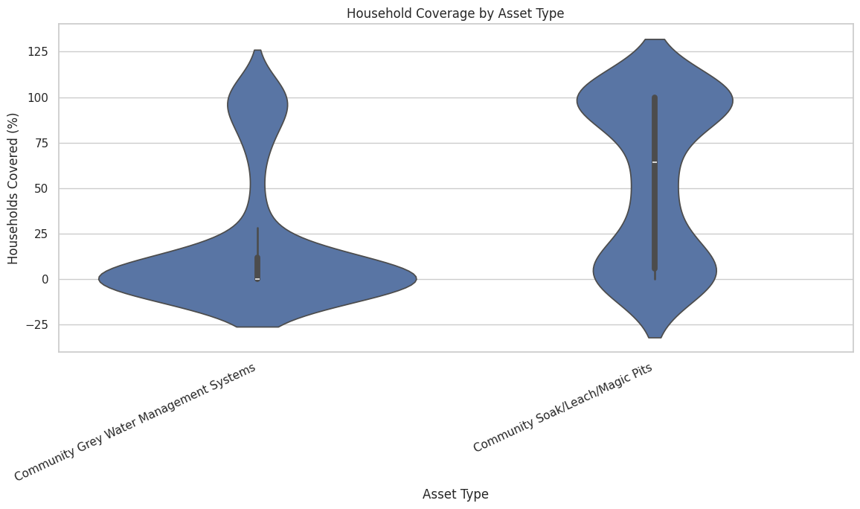

Compares the distribution of observed household-coverage values across asset types.

Figure 8 – Asset Type by State Heatmap
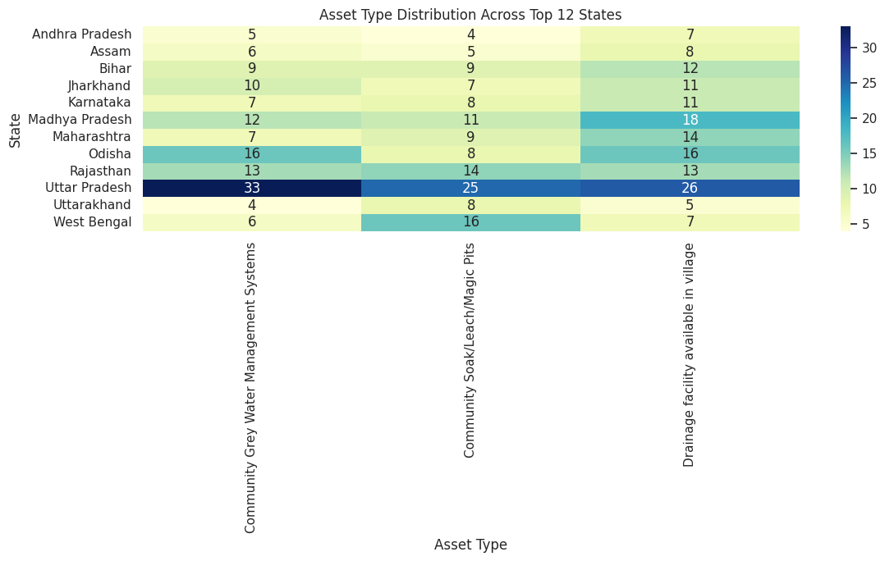

Shows counts for asset-type and state combinations among the 12 states with the highest record counts.

Figure 9 – Numeric Correlation Heatmap

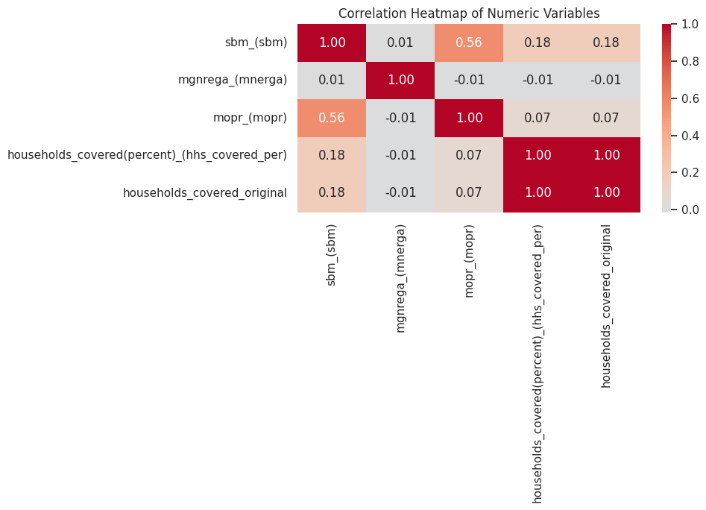

Figure 10 – LINE CHART - SCHEME VALUES BY ASSET TYPE
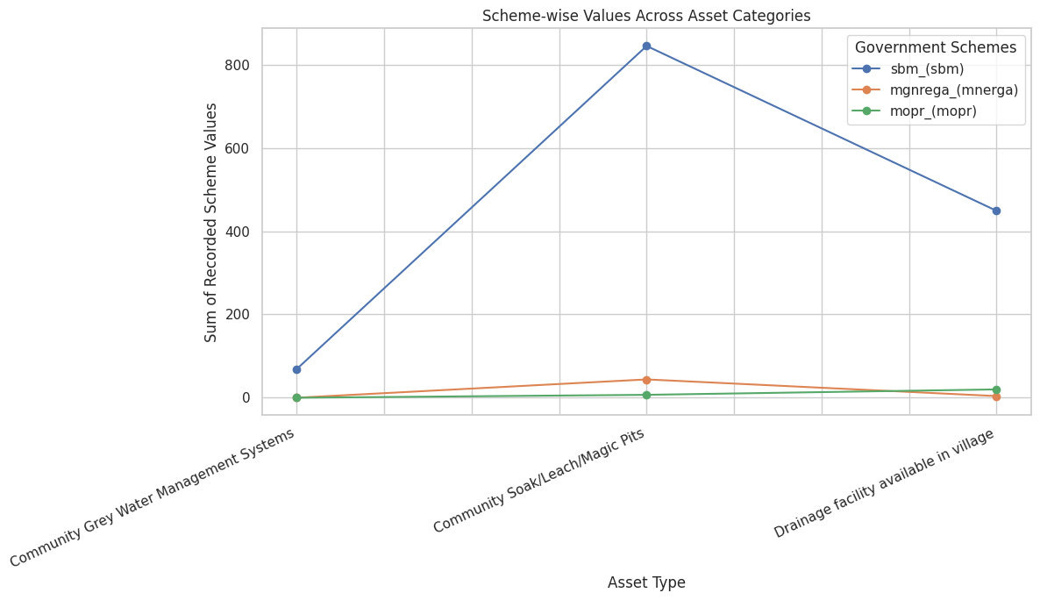

9. Key Findings and Insights
The saved execution output in the linked notebook reports the following findings:
- 1. The dataset contains 500 records after duplicate removal and preprocessing.
- 2. The most frequently recorded asset type is 'Drainage facility available in village' with 187 records (37.4% of records).
- 3. Uttar Pradesh has the highest number of records, with 84 records. This is a record count, not necessarily a measure of performance.
- 4. Azamgarh is the district with the highest number of records, with 6 records.
- 5. Observed household coverage has a mean of 36.81% and a median of 5.75%, calculated after excluding missing coverage values.
- 6. There are 187 records with missing household coverage out of 500 records (37.4%).
- 7. The difference between the most and least frequent asset categories is 34 records.
- 8. The strongest absolute pairwise correlation reported is between state_code and village_code (correlation = 0.93). Correlation does not establish causation; these are administrative identifiers.

10. Recommendations
- Investigate why household-coverage values are missing and determine whether missingness is concentrated in particular asset types or geographical areas.
- Verify the meaning, unit and valid range of the household-coverage field, particularly the observed value of 313.0.
- Confirm the definitions and units of the SBM, MGNREGA and MOPR fields before interpreting them as scheme outputs or outcomes.
- Use suitable population or household denominators before comparing states or districts. A larger record count alone does not mean better performance.
- Collect complete household-level and time-based data if the objective is to estimate actual coverage or measure changes over time.
- Clearly distinguish original observed values from imputed values in future analysis and reporting.

11. Conclusion
This project completed an exploratory data analysis of a 500-row, 17-column sample dataset related to village-level liquid-waste-management assets. Python libraries were used to load and inspect the data, perform preprocessing, analyse asset and geographical distributions, examine household-coverage values, and create ten visualizations.
The analysis identified drainage facilities as the most frequently recorded asset category in the sample and Uttar Pradesh as the state with the highest number of records. It also highlighted substantial missingness in household-coverage data and a need to validate the percentage field's range and the definitions of scheme-related columns.
Overall, the project demonstrates how Python-based data analytics can organise and explore liquid-waste-management information. The findings are descriptive and should be interpreted within the limitations of the sample dataset, missing values and available field definitions.

