**1) Load Paper Data :**

Intial Screen ,loaded from dbo. Enforcement_Final

**2) Transfer Paper:**

Flag in dbo.Enforcement_Final is set to 'N' and Transfer Date is the current date(unless changed by user)

**3) Update Criteria in the table**

Update dbo.Transfer_Enforcement

1) the TransFlag to 'Y' 2) Office Num 3) Date Received 4) Date Assessed

**4) After Transfer Populate:**

1) Change the Agency and user has to know the paper has been transferred

2) Populate Data from Transfer_Enforcement in the PaperView.aspx.cs page

3) How to Dispaly Data in the Main Page since we don’t have a Office num ? and Display the Paper has been transferred?

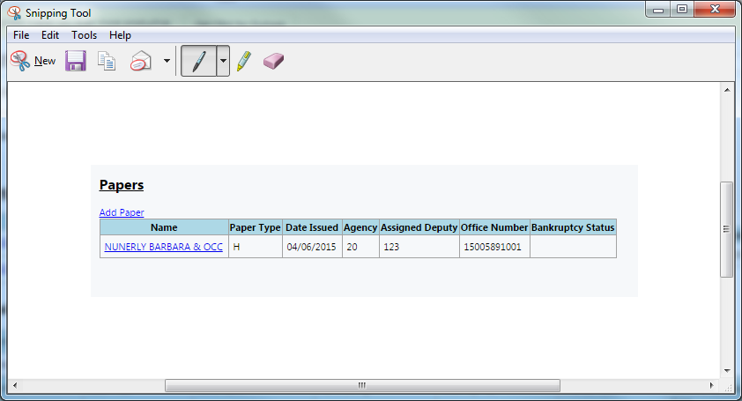

4) Updates to which table?