**TIS (Truancy Information System)**

**About:**

The Dallas county TIS is an application which connects Dallas County ISD’s to Dallas County Court System**.**

**TIS Users:**

* TIS Administrators
* Agencies who are responsible for reporting student truancy
* Agencies who need to access Truancy Information

**Roles:**

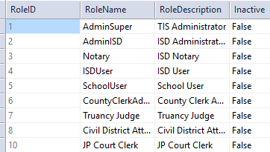

**Source Code:**

TruancyInformationSystem🡪HouseBill2398

Database: D08SRECTISQL1

**TIS Test:**

[**https://tistest.dallascounty.org/TIS/**](https://tistest.dallascounty.org/TIS/)

Depending on role(s) certain users may not see all the pages. Below screen is for AdminSuper role.

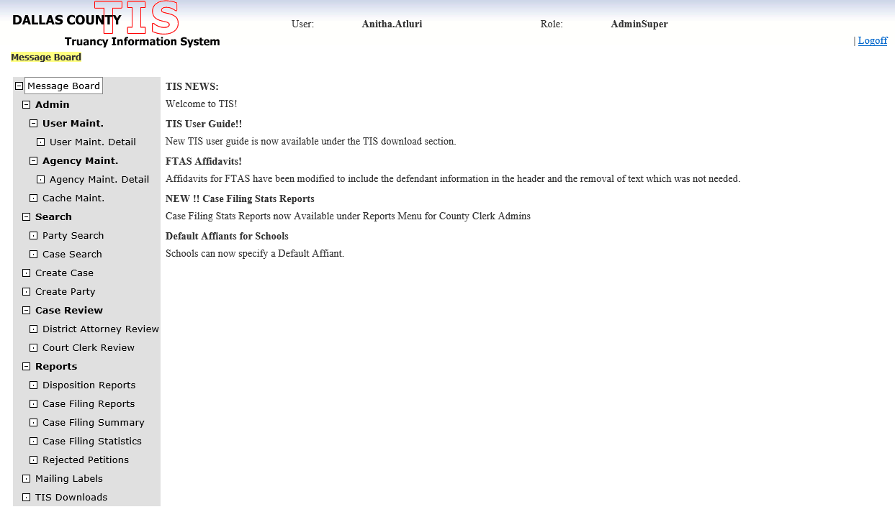

**Admin:** This view is only available to the AdminSuper Role.

User Maintenance, Agency Maintenance

**User Maintenance Page**: Click on User Maint.

* Landing Page : <https://tistest.dallascounty.org/TIS/UserMaintenance.aspx>
* Display the current users to the grid including their roles. Insert the new user. Edit the existing users (sometimes roles might be changed or they may leave the ISD)

List of users are in TIS. [dbo]. [User] table.

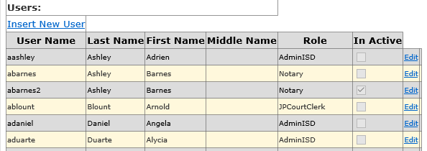

**Insert New user:**

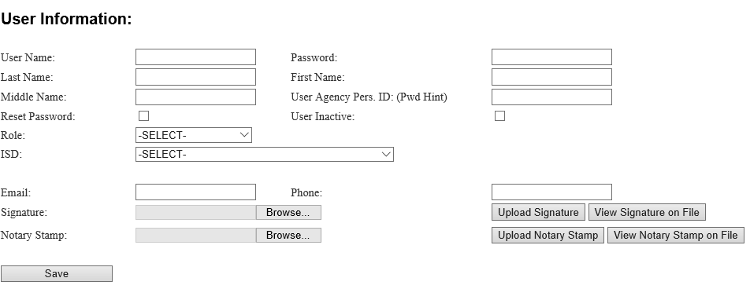

**Username:** First letter of the First Name followed by Last Name (Ex: User First Name: Diana, Last Name Cruz, Username: DCruz)

**Password:** set a Default password, after initial login the users will change their password.

**Role**: Roles are in TIS. [dbo]. [Role] table.

**ISD**: List of ISD’s including the schools belonging to the ISD’s, TIS.dbo. [Agency] table.

**Signature/Notary stamp**: This has to be in jpeg format. The Notary stamp is for the user who is the Notary role.

**Save:** The information entered should insert a record in the TIS. [dbo]. [User] table.

**Edit the User:**

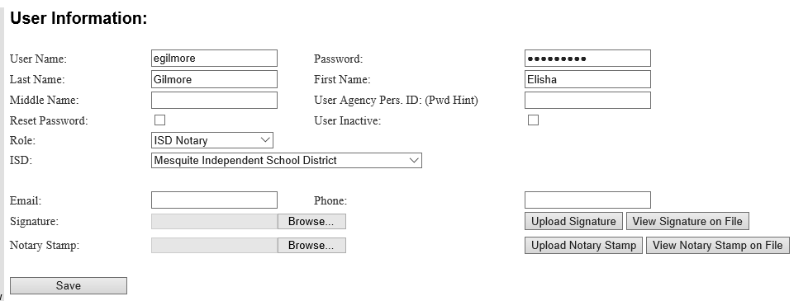

Display the data, when changed the data has to be updated to the TIS. [dbo]. [User] table.

**Agency Maint. :**

* This page is only visible for Admin Super Roles.
* Landing Page: <https://tistest.dallascounty.org/TIS/AgencyMaintenanceDetail.aspx>
* Actions include Displaying of current ISD’s ,Edit /Delete ,Insert new ISD’s .

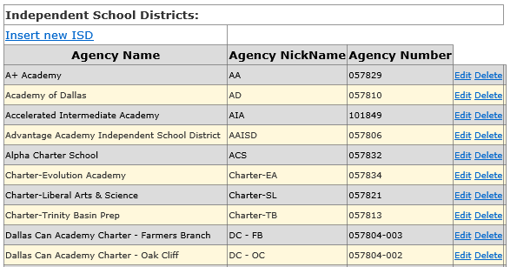

**Display of current ISD ‘s:** TIS. [dbo]. [Agency]

Display: ISD’s

select * from dbo. [Agency] with(nolock) where AgencyTypeID = 2

Display of School’s under ISD’s: TIS. [dbo]. [Agency]

select * from dbo. [Agency] with(nolock) where ParentAgencyID = 137

137- AgencyID for the DallasISD.

* Displaying of current courts

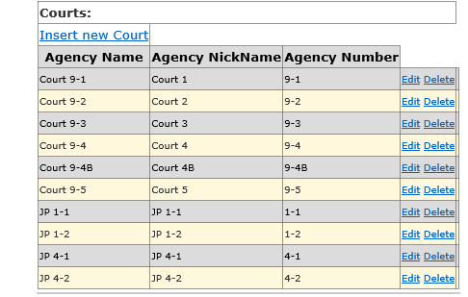

select * from dbo.[Agency] with(nolock) where AgencyTypeID = 4

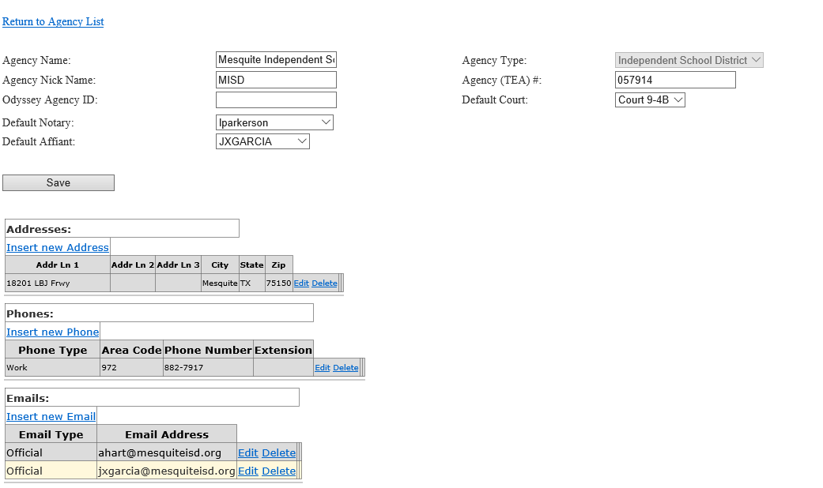

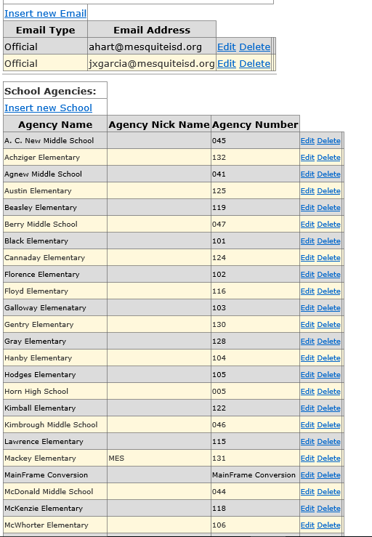

**Creating a Case**:

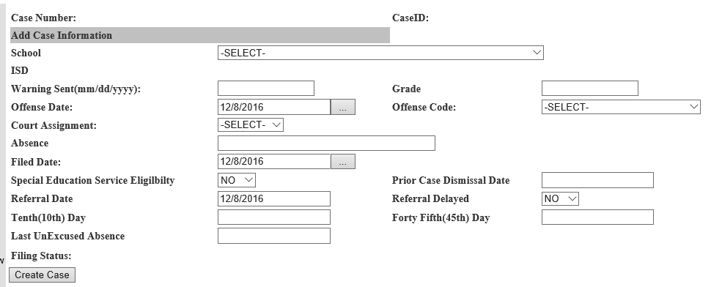

**Case Number**: is generated after the case has been submitted to the Odyssey.

**CaseID**: Generated when case is Created in TIS.

**School**: Populate the list of Schools from the Agencies table

select * from dbo. [Agency] with(nolock) where AgencyTypeID = 3

order by AgencyName

**ISD**: Populate the ISD after selecting the School from the list.

**WarningDate:** Validate the warning date to mm/dd/yyyy format.

**Grade:** Text field

**Offense Date**: Offense Date is the date when the case has been created.

**Offense Code:** Populate the offense Code from Offense table.

select * from TIS.[dbo].[Offense] with(nolock)

**CourtAssignment:** Populate the list of courts from the Agency table

select * from dbo.[Agency] with(nolock) where AgencyTypeID = 4

order by AgencyName

**Absence**: Text field, typically separated by coma or Semicolon in the database table.

**FiledDate:** Is the date when Case has been created.

**Special Education Service Eligibility:** Yes/No list, default to NO

**Prior Case Dismissal Date:**

**Referral Date**: Current Date

**Referral Delayed**: Yes/No list, default to NO

**Tenth Day**: Tenth Day (10th) day after the last unexcused absence

**Forty Fifth Day**: The 45 days is 45 calendar days from the last unexcused absence, so that value will not change from school district to school district

**Last Unexcused Absence**: Date

**Filing Status**: If it’s the AOT Case ,the case is in DAReview Queue ,with FilingStatus = 14 Else if it’s a PCCT Case ,the case in Clerk Queue ,With FilingStatus = 1 Else if the Case is created by ISD User ,it needs to be in the PreFile Status , with FilingStatus = 15 ,till the ISD User submits the Case to the prospective queues.

**Create Case**: When clicked on the Create Case button, do the necessary validation and it should insert a record in the TIS. [dbo]. [Case] table.

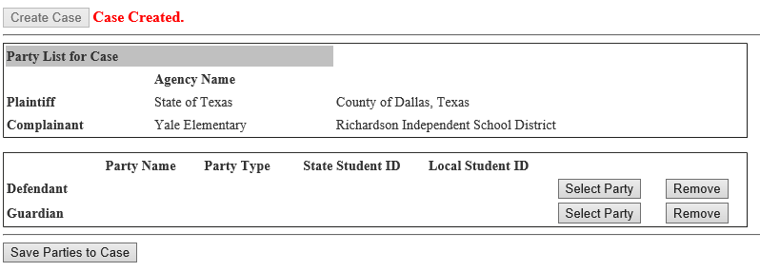

Plaintiff: State of Texas

Complainant: School Name and School District

**Selecting the Parties**:

If it’s the AOT Case, the Defendant is the Student and the Guardian is the Parent / Guardian

If it’s the PCCT Case, the Defendant is the Parent and Guardian is the Student.

Remove: Delete the selected Defendant /Guardian.

**Save Parties to Case**: The records need to be Inserted to the Case Party table.

**Create Party:**