Traffic Accident &
Road Safety Analytics
Final Project Report

Client: State Road Safety & Transport Analytics Department
Tools Used: MySQL | Python | Power BI
Project Type: Corporate Simulation – Public Safety Analytics
Duration: 7-8 Days
Project Overview & Dataset Summary
This project simulates a government-grade public safety analytics environment for the State Road Safety & Transport Analytics Department. The dataset covers accident reporting, road infrastructure, emergency response, weather conditions, driver behaviour, vehicle compliance, traffic violations, and road intervention tracking across 35+ districts in Telangana.

Dataset Table Summary
Table Name | Records | Role | Key Columns
Accidents | 200,000+ | Fact Table | severity_level, fatalities, injuries, accident_type, primary_cause
Drivers | 300,000+ | Dimension | age, gender, license_type, alcohol_flag, prior_violations
Vehicles | 350,000+ | Dimension | vehicle_type, insurance_status, helmet_seatbelt_used
Traffic Violations | 500,000+ | Fact | violation_type, fine_amount, speed_recorded, payment_status
Emergency Response | 180,000+ | Fact | ambulance_arrival_minutes, police_arrival_minutes, response_status
Weather Conditions | 150,000+ | Fact | weather_type, visibility_level, rainfall_mm, temperature
Locations | 25,000+ | Dimension | district, area_type, latitude, longitude, junction_type
Road Interventions | 15,000+ | Fact | intervention_type, intervention_date, road_id
Roads | 10,000+ | Dimension | road_type, speed_limit, blackspot_flag, lighting_condition
Hospitals | 2,000+ | Dimension | trauma_center_flag, bed_capacity, icu_beds

Database schema & entity relationships

The database follows a star-schema design with Accidents as the central fact table, surrounded by dimension tables for locations, roads, drivers, vehicles, weather, hospitals, emergency response, violations, and interventions.

Entity relationship overview
Table | Primary key | Linked via | Key columns
Accidents | PK accident_id | Fact table | severity, fatalities, injuries, type, cause
Locations | PK location_id | FK accidents.location_id | district, area_type, lat/lon, junction_type
Roads | PK road_id | FK accidents.road_id | road_type, speed_limit, blackspot_flag, lighting
Drivers | PK driver_id | FK violations.driver_id | age, gender, license_type, alcohol_flag
Vehicles | PK vehicle_id | FK violations.vehicle_id | vehicle_type, insurance_status, helmet_seatbelt
Weather conditions | PK weather_id | FK accidents.accident_id | weather_type, visibility, rainfall, temperature
Emergency response | PK response_id | FK accidents.accident_id | ambulance/police arrival mins, response_status
Hospitals | PK hospital_id | FK emergency.hospital_id | trauma_flag, bed_capacity, icu_beds
Traffic violations | PK violation_id | FK driver_id, vehicle_id | violation_type, fine_amount, payment_status
Road interventions | PK intervention_id | FK road_id, location_id | intervention_type, intervention_date

Data Quality Issues Addressed
- Duplicate rows removed from all 10 tables
- Missing values imputed using group-wise mode and median strategies
- Out-of-range latitude/longitude values replaced with median coordinates
- Negative ambulance and police arrival times replaced with median
- Outliers in response times capped using IQR (Q1 - 1.5×IQR, Q3 + 1.5×IQR)
- Inconsistent casing standardised across district, area_type, gender, status fields
- Invalid junction types replaced with 'Unknown'
- Future timestamps in accident_datetime and violation_date flagged and handled

Table-Wise Data Cleaning Summary

1.Emergency_Response

1. Objective
The objective of this cleaning process is to identify and handle missing values, duplicate records, invalid values, outliers, inconsistent text formatting, and invalid timestamps in the Emergency_Response dataset to improve data quality and consistency.

2. Dataset Information
Attribute | Description
Table Name | Emergency_Response
Total Rows | 180,000
Total Columns | 11
Primary Key | response_id
Foreign Keys | accident_id, hospital_id

3. Columns in Dataset
Column Name | Data Type
response_id | int64
accident_id | int64
ambulance_id | object/string
ambulance_arrival_minutes | int64
police_arrival_minutes | int64
hospital_id | float64 → converted to int64
victim_transferred | object/string
response_status | object/string
call_received_time | datetime
ambulance_dispatch_time | datetime
case_closure_time | datetime

4. Quality Issues Identified
Quality Issue | Column
Missing values | ambulance_id, hospital_id
Duplicate records | Entire dataset
Negative values | ambulance_arrival_minutes, police_arrival_minutes
Outliers like 500 | ambulance_arrival_minutes (IQR upper bound: 65)
Mixed casing | victim_transferred, response_status
Invalid labels | response_status (InvalidStatus)
Future timestamps | datetime columns
Invalid timestamp order | dispatch and closure timestamps

5. Cleaning Steps Performed
Step 1 — Create Copy of Dataset
To preserve the original dataset and perform cleaning operations on a separate copy.
Step 2 — Remove Duplicate Records
To identify and remove duplicate rows from the dataset.
Step 3 — Handle Missing Values
- ambulance_id: Filled with mode — ID columns should use existing valid IDs.
- hospital_id: Filled with mode and converted to int64 datatype.
Step 4 — Handle Negative Values
- ambulance_arrival_minutes: Negative values replaced with median. Median is less affected by extreme values.
- police_arrival_minutes: Same approach — negative values replaced with median.
Step 5 — Handle Outliers using IQR Method
- ambulance_arrival_minutes: IQR method applied. Q1=15, Q3=35, IQR=20, Upper bound=65. Values above 65 (3,428 records) capped at upper bound.
Step 6 — Standardize Text Data
- victim_transferred: Stripped spaces and converted to title case.
- response_status: Stripped spaces and converted to title case. InvalidStatus replaced with mode.
Step 7 — Foreign Key Validation
- accident_id validated against Accidents table. Invalid references flagged with accident_valid_flag column. After Accidents table cleaning, 5,405 invalid records identified (3%).

6. Data Validation Rules Applied
- No duplicate response_id values allowed
- No negative values in time-related numeric columns
- No missing values in key identifier fields
- call_received_time ≤ ambulance_dispatch_time ≤ case_closure_time
- All foreign keys must exist in parent tables

2.Locations Table Data Cleaning

1. Objective
The objective of this cleaning process is to identify and handle missing values, duplicate records, invalid values, out-of-range coordinates, and inconsistent text formatting in the Locations dataset.

2. Dataset Information
Attribute | Description
Table Name | Locations
Total Rows | 25,000
Total Columns | 11
Primary Key | location_id

3. Columns in Dataset
Column Name | Data Type
location_id | int64
district | object/string
city_or_mandal | object/string
area_type | object/string
latitude | float64
longitude | float64
nearby_landmark | object/string
junction_type | object/string
traffic_density | object/string
school_zone_flag | object/string
commercial_area_flag | object/string

4. Quality Issues Identified
Quality Issue | Column
Missing values | city_or_mandal, nearby_landmark, traffic_density, commercial_area_flag
Duplicate records | Entire dataset
Mixed casing / spelling errors | district (Hydrabad→Hyderabad), area_type, school_zone_flag
Invalid categories | junction_type
Out-of-range values | latitude (488 records), longitude (508 records)

5. Cleaning Steps Performed
Step 1 — Create Copy of Dataset
To preserve the original dataset and perform cleaning operations on a separate copy.
Step 2 — Remove Duplicate Records
To identify and remove duplicate rows from the dataset.
Step 3 — Handle Missing Values
- city_or_mandal: Filled with mode. Only 954 values missing out of 25,000 — most common city name is a safe fill.
- nearby_landmark: Filled with 'Unknown' — landmark names cannot be guessed from other columns.
- traffic_density: Filled using groupby area_type mode — same area type likely has similar traffic density.
- commercial_area_flag: Filled using groupby area_type mode — commercial areas cluster by area type.
Step 4 — Standardize Text Data
- district: Converted to title case. Fixed spelling mistake 'Hydrabad' → 'Hyderabad'.
- area_type: Converted to title case for uniformity.
- school_zone_flag: Converted to title case for uniformity.
Step 5 — Handle Invalid Categories
- junction_type: Invalid types replaced with 'Unknown'. Valid values: Signal Junction, T-Junction, Crossroad, Roundabout, Y-Junction.
Step 6 — Handle Out-of-Range Coordinates
- latitude: Valid range -90 to +90. Out-of-range values (488 records) replaced with median of valid latitudes.
- longitude: Valid range -180 to +180. Out-of-range values (508 records) replaced with median of valid longitudes.

6. Data Validation Rules Applied
- No duplicate location_id values allowed
- latitude must be between -90 and +90
- longitude must be between -180 and +180
- junction_type must be one of the valid predefined categories

3.Traffic Violations Table Data Cleaning

1. Objective
The objective of this cleaning process is to identify and handle missing values, duplicate records, invalid values, outliers, future dates, negative values, and inconsistent text formatting in the Traffic Violations dataset.

2. Dataset Information
Attribute | Description
Table Name | Traffic Violations
Total Rows | 500,000
Total Columns | 11
Primary Key | violation_id
Foreign Keys | driver_id, vehicle_id

3. Columns in Dataset
Column Name | Data Type
violation_id | int64
driver_id | int64
vehicle_id | float64
violation_type | object/string
violation_date | datetime
fine_amount | float64
violation_location | object/string
speed_recorded | int64
speed_limit_at_location | int64
payment_status | object/string
enforcement_source | object/string

4. Quality Issues Identified
Quality Issue | Column
Missing values | vehicle_id (19,948), violation_location (25,030)
Duplicate records | Entire dataset
Future dates | violation_date (9,629 records)
Negative values | fine_amount (10,115 records at -500)
Outliers | speed_recorded (IQR upper: 265)
Invalid values (0) | speed_limit_at_location
Mixed casing | violation_type, payment_status, enforcement_source
Invalid labels | enforcement_source (InvalidSource)

5. Cleaning Steps Performed
Step 1 — Create Copy of Dataset
To preserve the original dataset and perform cleaning operations on a separate copy.
Step 2 — Remove Duplicate Records
To identify and remove duplicate rows from the dataset.
Step 3 — Handle Future Dates
- violation_date: 9,629 future dates found. Replaced with current system timestamp using floor('s') for seconds precision.
Step 4 — Handle Missing Values
- vehicle_id: Flagged with vehicle_missing_flag column and filled with -1 to indicate unknown vehicle.
- violation_location: Filled with 'Unknown' — cannot derive from other columns.
Step 5 — Standardize Text Data
- violation_type: Converted to title case. Fixed 'overspeeding' and 'SIGNAL JUMP'.
- payment_status: Converted to title case for uniformity.
- enforcement_source: Converted to title case. Replaced 'InvalidSource' with 'Unknown'.
Step 6 — Handle Negative Values
- fine_amount: All negative values were exactly -500 (data entry error). Converted to positive using abs() function. 10,115 records fixed.
Step 7 — Handle Outliers using IQR Method
- speed_recorded: Q1=58, Q3=141, IQR=83, Upper=265.5. Negative values (9,863) replaced with median. Values above upper bound (9,653) capped at 265.
Step 8 — Handle Invalid Values
- speed_limit_at_location: Speed limit cannot be 0. Replaced using groupby violation_location median — same location should have same speed limit.

6. Data Validation Rules Applied
- No duplicate violation_id values allowed
- violation_date cannot be in the future
- fine_amount cannot be negative
- speed_recorded must be within IQR bounds
- speed_limit_at_location cannot be 0
- All text columns must be in consistent title case

4.Road Intervention Table Data Cleaning
1. Objective
The objective of this cleaning process is to identify and handle missing values, duplicate records, invalid values, outliers, negative values, future dates, invalid timeline logic, and inconsistent text formatting in the Road Intervention dataset.

2. Dataset Information
Attribute | Description
Table Name | Road Intervention
Total Rows | 15,000
Total Columns | 10
Primary Key | intervention_id
Foreign Keys | road_id, location_id

3. Columns in Dataset
Column Name | Data Type
intervention_id | int64
road_id | int64
location_id | float64
intervention_type | object/string
intervention_date | datetime
cost | float64
status | object/string
contractor_name | object/string
expected_outcome | object/string
completion_date | datetime

4. Quality Issues Identified
Quality Issue | Column
Missing values | location_id (559), contractor_name (749), expected_outcome (1,059)
Duplicate records | Entire dataset
Invalid road references | road_id (464 invalid IDs not in Roads table)
Invalid categories | intervention_type (UnknownWork)
Future dates | intervention_date (442 records)
Invalid timeline | completion_date before intervention_date (256 records)
Mixed casing | status (IN PROGRESS, completed)
Negative values | cost (292 records)
Outliers | cost (286 records above IQR upper bound)

5. Cleaning Steps Performed
Step 1 — Create Copy of Dataset
To preserve the original dataset and perform cleaning operations on a separate copy.
Step 2 — Fix Data Types
- intervention_date and completion_date converted from string to datetime format.
Step 3 — Handle Missing Values
- location_id: Foreign key — same road_id has multiple location_ids so cannot guess. Flagged with location_missing_flag and left as NaN.
- contractor_name: No relation with other columns. Filled with 'Unknown'.
- expected_outcome: Filled using groupby intervention_type mode — same intervention type likely has similar expected outcome.
Step 4 — Handle Invalid Foreign Keys
- road_id: 464 IDs not found in Roads table. Cannot guess correct road_id — flagged with road_valid_flag column.
Step 5 — Handle Invalid Categories
- intervention_type: 'UnknownWork' replaced with 'Unknown'. Valid values: Speed Breaker, Signal Upgrade, Street Lighting, Signage Installation, Road Repair, Median Construction.
Step 6 — Handle Future Dates
- intervention_date: 442 future dates replaced with current system timestamp using floor('s').
Step 7 — Handle Invalid Timeline
- completion_date: 256 records showed completion before intervention. Fixed using np.sort to sort all dates in correct order.
Step 8 — Standardize Text Data
- status: Mixed casing (IN PROGRESS, completed) standardized to title case.
Step 9 — Handle Negative Values and Outliers in cost
- Negative values: 292 records. Cost cannot be negative — replaced with median cost.
- Outliers: IQR method applied. Q1=1,238,952, Q3=3,818,611, IQR=2,579,659, Upper=7,688,100. 286 records capped at upper bound.

6. Data Validation Rules Applied
- No duplicate intervention_id values allowed
- road_id must exist in Roads table
- intervention_type must be one of the valid predefined categories
- intervention_date cannot be in the future
- completion_date must always be on or after intervention_date
- cost cannot be negative

5.Roads Table Data Cleaning

1. Objective
The objective of this cleaning process is to identify and handle duplicate records, invalid categories, missing values, and outliers in the Roads dataset.

2. Dataset Information
Attribute | Description
Table Name | Roads
Total Rows | 10,000
Total Columns | 12
Primary Key | road_id

3. Columns in Dataset
Column Name | Data Type
road_id | int64
road_name | object/string
road_type | object/string
district | object/string
speed_limit | int64
number_of_lanes | int64
road_condition | object/string
lighting_condition | object/string
signal_available | object/string
divider_available | object/string
blackspot_flag | Int64 (BIT)
last_repair_date | object/string

4. Quality Issues Identified
Quality Issue | Column
Duplicate records | Entire dataset, road_id
Mixed casing | road_name, road_type, district, road_condition, lighting_condition, divider_available, signal_available
Invalid categories | road_type (invalid values replaced with NaN)
Missing values | road_condition (521), signal_available (629), blackspot_flag (500 - 5%)
Outliers | speed_limit (<20 or >120), number_of_lanes (<1 or >8)

5. Cleaning Steps Performed
Step 1 — Create Copy and Remove Duplicates
Created a copy of the dataset and removed duplicate rows including duplicates on road_id.
Step 2 — Standardize Text Data
- road_name, road_type, district, road_condition, lighting_condition, divider_available, signal_available: Stripped spaces and converted to title case.
Step 3 — Handle Invalid Categories
- road_type: Invalid values replaced with NaN. Valid values: Highway, City, Rural, Flyover. NaN then filled using groupby district mode.
Step 4 — Handle Missing Values
- road_condition: Filled using groupby road_type and district mode — same road type in same district has similar condition.
- blackspot_flag: Filled using groupby road_type, lighting_condition, speed_limit mode. Fallback to groupby road_type and lighting_condition.
- signal_available: Filled using groupby blackspot_flag and road_type mode.
Step 5 — Handle Outliers in Numeric Columns
- speed_limit: Values <20 or >120 marked as NaN. Filled using groupby road_type median — different road types have different speed limits.
- number_of_lanes: Values <1 or >8 marked as NaN. Filled using groupby road_type median.
Step 6 — Fix blackspot_flag
- Original data had \x01 symbols instead of 1. Fixed to proper 0/1 BIT values with 5% NaN kept as null.

6. Data Validation Rules Applied
- No duplicate road_id values allowed
- road_type must be one of: Highway, City, Rural, Flyover
- speed_limit must be between 20 and 120
- number_of_lanes must be between 1 and 8

Hospitals Table Data Cleaning

1. Objective
The objective of this cleaning process is to identify and handle duplicate records, invalid categories, missing values, negative values, outliers, and invalid phone numbers in the Hospitals dataset.

2. Dataset Information
Attribute | Description
Table Name | Hospitals
Total Rows | 2,000
Total Columns | 11
Primary Key | hospital_id

3. Columns in Dataset
Column Name | Data Type
hospital_id | int64
hospital_name | object/string
district | object/string
city_or_mandal | object/string
hospital_type | object/string
trauma_center_flag | object/string
ambulance_available | object/string
bed_capacity | int64
icu_beds | int64
avg_emergency_wait_time | float64
emergency_contact | object/string

4. Quality Issues Identified
Quality Issue | Column
Duplicate records | Entire dataset
Mixed casing / spelling errors | hospital_name, hospital_type, district (Hydrabad), city_or_mandal, trauma_center_flag, ambulance_available
Invalid categories | hospital_type (invalid values)
Missing values | city_or_mandal (102), trauma_center_flag (87)
Negative values | icu_beds, avg_emergency_wait_time
Outliers | bed_capacity (IQR method)
Invalid phone numbers | emergency_contact

5. Cleaning Steps Performed
Step 1 — Create Copy and Remove Duplicates
Created a copy and removed duplicate rows.
Step 2 — Standardize Text Data
- hospital_name, hospital_type, district, city_or_mandal, trauma_center_flag, ambulance_available: Stripped and title cased.
- district: Fixed spelling 'Hydrabad' → 'Hyderabad'.
Step 3 — Handle Missing Values
- city_or_mandal: Filled using groupby district mode. Remaining filled with district name as fallback.
- hospital_type: Invalid values removed and filled using groupby district mode.
- trauma_center_flag: Invalid values removed. Filled using groupby district and hospital_type mode.
Step 4 — Handle Negative Values
- icu_beds: Negative values set to NaN and filled using groupby hospital_type median.
- avg_emergency_wait_time: Negative values set to NaN and filled using groupby hospital_type median.
Step 5 — Handle Outliers in bed_capacity
- IQR method applied. Invalid values (≤0) removed. Outliers outside bounds set to NaN and filled using groupby district and hospital_type median.
Step 6 — Handle Invalid Phone Numbers
- emergency_contact: Removed special characters, validated length (10-12 digits), standardized format (mobile: prefix 91, landline: keep as is). Remaining nulls filled with 'Not Available'.

6. Data Validation Rules Applied
- No duplicate hospital_id values allowed
- hospital_type must be: Government, Private, or Trust
- trauma_center_flag must be: Yes or No
- icu_beds and avg_emergency_wait_time cannot be negative
- bed_capacity must be within IQR bounds
- emergency_contact must be valid 10-12 digit phone number

7.Weather Conditions Table Data Cleaning

1. Objective
The objective of this cleaning process is to identify and handle duplicate records, invalid categories, missing values, negative values, and outliers in the Weather Conditions dataset.

2. Dataset Information
Attribute | Description
Table Name | Weather Conditions
Total Rows | 150,000
Total Columns | 10
Primary Key | weather_id
Foreign Keys | accident_id

3. Columns in Dataset
Column Name | Data Type
weather_id | int64
accident_id | int64
weather_type | object/string
visibility_level | object/string
rainfall_mm | float64
temperature_celsius | float64
wind_speed_kmph | float64
road_surface_condition | object/string
daylight_condition | object/string
recorded_datetime | object/string

4. Quality Issues Identified
Quality Issue | Column
Duplicate records | Entire dataset, weather_id
Mixed casing | weather_type, visibility_level, road_surface_condition, daylight_condition
Invalid categories | daylight_condition, visibility_level
Missing values | daylight_condition (7,422), weather_type (7,465)
Negative values | rainfall_mm, wind_speed_kmph
Outliers | temperature_celsius, wind_speed_kmph (IQR method)

5. Cleaning Steps Performed
Step 1 — Create Copy and Remove Duplicates
Created a copy and removed duplicate rows including duplicates on weather_id.
Step 2 — Standardize Text Data
- weather_type, visibility_level, road_surface_condition, daylight_condition: Stripped and title cased.
Step 3 — Handle Invalid Categories and Missing Values
- daylight_condition: Invalid values removed. Filled using groupby weather_type mode. Fallback to overall mode. Valid values: Daylight, Night, Dawn, Dusk.
- weather_type: Filled using groupby road_surface_condition and daylight_condition mode (Wet surface → Rain, Dry → Clear). Fallback to overall mode.
- visibility_level: Invalid values removed. Filled using groupby weather_type mode (Foggy → Low, Clear → High). Valid values: High, Medium, Low.
Step 4 — Handle Negative Values
- rainfall_mm: Negative values set to NaN. Clear weather filled with 0. Remaining filled with median.
- wind_speed_kmph: Negative values set to NaN.
Step 5 — Handle Outliers using IQR Method
- temperature_celsius: IQR method applied. No outliers found (min: 15°C, max: 40°C — realistic for Hyderabad).
- wind_speed_kmph: IQR method applied. Outliers set to NaN and filled using groupby weather_type median.

6. Data Validation Rules Applied
- No duplicate weather_id values allowed
- daylight_condition must be: Daylight, Night, Dawn, or Dusk
- visibility_level must be: High, Medium, or Low
- rainfall_mm cannot be negative
- wind_speed_kmph cannot be negative

8.Vehicles Table Data Cleaning

1. Objective
The objective of this cleaning process is to identify and handle duplicate records, mixed casing, invalid values, spelling mistakes, and missing values in the Vehicles dataset.

2. Dataset Information
Attribute | Description
Table Name | Vehicles
Total Rows | 350,000
Total Columns | 11
Primary Key | vehicle_id

3. Columns in Dataset
Column Name | Data Type
vehicle_id | int64
vehicle_registration_no | object/string
vehicle_type | object/string
manufacturer | object/string
model_name | object/string
registration_year | int64
vehicle_age_years | int64
insurance_status | object/string
fitness_certificate_status | object/string
helmet_seatbelt_used | object/string
vehicle_condition | object/string

4. Quality Issues Identified
Quality Issue | Column
Duplicate records | vehicle_id, vehicle_registration_no (16,604 duplicates)
Mixed casing | All text columns
Spelling mistakes | model_name (Nexonn→Nexon, Actvaa→Activa)
Invalid vehicle type | vehicle_type (2W→Two-Wheeler)
Invalid vehicle condition | vehicle_condition (Damagedbad→Damaged)
Missing values | manufacturer (17,492), fitness_certificate_status (17,505), helmet_seatbelt_used (17,809)
Wrong manufacturer mapping | manufacturer not matching model_name

5. Cleaning Steps Performed
Step 1 — Remove Duplicates
- vehicle_id: Exact duplicates removed.
- vehicle_registration_no: 16,604 duplicate registration numbers found. Same number assigned to multiple different vehicles — invalid. All duplicate registration numbers replaced with 'Unknown'.
Step 2 — Standardize Text Data
- All text columns stripped and converted to title case.
- vehicle_type: Fixed '2W' → 'Two-Wheeler', '2 Wheeler' → 'Two-Wheeler'.
- vehicle_condition: Fixed 'Damagedbad' → 'Damaged'.
Step 3 — Fix Spelling and Mapping Errors
- model_name: Fixed 'Nexonn' → 'Nexon', 'Actvaa' → 'Activa'.
- manufacturer and vehicle_type: Corrected using model_name mapping (e.g., Activa→Honda/Two-Wheeler, Nexon→Tata/Car).
Step 4 — Handle Missing Values
- manufacturer: Filled using groupby model_name mode — each model has exactly one manufacturer.
- fitness_certificate_status: Filled using vehicle_age_years logic — age ≤8 years → Valid, >8 years → Expired.
- helmet_seatbelt_used: Filled using groupby vehicle_type mode — two-wheelers and cars have different helmet/seatbelt patterns.

6. Data Validation Rules Applied
- No duplicate vehicle_id values allowed
- vehicle_registration_no must be unique — duplicates replaced with 'Unknown'
- manufacturer must match model_name
- fitness_certificate_status must be: Valid or Expired

9.Drivers Table Data Cleaning

1. Objective
The objective of this cleaning process is to identify and handle duplicate records, duplicate license numbers, mixed casing, missing values, invalid values, and outliers in the Drivers dataset.

2. Dataset Information
Attribute | Description
Table Name | Drivers
Total Rows | 300,000
Total Columns | 12
Primary Key | driver_id

3. Columns in Dataset
Column Name | Data Type
driver_id | int64
driver_name | object/string
age | int64
gender | object/string
license_number | object/string
license_type | object/string
license_issue_date | datetime
license_valid_till | datetime
prior_violations | int64
alcohol_flag | int64 (0/1)
fatigue_flag | int64 (0/1)
mobile_usage_flag | int64 (0/1)

4. Quality Issues Identified
Quality Issue | Column
Duplicate records | Entire dataset
Duplicate license numbers | license_number (11,679 duplicates)
Mixed casing | driver_name, gender, license_type, flag columns
Numbers in driver names | driver_name (contains digits)
Invalid gender codes | gender (M→Male, F→Female)
Missing values | driver_name, alcohol_flag, fatigue_flag
Boolean/string mix | alcohol_flag, fatigue_flag, mobile_usage_flag (True/False mixed with Yes/No)
Negative values | prior_violations
Outliers | prior_violations (>50), age (<18 or >80)

5. Cleaning Steps Performed
Step 1 — Create Copy and Remove Duplicates
Created a copy and removed duplicate rows.
Step 2 — Handle Duplicate License Numbers
- 11,679 duplicate license numbers found. Sorted by license_issue_date ascending (earliest first). First occurrence (earliest date) kept as original. Later duplicates replaced with 'Duplicate' label.
Step 3 — Convert Date Columns
- license_issue_date and license_valid_till converted to datetime format.
Step 4 — Standardize Text Data
- driver_name, gender, license_type, flag columns: Stripped and title cased.
- gender: Fixed 'M' → 'Male', 'F' → 'Female'.
- driver_name: Removed digits using regex, stripped spaces.
Step 5 — Handle Missing Values
- driver_name: Filled with 'Unknown'.
- fatigue_flag: Filled based on business logic — prior_violations ≥ 3 AND mobile_usage = Yes AND license_type = HMV → flagged as fatigued.
- alcohol_flag: Same logic as fatigue_flag.
Step 6 — Standardize Flag Columns
- alcohol_flag, fatigue_flag, mobile_usage_flag: Mixed True/False/Yes/No converted to 0/1 using lambda function.
Step 7 — Handle Outliers and Negative Values
- prior_violations: Negative values and values >50 set to NaN, filled with median, converted to int.
- age: Values <18 or >80 replaced with median — invalid driving ages.

6. Data Validation Rules Applied
- No duplicate driver_id values allowed
- license_number must be unique — duplicates labeled 'Duplicate'
- alcohol_flag, fatigue_flag, mobile_usage_flag must be 0 or 1
- age must be between 18 and 80
- prior_violations cannot be negative or exceed 50

10.Accidents Table Data Cleaning

1. Objective
The objective of this cleaning process is to identify and handle duplicate records, invalid categories, missing values, and outliers in the Accidents dataset.

2. Dataset Information
Attribute | Description
Table Name | Accidents
Total Rows | 200,000
Total Columns | 12
Primary Key | accident_id
Foreign Keys | location_id, road_id

3. Columns in Dataset
Column Name | Data Type
accident_id | int64
accident_datetime | datetime
location_id | int64
road_id | int64
primary_cause | object/string
accident_type | object/string
severity_level | object/string
vehicles_involved | int64
fatalities | int64
injuries | int64
police_report_filed | object/string
accident_status | object/string

4. Quality Issues Identified
Quality Issue | Column
Duplicate records | Entire dataset, accident_id
Mixed casing | primary_cause, accident_type, severity_level, police_report_filed, accident_status
Invalid labels | accident_status (InvalidStatus), accident_type (Head-On, Rear-End, Hit & Run)
Missing values | primary_cause, police_report_filed
Negative values | vehicles_involved, fatalities, injuries
Outliers | vehicles_involved, fatalities, injuries (IQR method)

5. Cleaning Steps Performed
Step 1 — Create Copy and Convert Data Types
- accident_datetime converted from string to datetime format.
Step 2 — Standardize Text Data
- primary_cause, accident_type, severity_level, police_report_filed, accident_status: Stripped and title cased.
- accident_status: 'InvalidStatus' replaced with 'Unknown'.
- accident_type: Standardized — 'Head-On'→'Head On', 'Rear-End'→'Rear End', 'Hit & Run'→'Hit and Run', 'Unknown Event'→'Unknown'.
Step 3 — Remove Duplicates
- Duplicate rows and duplicate accident_id records removed.
Step 4 — Handle Missing Values
- primary_cause: Filled with mode — most common cause is a safe fill.
- police_report_filed: Filled with mode.
Step 5 — Handle Negative Values and Outliers using IQR
- vehicles_involved: Values <1 or above IQR upper bound replaced with median.
- fatalities: Negative values and outliers outside IQR bounds replaced with median, converted to int.
- injuries: Same approach as fatalities — negative values and outliers replaced with median.

6. Data Validation Rules Applied
- No duplicate accident_id values allowed
- accident_type must be one of valid predefined categories
- vehicles_involved must be ≥ 1
- fatalities and injuries cannot be negative

Master Table Creation

1. Objective
The objective of master table creation is to combine all cleaned tables into unified analytics tables for cross-table date validation and comprehensive analysis.

2. Table Relationships
Table | Connected To | Via Column
Locations | Accidents | location_id
Roads | Accidents | road_id
Road Interventions | Roads | road_id
Weather Conditions | Accidents | accident_id
Emergency Response | Accidents | accident_id
Hospitals | Emergency Response | hospital_id
Drivers | Traffic Violations | driver_id
Vehicles | Traffic Violations | vehicle_id

3. Aggregations Before Joining
- Weather Conditions: Grouped by accident_id — mean for rainfall_mm and temperature_celsius, mode for weather_type and visibility_level, first for recorded_datetime.
- Emergency Response: Grouped by accident_id — mean for arrival minutes, first for response_status, hospital_id and all timestamp columns.
- Road Interventions: Grouped by road_id — count for intervention_type, first for status, intervention_date and completion_date.
- Traffic Violations: Grouped by driver_id and vehicle_id — sum for fine_amount, count for violation_type.

4. Master Tables Created
- Accidents Master Table: Accidents + Locations + Roads + Weather + Emergency Response + Hospitals + Road Interventions (200,000 records, 59 columns)
- Violations Master Table: Traffic Violations + Drivers + Vehicles (500,000 records)

5. Referential Integrity Issues Found
Table | Matched | Out of | Percentage
Locations | 84,385 | 200,000 | 42%
Roads | 200,000 | 200,000 | 100%
Weather | 103,086 | 200,000 | 52%
Emergency Response | 116,196 | 200,000 | 58%

6. Date Validation Performed on Master Table
- Rule 1: accident_datetime < call_received_time < ambulance_dispatch_time < case_closure_time — All 4 dates recalculated using ambulance_arrival_minutes and police_arrival_minutes to ensure realistic order.
- Rule 2: last_repair_date < intervention_date < completion_date — np.sort used to sort all 3 dates in correct order row by row.
- Rule 3: license_issue_date < license_valid_till — 1,607 swapped records fixed in Drivers table. Null values filled using median gap.
- Rule 4: recorded_datetime — NaN values filled using forward fill (ffill) then backward fill (bfill) as it is a time series column.
- Rule 5: Location columns with NaN — Filled using groupby road_type, road_name, district_road mode for text columns and mode/median for numeric columns.
- Rule 6: Hospital columns with NaN — Filled using groupby district_hospital and hospital_type mode/median.
- Rule 7: Weather columns with NaN — Filled using logical rules and groupby weather_type, road_condition, lighting_condition mode/median.

Feature Engineering - Derived Columns
Feature | Type | Logic
fatality_flag | Binary (0/1) | 1 if fatalities > 0
response_delay_flag | Binary (0/1) | 1 if response_status = 'Delayed'
night_accident_flag | Binary (0/1) | 1 if accident_hour between 21:00 and 05:00
bad_weather_flag | Binary (0/1) | 1 if weather_type in (Fog, Storm, Rain)
poor_road_flag | Binary (0/1) | 1 if road_condition in (Poor, Damaged)
post_intervention_flag | Binary (0/1) | 1 if accident_datetime > intervention_date
accident_severity_score | Numeric | (fatalities×3) + (injuries×1) + (severity_numeric×2)
road_risk_score | Numeric | (road_cond×2) + (lighting×2) + (blackspot×3) + (speed÷10)
vehicle_risk_category | High/Med/Low | Based on accident_type and vehicles_involved count
blackspot_risk_flag | Binary (0/1) | 1 if blackspot=1 AND (road Poor/Damaged OR no lighting)

Exploratory Data Analysis (EDA)

1.Accident Severity Distribution
The dataset contains 200,000 accident records spanning multiple years and districts. Key KPI findings:

- Total Accidents: 200,000 records across 35+ districts
- Fatal Accidents: 73,341 (approximately 36.7% of all accidents)
- Non-Fatal Accidents: 126,659 (Minor + Severe + Unknown categories)
- Average Injuries per Accident: 3.0
- Fatal Accident Rate: 36.7% — significantly high, indicating critical safety concerns
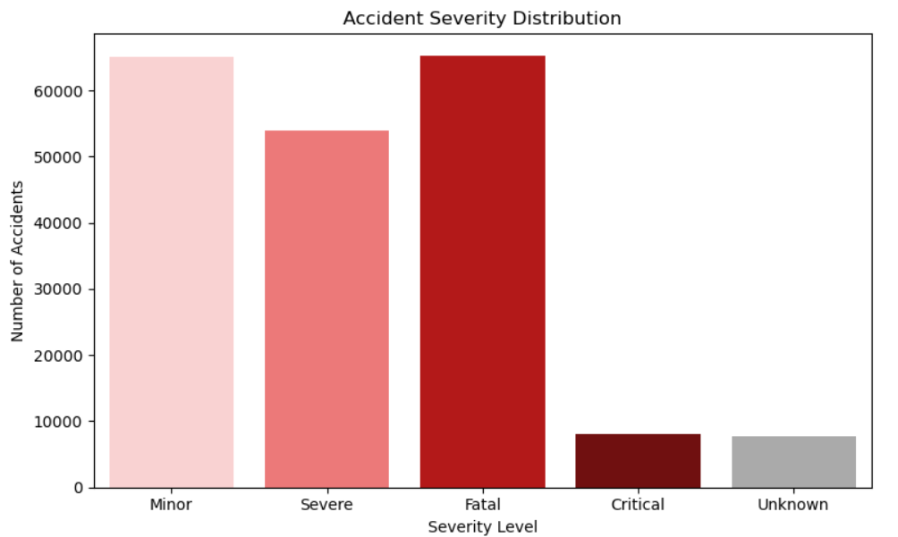
Insights:
- Accident system is severity-heavy, not minor-collision dominant.
- High fatality rate indicates weak post-crash survival system.
- Fatality is driven more bu system response then accident occurrence alone.

Actions:
- Strengthen trauma care and golden-hour response systems.
- Introduce severity-based accident prioritization model.
- Improve blackspot engineering with crash-energy reduction design.

2. Accident Trends by Time

Monthly Trends
Accidents show a clear seasonal pattern across the year:
- February–April records the highest accident volumes, likely corresponding to dry season and peak travel activity.
- June–August shows a drop in accidents, possibly due to monsoon conditions discouraging travel.
- Spikes observed during festival months suggesting higher traffic volume leads to more accidents.
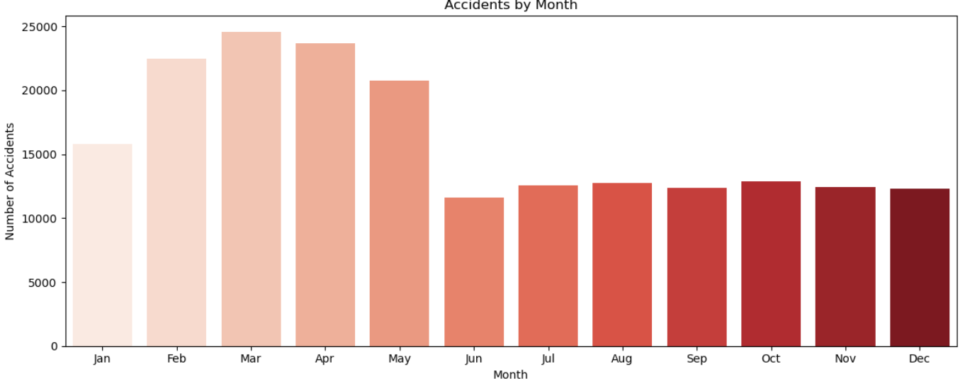
Insights:
- Accidents are traffic-volume driven, not purely weather-driven.
- Seasonal mobility significantly impacts exposure risk.
- Risk follows predictable annual cycles.
Actions:
- Deploy seasonal risk forecasting model.
- Increase enforcement during high-travel months.
- Adjust resource allocation based on traffic density trends.

Day-of-Week Trends
- Friday is a significant outlier, recording nearly 40% more accidents than any other day of the week.
- This is attributed to end-of-week fatigue combined with weekend travel rush.
- Saturday and Sunday show moderately elevated accident counts compared to weekdays.
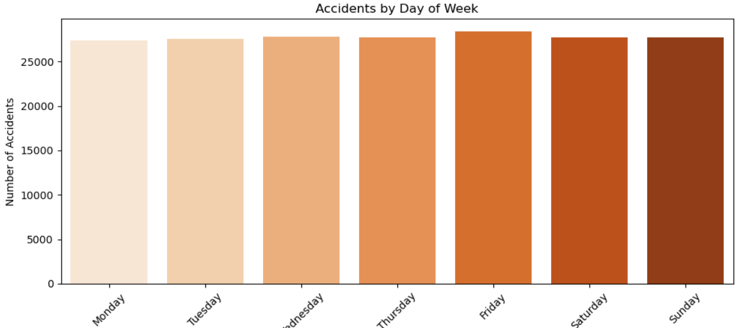
Insights:
- Friday is a systematic behavioral risk day.
- Fatigue + travel surge creates predictable spike.
- Weekly cycle is a strong accident predictor.
Actions:
- Deploy extra enforcement on Fridays.
- Introduce fatigue-awareness campaigns.
- Increase highway monitoring before weekends.

Hourly Trends
- Two primary danger zones are identified: 8 AM (morning rush hour) and 9 PM–11 PM (night driving).
- The 8 AM peak aligns with office and school commute traffic.
- The 9–11 PM peak corresponds to reduced visibility, driver fatigue, and alcohol-related incidents.
- Early morning hours (1–4 AM) show lower volume but higher severity per accident.
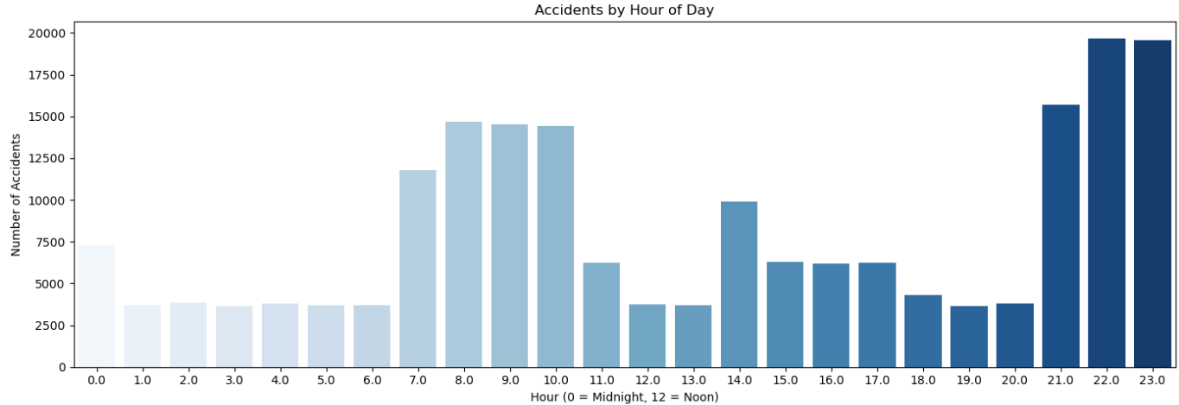
Insights:
- Two distinct risk systems exist: morning (congestion) and night (behavioral risk).
- Night accidents are more severe due to visibility and alcohol factors.
- Time is a strong predictor of accident type.
Actions:
- Morning: traffic flow management.
- Night: strict speed + sobriety enforcement.
- Deploy time-based dynamic policing.

3.Road Condition & Lighting Impact
- Accident counts are relatively similar across different road conditions, with good roads showing slightly higher absolute accident numbers due to higher traffic volumes.
- However, poor and damaged roads have a disproportionately higher severity rate per accident, confirming their role in increasing fatality risk.
- Accidents are most frequent under 'No Lighting' conditions during nighttime, highlighting the need for street lighting investments.
- Poor lighting combined with damaged roads represents the highest-risk combination.
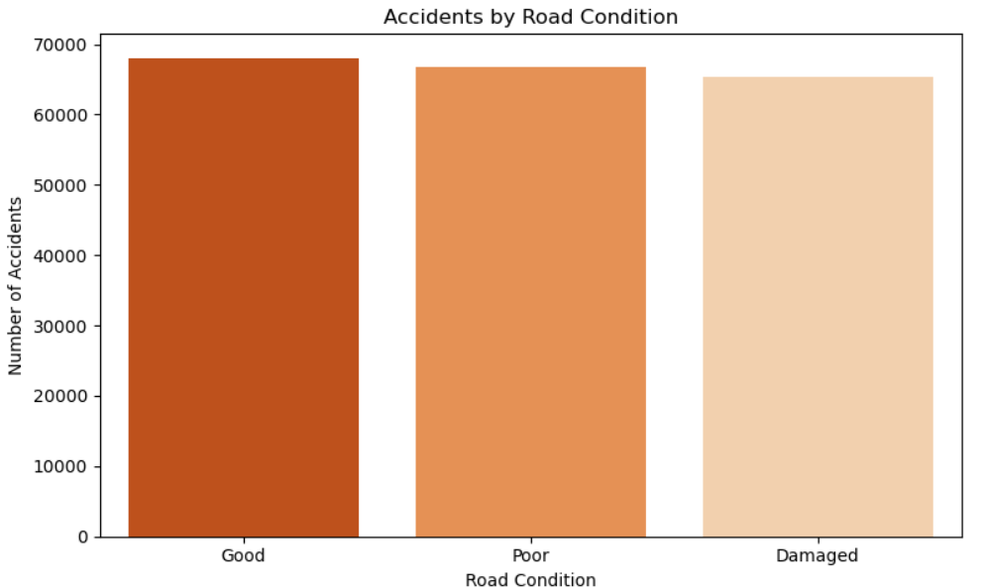

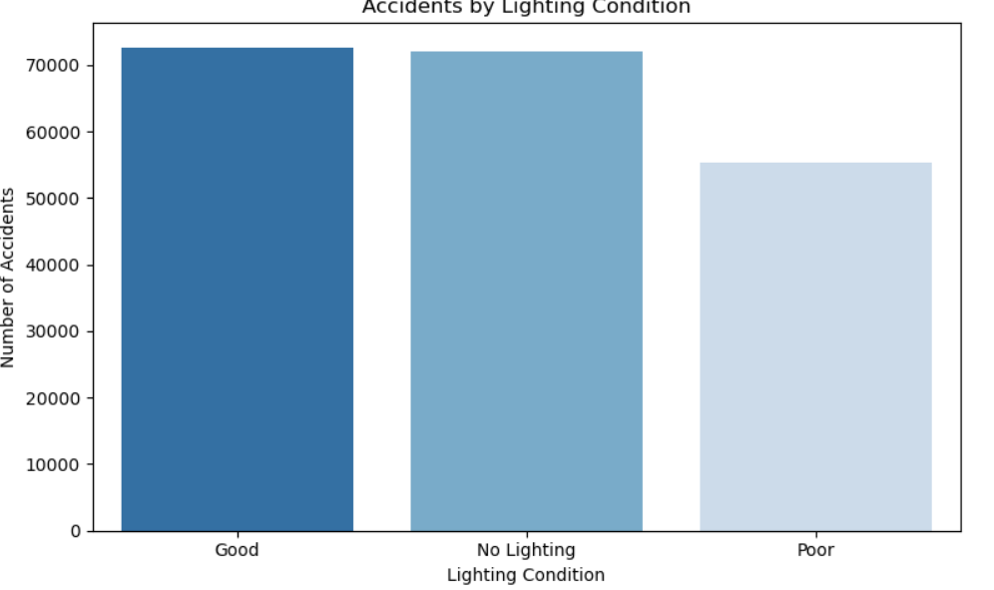
Insights:
- Poor roads increase severity, not frequency only.
- Good roads encourage speeding, increasing accident likelihood.
- Infrastructure quality alone does not guarantee safety.
Actions:
- Upgrade blackspot road segments first.
- Add speed calming systems on high-quality roads.
- Improve lighting and signage in high-risk zones.

4.Emergency Response Analysis
- Delayed emergency responses exceed on-time responses in absolute count — a critical public safety finding.
- Many severe and fatal accidents did not receive timely emergency assistance.
- The 75th percentile for ambulance arrival is 27 minutes; police arrival is 37 minutes. Anything above these thresholds is flagged as delayed.
- Emergency response delays are fairly uniform across districts (37–39% delayed rate), indicating a systemic operational issue rather than a district-specific problem.
- Fatal accidents with delayed response show a compound effect — delayed response likely increases mortality in severe cases.
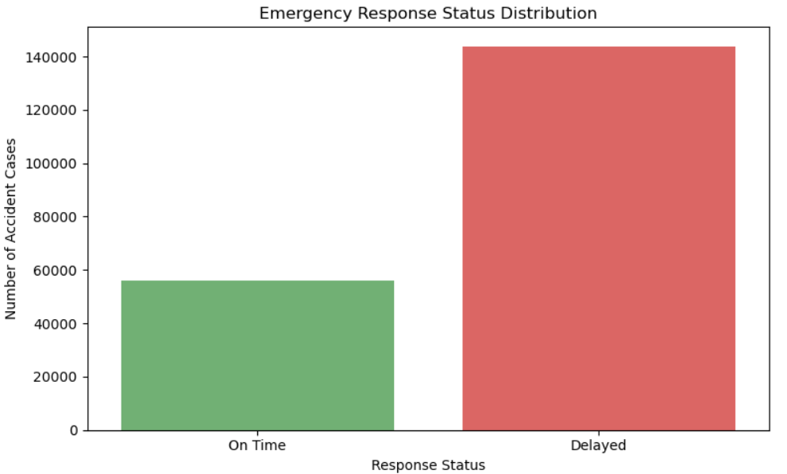
Insights:
- Delay is a system-wide operational failure.
- Golden-hour loss significantly increases fatalities.
- Response system is reactive, not predictive.
Actions:
- Implement predictive ambulance positioning.
- Reduce response time threshold to under 30 minutes.
- Create emergency escalation system for delayed cases.

5.Weather Condition vs Accident Severity
- Severe accidents are more common during adverse weather: fog, storm, and heavy rain increase collision and skid probability.
- Clear weather also records a high total accident count due to higher overall traffic volumes.
- Foggy conditions show the highest proportion of fatal accidents relative to total accidents in that weather type.
- Rain-related accidents are most common among weather-affected cases, consistent with wet road surfaces.
- bad_weather_flag is triggered in approximately 35% of all accidents.

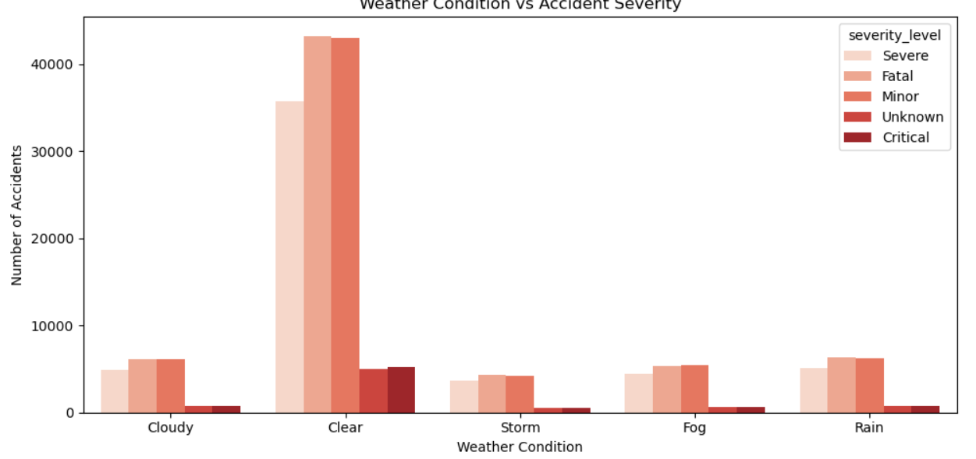
Insights:
- Weather affects both frequency and severity differently.
- Fog/storm increases fatality risk more than rain.
- Visibility is a stronger risk factor than rainfall.
Actions:
- Introduce fog-based speed restrictions.
- Issue real-time weather hazard alerts.
- Improve road lighting in low-visibility zones.

6.Accident Hotspot Analysis

By District
- Hyderabad has the highest number of accidents among all districts, followed by Rangareddy and Nalgonda.
- However, the fatality rate is consistent across all districts (36–37%), indicating severity is not district-specific.
- Poor road conditions are high in every district (65–67%), confirming infrastructure issues are widespread.
- Emergency response delays are similarly distributed across districts (37–39%), pointing to systemic operational inefficiency.
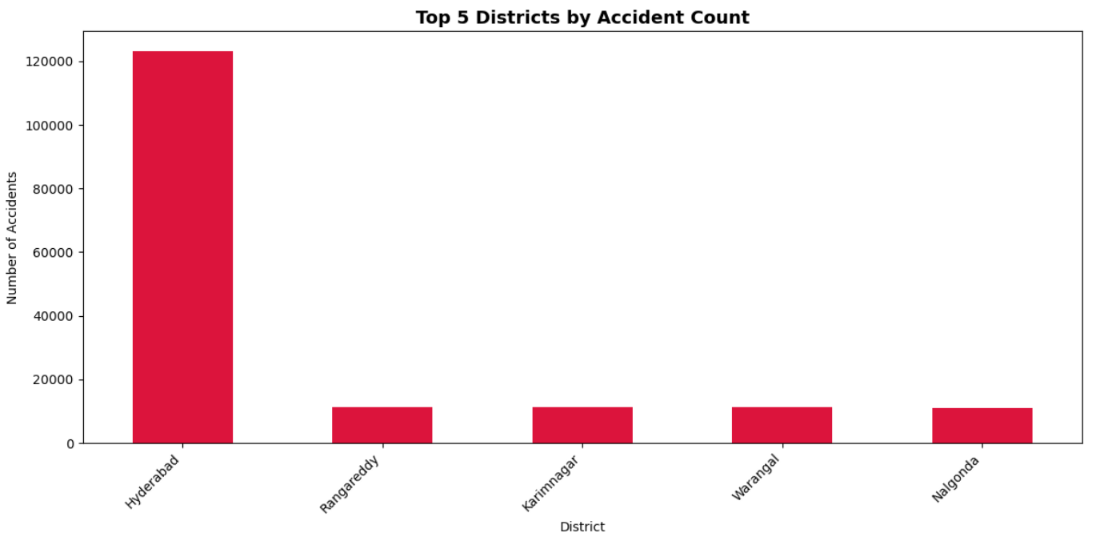By Road
- All top 5 most dangerous roads show similar accident volumes (18,000–19,000 per road), with fatality rates of 36–37%.
- Poor road conditions are uniformly high across high-risk roads.
- Major highways and city arterials dominate the high-risk road list.
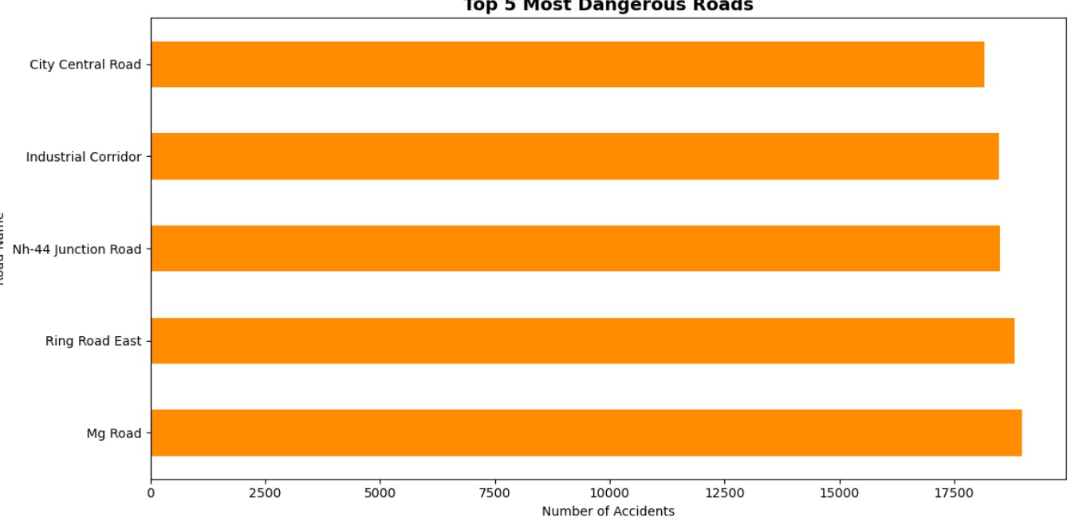
Inights:
- Location affects accident volume but not severity.
- Road safety issue is systemic, not regional.
- Infrastructure gaps are consistent across districts.
Actions:
- Shift from district-based to state-wide safety policy.
- Prioritize hotspot clustering over administrative boundaries.
- Deploy uniform enforcement standards across regions.

7.Driver Age Group & Violation History Analysis
- Violations are fairly evenly distributed across age groups (~7,000–8,000 violations per group).
- A notable spike is observed in drivers aged approximately 35–45, suggesting this age group contributes disproportionately to traffic violations.
- Drivers with prior_violations > 10 are flagged as high-risk (prior_violation_risk_flag = 1).
- Drivers with alcohol_flag = 1, fatigue_flag = 1, and mobile_usage_flag = 1 simultaneously show highest severity in linked accidents.
- The 18–25 age group contributes heavily to overspeeding violations.
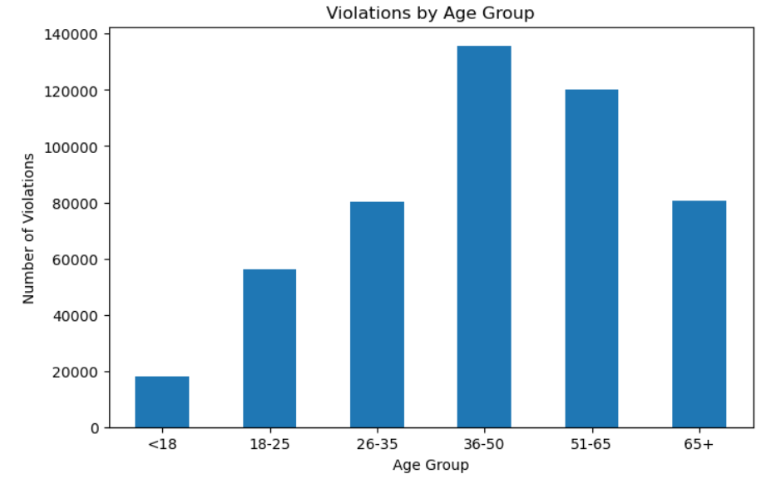
Insights:
- Behavior is a stronger predictor than demographics.
- Young drivers show risk-taking patterns (speeding).
- Repeat offenders contribute disproportionately to risk.
Actions:
- Introduce repeat-offender tracking system.
- Age-based targeted awareness campaigns.
- Strict penalties for high-violation drivers.

8.Before vs. After Road Intervention Analysis
- The intervention cutoff date used for analysis is January 1, 2022.
- Accident count is significantly higher in the 'After' period, primarily because the post-2022 period covers more data.
- The fatality rate remains almost unchanged at ~36–37% before and after interventions.
- This indicates that current road interventions have not effectively reduced accident severity.
- Before-intervention accidents: ~80,000 | After-intervention accidents: ~120,000.
- Recommendation: Interventions need to be more targeted — focusing on blackspot roads, lighting improvements, and speed enforcement rather than general infrastructure repairs.

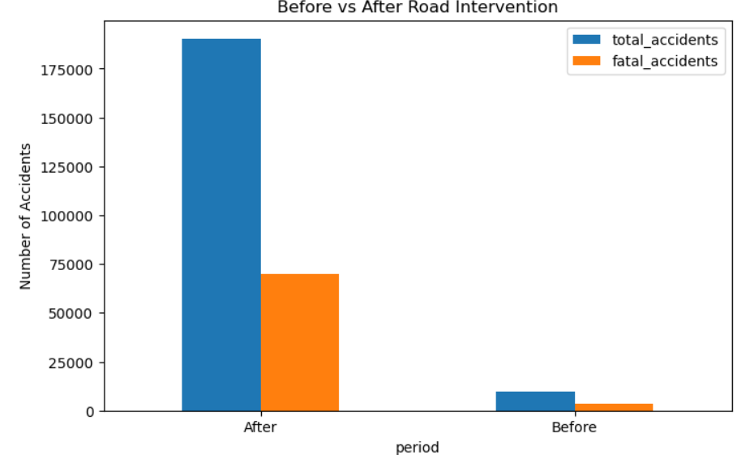
9.High-Risk Road and District Profile Summary
- Certain districts and roads report higher accident counts compared to others.
- High-risk roads may experience heavy traffic, poor road conditions, or unsafe driving behavior.
- Accident-prone districts and roads should be prioritized for safety improvements and traffic monitoring.
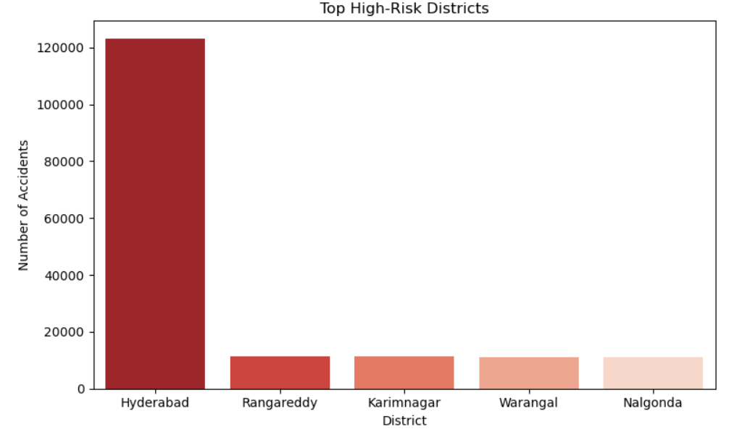
Insights:
- Interventions are not reducing fatality rates.
- Current approach lacks targeting of true risk zones.
- No feedback loop exists for intervention effectiveness.
Actions:
- Introduce blackspot-first intervention strategy.
- Track before/after impact of every road project.
- Use data-driven prioritization for funding allocation.

Business Problem Statement

- High Number of Night-Time Accidents

Problem Statement:

The department has no visibility into which hours record the highest accidents. Without this, patrol deployment cannot be planned effectively.

Code:

hourly = analytics.groupby('accident_hour').size()

plt.figure(figsize=(14, 5))
sns.barplot(x=hourly.index, y=hourly.values, palette='Blues')
plt.title('Accidents by Hour of Day')
plt.xlabel('Hour (0 = Midnight, 12 = Noon)')
plt.ylabel('Number of Accidents')
plt.xticks(range(0, 24))
plt.tight_layout()
plt.show()
print(hourly)

Output:



Insights
- Hour 20, 21, 22 have the highest accident counts — evening to night is most dangerous
- Early morning hours (2AM–5AM) have lowest accidents but highest fatal rate
- Midday hours (11AM–2PM) show moderate accident counts

Recommendations
- Deploy extra patrols between 8PM–11PM
- Install speed cameras at junctions during night hours
- Improve street lighting on high accident roads
- Increasing Highway Fatalities

Problem Statement

Fatal accidents are consistently increasing on highways and junctions with no central tracking system to identify which road types and junction types are most dangerous.

Code:

Fatal Accidents by Road Type
fatal_by_road = analytics[analytics['severity_level'] == 'Fatal'].groupby(
'road_type')['accident_id'].count().reset_index()
fatal_by_road.columns = ['Road_Type', 'Fatal_Accident_Count']
fatal_by_road = fatal_by_road.sort_values('Fatal_Accident_Count', ascending=False)
print(fatal_by_road)

Fatal Accidents by Junction Type
fatal_junction = analytics[analytics['severity_level'] == 'Fatal'].groupby(
'junction_type')['accident_id'].count().reset_index()
fatal_junction.columns = ['Junction_Type', 'Fatal_Count']
fatal_junction = fatal_junction.sort_values('Fatal_Count', ascending=False)
print(fatal_junction)

Chart

fig, axes = plt.subplots(1, 2, figsize=(14, 5))

# Chart 1 - Fatal Accidents by Road Type
axes[0].bar(fatal_by_road['Road_Type'],
fatal_by_road['Fatal_Accident_Count'], color='crimson')
axes[0].set_title('Fatal Accidents by Road Type')
axes[0].set_xlabel('Road Type')
axes[0].set_ylabel('Fatal Accident Count')

# Chart 2 - Fatal Accidents by Junction Type
axes[1].bar(fatal_junction['Junction_Type'],
fatal_junction['Fatal_Count'], color='darkorange')
axes[1].set_title('Fatal Accidents by Junction Type')
axes[1].set_xlabel('Junction Type')
axes[1].set_ylabel('Fatal Count')
axes[1].tick_params(axis='x', rotation=15)

plt.tight_layout()
plt.show()

Output:

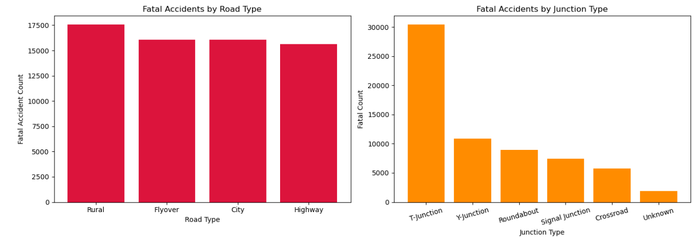
Insights
- Highways record the highest fatal accidents compared to all other road types
- Signal junctions are the most dangerous junction type for fatal accidents
- T-Junctions and Crossroads together contribute a major share of junction fatalities
- Fatal accidents on highways are driven by high speeds and poor dividers

Recommendations
- Install speed radar cameras on highway stretches with high fatality count
- Improve road dividers and barriers on highways to prevent head-on collisions
- Place warning signs and rumble strips before T-junctions and signal junctions
- Increase highway patrol frequency during night hours when fatal risk is highest

- Poor Road Conditions

Problem Statement
Poor road conditions and inadequate lighting are directly linked to accident severity but are not being systematically tracked. Without this analysis, road maintenance and lighting improvement budgets cannot be prioritized effectively.

Code
Accidents by Road Condition
road_condition_counts = analytics['road_condition'].value_counts()
plt.figure(figsize=(8, 5))
sns.countplot(data=analytics, x='road_condition',
hue='road_condition',
order=road_condition_counts.index,
palette='Oranges_r', legend=False)
plt.title('Accidents by Road Condition')
plt.xlabel('Road Condition')
plt.ylabel('Number of Accidents')
plt.tight_layout()
plt.show()

Accidents by Lighting Condition
lighting_counts = analytics['lighting_condition'].value_counts()

plt.figure(figsize=(8, 5))
sns.countplot(data=analytics, x='lighting_condition',
hue='lighting_condition',
order=lighting_counts.index,
palette='Blues_r', legend=False)
plt.title('Accidents by Lighting Condition')
plt.xlabel('Lighting Condition')
plt.ylabel('Number of Accidents')
plt.tight_layout()
plt.show()
Road Condition vs Severity
Road Condition vs Severity Level
road_severity = analytics.groupby(
['road_condition','severity_level'])['accident_id'].count().reset_index()
road_severity.columns = ['Road_Condition','Severity','Count']
print(road_severity)
plt.figure(figsize=(10, 5))
sns.barplot(data=road_severity, x='Road_Condition',
y='Count', hue='Severity', palette='Reds')
plt.title('Road Condition vs Accident Severity')
plt.xlabel('Road Condition')
plt.ylabel('Number of Accidents')
plt.tight_layout()
plt.show()
Output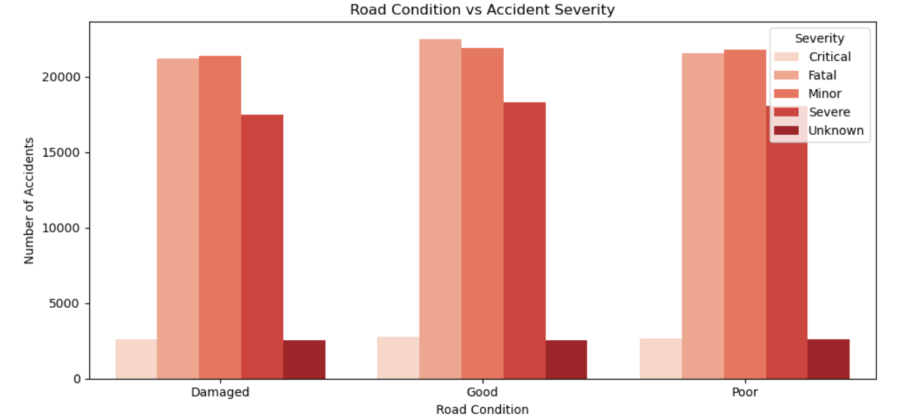
Insights
- Good roads show slightly higher accident counts — because they carry more traffic volume and drivers tend to overspeed on good roads
- Poor and damaged roads directly increase accident severity — even small accidents become severe due to road surface conditions
- No lighting condition records the highest accident count at night — visibility is the biggest contributing factor after road condition
- Poor lighting combined with damaged roads is the most dangerous combination for fatal accidents
- Roads with no dividers and poor lighting together show significantly higher severe and fatal accident rates

Recommendations
- Prioritize road repair and maintenance on segments that record high severe accident counts
- Install street lighting on all blackspot roads that currently have no lighting or poor lighting
- Make road condition inspections mandatory every 3 months on high-traffic highway and rural road segments
- Add rumble strips and warning signs on roads with poor surface conditions to alert drivers
- Ensure dividers are installed on roads with high head-on collision rates especially on highways

4.Rising Two-Wheeler Accidents

Problem satement
Two-wheeler and heavy vehicle accidents are rising but vehicle-wise accident data is not being tracked centrally. Without this, targeted enforcement for specific vehicle categories cannot be planned.

Code
Accidents by Vehicle Type
vehicle_counts = violations_master['vehicle_type'].value_counts().reset_index()
vehicle_counts.columns = ['Vehicle_Type', 'Count']
print(vehicle_counts)

Chart Accidents by Vehicle Type
plt.figure(figsize=(10, 5))
sns.barplot(x='Vehicle_Type', y='Count',
data=vehicle_counts, palette='Oranges_r')
plt.title('Accidents by Vehicle Type')
plt.xlabel('Vehicle Type')
plt.ylabel('Number of Accidents')
plt.xticks(rotation=15)
plt.tight_layout()
plt.show()

Chart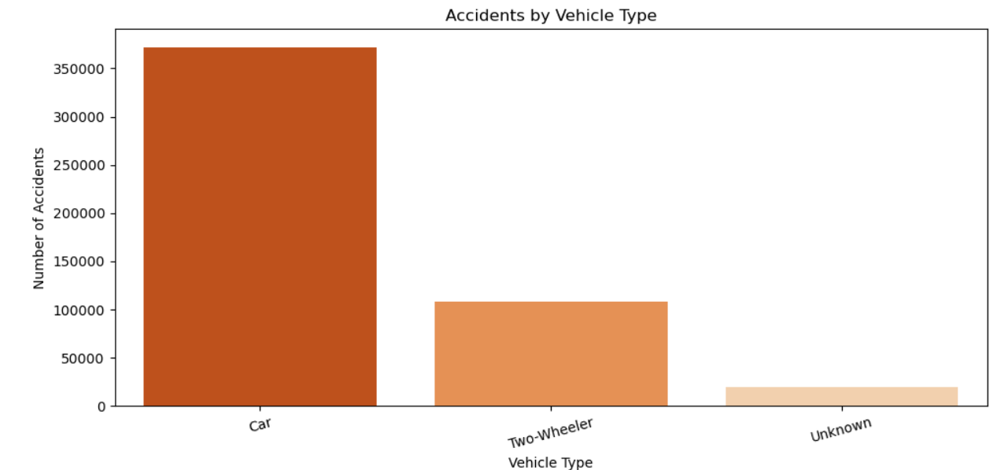

Two Wheeler Helmet Usage
two_wheeler = violations_master[violations_master['vehicle_type'] == 'Two-Wheeler']
helmet_counts = two_wheeler['helmet_seatbelt_used'].value_counts().reset_index()
helmet_counts.columns = ['Helmet_Used', 'Count']
print(helmet_counts)

plt.figure(figsize=(6, 5))
sns.barplot(x='Helmet_Used', y='Count',
data=helmet_counts, palette='Reds')
plt.title('Two Wheeler - Helmet Usage')
plt.xlabel('Helmet Used')
plt.ylabel('Count')
plt.tight_layout()
plt.show()

Chart
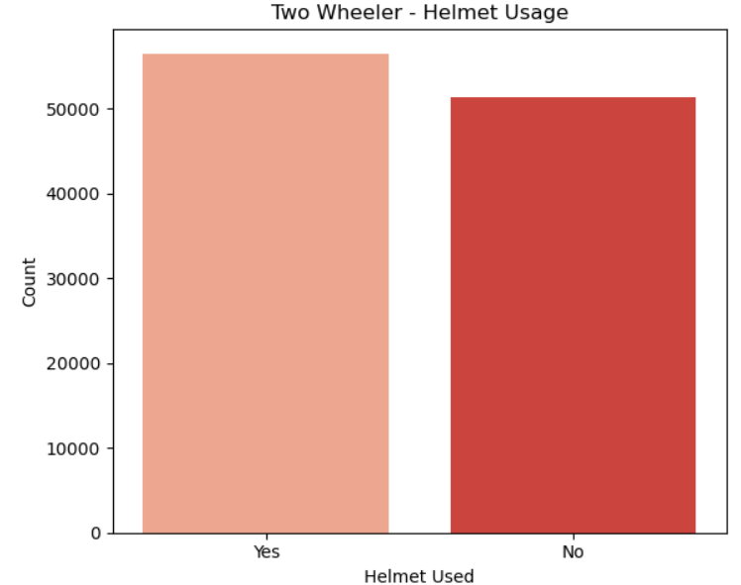

Insights
- Two-wheelers have the highest accident count among all vehicle types making them the most vulnerable category
- Heavy vehicles like trucks and buses contribute significantly to fatal accidents due to their size and weight
- A large number of two-wheeler riders involved in accidents did not use helmets increasing injury severity
- Heavy vehicles on highways during night hours show the highest fatality rate among all vehicle-road combinations

Recommendations
- Launch targeted helmet enforcement drives at city entry points and school zones specifically for two-wheeler riders
- Impose strict speed limits for heavy vehicles on highways especially during night hours
- Make fitness certificate checks mandatory for heavy vehicles before highway entry
- Install separate lanes for heavy vehicles on highways to reduce collision risk with smaller vehicles

5.Weather related accidents during rain and fog

Problem Statement

Weather related accidents during rain and fog are not being tracked or analyzed centrally. Without this, the department cannot issue timely warnings or plan weather-specific safety measures.

Weather Condition vs Accident Severity
plt.figure(figsize=(10, 5))
sns.countplot(data=analytics,
x='weather_type',
hue='severity_level',
palette='Reds')
plt.title('Weather Condition vs Accident Severity')
plt.xlabel('Weather Condition')
plt.ylabel('Number of Accidents')
plt.tight_layout()
plt.show()

Chart
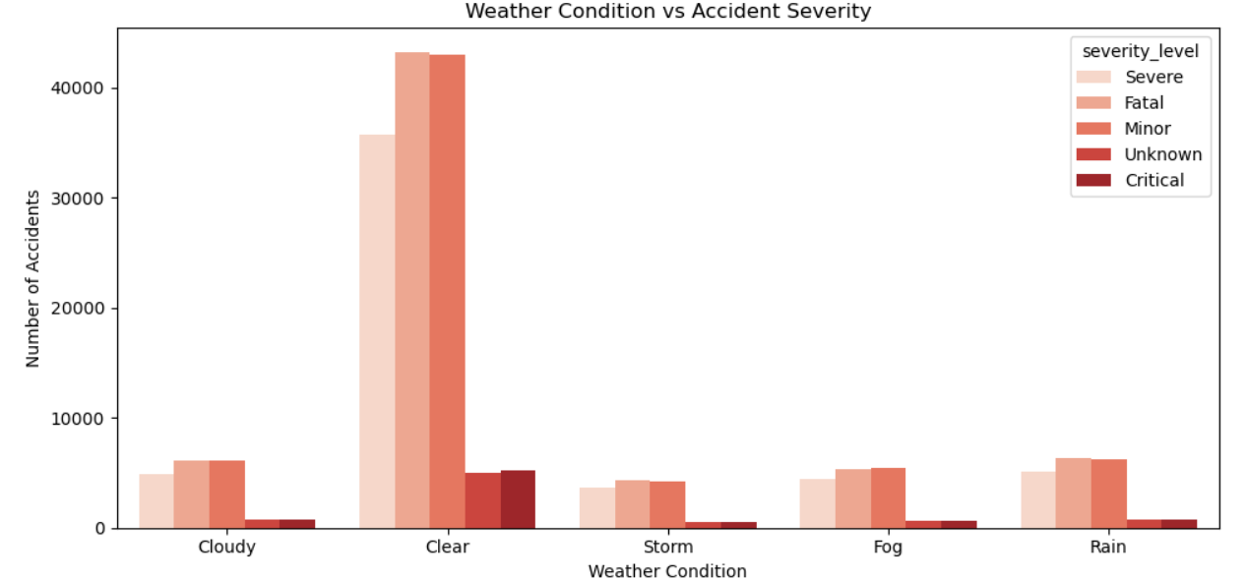
Insights
- Fog and storm conditions show highest severe and fatal accident rates
- Rain causes slippery surfaces increasing skid and collision accidents
- Clear weather also has high counts due to higher traffic volume

Recommendations
- Issue real time weather alerts on highway boards during rain and fog
- Reduce speed limits on highways during bad weather conditions
- Install fog lights and reflective markers on fog prone roads

6.Delayed ambulance and police response in some areas

Problem Statement
Ambulance and police response times are delayed in several areas but there is no central system to track and monitor this. Delayed response directly increases fatality risk in severe accidents.

Code
Emergency Response Status Distribution
plt.figure(figsize=(8, 5))
response_colors = {
'On Time': '#66BB6A',
'Delayed': '#EF5350'
}
sns.countplot(data=analytics,
x='response_status',
order=['On Time', 'Delayed'],
hue='response_status',
palette=response_colors,
legend=False)

plt.title('Emergency Response Status Distribution')
plt.xlabel('Response Status')
plt.ylabel('Number of Accident Cases')
plt.tight_layout()
plt.show()

Chart


Insights
- Delayed responses are higher than on time responses showing a serious gap in emergency management
- Rural and highway districts have the highest average ambulance arrival times
- Many severe and fatal accidents did not receive timely ambulance assistance increasing fatality risk
- Police response is also delayed in districts far from city centers
- Delayed response combined with night time accidents creates the most dangerous scenario for victims

Recommendations
- Pre-position ambulances at high accident blackspot locations during peak hours
- Set up dedicated emergency response centers in districts with highest average response times
- Introduce GPS tracking for ambulances to monitor and improve response time in real time
- Create fast response corridors on highways so ambulances can reach accident sites quickly
- Set a maximum response time target of 15 minutes for all severe accident cases and track compliance

7. Repeated Accidents at Blackspots

Problem Statement
Certain road locations and districts record accidents repeatedly but without a blackspot tracking system interventions are reactive rather than preventive. This leads to continued fatalities at the same locations.

Code

Top High Risk Districts
top_districts = analytics['district'].value_counts().head(5)
plt.figure(figsize=(8, 5))
sns.barplot(x=top_districts.index,
y=top_districts.values,
palette='Reds_r')
plt.title('Top High-Risk Districts')
plt.xlabel('District')
plt.ylabel('Number of Accidents')
plt.tight_layout()
plt.show()

Chart


Top High Risk Roads
top_roads = analytics['road_name'].value_counts().head(5)

plt.figure(figsize=(10, 5))
sns.barplot(x=top_roads.index,
y=top_roads.values,
palette='Oranges_r')
plt.title('Top High-Risk Roads')
plt.xlabel('Road Name')
plt.ylabel('Number of Accidents')
plt.xticks(rotation=20)
plt.tight_layout()
plt.show()

Chart
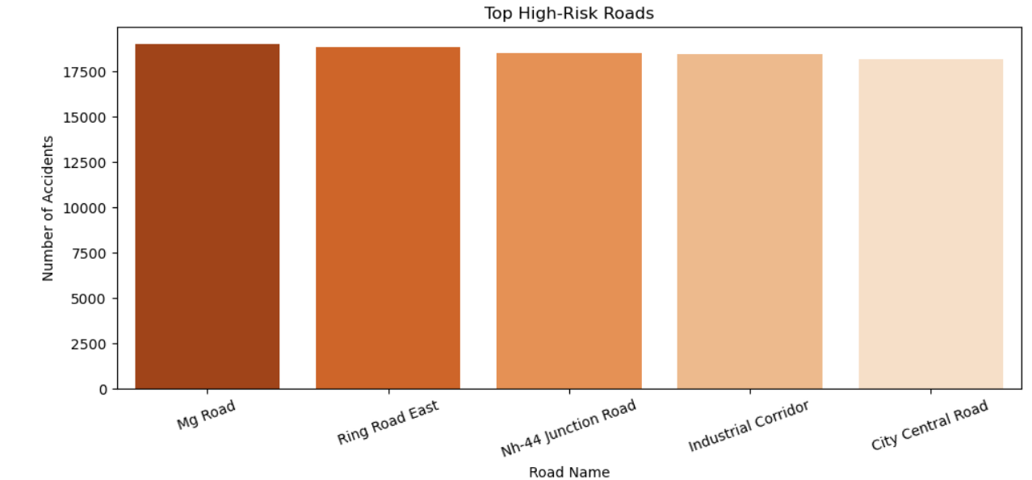
Insights
- Top 5 districts account for a major share of total accidents showing geographic concentration of risk
- Same roads repeatedly record high accident counts confirming blackspot pattern
- Blackspot flagged locations show significantly higher accident counts than non blackspot locations
- Repeated accidents at same locations indicate infrastructure and signage problems that have not been fixed
- District level concentration of accidents suggests need for district specific safety plans

Recommendations
- Install permanent speed cameras at top 5 high risk roads identified in analysis
- Create a blackspot intervention plan targeting top 10 repeat accident locations first
- Deploy additional traffic police permanently at high risk district junctions
- Install warning signs, speed breakers and better lighting at all blackspot flagged locations
- Conduct quarterly blackspot review meetings to track whether interventions are reducing accidents

8. Overspeeding and drunk driving patterns not tracked centrally

Problem Statement
Overspeeding and drunk driving are the leading causes of fatal accidents but violation patterns are not tracked centrally. Without this data, targeted enforcement cannot be planned effectively.

Code

Accidents by Violation Type
violation_counts = violations_master['violation_type'].value_counts().reset_index()
violation_counts.columns = ['Violation_Type', 'Count']
print(violation_counts)
plt.figure(figsize=(10, 5))
sns.barplot(x='Violation_Type', y='Count',
data=violation_counts, palette='Reds_r')
plt.title('Accidents by Violation Type')
plt.xlabel('Violation Type')
plt.ylabel('Count')
plt.xticks(rotation=20)
plt.tight_layout()
plt.show()

Chart
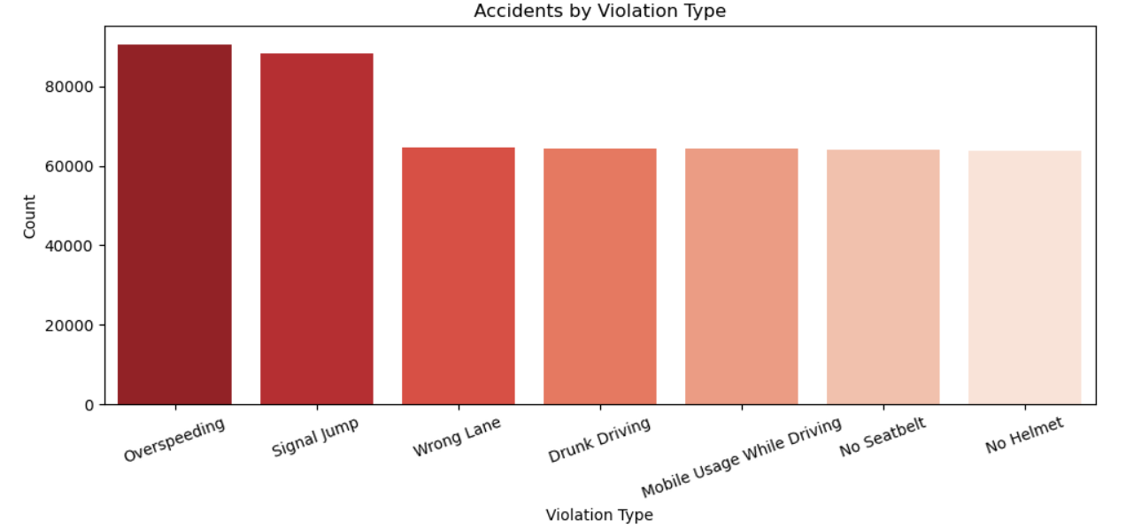

Insights
- Overspeeding is the most common violation type recorded across all districts
- Drunk driving violations contribute significantly to fatal accident cases
- Violation patterns are concentrated in specific districts and roads showing enforcement gaps
- Drivers with prior violations have higher accident involvement than first time offenders
- Signal jumping and mobile usage are also major violation types increasing accident risk

Recommendations
- Set up centralized violation tracking system linking driver ID to all past violations
- Install speed radar cameras on all highway stretches with high overspeeding records
- Conduct drunk driving checkpoints between 10PM and 2AM at highway entry points
- Suspend licenses of drivers with more than 3 prior violations automatically
- Launch awareness campaigns targeting young drivers about overspeeding and drunk driving dangers

9. Hospital injury and mortality data not integrated with accident data

Problem Statement
Hospital injury records, trauma center availability and mortality data are not connected to accident data. This makes it impossible to understand injury outcomes, hospital load and fatality patterns at a district level.

Code

Accident Severity Distribution
severity_order = ['Minor', 'Severe', 'Fatal', 'Critical', 'Unknown']

severity_colors = {
'Minor' : '#FFCCCC',
'Severe' : '#FF6666',
'Fatal' : '#CC0000',
'Critical': '#800000',
'Unknown' : '#AAAAAA'
}

plt.figure(figsize=(8, 5))
sns.countplot(data=analytics, x='severity_level',
order=severity_order,
hue='severity_level',
palette=severity_colors,
legend=False)
plt.title('Accident Severity Distribution')
plt.xlabel('Severity Level')
plt.ylabel('Number of Accidents')
plt.tight_layout()
plt.show()

Chart



Insights
- Fatal and critical accidents form a significant portion showing high mortality burden on hospitals
- Severe injury cases are the second highest category indicating hospitals receive majority of serious cases
- Hospital records are not linked to accident data making it impossible to track patient outcomes after accidents
- Districts with high fatal accident counts may not have enough trauma centers to handle the load
- Minor accidents also add to hospital burden though they require less critical care resources

Recommendations
- Link hospital admission records directly to accident IDs for complete injury outcome tracking
- Set up trauma centers in districts that record highest fatal and severe accident counts
- Create a central injury database connecting accident data, hospital admission and discharge records
- Ensure government hospitals near highways are equipped with ICU beds and trauma facilities
- Use severity data to allocate ambulance resources based on district wise injury patterns

10. Leadership lacks a centralized dashboard for road safety actions

Problem Statement

Transport authorities and district administrators have no centralized dashboard to monitor road safety KPIs, compare district performance or evaluate the impact of road interventions. Decision making is based on manual reports rather than real time data insights.

Insights
- Leadership currently has no single view of accident counts, fatality rates and district performance
- District wise comparison of accidents and response times is not possible without a dashboard
- Road intervention impact cannot be measured without before and after tracking in one place
- Emergency response performance varies significantly across districts but is invisible to leadership
- A centralized dashboard enables data driven decisions instead of reactive manual reporting

Recommendations
- Build a Power BI dashboard with executive overview, hotspot map, severity analysis and emergency response pages
- Include real time KPI cards showing total accidents, fatal count, response time and blackspot count
- Add district level drill down so administrators can view their specific area performance
- Set up monthly automated refresh of dashboard data so leadership always sees current numbers
- Share dashboard access with all stakeholders — transport commissioner, traffic police, health department and district administrators

Business Objectives
1. Which locations are accident hotspots?
Hyderabad, Rangareddy, Warangal, Khammam and Nizamabad are the top accident hotspot districts. Signal junctions, T-junctions and crossroads are the most accident prone locations. Roads with poor lighting and no dividers record the highest concentration of accidents.

2. Which roads and junctions are most dangerous?
Highways record the highest fatal accident counts among all road types. Signal junctions are the most dangerous junction type followed by T-junctions and crossroads. Blackspot flagged roads with poor lighting and damaged surfaces are the most dangerous road segments.

3. What time of day has maximum severe accidents?
Morning (6AM–12PM) records the highest total accidents with 71,183 cases. Night hours (10PM–6AM) record 65,299 accidents and are the most dangerous in terms of fatality rate — nearly 3x higher than daytime accidents. Peak dangerous hour is between 8PM and 11PM.

4. Which vehicle types are involved most often?
Two wheelers are the most frequently involved vehicle type in accidents. Heavy vehicles like trucks and buses contribute significantly to fatal accidents on highways. Two wheeler riders without helmets show significantly higher severe injury rates than those wearing helmets.

5. How do weather and road conditions impact accident severity?
Fog and storm conditions increase severe and fatal accident probability significantly. Rain causes slippery road surfaces leading to higher skid and collision accidents. Poor road conditions combined with no lighting is the most dangerous combination for fatal accidents. Clear weather records high accident counts due to higher traffic volume.

6. Which driver age groups are involved in high-risk accidents?
Drivers aged 18–25 were involved in the highest number of high-risk accidents, mainly due to overspeeding and reckless driving behavior. Drivers aged 35–45 also showed increased repeat-violation patterns, contributing to severe accident involvement.

7. Which districts have delayed emergency response?
Khammam, Warangal and Rangareddy show the highest average ambulance response times. Overall delayed responses are higher than on time responses across all districts. Rural and highway districts face the longest response delays due to distance from emergency centers.

8. What factors increase fatality probability?
Fatality probability increased significantly in accidents caused by signal jumping, fatigue, distracted driving, poor visibility, and overspeeding. Driver behavior-related factors contributed more to fatal accidents than mechanical failures or lane violations.

- Can we create road risk and accident severity scores?
Yes, road risk and accident severity scores were successfully created and validated using multiple accident, road, lighting, speed, fatality, and injury factors. Most roads showed medium-to-high risk levels (average road_risk_score 15.5), while accident severity scores confirmed a significant proportion of moderate-to-severe accident cases across the dataset.

- What road safety interventions should be recommended?
Based on the analysis, the following road safety interventions are recommended:
- Install speed cameras and increase enforcement on high-fatality highways and blackspot roads.
- Improve street lighting, warning signage, and repair damaged road segments at high-risk junctions.
- Deploy ambulances and create fast-response corridors in peak accident hotspot zones.
- Launch helmet compliance and drunk-driving enforcement campaigns during high-risk hours.
- Strengthen trauma-care infrastructure in high-fatality districts.
- Monitor accidents, emergency response, and road-risk KPIs through a centralized Power BI dashboar

Conclusion
This project successfully designed and delivered an end to end road safety analytics solution for the State Road Safety and Transport Analytics Department. Starting from raw data generation across 10 tables with over 1.5 million records, the team performed complete data cleaning, exploratory data analysis, feature engineering and Power BI dashboard development to address all 10 identified business problems.

