  Report Name = ANITHA_FA_HEALTHCARE
  Execution Time = 10/6/2022 4:46:00 PM
  User Name = CORPINDIA\EI13115
CASTE NAME | PID | CASTE NAME | SURGERY | DISTRICT NAME | CLAIM AMOUNT | HOSP NAME
BC |  |  |  |  | Sum:14495656
Minorities |  |  |  |  | Sum:3242224
OC |  |  |  |  | Sum:19355644
Others |  |  |  |  | Sum:12500
SC |  |  |  |  | Sum:9004296
ST |  |  |  |  | Sum:1847998

 | 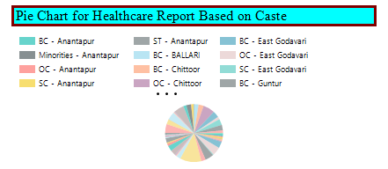
 | 