  Dashboard For Cinema Ticket Details Based On Film Type with respect to Flim code
Below Dashboard is to explain about the Cinema Ticket Details Report
Analysis - It is done based on the Film-type and No of tickets sold per day

 | 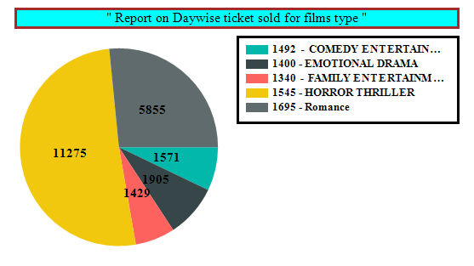 |  |  | 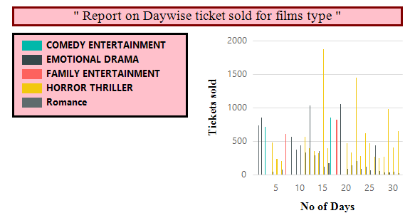
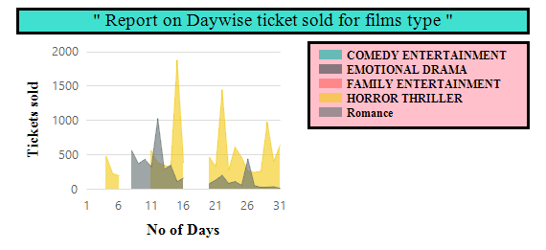 |  |  |  | 