**Inventory Web App user documentation**

* First Page of the Application is Login page, Login inventory web app by entering UserId and Password(UserID=THINK_01,Password=123).



* After Enter user id and password click on **login** button, it will be redirected to home page as shown below

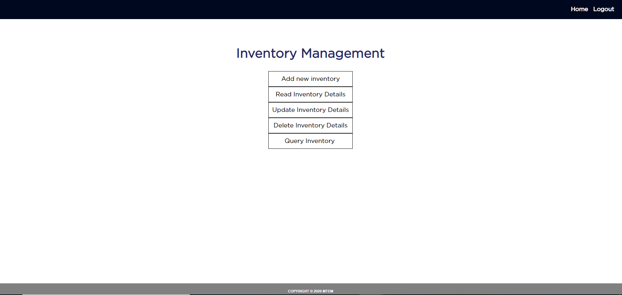

* Home page contain different option to Add new inventory click on **Add New Inventory button** the new unique code is generated automatically

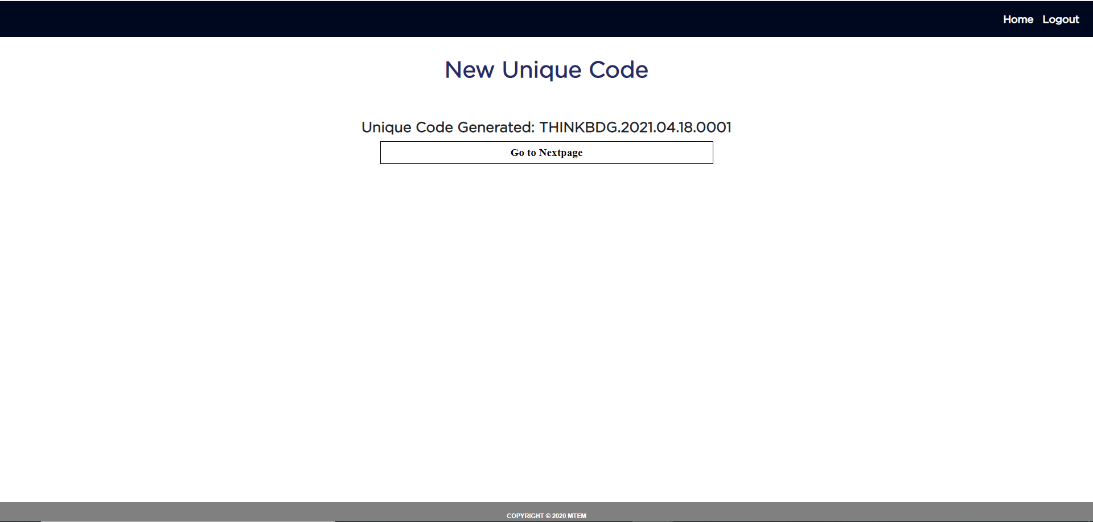

* Next click on **Go To Next Page** button it will be redirected to Inventory form to add details of the inventory

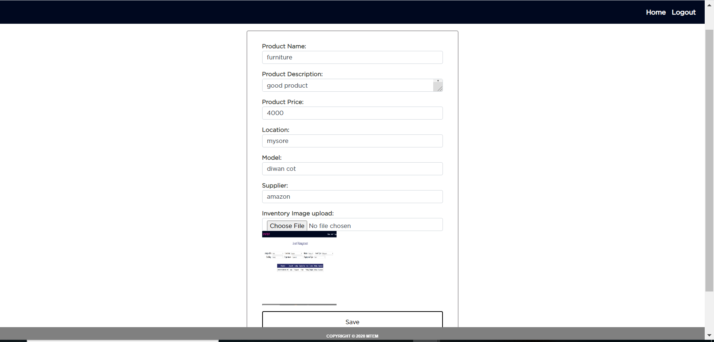

* After entering the inventory details click on **Save** button, on successful adding inventory details it will display the message as shown below

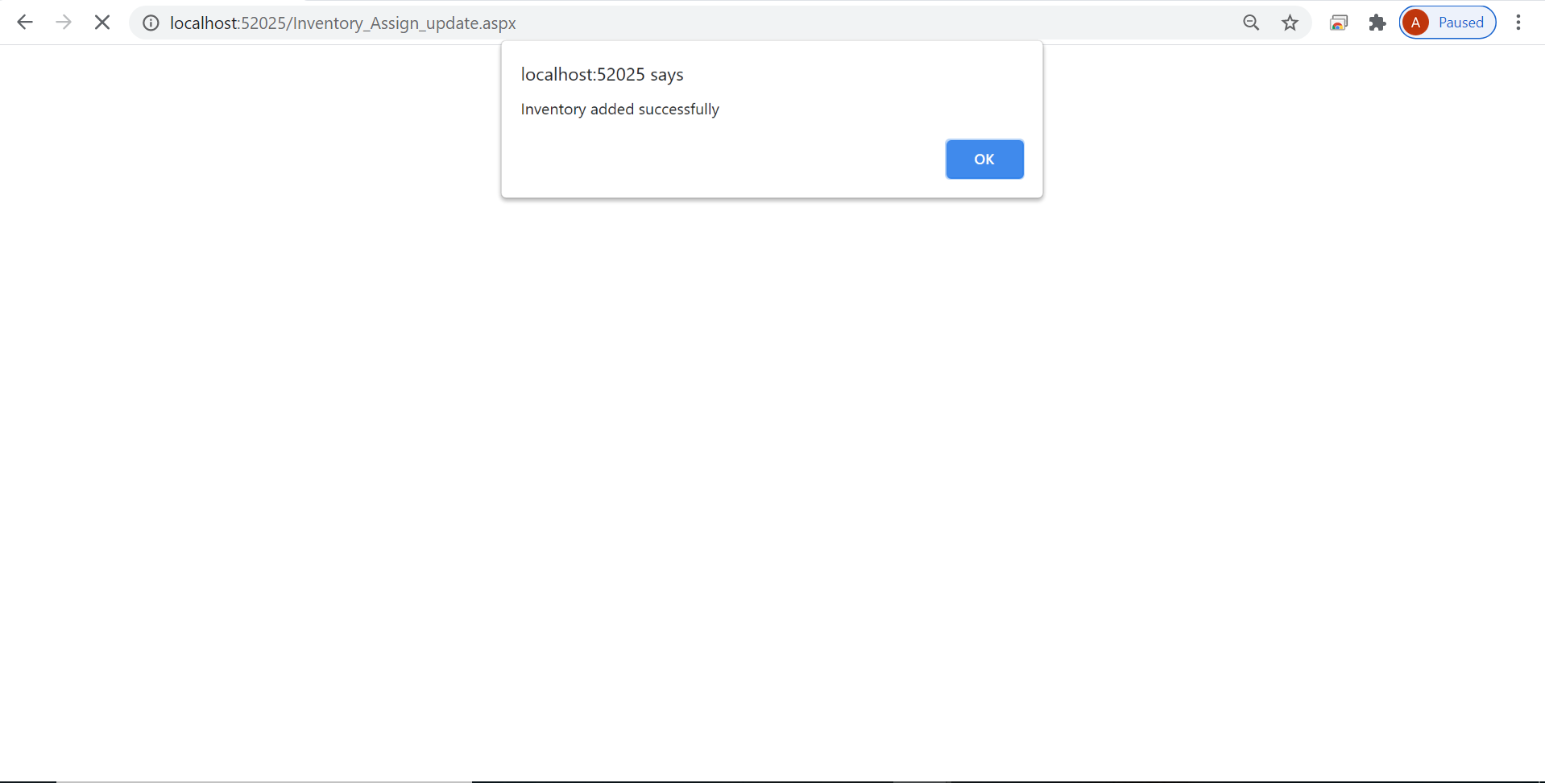

* Next click on **OK** it will be redirected to home page, Next if we want to read the detail of particular inventory click on **Read Inventory** button in Home page it will be redirected to Scan inventory page where it will ask you to enter unique code of Inventory

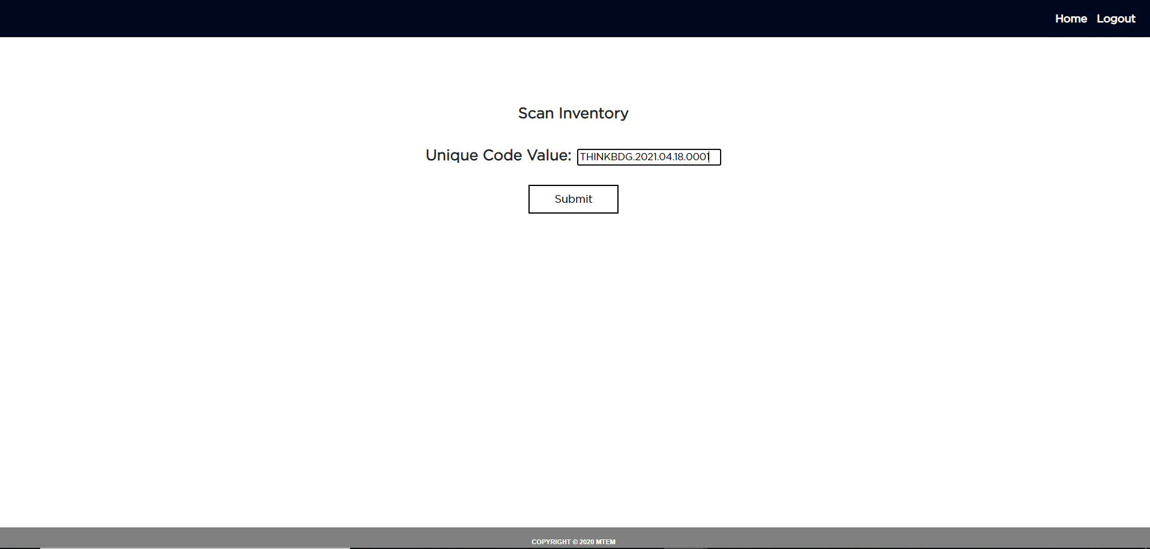

* Enter the unique code and click on **submit** button it will display the details of the inventory

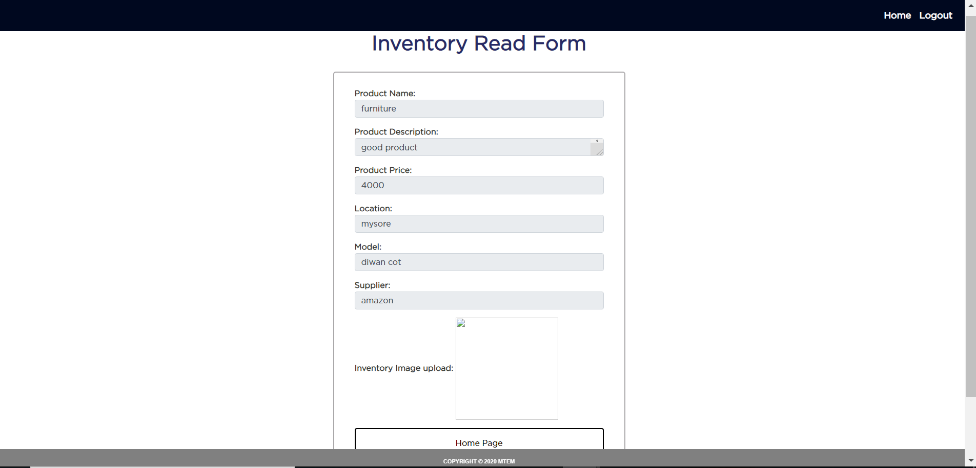

* In the same way if we want to update or remove the inventory enter the unique code it will redirected to update or remove form where we can update or remove the inventory as shown in below figures

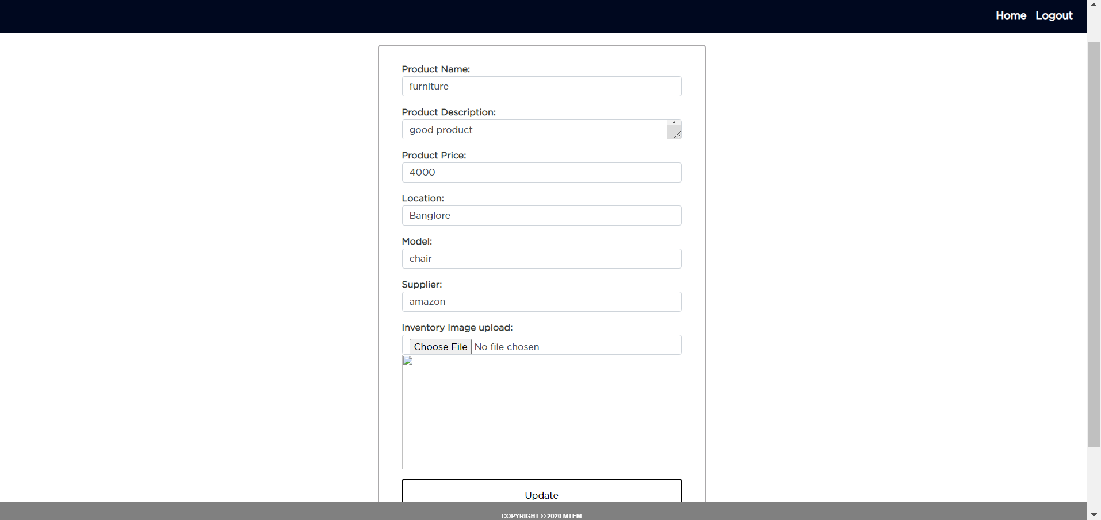

* Here I updated location (mysore to banglore) and model (diwan cot to chair) after that click on update button it will display updated successfully message

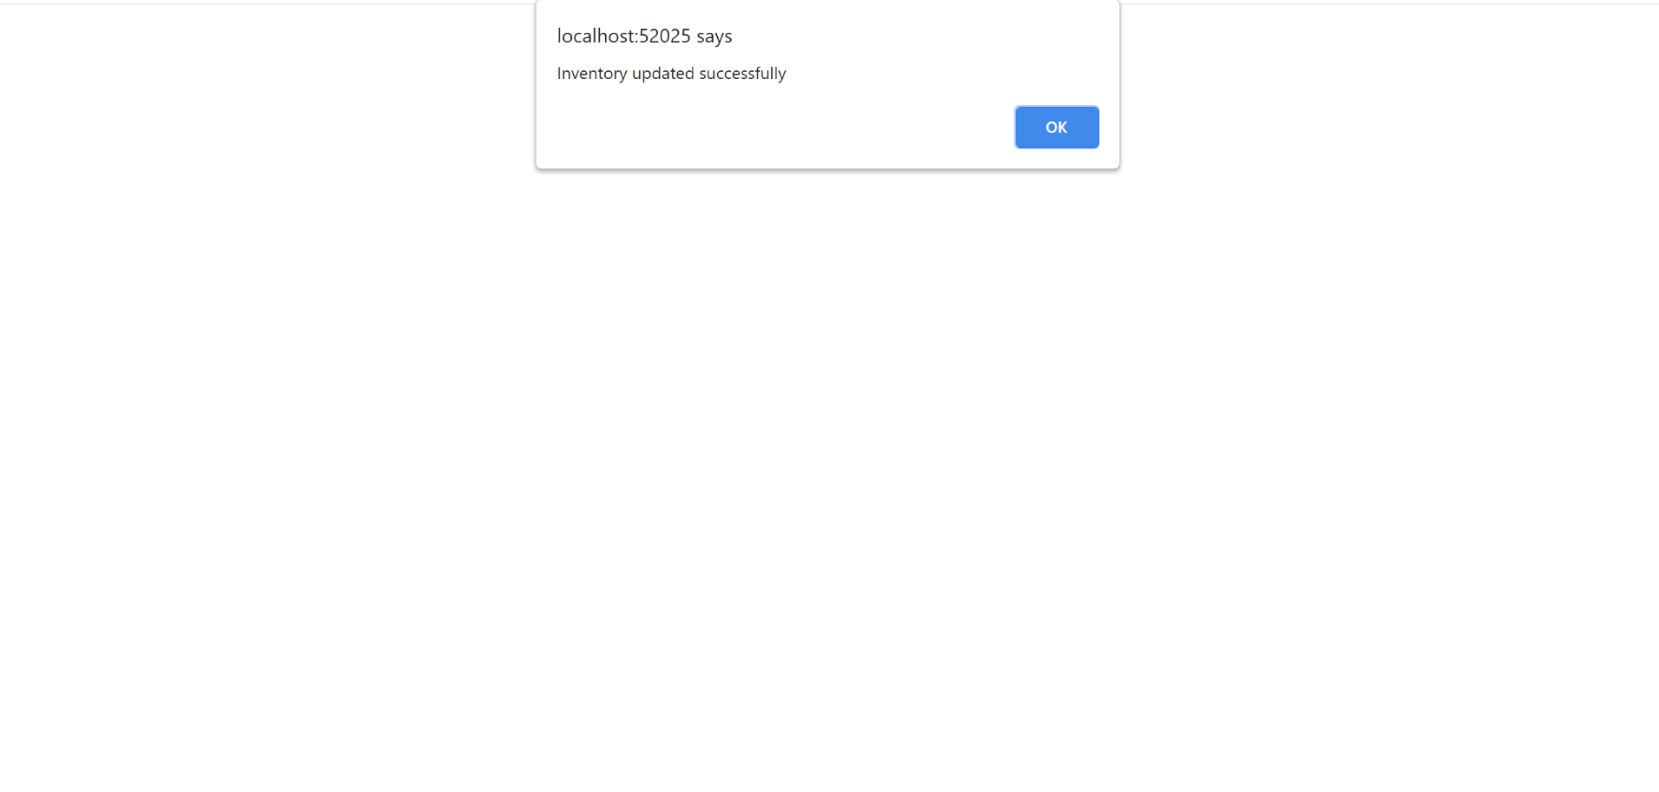

* Next if we want to remove particular inventory enter its unique code in scan inventory page it will redirected to remove form where we click delete button it will remove inventory and display remove successfully message after click on OK it will be redirected to Home Page
* Next if we try to read the removed inventory it will display not exist meassage as shown below

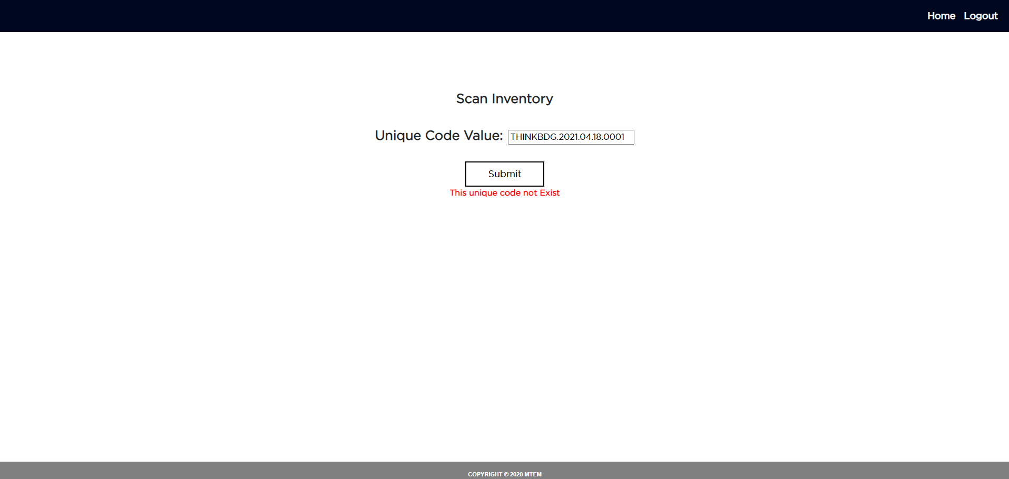

* Last option of home page query inventory ,if we click on this button it will be redirected to query page where we need to enter from-date to To- date it will display the list of existing inventory between these two Dates

