Django steps

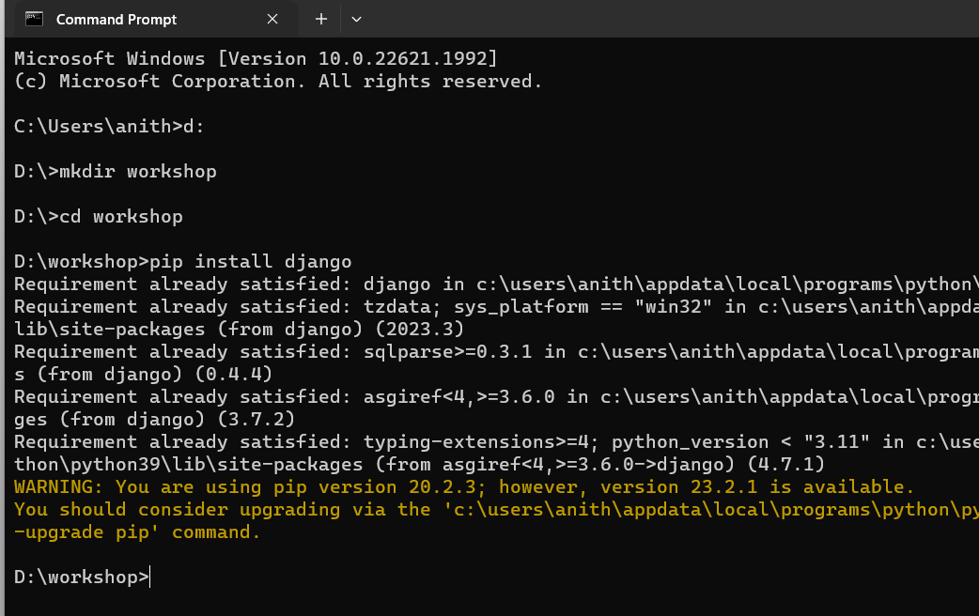

w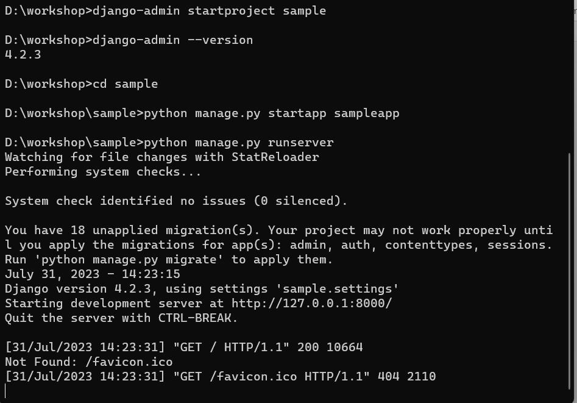

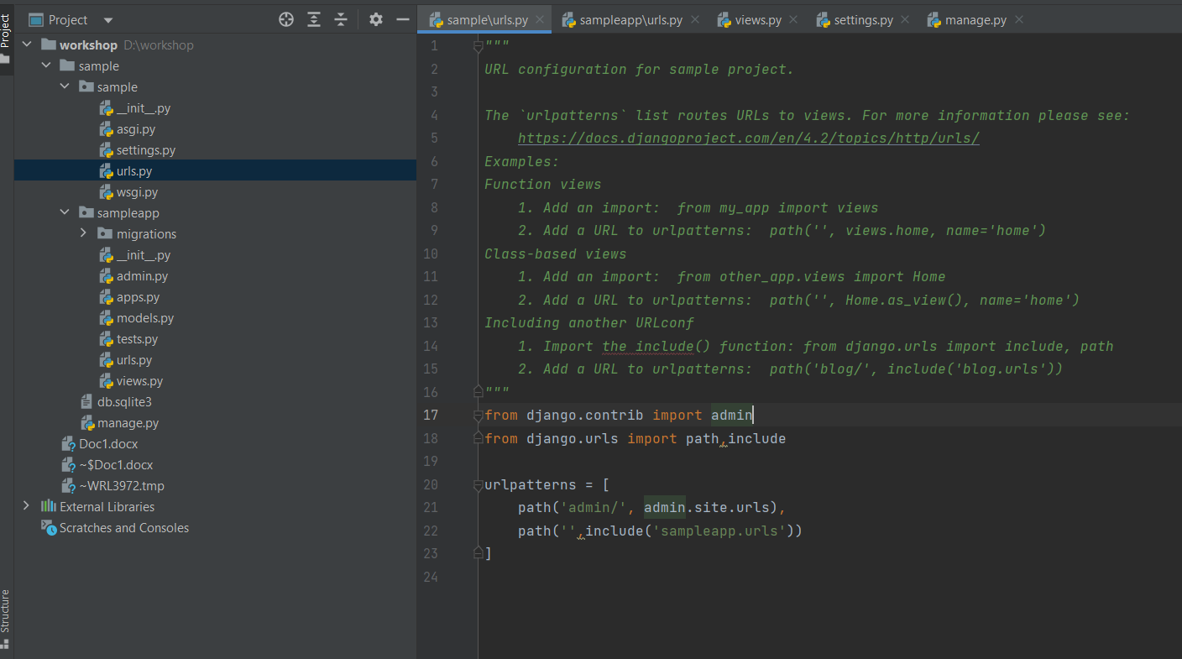

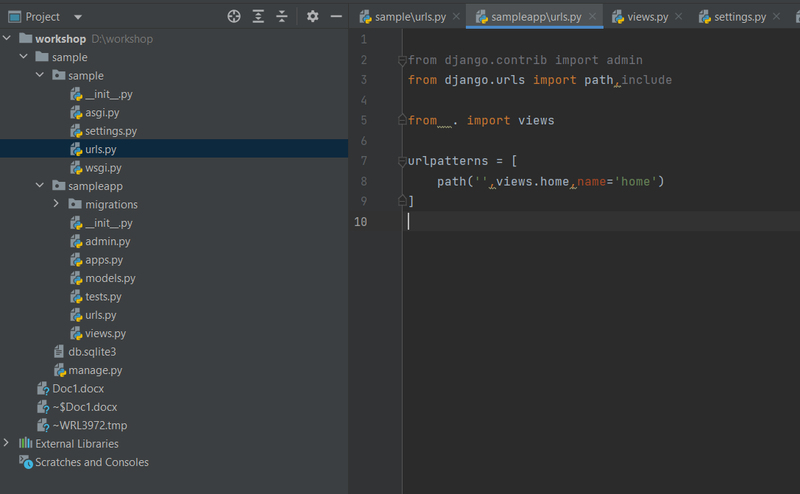

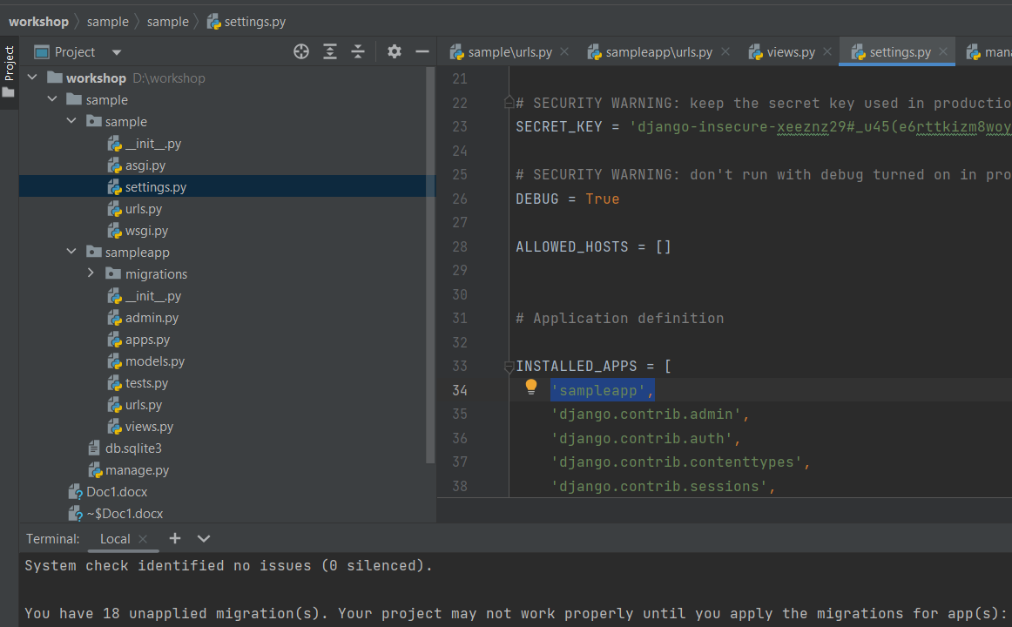

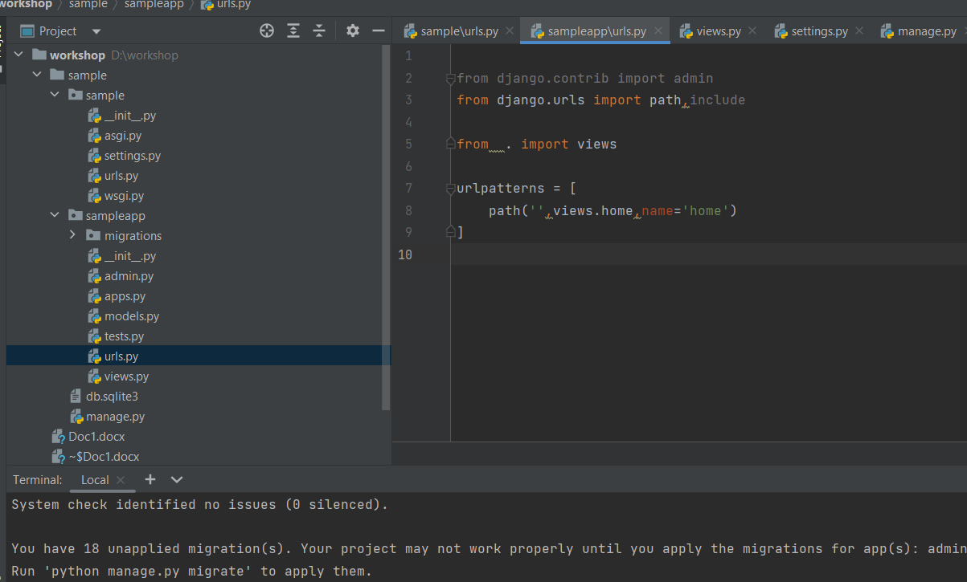urls only in sampleproject🡪

Need to create a python filr in sampleapp name like urls.py

Change the settings like in figure

Add sampleapp name in settings.py

Change views.py in sampleapp

In terminal type “ python manage.py runserver get a url , click on that

In terminal folder should be the project folder then runserver

First in sample project urls__> sampleapp_urls 🡪sampleapp__>views

Create directory templates in main folder

Create a html file inside the templates

Change in sample🡪settings.py🡪 add

TEMPLATES = [  
 {  
 'BACKEND': 'django.template.backends.django.DjangoTemplates',  
 'DIRS': [os.path.join(BASE_DIR,'templates')],  
 'APP_DIRS': True,  
 'OPTIONS': {  
 'context_processors': [

Sampleapp🡪 views.py🡪

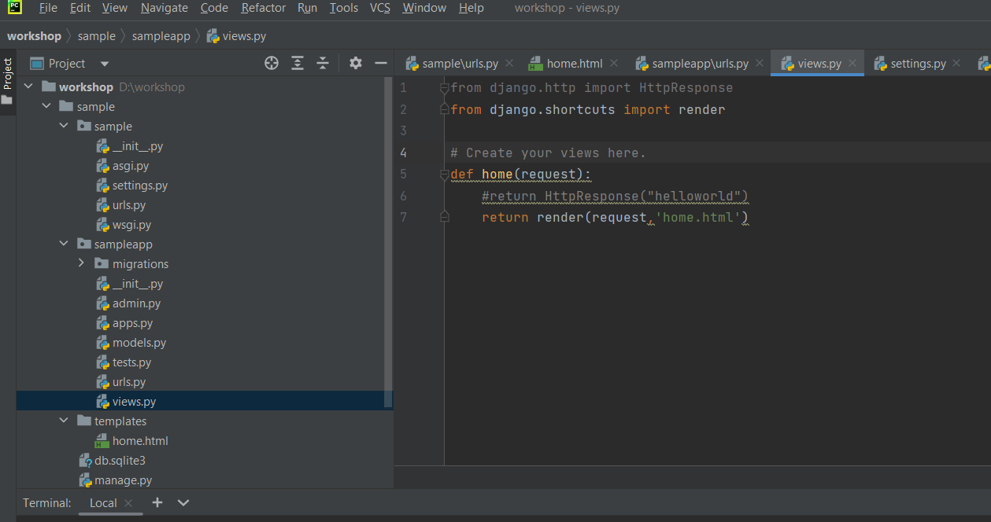

Templates added.

Index.html added

Created superuser

Python manage.py createsuperuser

127.0.0.1:80000/admin