

Project: Hate Speech Detection using Transformers (Deep Learning)
Week 13: Final Report

Name: Anitha Venkatachalam
Email: anitha.Venkat83@gmail.com
Country: Canada
Specialization: Data Science
Batch Code: LISUM14
Date: 28Dec 2022
Submitted to: Data Glacier

Outline
- Problem Statement
- System Architecture
- Result Evaluation
- Application Design
- Conclusion
- Reference

Problem Statement

The term hate speech is understood as any type of verbal, written or behavioral communication that attacks or uses derogatory or discriminatory language against a person or group based on what they are, in other words, based on their religion, ethnicity, nationality, race, color, ancestry, sex or another identity factor. In this problem, we will take you through a hate speech detection model with Machine Learning and Python.

Hate Speech Detection is a task of sentiment classification. So, for training, a model that can classify hate speech from a certain piece of text can be achieved by training it on data that is used to classify sentiments. So, for the task of the hate speech detection model, we will use Twitter tweets to identify tweets containing Hate speech.
System Architecture

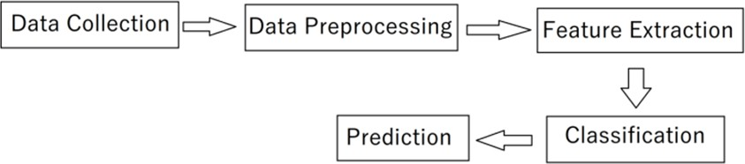

Figure 1: System Architecture

Data Collection

- The Data is about Twitter hate Speech taken from Kaggle [1] which contains the 3 number of features and 31962 number of observations. Dataset using Twitter data, it was used to research hate-speech detection. The text is classified as: hate-speech, offensive language, and neither. Due to the nature of the study, it is important to note that this dataset contains text that can be considered racist, sexist, homophobic, or offensive.

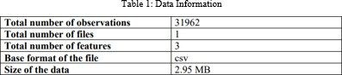

Data Preprocessing
- Text Cleaning
  - Lowercase
  - Remove Punctuation
  - Remove URLs
  - Remove @tags
  - Remove Special Characters

- Preprocessing Operations
  - Tokenization
  - Removing Stop Words
  - Lemmatization

Feature Extraction
- TF-IDF Model
  - Creating the histogram
  - frequent words from dictionaries
  - TF Matrix
  - IDF Matrix
  - TF-IDF Calculation

Result Evaluation
Confusion Matrix Visualization

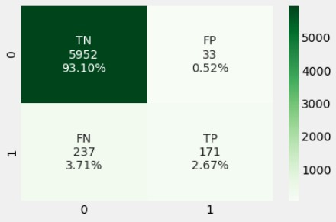

Result Evaluation (Cont'd)
- Result Visualization

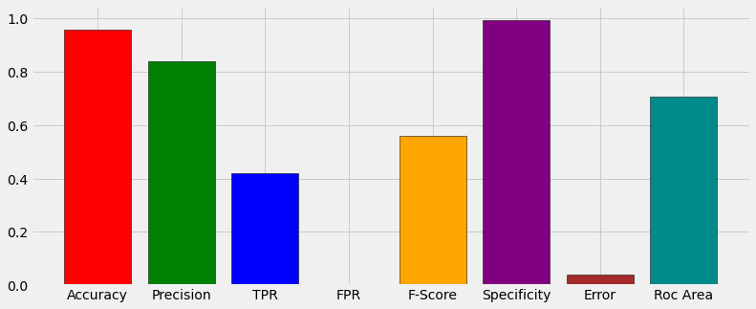

Application Design
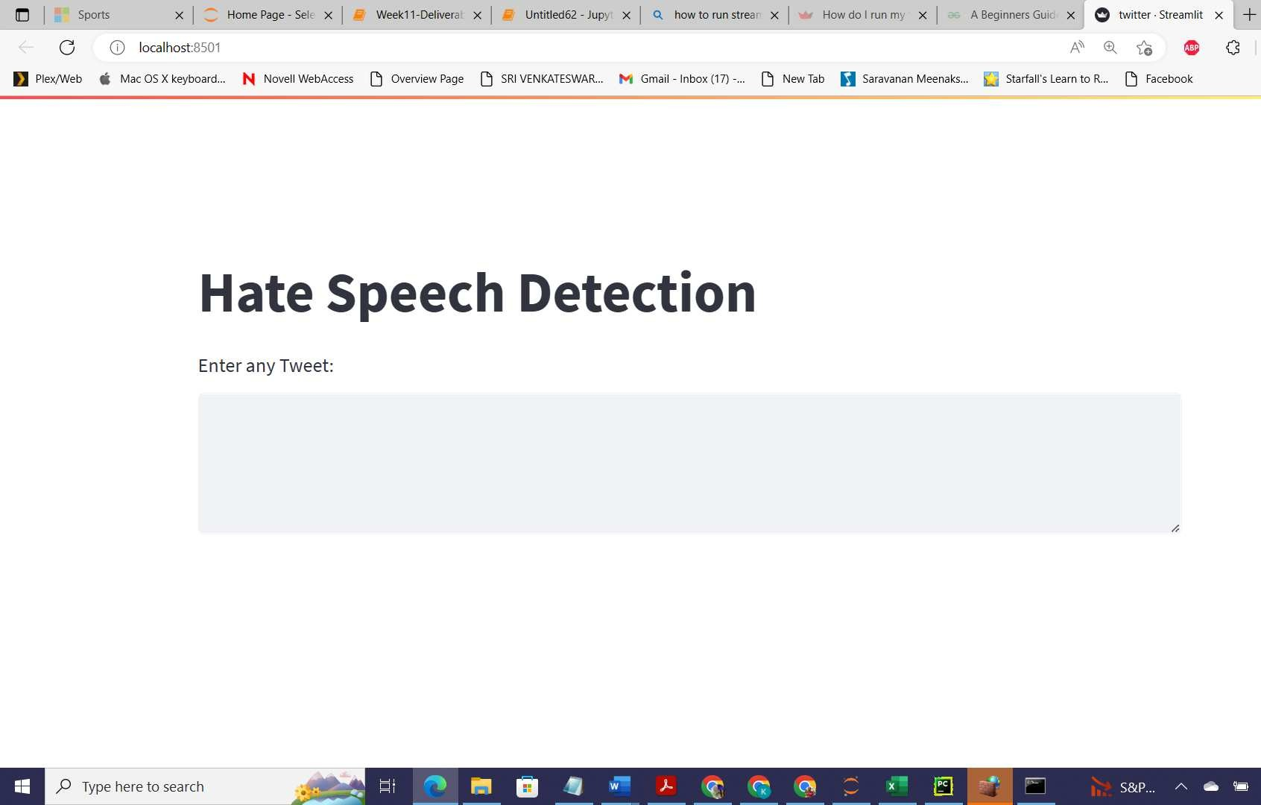

Conclusion

The goal of this project was to find capable methods and settings that could be used to help detection of Hate and Free Speech on twitter. The error rate of the model is not zero, so still, some incorrect can be classified as true by the model. In future, we will enhance this work by implementing Temporal Convolutional Network (TCN) and Random Multimodal Deep Learning (RMDL) Techniques.

Thank You☺

