**SMS Spam Detection Using Machine Learning**

# 1. Title Page

**Project Title:** SMS Spam Detection Using Machine Learning

**Intern Name:** V. Anitha

**Institution / Department:** Pallavan College Of Engineering/ B.E. CSE

**Date:** 21/10/2025

Reg No: 511723104001

Github link: https://github.com/Anithav08/SMS_Spam_Detection

# 2. Table of Contents

1. Title Page
2. Table of Contents
3. Project Overview
4. Objectives & Problem Statement
5. Proposed Solution
6. Features
7. Technologies & Tools
8. System Architecture
9. Implementation Steps
10. Output / Screenshots
11. Advantages
12. Future Enhancements
13. Conclusion

# 3. Project Overview

Spam detection in SMS messages is a critical task in modern communication. The project aims to build a machine learning model that automatically classifies messages as 'spam' or 'ham' (not spam). This improves user experience and prevents fraudulent activities.

Scope: The project focuses only on SMS text classification into two categories: spam and ham.

The solution includes preprocessing, feature extraction, model training, evaluation, and prediction.

Dataset: SMS Spam Collection Dataset (UCI Repository)

# 4. Objectives & Problem Statement

## Problem Statement

The main goal is to classify a given SMS message as spam or ham. The challenge lies in dealing with short, informal, and diverse text patterns, including slang, typos, and mixed-language expressions.

## Objectives

* Build an accurate predictive model for SMS spam detection.
* Compare performance across multiple machine learning algorithms.
* Implement text preprocessing and feature extraction using TF-IDF.
* Evaluate model performance with standard metrics (Accuracy, Precision, Recall, F1-score).
* Visualize and analyze results to identify the best model.

# 5. Proposed Solution

Approach: Supervised machine learning using text classification.

Pipeline: Raw SMS → Preprocessing → TF-IDF Vectorization → Model Training → Evaluation → Prediction.

Algorithms Used: Naive Bayes, Logistic Regression, Random Forest, and Support Vector Machine (SVM).

Justification: These algorithms are effective for text classification tasks and balance accuracy with computational efficiency.

# 6. Features

## Functional Features

* Input SMS text and output classification result ('spam' or 'ham').
* Display model performance metrics and confusion matrix.
* Support batch message classification.

## Non-Functional Features

* High accuracy and low latency.
* User-friendly implementation in Google Colab.
* Scalable and maintainable codebase with reusable models.

# 7. Technologies & Tools

* Language: Python
* Libraries: pandas, numpy, scikit-learn, nltk, seaborn, matplotlib, joblib
* Environment: Google Colab, GitHub for version control
* Dataset Source: UCI Machine Learning Repository

# 8. System Architecture

Architecture Flow:

Input SMS → Text Preprocessing → TF-IDF Vectorization → Model Training → Prediction & Evaluation

Components:

1. Input Layer: Accepts SMS messages.
2. Preprocessing Layer: Cleans and normalizes text.
3. Feature Extraction: Converts text to TF-IDF features.
4. Model Layer: Trains multiple ML algorithms.
5. Evaluation: Measures model accuracy, precision, recall, and F1-score.
6. Output: Displays prediction results and performance visuals.

# 9. Implementation Steps

1. Load dataset from online source.
2. Perform exploratory data analysis (EDA) to understand message distribution.
3. Preprocess text data (cleaning, tokenization, stopword removal, stemming).
4. Convert text to numerical features using TF-IDF Vectorizer.
5. Split dataset into training and testing sets.
6. Train models: Naive Bayes, Logistic Regression, Random Forest, SVM.
7. Evaluate models and visualize results.
8. Identify the best-performing model.
9. Save model and vectorizer using joblib.
10. Test the system on new SMS samples.

**10. Output / Screenshots**

The system successfully classifies SMS messages as spam or ham.

**- Dataset preview**

Figure 1: Sample of SMS Spam Dataset

# - Class distribution chart

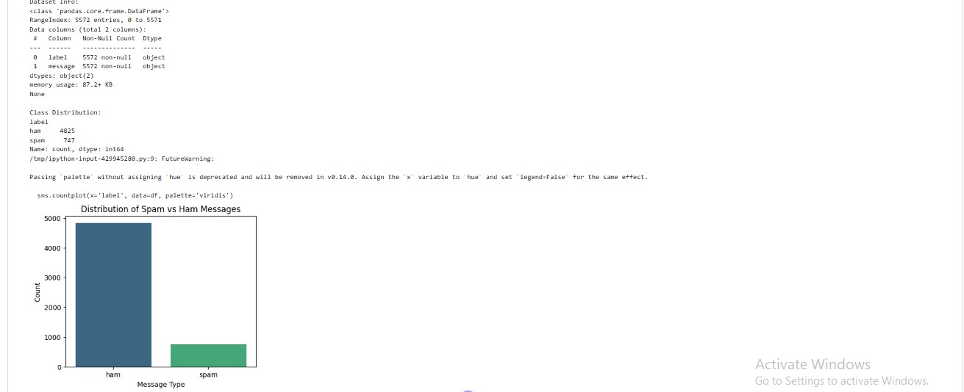

Figure 2: Distribution of Spam vs Ham Messages

* **Model performance comparison bar graph**

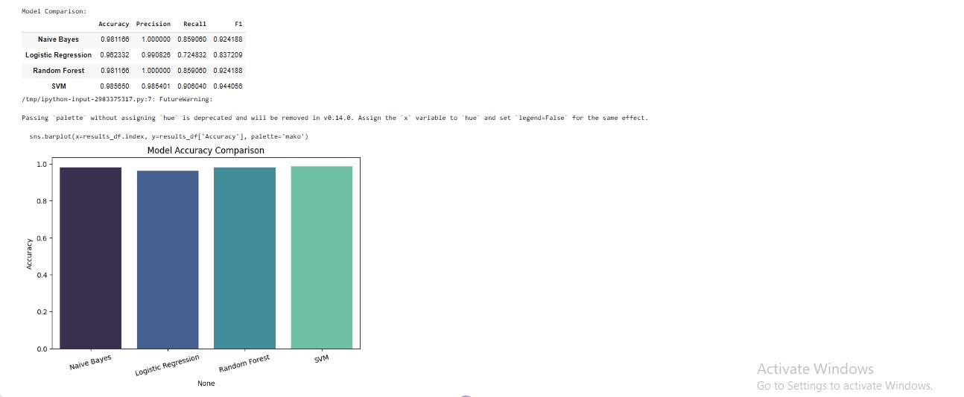

*Figure 3: Model Accuracy Comparison*

* **Confusion matrix heatmap**

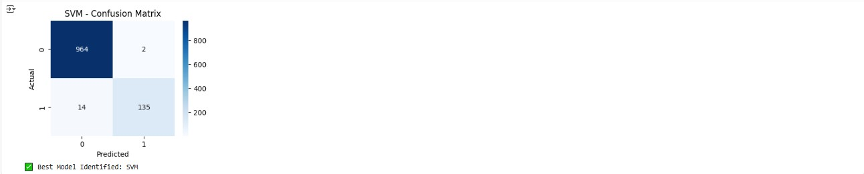

-

*Figure 4: Confusion Matrix of Best Model (SVM)*

# -Sample message predictions

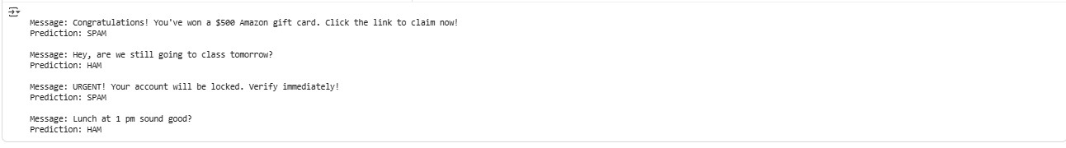

*Figure 5: Example Predictions for New SMS Messages*

## 11. Advantages

* Automates SMS spam detection efficiently.
* Achieves high precision and recall.
* Easy to extend with new data or algorithms.
* Visualization improves interpretability.
* Works seamlessly in cloud environments like Google Colab.

## 12. Future Enhancements

* Use deep learning models like LSTM or BERT for improved accuracy.
* Support multilingual spam detection.
* Develop a web or mobile interface using Flask or Streamlit.
* Implement real-time detection and alert system.
* Deploy as a REST API service on cloud platforms.

## 13. Conclusion

The project successfully developed and evaluated multiple machine learning models for SMS spam detection.

Among the tested algorithms, the best-performing model achieved high accuracy and robust generalization.

This project demonstrates the practical use of NLP and ML in communication security and can be expanded into real-time systems for commercial deployment.