**EXPERIMENT NO :8**

create table Customer (CustomerID int primary key,

Customername varchar(50),

ContactNo varchar(10),

Address varchar(100),

City varchar(30),

PostalCode varchar(50),

Country varchar(25));

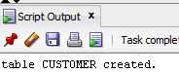

desc Customer;

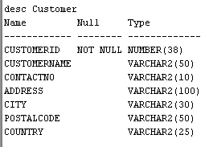

create table Employees(EmployeeID int primary key,

LastName varchar(30),

FirstName varchar(30),

BirthDate date);



desc Employees;

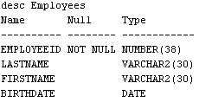

create table Orders(OrderID int primary key,

CustomerID int,

EmployeeID int,

OrderDate date,

ShipperID int,

foreign key (CustomerID) references Customer(CustomerID),

foreign key (EmployeeID) references Employees(EmployeeID));



desc Orders;

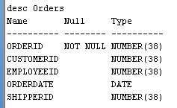

insert into Customer values(01,'Harry',9123456780,'Lakesvilla','Texas','037546','USA');

insert into Customer values(02,'Ronald',652783012,'Rosegarden','Portugal','037906','United Kingdom');

insert into Customer values(03,'Draco',7193026480,'Rocksvilla','New York','230946','USA');

insert into Customer values(04,'Luna',4590128743,'Edeanhome','Salt Lake City','037546','USA');

insert into Customer values(05,'Suzuki',0118123903,'Futari','Tokyo','71234','Japan');

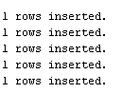

select * from Customer;

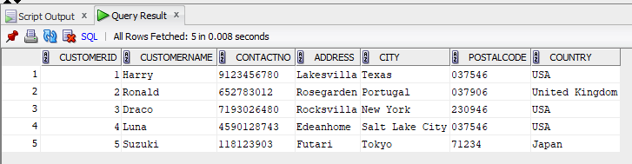

insert into Employees values(100,'Jitraphol','Jimmy',to_date('21-08-1994','dd-mm-yyyy'));

insert into Employees values(101,'Jakarapart','William',to_date('14-02-1975','dd-mm-yyyy'));

insert into Employees values(102,'Kentaro','Mitusha',to_date('08-12-1996','dd-mm-yyyy'));

insert into Employees values(103,'Kim','Jisoo',to_date('03-01-1995','dd-mm-yyyy'));

insert into Employees values(104,'Granger','Hermione',to_date('11-10-1971','dd-mm-yyyy'));



select * from Employees;

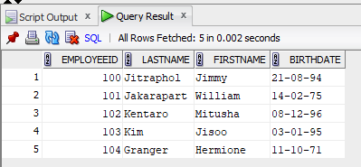

insert into Orders values(1001, 01, 101, to_date('01-01-2023','dd-mm-yyyy'), 1);

insert into Orders values(1002, 01, 102, to_date('10-02-2023','dd-mm-yyyy'), 2);

insert into Orders values(1003, 01, 103, to_date('15-03-2023','dd-mm-yyyy'), 1);

insert into Orders values(1004, 02, 104, to_date('20-04-2023','dd-mm-yyyy'), 3);

insert into Orders values(1005, 05, 100, to_date('25-05-2023','dd-mm-yyyy'), 2);



select * from Orders;

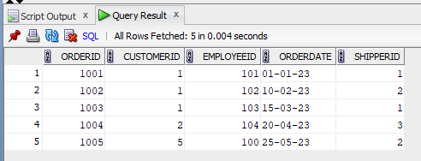

1. select * from Customer order by CustomerName asc;

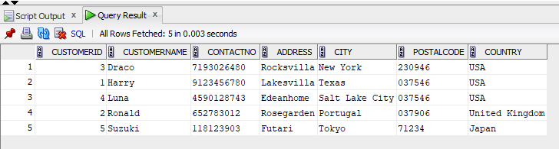

1. select * from Orders order by OrderDate asc;

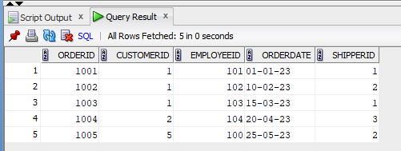

1. select * from Employees where extract(year from BirthDate)> 1980 order by BirthDate desc;

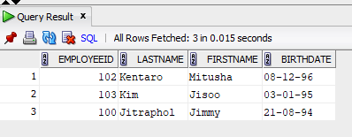

1. select * from Orders where CustomerID in (select CustomerID from Customer where Country='USA');

