ANSHA ANTONY

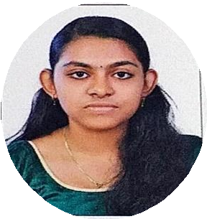

Manavalan House Manjapra P O, PIN :683581 Ernakulam district, Kerala

Email [:anshaantonymanavalan@gmail.com](mailto:anshaantonymanavalan@gmail.com) Phone :9946576139

**Objectives**

Looking forward to work in an organization to expand and utilize my learning , skills and

knowledge.

**Education**

2013-2014

**Class**- 10th std

**School** -St Joseph’s HSS Kidangoor

Ernakulam district , Kerala.

**Percentage**- 90

2014-2016

**Class** -12th std

**School-** Government HSS Manjapra Ernakulam district , Kerala.

**Percentage** -78

2016-2019

**UG** -Bachelor’s of Computer Application (BCA)

**College** -Naipunnya Institute of Management and Information Technology, Koratty Thrissur district ,Kerala.

**Percentage** -72

2019-2022

(Present)

**PG** – Master of Computer Application(MCA) **College** -Government Engineering College Thrissur **SGPA -S2(7.5) ,S3(8.55)**

**SKILLS**

TECHNICAL

* Languages known – C, C++, JAVA , HTML,PHP, Python,Django,Flask
* Database – RDBMS
* Operating System -Windows , Linux, Android PERSONAL
* Adaptive
* Hard working and co-ordination skill
* Flexible and positive minded LANGUAGE
* English
* Hindi
* Malayalam

**PERSONAL DETAILS**

Nationality - Indian

Gender - Female

Father’s name- M.P Antony

Date of Birth - 22-05-1999

**PROJECT WORK**

* Project Name -Blood bank management system
* Technology used -Front end:PHP, Back end -MYSQL
* Project Description -It is designed to provide blood donation service to the city.

**DECLARATION**

I hereby declare that the above -mentioned details are true to the best of my knowledge and I bear the responsibility for the correctness of the above-mentioned particulars.

Place : Manjapra

Date : (Ansha Antony)