Experiment No: 03 Anitta Antony

S4 MCA

Roll.no:6

**Create bulk users with loginID and password. Create directories for each user ,create files in bulk and change the file permissions recursively**

1. **Create bulk users**

Adding a single new user to a Linux system can be achieved through the useradd command. But system admins often get request to add many users. So Linux provides a different to do a bulk addition of many users to a system.This is the newusers command.

Syntax

**sudo newusers users.txt**

users.txt is the filename containing the details of all usernames to be added.



1. **Giving Permissions to the User Details File**
2. Create files in bulk

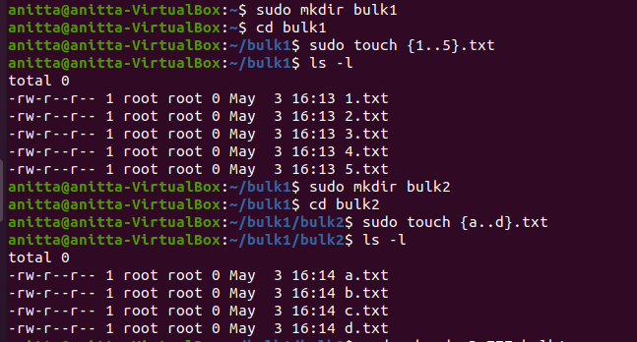

1. Change file permissions

