TaskGraph

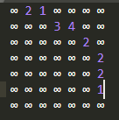

Execution

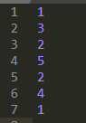

Map



Priority

