Site Map of Restaurant Website

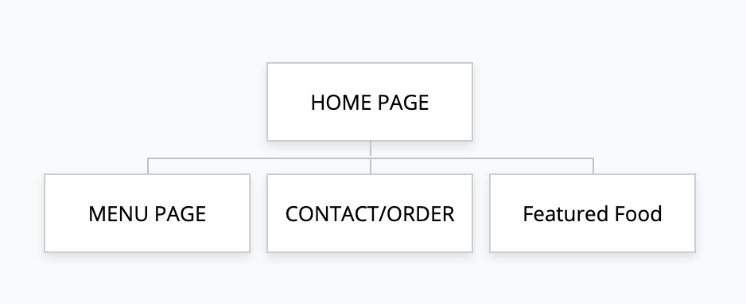

Reference

*Restaurant Marketing & Commerce Platform: BentoBox* (no date) *Restaurant Marketing & Commerce Platform | BentoBox*. Available at: https://www.getbento.com/ (Accessed: 09 December 2024).