The low expressed transcripts are filtered based on count per million (CPM) reads:

$$CPM=\frac{X_{i}}{N}×{10}^{6}$$

where $X_{i}$ is read count of transcript $i$ and $N$ is the library size of the sample.

* An expressed transcript must have $≥n$ samples with expression $≥m$ CPM.
* An expressed gene must have at least one expressed transcript.

The sample number cut-off $n$ and CPM cut-off $m$ are determined by the mean-variance trend plot. Read counts are assumed to be negative binomial distributed of which the mean and variance has a relation:

$$Var(\log_{2}X)=\frac{1}{μ}+ϕ$$

where $X$ is read count, $μ$ is the mean and $ϕ$ is the overdispersion. The expression variance decreasing monotonically with the increasing of the mean. In real RNA-seq data, the low expressed transcripts confound with noise and the expression distribution is different to the expressed transcripts. In the mean-variance trend plot, the low expressed transcripts cause a drop trend in low expression region. Therefore, the cut-offs $n$ and $m$ to filter the low expression can be optimised until the drop trend in low expression region disappeared in the mean-variance trend plot.

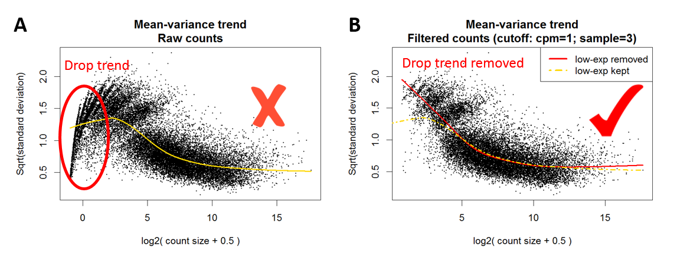

**Figure**: Mean-variance trend plot before (A) and after (B) low expression filters. Each black point in the figure represents a gene/transcript. The red and yellow lines are the fitted trends of the genes/transcripts.