Three input data must be provided for 3D analysis:

* Sample information in csv format (comma delimited; Figure A). The spreadsheet must inlcude 1) a column of single factor or multiple columns of multi-factors, which are relevant to the expression changes of experimental design; 2) a column to distinguish biological replicates (bio-reps) of samples; 3) a column to distinguish sequencing replicates (seq-reps) if exist and 4) a column of sample-based transcript quantification folder names from tool salmon/kallisto (Patro et al., 2017; Bray et al., 2016).
* Transcript-gene mapping in csv format (comma delimited; Figure B). The first column is transcript list and the second column is gene list.
* The transcript quantification output from salmon/kallisto (Patro et al., 2017; Bray et al., 2016) (Figure C).

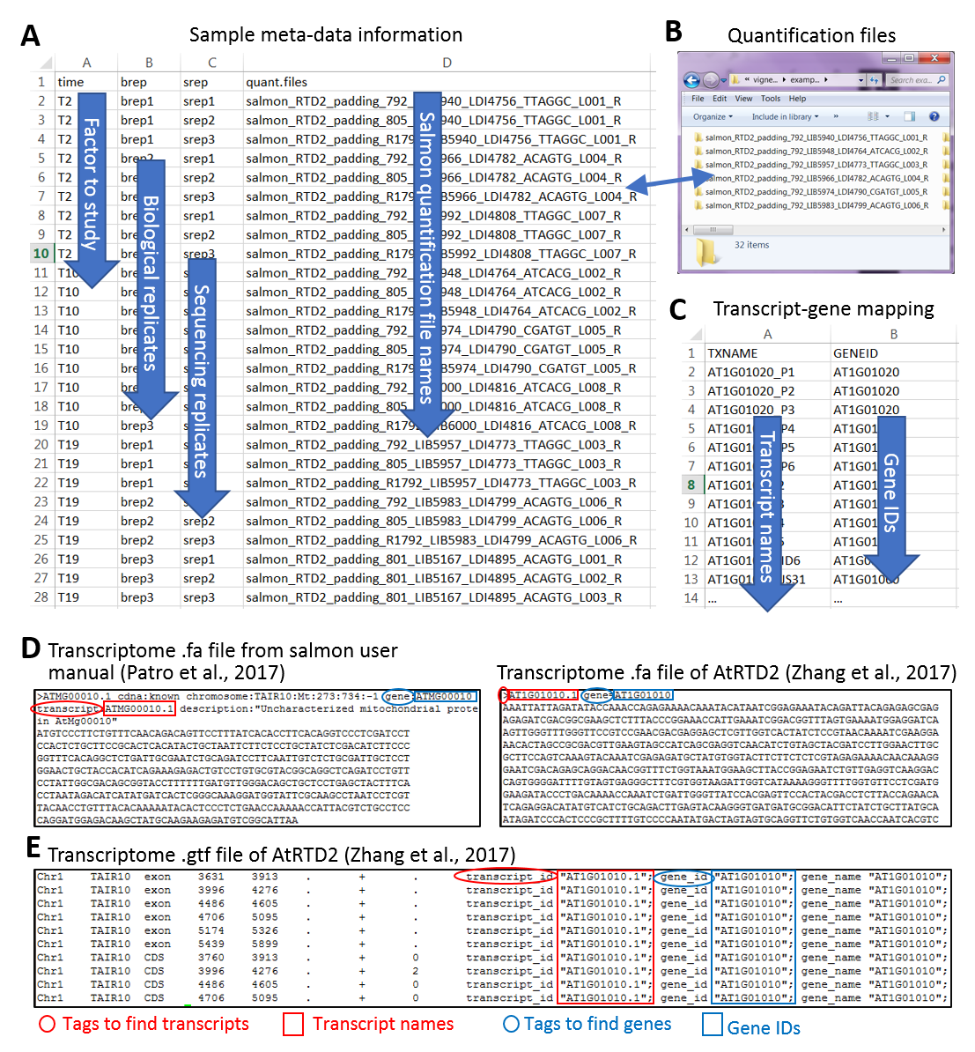

**Figure**: Example of input data for 3D RNA-seq analysis. The example is a subset from RNA-seq study of Arabidopsis in respond to cold (Calixto et al., 2018). The example has a single factor time-points, T2, T10 and T19. Each time-point has 3 bio-reps and each bio-rep has 3 seq-reps. The transcripts were quantified using salmon (Patro et al., 2017) and reference transcriptome AtRTD2 (Zhang et al., 2017). A) Sample information, B) transcript-gene mapping and C) sample-based folders of salmon-quantification output.

### References

Bray,N.L., Pimentel,H., Melsted,P., and Pachter,L. (2016) Near-optimal probabilistic RNA-seq quantification. Nat. Biotechnol., 34, 525-527.

Calixto,C.P.G., Guo,W., James,A.B., Tzioutziou,N.A., Entizne,J.C., Panter,P.E., Knight,H., Nimmo,H., Zhang,R., and Brown,J.W.S. (2018) Rapid and dynamic alternative splicing impacts the Arabidopsis cold response transcriptome. Plant Cell, tpc.00177.2018.

Patro,R., Duggal,G., Love,M.I., Irizarry,R.A., and Kingsford,C. (2017) Salmon provides fast and bias-aware quantification of transcript expression. Nat. Methods, 14, 417-419.

Zhang,R., Calixto,C.P.G., Marquez,Y., Venhuizen,P., Tzioutziou,N.A., Guo,W., Spensley,M., Entizne,J.C., Lewandowska,D., Have,S. Ten, Frey,N.F., Hirt,H., James,A.B., Nimmo,H.G., Barta,A., Kalyna,M., and Brown,J.W.S. (2017) A high quality Arabidopsis transcriptome for accurate transcript-level analysis of alternative splicing. Nucleic Acids Res., 45, 5061-5073.