t-Test Hypothesis Testing using R

Apple has been trying out a new advertisement to increase the sales of new Apple 11 pro, previous ad for which generated 30,000 mean sales per week. Now Apple wants to test whether the sales data of new ad (collected over the past 15 weeks) has the similar mean as that of the previous ad (ad1) sales data, since they consider that the new ad (ad2) has no incremental effect on the sales of the product in question.

Goal of the Analysis: The Apple team is trying to determine if the new ad has same mean sales as the mean from the previous ad, which is weekly mean sales of 30,000 units.

Here we will conduct the t-Test to determine the increment/decrement or similarity between the population and the sample mean. It will be a two-tailed test, since we have to check for the equality or inequality between the sample and population means.

Before conducting the t-Test we need to validate the requirements; here we do not know the population variance and our sample size is smaller than 30 (n=15 < 30). Therefore, it will be a one sample t-Test.

* Checking for the t-Test assumptions:

1. Data is independent.
2. Data is collected randomly.
3. Data is approximately normally distributed.

* First two assumptions are seemingly satisfied, however we should check for the third requirement.

Here, we can see from the histogram that the sample data is nearly normally distributed. Hence, all the requirements are satisfied for the t-Test to be valid.

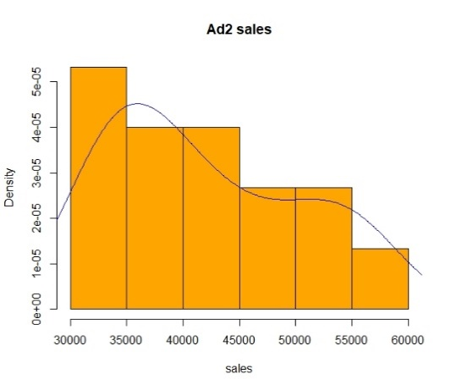

t-Test step-by-step process

**Null Hypothesis**: There is no difference between the mean from Ad2 data and that from Ad1 data. That is, the sample mean is equal to the population mean.

**Alternate Hypothesis**: Ad2 mean weekly sales is greater or less than the Ad1 mean weekly sales.

**Step 1**: Stating the null and alternative hypothesis

Ho: µs = 30000

Ha: µs ≠ 30000

**Step 2**: Specifying the significance level

Significance level α = 0.05

**Step 3**: Conducting one sample t-Test

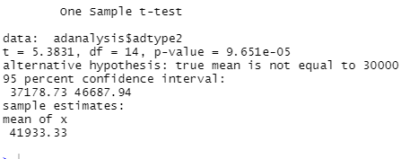

**Step 4:** Here p- value of 9.651e-05 is infinitesimally smaller than 0.05 confidence interval. That indicates the rejection of Null hypothesis.

**Conclusion:** We reject the Null Hypothesis (Ho) that is the sample mean is equal to the population mean at 0.05 significance level. Therefore, we accept the Alternate Hypothesis (Ha) that the sample mean differs from the population mean.

In other words, we conclude that the ad2 sales data has mean not equal to the ad1 mean of 30000. Additionally, from the t-Test result, mean of Ad2 sales data is 41933.33 which is apparently greater than the mean of ad1 data. We, therefore, can conclude that the weekly sales of Apple 11 pro have risen with the launch of new advertisement.

R syntax for the t-Test Hypothesis Testing Exercise

# Loading the data

View(adanalysis$adtype2)

class(adanalysis$adtype2)

# Checking for the normality

hist(adanalysis$adtype2, freq = F, col='orange', main="Ad2 sales", xlab='sales')

lines(density(adanalysis$adtype2), col='blue')

# Statistical summary

summary(adanalysis$adtype2) # Here data is all greater than population mean of 30,000

# Conducting one sample t-Test

t.test(adanalysis$adtype2, mu=30000)

Screenshot of the exercise in R

