This repository contains scripts used to analyse capture sequencing data from a single Swedish *Littorina saxatilis* hybrid zone (Anglavebukten / “ANG”), and a family resulting from a lab cross of Crab ecotype individuals (“MAP”).

Bioinformatic steps performed on all sequencing data files (ANG and MAP):

|  |  |
| --- | --- |
| ang05_trim_PE.sh |  |
| ang05_trim_SE.sh |  |
| ang06_map_paired_reads.sh |  |
| ang06_map_single_reads.sh |  |
| ang06_map_unpaired_reads.sh |  |
| ang06a_index_ref.sh |  |
| ang07_get_contigs1.sh |  |
| ang07_get_contigs2.sh |  |
| ang07_make_bed.sh |  |
| ang08_bam_sort_filter_index.sh |  |
| ang09_dedup.sh |  |
| ang10_clip_overlap.sh |  |
| ang11_merge.sh |  |
| ang11b_merge_parents.sh |  |
| ang12a_prep_calling.sh |  |
| ang12b_call.sh |  |

After the SNP calling step, processing and filtering varied between different downstream analyses. An overview is given in the following scheme.

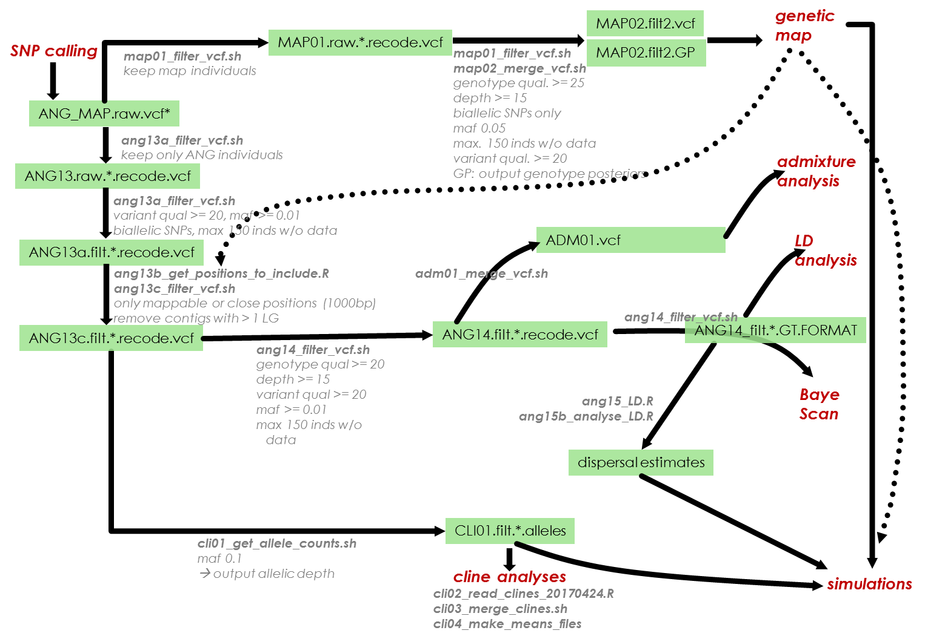

Scripts for downstream analyses (red) are in separate folders.