# 2. Analysis

## 2.1 Introduction to analysis

The process of breaking up of any whole into its parts to learn what they do and how they relate to one another is known as analysis. Analysis is the first process to start any project and it is the most important to do for any project to be successful. The Analysis phase is where the project life cycle begins. It is also the part of the project where you identify the overall direction that the project will take through.

Online Gift Shop is my project. The reason why it is important for my project is to understand the vision of the project; it also defines a clear scope. The more that can be defined and clarified at the start of the project, the more time(and money) you will save in the long run since there will be fewer change orders requested, fewer modifications during the testing period and a higher number of users who will be willing to adopt to this new system. For the successful implementation here I have gather the needs of the customers by asking for suggestion from those who will be using the system every day. From the field level to the complete feature set, I make sure that this project has a purpose and that is helping, not hindering the time required to complete a task.

Online gift shop is the title of the project where there will be customer registration, login, managing items, ordering items, search where customers can search about any items they want, delivering ordered items and cash on delivery i.e. payment should be cash on delivery are the need of my project.

### Analysis Methodology

The analysis methodology information is organized by analytical function. It is the process concerned with the detailed process for doing a particular job. In analysis methodology for making the successful project from various analysis methodology like SWOT, PEST, object oriented, hard approach, soft approach. Soft Systems Methodology (SSM) is a cyclic learning system, which uses models of human activity to explore with the actors in the real world problem situation, their perceptions of that situation and their readiness to decide upon purposeful action, which accommodates different actor’s perceptions, judgments and values. (Check land, 1999)

The SSM intervention follows as such:

* Determine the situation
* Think about different systems which could or could not be employed in the situation
* Measure the thinking to the systems
* Take an action depending on previous information learned.

Therefore, here in my project I have use soft system methodology because:

* It contains set of rules to help users carry out the steps.
* It provide a tool for investigating an unstructured problem situation.
* It provides a set of feasibility and culturally acceptable actions, which can be taken to improve the problem situation.
* Soft system methodology attempts to foster learning and appreciation of the problem situation between groups of stakeholders rather than set out to solve a pre-defined problem.
* It also provides a framework for tackling such situations.
* This helps to identify areas that need to improve in my project.
* It helps produces solutions in a sense that it defines the problem well enough for other system approaches to take over such as hard techniques.
* In my project, I have use SSM because it relies on a holistic view for the problem to be solved successfully.

I have use following 3 steps of SSM model. They are:

* Rich Picture
* Root Definition
* Conceptual diagram

In stage 1: Diagramming rich picture

It is a compilation of drawings, pictures, symbols and text that represents a particular situation or issues from the viewpoints of the person, which shows relations, connections, influences, causes and effects. For my project, I have use rich picture because:

* It can depict complicated situations or issues.
* It also offers a great deal of scope for creative thinking and freedom in how we represents our ideas.
* In my project further it helps to show which parts should be regarded as structure and which as process.
* It helps to concise overview of complex systems.
* It is efficient and simple to use so I have use this in my project.
* By using rich pictures, it helps to improve understanding.

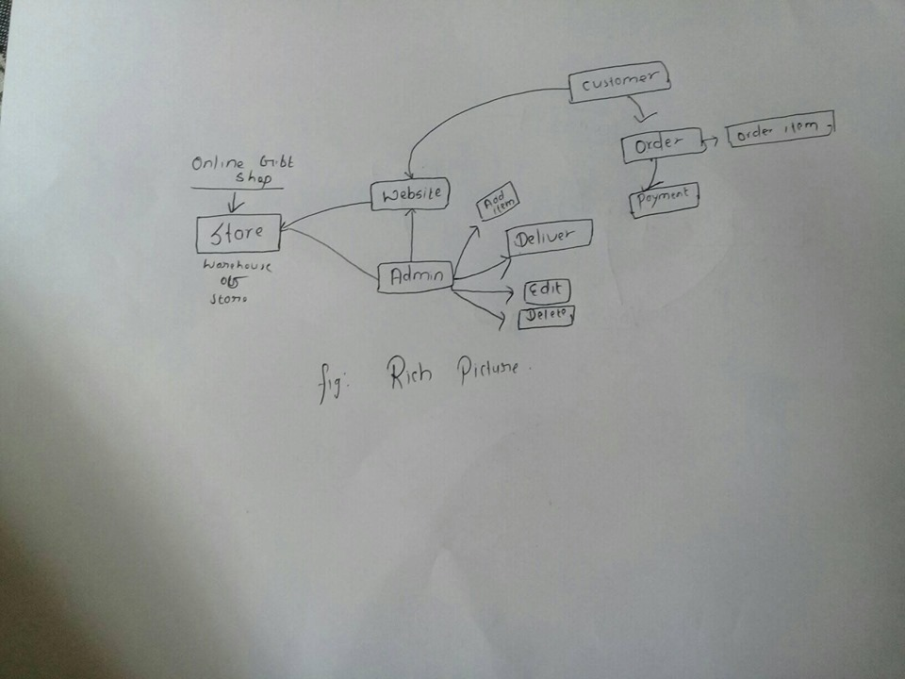 Fig1: Rich Picture

In stage 2: Root Definition

Root definition is a structured description of a system. It is a clear statement of activities, which take place in the organization being studied. Various mnemonics have been suggested to help the process of formulating a root definition.

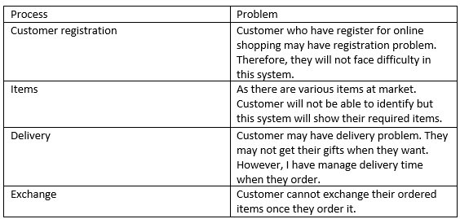

Fig2: Root Definition

In stage 3: Conceptual Model

Conceptual model is a representation of a system, made of the composition of concepts, which are used to help people know, understand, or simulate a subject the model represents.

<https://en.wikipedia.org/wiki/Conceptual_model>

I have use the rich picture and root definition to construct the conceptual ‘ideal’ system that defines:

* The must have aspects of the system.
* The desirable aspects of the system.

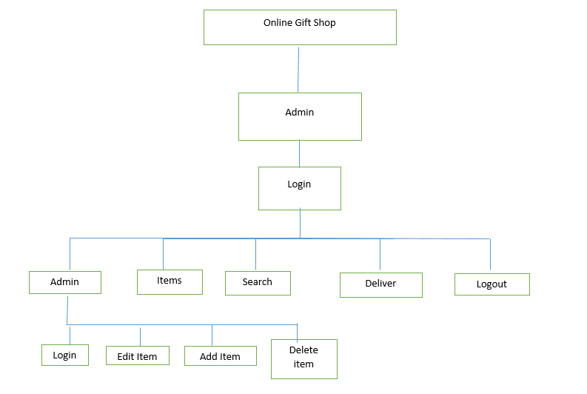Fig3: Conceptual Model for admin.

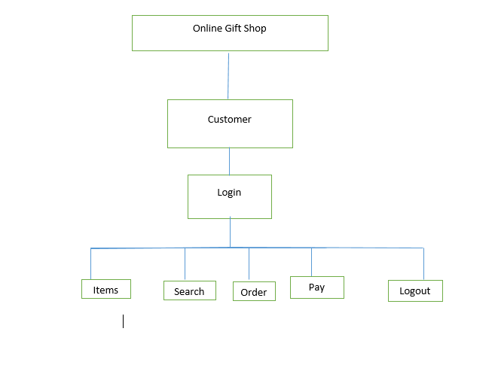 Fig4: Conceptual diagram for Customer.

### 2.3 Feasibility Study

An evaluation and analysis of a project or system that somebody has proposed is known as feasibility study or feasibility analysis. For my project Online Gift Shop, I also have done feasibility study because:

* It helps to determine whether the project is technically or financially feasible or not i.e. Is it technically or financially viable?
* This also helps to know me about my project will be profitable or not.
* This helps in my project whether something will work.
* I have done this study in my project because it supports financial data, tax implementation and obligation, legal requirements, marketing research data and policies, details of all the operations and management, marketing research data and policies.

For my project to be done successfully I have followed the following steps of feasible study:

1. Technical feasibility

I have done technical feasibility in my project as the assessment is centered on the technology resources available for the project. Technical feasibility helps in my project as it capable of converting the ideas into working systems or not. This also involves evaluation of the hardware and software of the system that I am making.

1. Economical or financial feasibility

This is important in my project and I have consider this because it helps to assess the viability, cost, and benefits associated with projects; before financial resource are allocated. Also helps to decision to determine the positive economic benefits and qualify them too. Cost, benefits, analysis, requirement that are needed for my project to make a complete system is under this.

1. Legal feasibility

Legal feasibility is important in my project because it investigates about the proposed system conflicts with legal requirements like’s data protection acts or social media laws. As we know, that law is very important things to consider in any things not only projects.

1. Social feasibility

I have use social feasibility in my project because the proposed project may have on the social system in the project environment. For guarantee compatibility project should be evaluated in order. By using this I can identify that employee in the particular industries may have specific status symbols within the society.

1. Political study

For proposed project the direction are mostly dictated by the political considerations. For large projects with potential visibility that may have important political implications and government inputs this is certainly correct. On the other hand, because of political factors, value able projects may face uncontrolled opposition.

#### 2.4 Software requirement specification

It is a document or set of document that describes the features and behavior of a system or software application. It includes a variety of elements that attempts to define the intended functionality required by the customer to satisfy their different users. (<https://www.inflectra.com/ideas/topic/requirements-definition.aspx>). It is also a detailed description of a software system to be developed with its functional and non-functional requirements. It is developed based on the agreement between contractors and customer.

##### 2.4.1 Functional Requirement Specification.

Functional requirement are products features or function that developers must implement to enable users to accomplish their tasks. Therefore, it is important to make them clear both for the development team and for stakeholders. Here, in my project I have use functional requirement because it helps to describe system behavior under specific conditions.

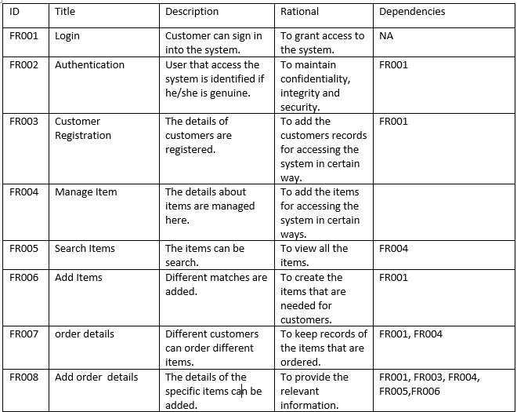

Fig5: Functional requirement specification of Online Gift Shop.

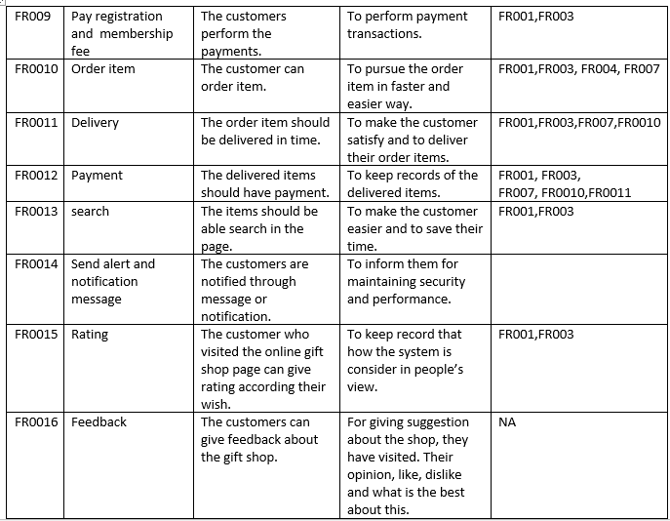

Fig6: Functional Requirement.

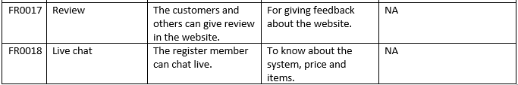

Fig7: Functional requirement specification.

###### 2.4.2 Non-Functional Requirement

Nonfunctional requirement shows how a system must behave and establish constraints of its functionality. This type of requirement is also known as the system’s quality attributes. Here are the following nonfunctional requirement that I have used in my project:

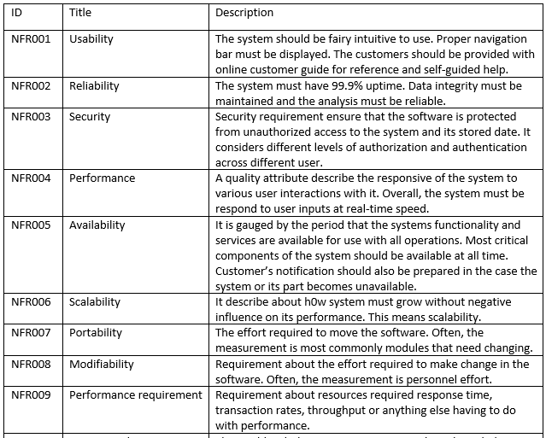

Fig8: Non-Functional requirement specification.

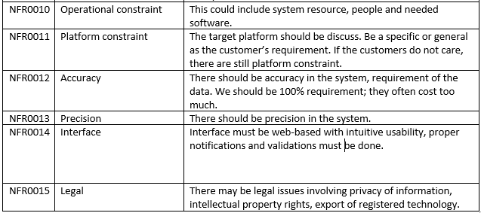

Fig9: Non-functional requirement specification.

###### 2.4.3 Moscow prioritization

The process that arranges items or activities in order of importance relative to each other is known as prioritization. It is a ranking of things according to your goals. It is also a fundamental basic for decision-making.

Moscow is a popular technique for managing requirements. This method is commonly used to help key stakeholders to u understand the significance of initiatives in specific release. In my project it is important because it reduces development costs, shorten the project requirement, helps to manage project better, helps to ensure that the most important requirement are taken care of.

I prioritize work:

* To collect a list of all my tasks.
* To identify urgent vs important.
* To value the access
* To order task by estimated effort.

The acronym, Moscow stands for four different categories:

* Must-haves
* Should-haves
* Could-haves
* Will not have or would haves.

Following are the points I have consider for Moscow prioritization:

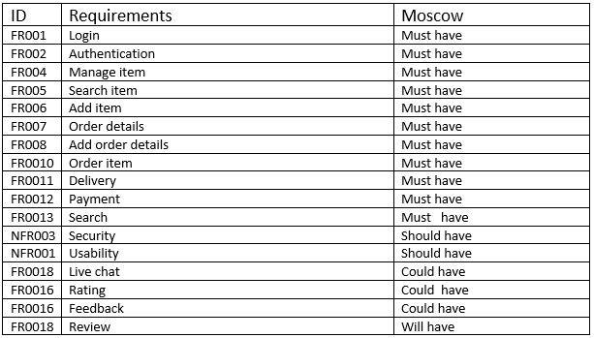

Fig10: Moscow prioritization.

###### 2.4.4 Hardware software specification

Hardware and software requirements may vary depending on the machine and operating systems. Advance hardware and software is use by our system is it provide a path for future growth and sustainability.

Here are the required hardware for Online Gift Shop:

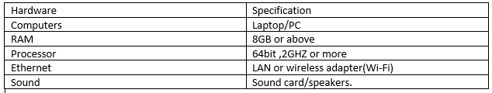

Fig11: Hardware Specification.

Some of the software that will be required for the system are as follow:

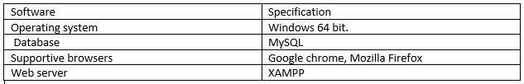

Fig12: Software specification.

#### 2.5 Use Case Diagram

A use case is a methodology used in systems analysis to identify, clarify, and organize system requirements. Similarly, use case diagram is a graphical depiction of the interactions among the elements of a system. It is also the primary form of system/software requirements for a new software program under developed. I have use Extend and Include in use case for my project. Extend is used when a use case conditionally add steps to another first class use case where include is used to extract use case fragments that are duplicated in multiple use cases.

In my project for Online Gift Shop, I have considered Use Case Diagram because:

* It specifies the expected behavior.
* It also helps us to design a system from end users perspectives.

The complete use case diagram for Online Gift Shop are is shown below:

Here in the figure admin can register which include authentication. Admin can also login manage items, items, where items can edit, add and delete, delivery, search and can logout.

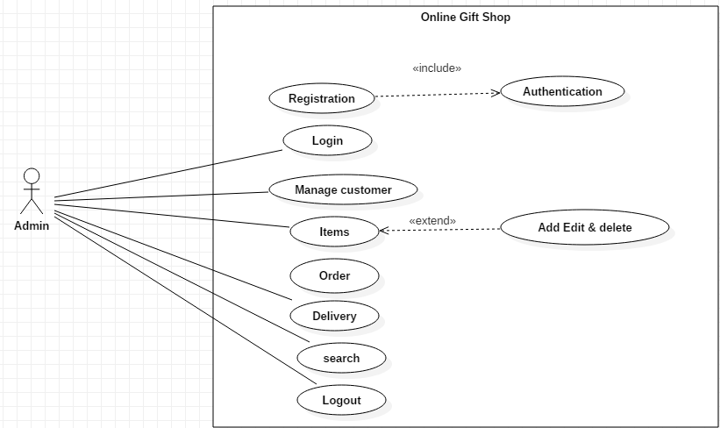

Fig13: Use Case Diagram for Admin.

Here is the use case for online gift shop where customer can register which include authentication. In addition, extends edit. Customer can also login in the system, search for items, order items what they want and can logout.

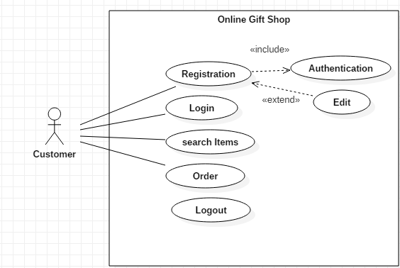

Fig14: Use Case Diagram for customer.

The detailed about the use case diagram for admin and customer for Online Gift Shop are briefly describe below:

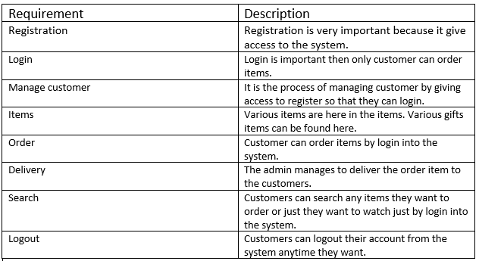

Fig15: Explaining use-case in tabular form.

###### 2.6 Initial class diagram (Natural Language Analysis)

Natural Language Analysis

The process of identifying verbs, adjectives, and noun in a piece of descriptive text, which permits us to obtain a list of candidate class, their relationship and attributes is known as NLA. It is the process of obtaining class diagram. So here, I have created my own scenario for Online Gift Shop.

Scenario

Online gift shop is one of the online shopping established for the customers. The person who is purchasing the gift spends lot of time and money to buy the perfect gifts. Therefore, to make customer easier I have make Online Gift Shop. Here you can get large number of gifts for every occasion. The customers can select gifts according to their budget. The sites will be regularly updated with the latest product of gifts that are available.

Online gift shop is established to make customer life style easy and to be profitable for their own need. Here admin can register, login into the system, can add items, edit items, delete items, can also search for the items, deliver order items to the customers and can also logout from the system. Where the customers in other hand can register and login into the system, can order various items, which are available in the gift shop, can also search for the items they want to order but payment should be cash in delivery.

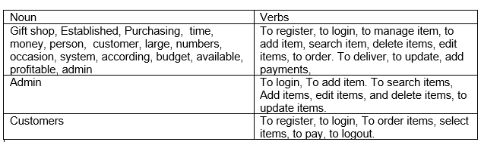

Fig16: Noun and verbs.

Class diagram is the method of showing the different objects in a system, their attributes, their operation and the relationship among them. The classes are arranged in groups that share common characteristics. It resembles flowchart in which classes are portrayed as boxes, each having rectangular inside.

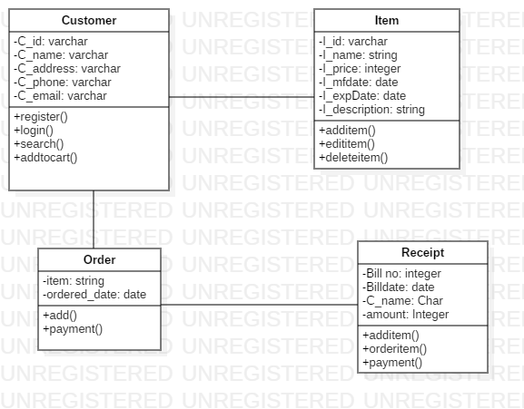

Fig17: Initial class Diagram