Unleashing The Power Of Web Scrapping, Unveiling Its Benefits and Use Cases

**Introduction to Web Scraping:**

Web scraping, also known as web data extraction, is the process of extracting data from websites. It involves using specialized software to navigate through web pages, extract the desired data, and store it in a structured format for further analysis. This process can be done using various programming languages and tools.

**Evolution and Importance of Web Scraping**

Web scraping has evolved with the growth of the internet. In the early days, it was mainly used for indexing and cataloging websites. However, with the explosion of data available on the web, web scraping has become an essential tool for businesses and organizations to extract valuable information that can support their decision-making processes.

**How Web Scraping Works**

Web scraping typically involves sending HTTP requests to a website and then parsing the HTML content of the response to extract the desired data. This process can be done either by writing custom code or by using web scraping frameworks and libraries. The extracted data can then be stored in various formats, such as CSV, JSON, or a database, for further analysis and use.

**Web Scraping Tools and Technologies**

There are various tools and technologies available for web scraping. Choosing the right one depends on factors such as scalability, performance, handling of dynamic web pages, and extraction capabilities.

**Web Scraping Frameworks:**

**Beautiful Soup**: Beautiful Soup is a Python library that simplifies web scraping. It provides a convenient way to navigate, search, and modify the HTML structure of a web page. It has intuitive syntax which makes it easy for developers to extract data from HTML documents.

**Scrapy**: Scrapy is a powerful Python framework for web scraping. It provides a comprehensive set of tools and libraries for building scalable and efficient web scrapers. Scrapy handles asynchronous requests, manages proxies, and provides a good framework for organizing and processing scraped data.

**Selenium**: Selenium is a popular web scraping framework that allows for the automation of web browsers. It can interact with dynamic web pages, fill in forms, and simulate user actions. Selenium is often used for scraping websites that heavily rely on JavaScript or have complex interactive elements

**Advantages of Web Scraping:**

Web scraping offers numerous benefits that can greatly enhance data acquisition, time and cost efficiency, competitor analysis and market research efforts.

**High-Quality Data Acquisition**

1. Web scraping allows users to fetch structured data from websites, which can be used for various purposes such as market analysis, trend identification, and decision-making processes.
2. With web scraping, it is possible to extract comprehensive information from websites, including product details, pricing data, reviews, and other relevant content which can provide valuable insights for businesses.
3. Web scraping ensures data consistency, eliminating human error and ensuring that the data remains up-to-date and accurate.

**Time and Cost Efficiency**

1. Web scraping automates the process of data retrieval, eliminating the need for manual copy-pasting or data entry. This saves time and resources, allowing businesses to allocate their valuable human resources to other critical tasks.
2. Web scraping minimize manual efforts involved in data collection, thus reducing labor costs and increasing productivity.
3. Web scraping enables businesses to streamline their data management processes by automatically organizing and storing the extracted data in a structured format. This makes it easier to analyze and utilize the data efficiently.

**Competitor Analysis and Market Research**

1. Web scraping can be used to gather competitive intelligence by extracting data from competitor websites, such as product offerings, pricing information, and customer reviews. This provides businesses with valuable insights into their competitors' strategies and helps them make informed decisions.
2. Web scraping allows businesses to monitor and analyze pricing data from various sources, giving them a competitive edge in the market. It helps to understand pricing strategies of their competitors, they can adjust their own accordingly.
3. Web scraping, helps to keep track of market trends by extracting relevant data from industry websites, news sources, and social media platforms. This information can be used to identify emerging trends, optimize marketing strategies, and stay ahead of the competition.

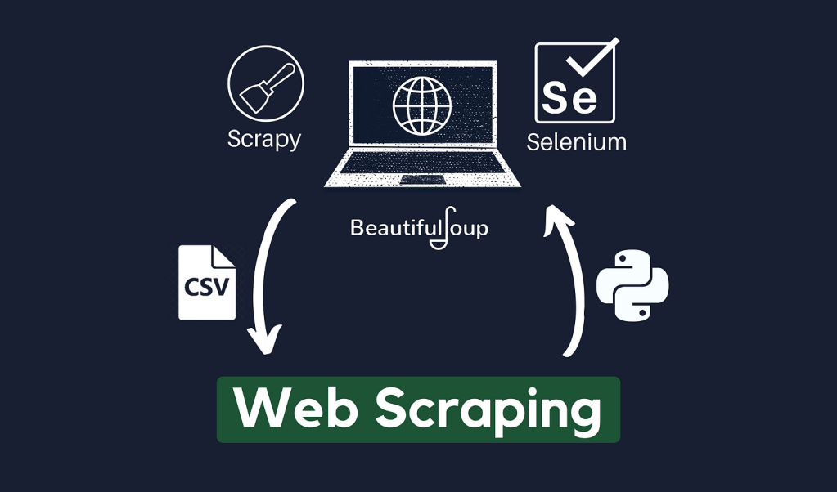

**Common Use Cases of Web Scraping**

Web scraping finds applications in various industries and business domains. Here are some common use cases:

**Price Comparison and Aggregation**

1. Web scraping can be used to extract product details, prices, and availability from e-commerce websites. This allows businesses to offer their customers a wider range of choices, compare prices across multiple platforms, and ensure competitive pricing.
2. By collecting pricing data from different sources, businesses can analyze market trends, identify pricing strategies of competitors, and make data-driven decisions to optimize their pricing strategies.
3. Web scraping can help businesses provide their users with options by aggregating product information from different e-commerce platforms or classified ads websites. This enhances the user experience and increases the chances of making a sale.

**News and Social Media Monitoring**

1. Web scraping can be used to monitor news websites and extract relevant information, such as articles, headlines, and sentiment analysis. This helps businesses stay up-to-date with the latest news and identify media coverage related to their brand or industry.
2. By scraping social media platforms, businesses can analyze public sentiment towards their brand or product. This information can be valuable for reputation management, brand monitoring, and identifying customer feedback.
3. Web scraping can be utilized to track public opinion on various topics or issues by scraping online forums, discussion boards, or social media platforms. This enables businesses to gain insights into the preferences and concerns of their target audience.

**Lead Generation and Sales Prospecting**

1. Web scraping can help businesses extract contact information, such as email addresses and phone numbers, from websites, directories, or social media platforms. This data can be used for lead generation, sales prospecting, and targeted marketing campaigns.
2. By scraping data from relevant websites, businesses can create a database of potential customers based on specific criteria, such as demographics, industry, or interests. This enables targeted marketing efforts and personalized communication with potential leads.
3. Web scraping can provide valuable insights into the behavior and preferences of potential customers. By analyzing scraped data, businesses can tailor their sales and marketing strategies to offer products or services that align with customer needs.

**Content Aggregation and Research**

1. Web scraping can be used to extract content from blogs, articles, or news websites. This allows businesses to aggregate relevant information and analyze trends, enabling them to generate informative reports, industry insights, or research papers.
2. By scraping data from social media platforms or news aggregators, businesses can identify trending topics, hashtags, or keywords. This information can be used to create content that resonates with the target audience and remains relevant in the ever-changing digital landscape.
3. Web scraping can be a valuable tool for researchers, as it allows for the collection of data from various sources. By efficiently gathering information from scientific papers, journals, or public repositories, researchers can save time and streamline the research process.

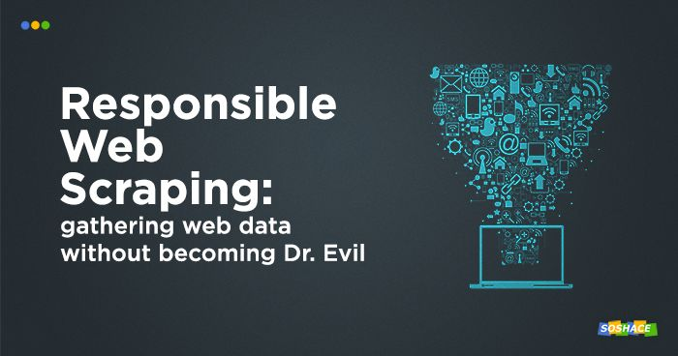

**Ethical Considerations and Legal Aspects**

When conducting web scraping, it is important to consider ethical and legal boundaries to ensure responsible data acquisition and avoid potential conflicts.

**Understanding Website Terms of Service**

Before scraping data from a website, it is crucial to review and understand the website's terms of service or usage policy. Some websites explicitly prohibit scraping or impose specific limitations on data extraction. Respecting these terms is essential to avoid legal consequences.

**Respecting Robots.txt Protocol**

The Robots Exclusion Protocol, commonly known as robots.txt, is a standard used by websites to communicate the rules and permissions for web crawlers or scrapers. It is essential to check the website's robots.txt file before scraping to ensure compliance and respect the website owner's wishes.

**Maintaining Data Privacy and Security**

When scraping data from websites, it is crucial to handle the collected data responsibly and maintain its privacy and security. This includes implementing encryption, access control measures, and complying with relevant data protection regulations.

**Avoiding Unauthorized Access and Scraping**

Unauthorized access to websites or scraping data from sources without permission is not only ethically questionable but also illegal in many jurisdictions. It is important to ensure that scraping activities comply with applicable laws, respect intellectual property rights, and obtain consent if required.

**How to do an Incremental update in web scrapping**

* Using a database to store the list of URLs that have already been scraped. This will make it much faster to check if a URL has already been scraped.
* Using a hash function to generate a unique identifier for each page. This will allow to quickly check if a page has been updated since it was last scraped.
* Schedule the scraper to run periodically. This will ensure that we always have the latest data.

**Multilingual data extraction in Web Scrapping**

* Using a language detection library that supports the languages of the websites you want to scrape.
* Using a translation service that supports the languages of the websites you want to scrape.
* Test your scraper on a variety of websites to make sure that it can correctly identify and extract data from different languages.

**Limitations of python in terms of web scrapping**

Performance and speed: Python may not be as performant as lower-level languages like C++ or Rust. This can be a limitation when dealing with large-scale web scraping tasks or when scraping websites with complex structures.

Memory consumption: Python can consume more memory compared to languages like C or C++. When scraping large amounts of data or processing numerous requests concurrently, memory usage can become a limiting factor.

JavaScript-heavy websites: Python's standard library for web scraping, such as urllib or requests, is not capable of executing JavaScript. Many modern websites heavily rely on JavaScript to render content dynamically. To scrape such websites effectively, you would need to use additional libraries like Selenium or Scrapy in combination with browser automation tools like Puppeteer or Selenium WebDriver.

**Suspicious Activities**  
Hits are termed as suspicious activities. Apart from that, here are some other activities that are termed as suspicious in web scraping:

* **Using multiple IP addresses or proxies.** This can be seen as an attempt to mask your identity and avoid detection.
* **Scraping at high speeds.** This can put a strain on the website's servers and make it difficult for other users to access the site.
* **Scraping sensitive data.** This includes data such as credit card numbers, social security numbers, and medical records.
* **Scraping without permission.** This is a violation of the website's terms of service and can result in legal action.

**Conclusion**

Web scraping proves to be a powerful tool in today's data-driven world. It offers a wide range of benefits, including high-quality data acquisition, time and cost efficiency, competitor analysis, and market research. By utilizing web scraping tools and adhering to ethical and legal guidelines, businesses can unlock valuable insights, optimize their processes, and gain a competitive edge.

**FAQs (Frequently Asked Questions)**

Here are some commonly asked questions about web scraping:

**What programming languages are commonly used for web scraping?**

Python is one of the most popular programming languages for web scraping due to its rich ecosystem of scraping tools and libraries, such as Beautiful Soup and Scrapy. However, other languages like PHP, Ruby, or JavaScript can also be used for web scraping, depending on the specific requirements and preferences.

**How to extract images and videos in web scrapping ?**  
Extracting images and videos in web scraping can be done using a variety of methods. Here are a few common approaches:

* **Using a regular expression.** A regular expression is a pattern that can be used to match text. You can use a regular expression to match the HTML code for an image or video tag, and then extract the URL of the image or video from the tag.
* **Using the Beautiful Soup library.** Beautiful Soup is a Python library that can be used to parse HTML and XML documents. You can use Beautiful Soup to find and extract images and videos from a website.

**References:**

<https://www.optisolbusiness.com/insight/data-scraping-top-5-advantages>

<https://dataforest.ai/blog/top-10-web-scraping-use-cases-in-2023>

<https://medium.com/@dan_21864/best-web-scraping-tools-apis-and-frameworks-655cb71944fe>

<https://monashdatafluency.github.io/python-web-scraping/section-5-legal-and-ethical-considerations/>

-Anjali