 

Project on

MER

(Movie Extractor and Recommender)

**TEAM 48:**

TEAM MEMBERS:

Anjali Pal

Niranjan Jena

Prakhar Gupta

Satyajit Kumar

Soumyabrata Ghosh

ACKNOWLEDGEMENT

We owe our deep gratitude to Dr. Laxmidhar Behera, Dr. Himanshu Singh, Dr. Vipul Arora , Dr. Pawan Goyal and Sandeep Gupta  for providing us an opportunity to do this project work at Indian Institute of Technology , Kanpur and giving us all support and guidance which made us complete the project duly.

We would not forget to remember the support of Teacher Assistants for their encouragement and more over for their timely support and guidance till the completion of our project work.

**INDEX**

1. Introduction
2. Dataset-MovieLens
3. Approaches
4. Content-Based
5. Collaborative Filtering
6. Hybrid Recommendation System
7. What have we done? – Our Approach
8. The Website
9. References

**INTRODUCTION**

Recommender System is a system that seeks to predict or filter preferences according to the user’s choices.

They are utilized in a variety of areas, and are most commonly recognized as playlist generators for video and music services like Netflix, YouTube and Spotify, product recommenders for services such as Amazon, or content recommenders for social media platforms such as Facebook and Twitter.

**DATASET – MOVIELENS-LATEST**

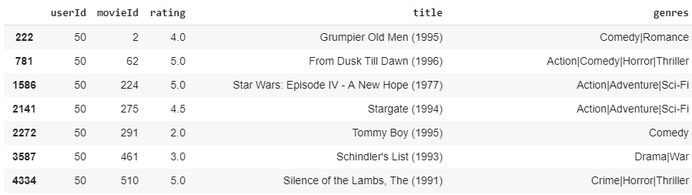

This dataset (ml-latest-small) describes 5-star rating and activity from [Movie Lens] (http://movielens.org), a movie recommendation service. It contains 100836 ratings across 9742 movies. These data were created by 610 users between March 29, 1996 and September 24, 2018. This dataset was generated on September 26, 2018.

**APPROACHES**

The three most prominent approaches in Recommendation Systems are:

1. Collaborative System

2. Content Based System

3. Hybrid System (Collaborative + Content)

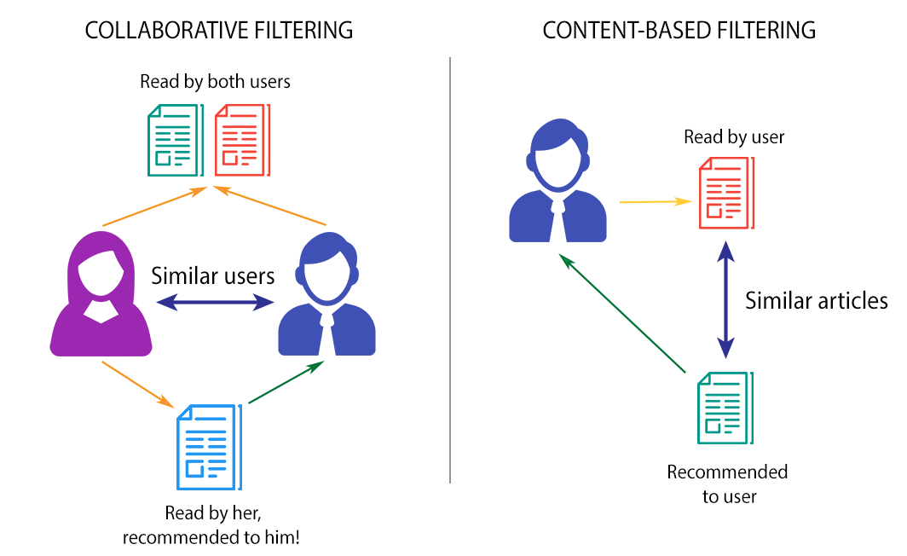

**Content Based Approach**

A content-based recommender works with data that the user provides, either explicitly (rating) or implicitly (clicking on a link). Based on that data, a user profile is generated, which is then used to make suggestions to the user.

As the user provides more inputs or takes actions on the recommendations, the engine becomes more and more accurate.

**Collaborative Based Approach**

Collaborative filtering is a method of making automatic predictions (filtering) about the interests of a user by collecting preferences or taste information from many users (collaborating).

The underlying assumption of the collaborative filtering approach is that if a person *A* has the same opinion as a person *B* on an issue, A is more likely to have B's opinion on a different issue than that of a randomly chosen person.

**HYBRID RECOMMENDATION SYSTEM**

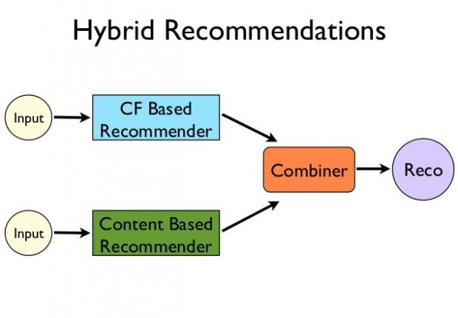

**OUR APPROACH**

**Content Filtering Algorithm**

Here, we have only taken into account the three movies, the user has provided.

Based on the genres, the system tries to find similar movies using cosine similarity.

**Collaborative Filtering System**

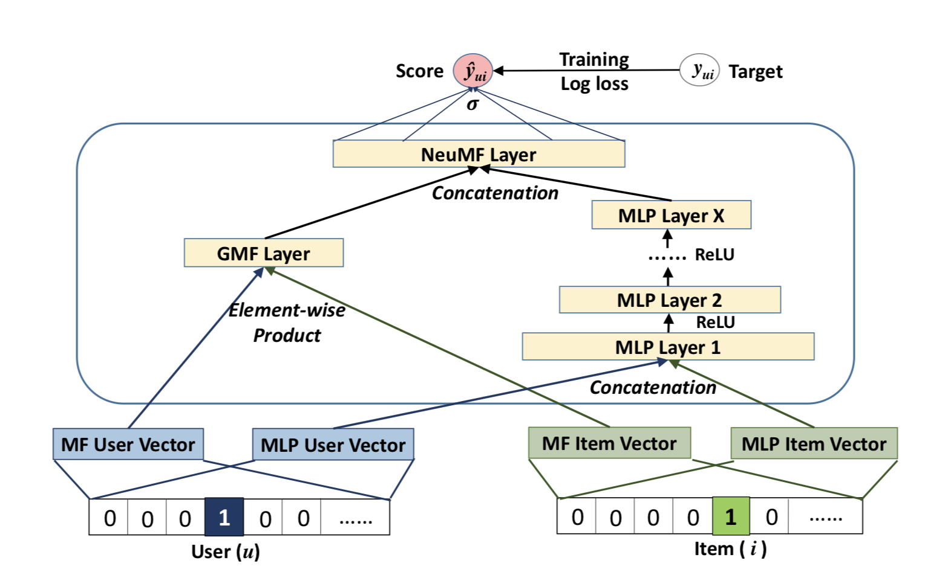

**We have used a hybrid recommendation wherein we are using plot and genres of movies for content-based filtering and Users are used for collaborative filtering.**

**Then, we have clubbed the two approaches together to get our final recommendation list.**

**WEBSITE**

Made using Flask

**TRAILERS**

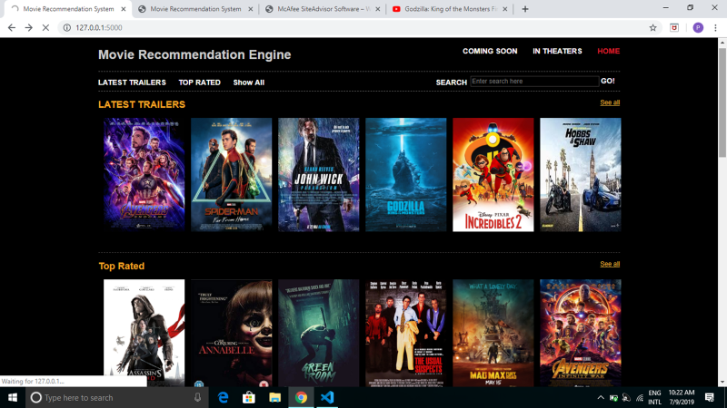

**ALL MOVIES**

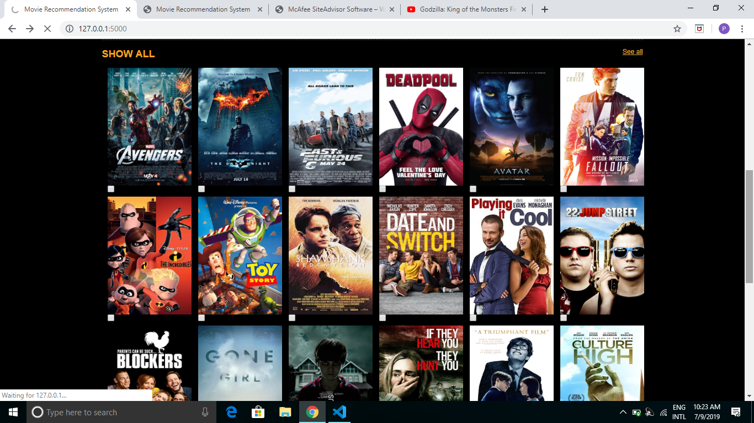

**RECOMMEND OPTION**

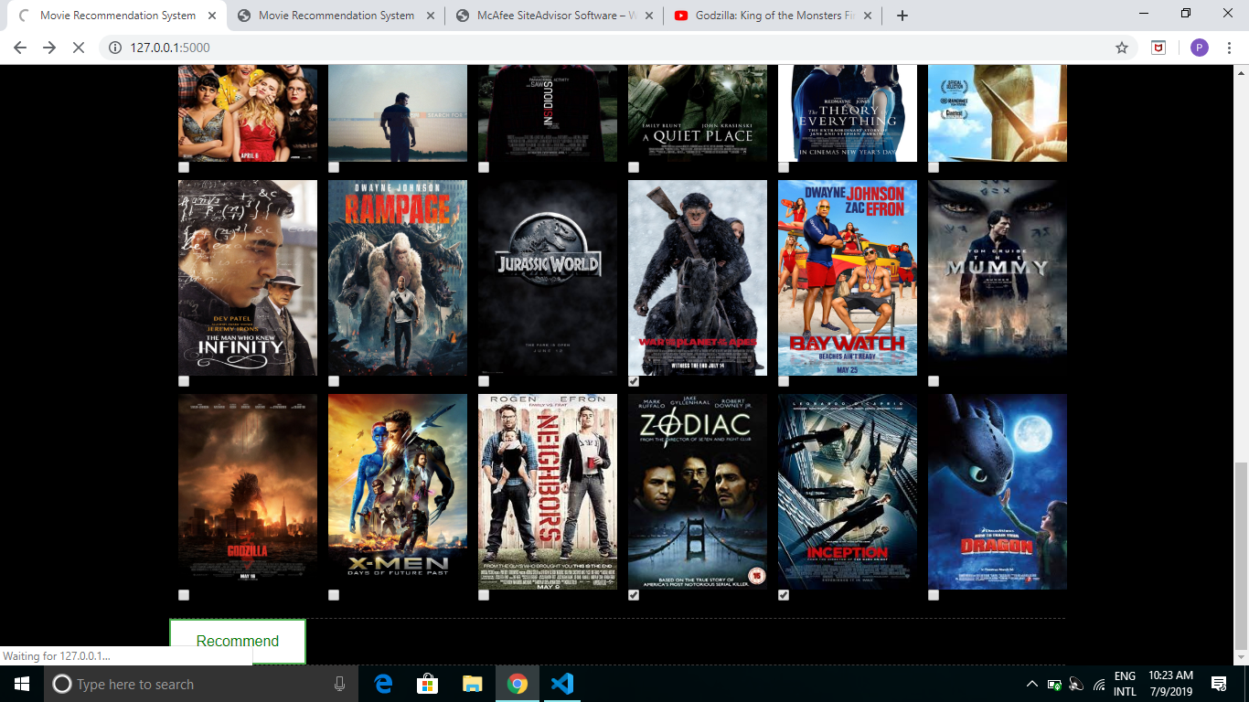

**FINAL OUTPUT**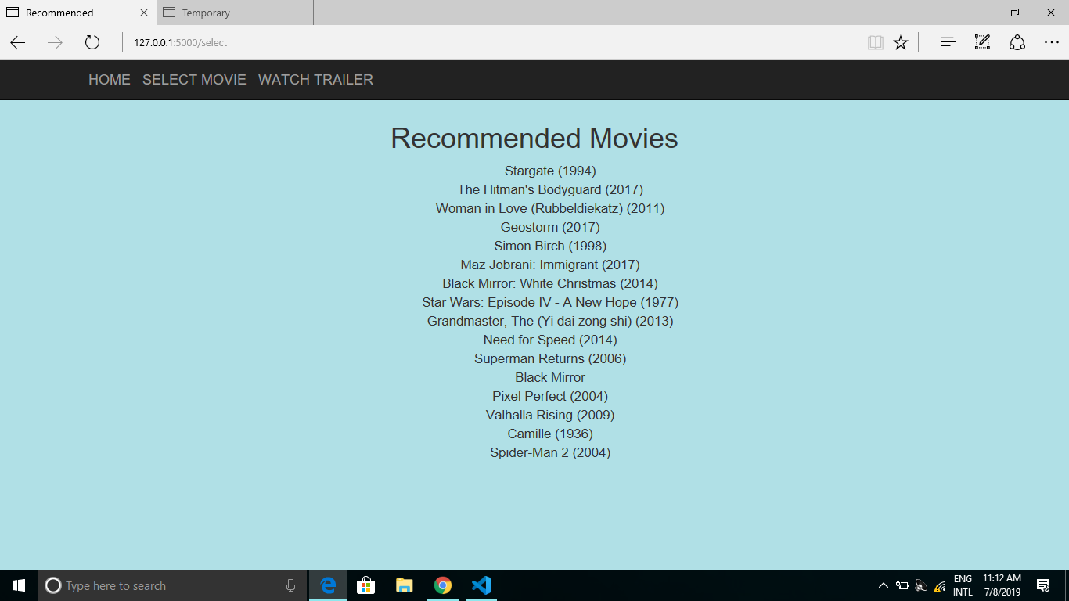

**REFERENCES**

1. Research Paper:

<https://dl.acm.org/citation.cfm?id=3052569>

By: He Xiangnan , Liao Lizi , et.al

Published in 2017

2. Neu-mf approach <https://nipunbatra.github.io/blog/2017/neural-collaborative-filtering.html>

3. GeeksForGeeks

4. Analytics Vidhya