***Setting OpenGL on Windows (Eclipse)***

1. Download Eclipse and MinGW from Following link:

Put these both Folders on OS installed drive (assume C:\).

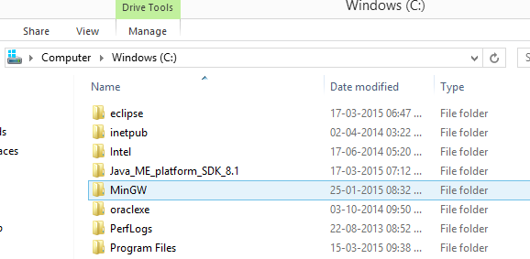

Also download OpenGL libraries. (These folders must be placed inside one of the folders in MinGW. Probably C:\MinGW\include\GL )

* + - ***Important:*** Also download “freeglut.dll” file. Then put that file in:

C:\Windows\System32 → [for 32-bit OS Users].

C:\Windows\System32 and C:\Windows\SysWOW64 → [for 64-bit OS Users].

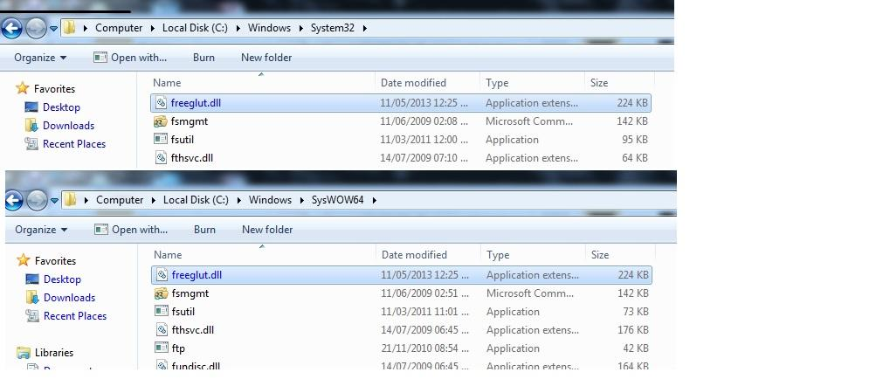

* + - After Downloading Eclipse install C/C++ Development Tools plugin [Google it].

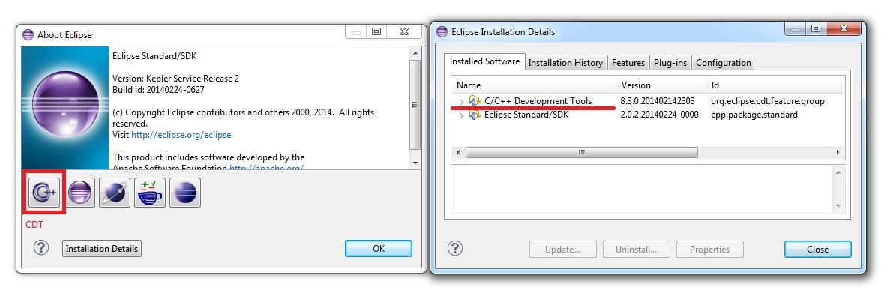

1. Right click on My Computer→Properties→Advanced system settings→Environment Variables.

Choose Path and click Edit.

Copy paste Following in Variable value as it is (only if MinGW is in ‘C:\’) :

inn:C:\MinGW\bin;

C:\MinGW\include\GL;

C:\MinGW\lib;

C:\MinGW\lib\gcc\mingw32\4.8.1\include

Then OK in all three windows.

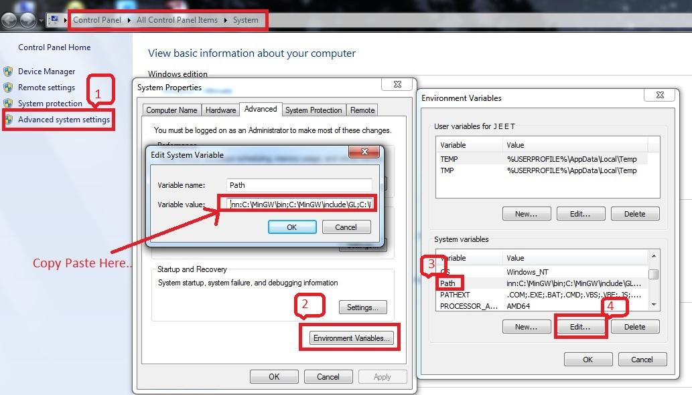

1. Run Eclipse.

3.1 File→New→Project→Double click on C/C++→C Project→Next→Fill Fields→Next→Check both Debug and Release→Finish→Yes.

3.2 In Eclipse under Project Explorer right click on project name→Properties→Double click on C/C++General→Paths and Symbols.

3.2.1 In Configuration select Release→click on Manage Configuration→Select Release then set Active→OK→Apply.

3.2.2 Under Includes tab in Languages select GNU C.

3.2.3 Click on Libraries→Add→add three libraries: freeglut, glu32, opengl32 one by one→Apply→OK.

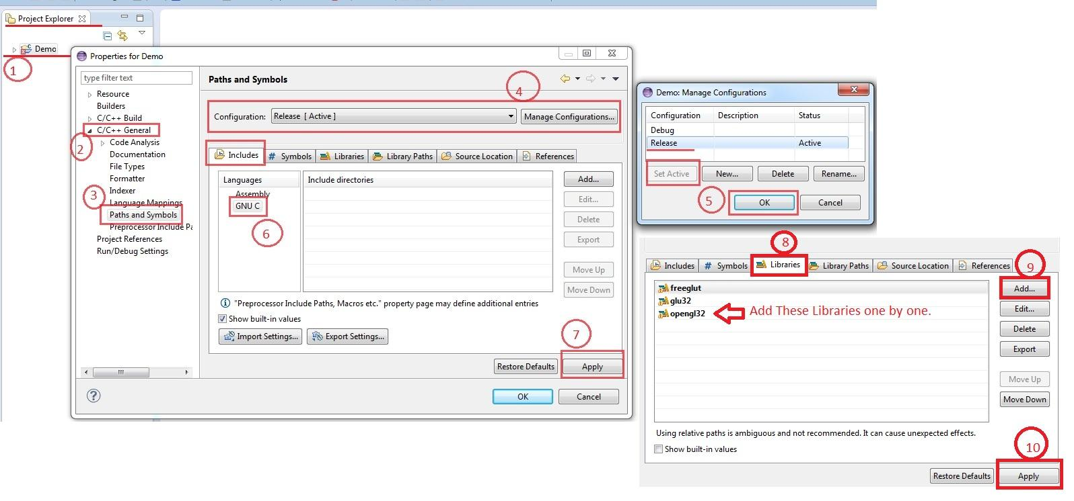

3.3 Add the sample OpenGL program and then build and Run it.