## **Assignment: Git Hands-on Practice**

### **Task 1: Configure Git**

1. Set your username and email in Git.
2. Verify the configuration.
git config --global user.name "Anjali"
git config --global user.email "23652anjali.2020cse@gmail.com"
git config --global --list

**Expected Output:**
Screenshot or command output showing configured username and email.
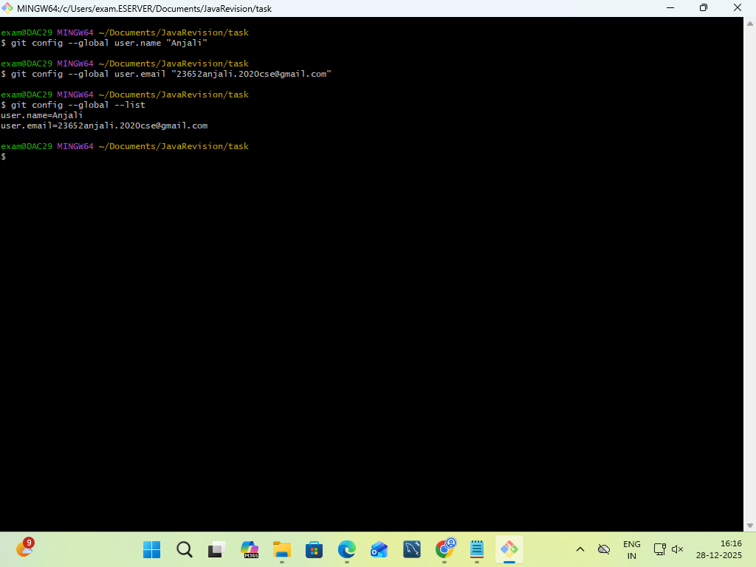

### **Task 2: Initialize a Local Repository**

1. Create a new folder named `git-hands-on`.
2. Initialize it as a Git repository.
3. Check the repository status.
mkdir git-hands-on
cd git-hands-on
git init
git status

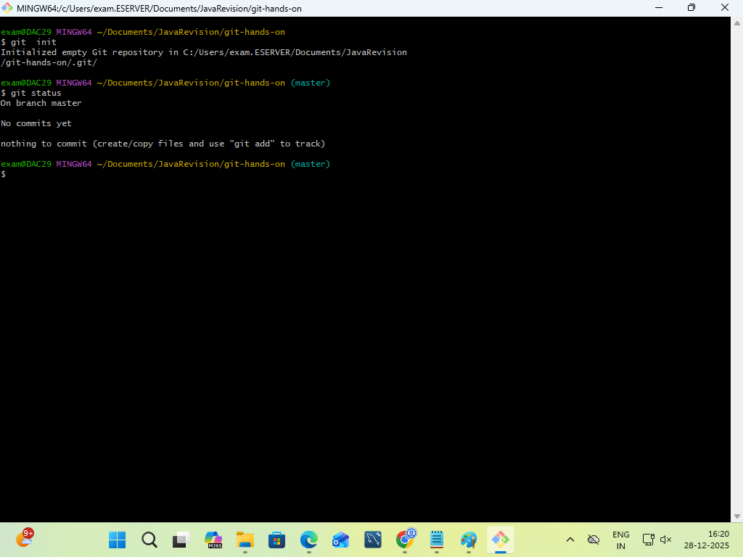

### **Task 3: Create and Track Files**

1. Create a file named `documentation.txt`.
2. Add a short project description inside it.
3. Check file status.
4. Stage the file.
5. Commit the changes with an appropriate message.
git status
git add documentation.txt
git commit -m "initial changes

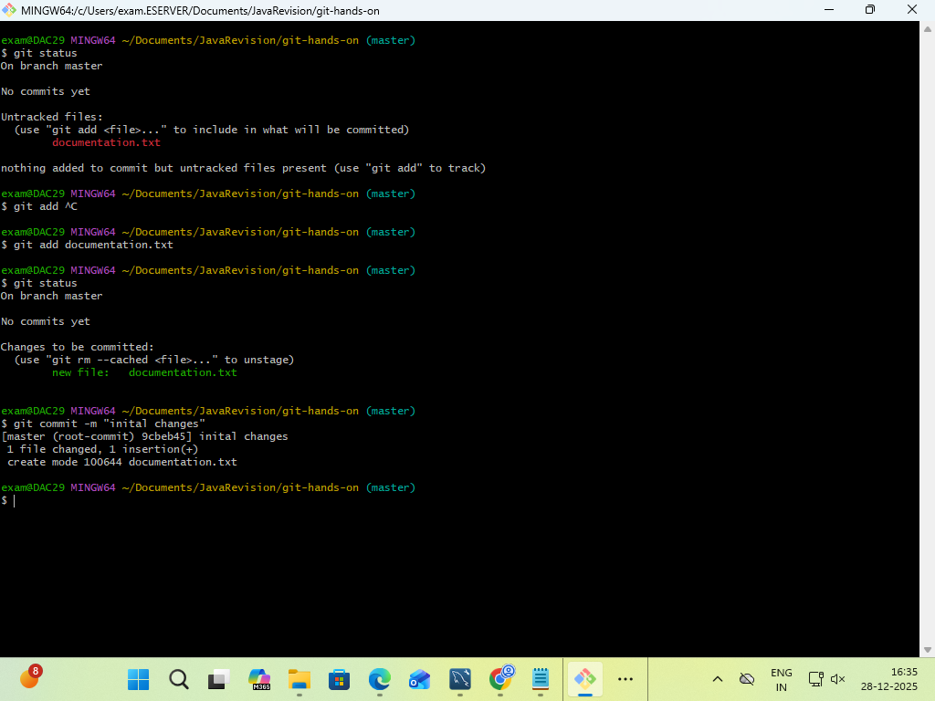
### **Task 4: Modify and Commit Changes**

1. Edit `documentation.txt` and add one more line.
2. View the differences between working directory and staging area.
3. Stage and commit the changes.
git diff
git add documentation.txt
git commit -m "second changes"

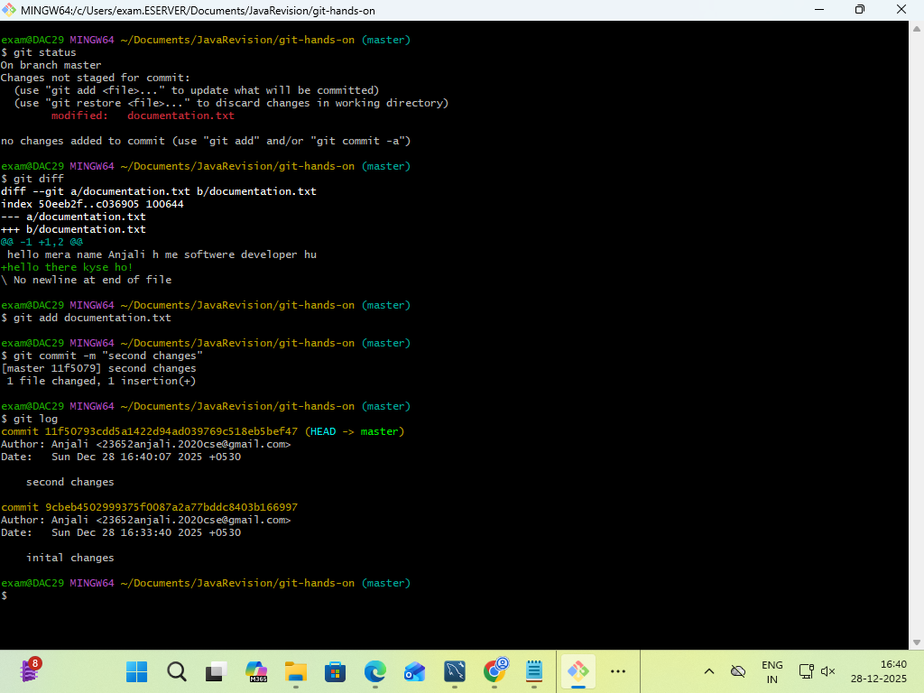
### **Task 5: View Commit History**

1. View the complete commit history.
2. View commit history in one-line format.
git log
git log --pretty=oneline

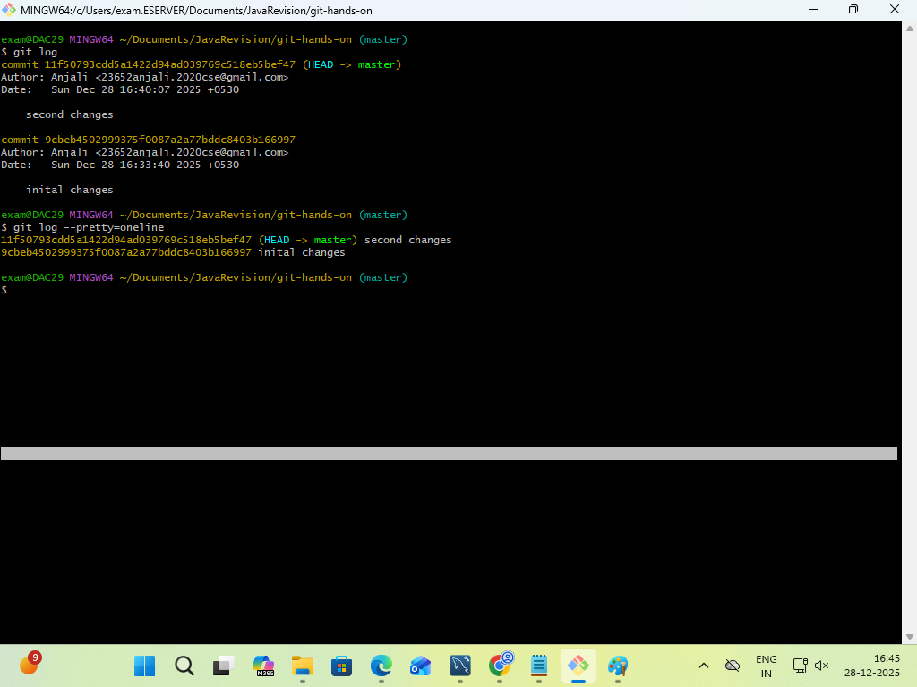
### **Task 6: Create and Work with Branches**

1. Create a new branch named `feature-1`.
2. Switch to the new branch.
3. Create a new file `feature.txt`.
4. Commit the changes.
5. Switch back to the main branch.
git branch feature-1
git checkout feature-1
touch feature.txt
git add feature.txt
git commit -m "new changes
git checkout master

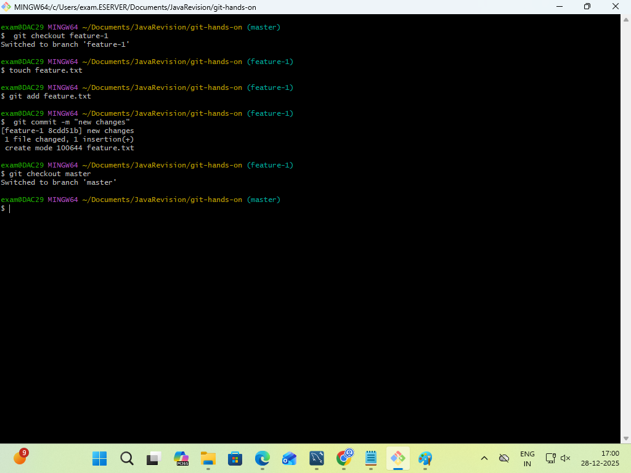
### **Task 7: Merge Branches**

1. Merge `feature-1` branch into `main`.
2. Verify the merge using commit history.
git merge feature-1
git log

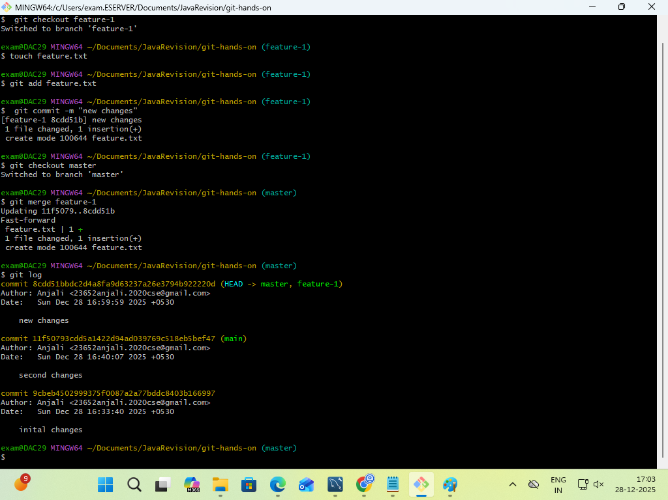
### **Task 8: Connect to a Remote Repository**

1. Create a new repository on GitHub.
2. Add the remote repository URL to your local repo.
3. Verify the remote connection.
git remote add origin https://github.com/Anjali1-cse/tests.git
git remote -v

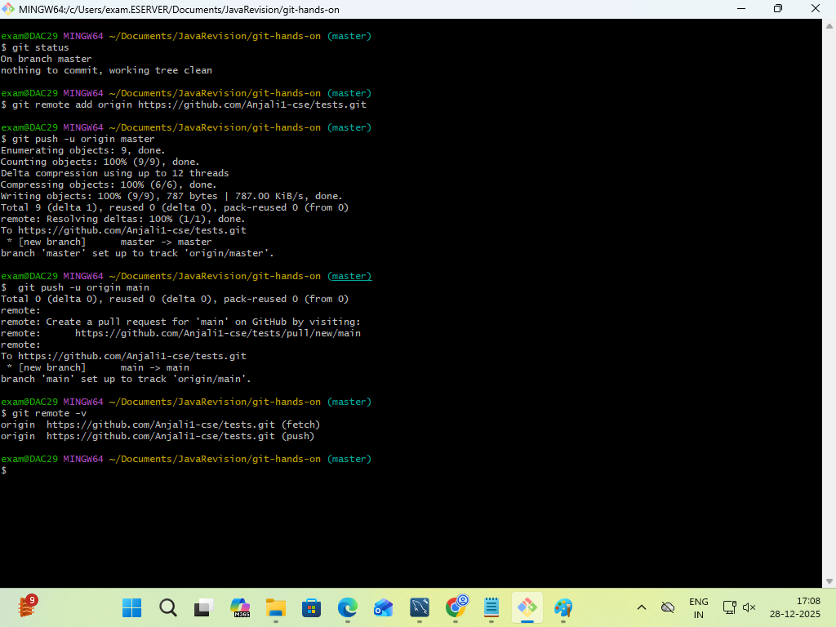

### **Task 9: Push Code to GitHub**

1. Push the `main` branch to GitHub.
2. Verify files on GitHub.
git push -u origin main
https://github.com/Anjali1-cse/tests

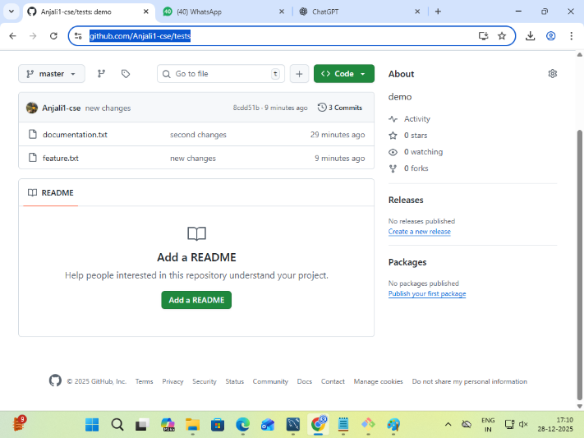

### **Task 10: Clone a Repository**

1. Clone the same GitHub repository into a different folder.
2. Verify the cloned content.
git clone https://github.com/Anjali1-cse/tests

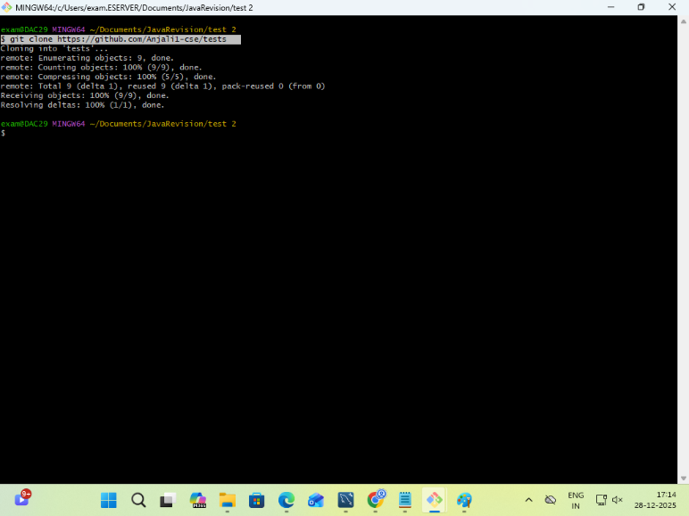

### **Task 11: Undo Changes**

1. Make a change in `documentation.txt` but do not commit.
2. Discard the changes.
3. Verify the file status.
git status
git log
git reset 8cdd51bbdc2d4a8fa9d63237a26e3794b922220d --hard
git status

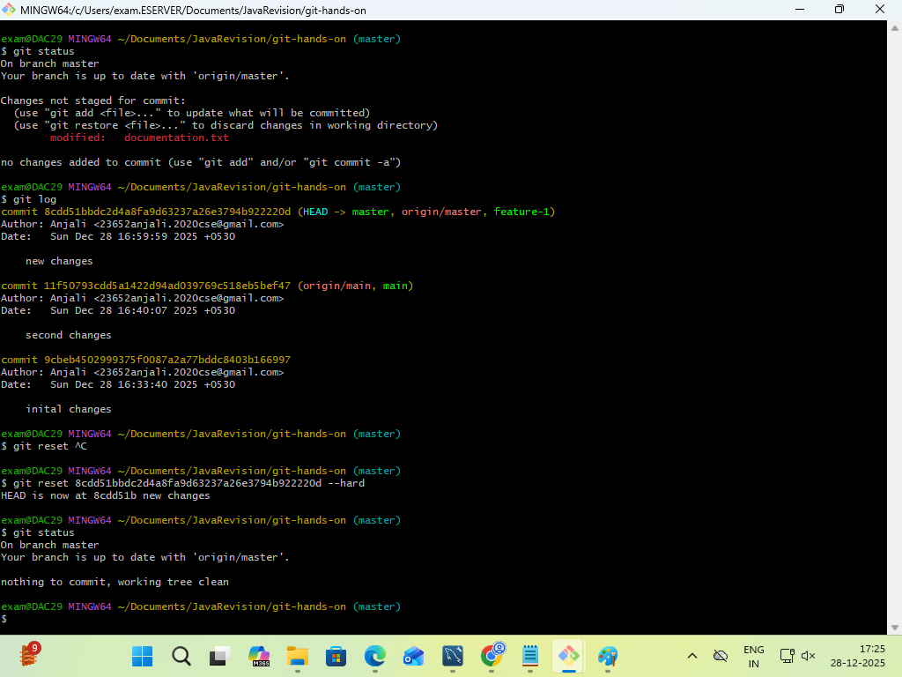

### **Task 12: Remove Files**9
1. Delete `feature.txt` using Git.
2. Commit the deletion.
git rm feature.txt
git commit -m "Remove feature.txt"
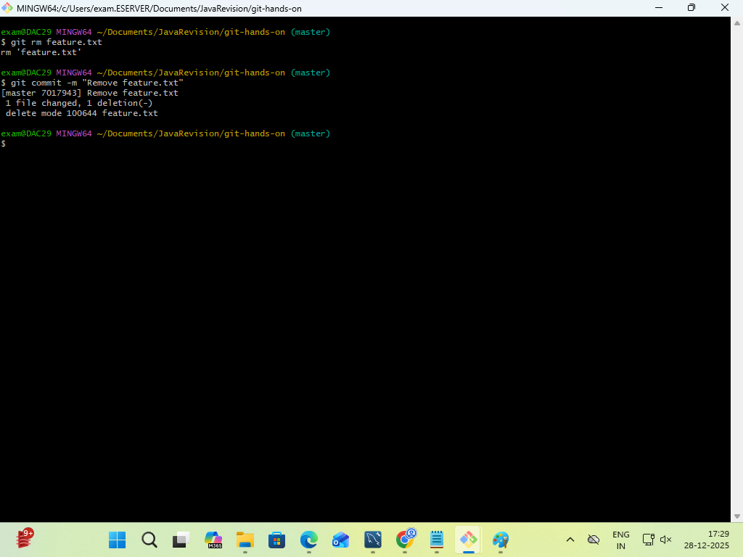

## **Submission Guidelines**

* Submit screenshots or terminal output for each task
* Provide GitHub repository link
https://github.com/Anjali1-cse/tests
* Ensure commit messages are meaningful

