Section 10: Integrate AI agent into existing Test Automation framework -Playwright

Code:

// @ts-check

const { test, expect } = require('@playwright/test');

import {ai} from "@zerostep/playwright"

test('AI Test capability', async ({ page }) => {

  const aiArgs = {page,test}

  await page.goto('https://rahulshettyacademy.com/seleniumPractise/#/offers');

  const discountPrice = await ai("What is the Discount price of Tomato",aiArgs)

  expect(discountPrice).toEqual("26")

  const price = await ai("What is the Price of Tomato",aiArgs)

  expect(price).toEqual("37")

  const diff = await ai("What is the value difference between price and Discounr price of tomato",aiArgs)

  expect(diff).toEqual("11")

  await page.goto("https://rahulshettyacademy.com/dropdownsPractise/")

  const blinkingText = await ai("Get blinkingText in the page",aiArgs)

  expect(blinkingText).toEqual("London QA Meetup @Rahul Shetty - Limited Seats! Book Now!")

  const firstValue = await ai('Split ${blinkingText} with "-" and give 0th index value',aiArgs)

  console.log(firstValue)

  expect(firstValue).toEqual("London QA Meetup @Rahul Shetty")

});

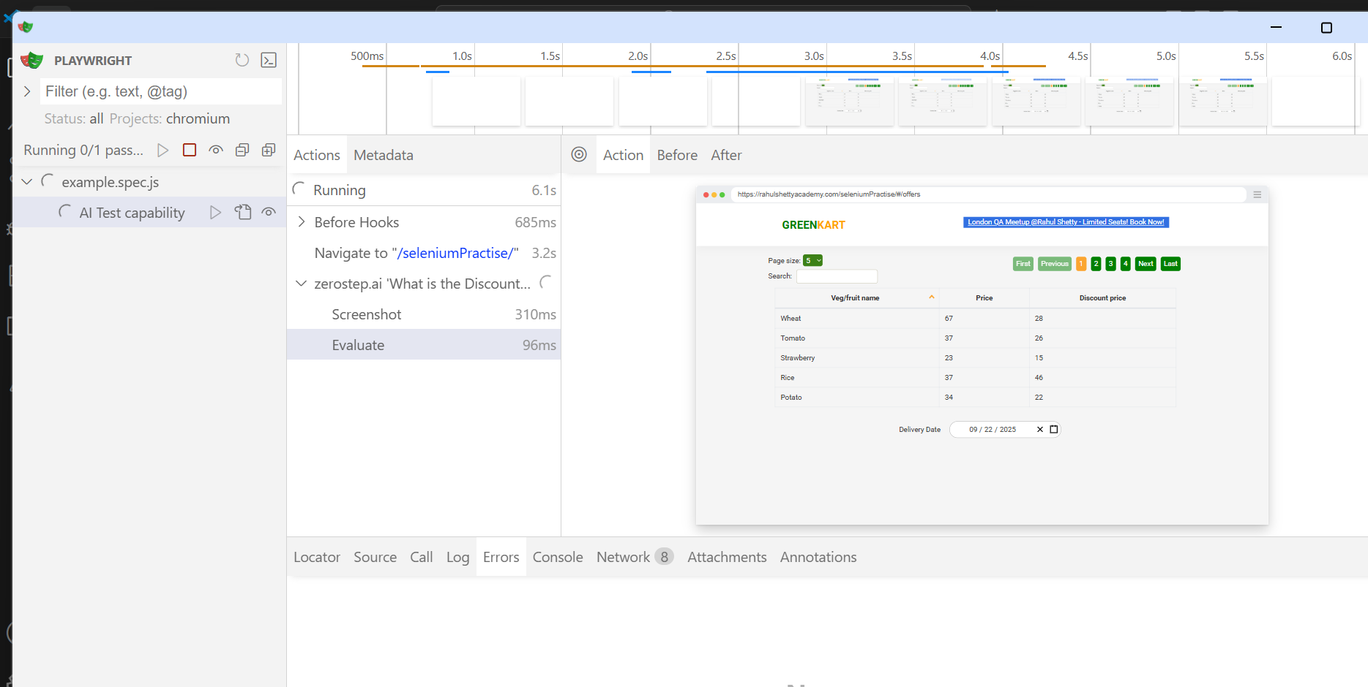

Test2: Failed as text not matching.

Url: <https://rahulshettyacademy.com/dropdownsPractise/>

Get blinkingText in the page

Expected: Free Access to InterviewQues/ResumeAssistance/Material

Output: London QA Meetup @Rahul Shetty - Limited Seats! Book Now!

