E-Commerce Data Cleaning, Analysis and Dashboard Development Report
Tools & Technologies
- Python
- Pandas
- Microsoft Excel
- Power BI
- Visual Studio Code

Abstract
Data quality plays a crucial role in ensuring accurate business reporting and decision-making. This project focused on cleaning, validating, and analyzing an e-commerce dataset containing customer orders, product information, payment details, and revenue data.
The project involved identifying missing values, validating business rules, ensuring data consistency, performing exploratory analysis, and developing an interactive Power BI dashboard. The final outcome was a clean, reliable dataset and a business intelligence dashboard capable of delivering meaningful insights into sales performance, customer behavior, and revenue trends.

1. Introduction
Organizations rely on high-quality data to make strategic decisions. However, raw datasets often contain missing values, inconsistencies, formatting issues, and other quality problems that can impact analysis.
This project demonstrates the complete data analytics workflow:
- Data Cleaning
- Data Validation
- Exploratory Data Analysis (EDA)
- Dashboard Development
- Business Insight Generation
The objective was to transform raw transactional data into a structured and analysis-ready dataset while creating an interactive dashboard for decision-making.

2. Project Objectives
The primary objectives of this project were:
- Identify and handle missing values.
- Detect duplicate records.
- Validate data consistency and business rules.
- Standardize and prepare data for analysis.
- Perform exploratory data analysis.
- Create a professional Power BI dashboard.
- Generate actionable business insights.

3. Dataset Overview
The dataset contains e-commerce order transactions and customer purchase information.
Dataset Summary
Metric | Value
Total Records | 1200
Total Columns | 14
Dataset Type | E-Commerce Sales Data
Dataset Attributes
- OrderID
- Date
- CustomerID
- Product
- Quantity
- UnitPrice
- ShippingAddress
- PaymentMethod
- OrderStatus
- TrackingNumber
- ItemsInCart
- CouponCode
- ReferralSource
- TotalPrice

4. Data Cleaning Process
4.1 Dataset Inspection
The dataset was loaded into Python using the Pandas library and examined using:
df.info()
df.describe()
df.isnull().sum()
This helped identify missing values, data types, and overall dataset structure.

4.2 Missing Value Analysis
A missing value assessment was performed across all columns.
Findings
Column | Missing Values
CouponCode | 309
Other Columns | 0
Action Taken
Since coupon usage is optional in e-commerce transactions, missing values in the CouponCode column were replaced with:
No Coupon
using:
df["CouponCode"] = df["CouponCode"].fillna("No Coupon")
Outcome
All missing values were successfully resolved.

4.3 Duplicate Record Detection
Duplicate records were checked to ensure data uniqueness.
Checks Performed
- Duplicate Rows
- Duplicate Order IDs
- Duplicate Tracking Numbers
Results
Validation | Result
Duplicate Rows | 0
Duplicate Order IDs | 0
Duplicate Tracking Numbers | 0
Outcome
No duplicate records were found.

4.4 Data Validation
Business rules were applied to identify invalid entries.
Validation Criteria
- Quantity > 0
- UnitPrice > 0
- TotalPrice > 0
- ItemsInCart > 0
Results
Validation Rule | Invalid Records
Quantity ≤ 0 | 0
UnitPrice ≤ 0 | 0
TotalPrice ≤ 0 | 0
ItemsInCart ≤ 0 | 0
Outcome
No invalid records were detected.

4.5 Pricing Consistency Verification
To ensure pricing accuracy, TotalPrice was verified using:
TotalPrice = Quantity × UnitPrice
The verification process confirmed that all records followed the expected business calculation.
Result
Check | Result
Pricing Mismatches | 0

4.6 Data Standardization
To maintain consistency across text-based fields:
- Leading spaces were removed.
- Trailing spaces were removed.
- Date formats were verified.
- Data types were validated.
The dataset was standardized and prepared for further analysis.

5. Exploratory Data Analysis (EDA)
After cleaning, exploratory analysis was conducted to uncover patterns and trends.
Areas Analyzed
- Revenue distribution
- Product performance
- Customer purchasing behavior
- Payment method preferences
- Monthly revenue growth
- Order status analysis
- Marketing channel performance
The analysis provided a deeper understanding of customer transactions and business performance.

6. Power BI Dashboard Development
Following data preparation, the cleaned dataset was imported into Power BI to build an interactive business intelligence dashboard.
The dashboard was designed to provide a consolidated view of sales performance and customer activity while enabling interactive filtering and drill-down analysis.

Dashboard Layout
KPI Section
The top section of the dashboard contains key performance indicators (KPIs) that provide a quick overview of business performance.
KPIs Included:
- Total Revenue
- Total Orders
- Total Customers
- Average Order Value
- Quantity Sold
- Revenue per Customer
These metrics allow stakeholders to evaluate overall business performance at a glance.

Revenue Trend Analysis
A line chart was developed to visualize monthly revenue trends.
Purpose:
- Monitor sales growth over time.
- Identify seasonal patterns.
- Detect periods of high or low performance.

Product Performance Analysis
A bar chart was created to display:
Top Products by Revenue
Purpose:
- Identify best-selling products.
- Evaluate product profitability.
- Support inventory planning and marketing decisions.

Marketing Channel Analysis
A donut chart was used to analyze:
Revenue by Marketing Channel
Purpose:
- Measure channel effectiveness.
- Identify high-performing acquisition sources.
- Optimize marketing investments.

Payment Method Analysis
A donut chart was created to visualize:
Revenue by Payment Method
Purpose:
- Understand customer payment preferences.
- Evaluate transaction trends.
- Support payment strategy decisions.

Interactive Filtering
The dashboard includes slicers for:
- Order Status
- Payment Method
These filters enable users to explore specific segments of the data and generate customized insights.

Dashboard Screenshot
Figure 1: E-Commerce Sales Analytics Dashboard
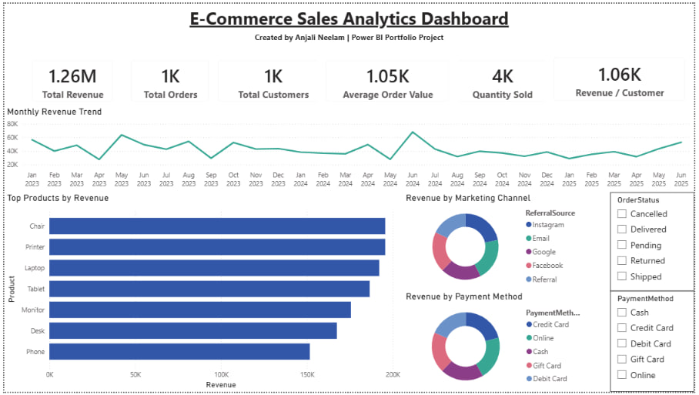Figure 1. Interactive Power BI Dashboard developed using the cleaned e-commerce dataset.

7. Dashboard Highlights
The dashboard provides the following business metrics and visualizations:
Key Performance Indicators
- Total Revenue KPI
- Total Orders KPI
- Total Customers KPI
- Average Order Value KPI
- Quantity Sold KPI
- Revenue per Customer KPI
Business Visualizations
- Monthly Revenue Trend Analysis
- Top Products by Revenue
- Revenue by Marketing Channel
- Revenue by Payment Method
- Interactive Filters for Order Status
- Interactive Filters for Payment Method

8. Skills Applied and Learned
This project strengthened practical skills across the data analytics lifecycle.
Data Analytics Skills
- Data Cleaning
- Data Validation
- Data Transformation
- Exploratory Data Analysis
- Business Intelligence Reporting
Python Skills
- Pandas Data Manipulation
- Missing Value Handling
- Duplicate Detection
- Data Validation Techniques
Power BI Skills
- Dashboard Development
- KPI Design
- DAX Measures and Calculations
- Interactive Slicers and Filters
- Data Visualization Best Practices
- Dashboard Layout and Design

9. Results Summary
Quality Check | Status
Missing Values | Resolved
Duplicate Records | None Found
Invalid Values | None Found
Data Consistency | Verified
Exploratory Analysis | Completed
Dashboard Development | Completed

10. Conclusion
The project successfully transformed a raw e-commerce dataset into a clean, validated, and analysis-ready dataset. Missing values were handled, duplicate checks were performed, business rules were validated, and pricing consistency was verified.
Using the cleaned dataset, an interactive Power BI dashboard was developed to visualize sales performance, customer behavior, product performance, payment preferences, and marketing effectiveness.
The project demonstrates practical expertise in data cleaning, exploratory analysis, business intelligence reporting, and dashboard development. The resulting dashboard provides valuable insights that can support data-driven business decisions and performance monitoring.

Deliverables
- Raw Dataset
- Cleaned Dataset
- Python Data Cleaning Script
- Exploratory Data Analysis Script
- Dashboard Visualization Script
- Power BI Dashboard (.pbix)
- Dashboard Images
- Project Report

Author
Anjali Neelam

