E-Commerce Sales Data Analysis Report
Project Information
Project Title: E-Commerce Sales Data Analysis & Dashboard
Internship Task: Task 2 – Exploratory Data Analysis (EDA)
Prepared By: Anjali Neelam
Tools Used: Python, Pandas, NumPy, Matplotlib, VS Code

1. Introduction
The objective of this project is to perform Exploratory Data Analysis (EDA) on an E-Commerce Sales dataset to identify sales trends, customer purchasing behavior, product performance, and revenue patterns. The analysis was conducted using Python libraries such as Pandas and Matplotlib.
The dataset used for this project was cleaned and prepared during Task 1 (Data Cleaning & Preparation) before being utilized for analysis.

2. Dataset Overview
The dataset contains transactional sales records from an e-commerce platform.
Dataset Summary
Attribute | Value
Total Records | 1200
Total Columns | 14
Dataset Type | E-Commerce Sales Data
Features Included
- OrderID
- Date
- CustomerID
- Product
- Quantity
- UnitPrice
- ShippingAddress
- PaymentMethod
- OrderStatus
- TrackingNumber
- ItemsInCart
- CouponCode
- ReferralSource
- TotalPrice

3. Exploratory Data Analysis
3.1 Statistical Summary
The dataset was analyzed using descriptive statistics to understand the distribution of sales data.
Quantity Analysis
- Average Quantity Sold: 2.95
- Median Quantity Sold: 3
Unit Price Analysis
- Average Unit Price: ₹356.41
- Median Unit Price: ₹364.21
Total Price Analysis
- Average Order Value: ₹1053.97
- Median Order Value: ₹823.62

3.2 Product Analysis
The frequency of product orders was analyzed to identify top-selling products.
Top Products
- Printer
- Tablet
- Chair
- Laptop
- Desk
Observation:
Printer was identified as the highest-selling product among all categories.

3.3 Payment Method Analysis
Customer payment preferences were analyzed.
Most Preferred Payment Methods
- Online Payment
- Cash
- Credit Card
- Debit Card
- Gift Card
Observation:
Online Payment was the most frequently used payment method.

3.4 Revenue Analysis
Revenue metrics were calculated to evaluate business performance.
Revenue Statistics
Metric | Value
Total Revenue | ₹1,264,761.96
Highest Order Value | ₹3,456.40
Lowest Order Value | ₹11.39
Observation:
The business generated over ₹1.26 million in revenue across 1200 orders.

3.5 Monthly Revenue Trend
Monthly sales performance was analyzed using time-series aggregation.
Observation:
Revenue fluctuated across different months, indicating possible seasonal purchasing patterns and varying customer demand.

3.6 Outlier Detection
The Interquartile Range (IQR) method was used to identify unusual order values.
Results
- Outliers Detected: 8
Observation:
A small number of transactions were identified as unusually high-value orders.

4. Data Visualizations
The following visualizations were generated:
Product Orders Analysis
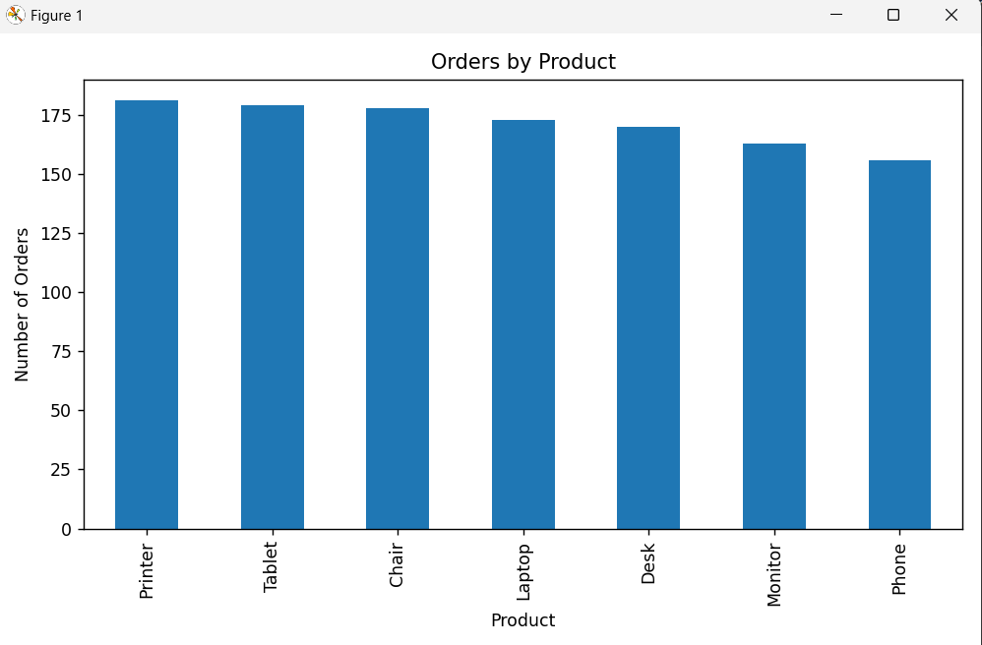
Payment Method Distribution
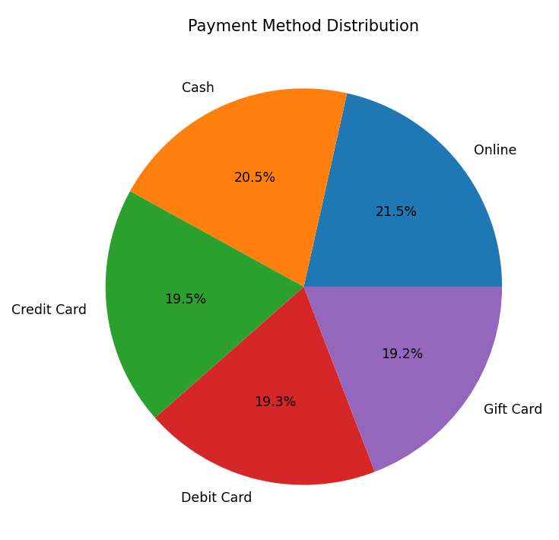

Monthly Revenue Trend
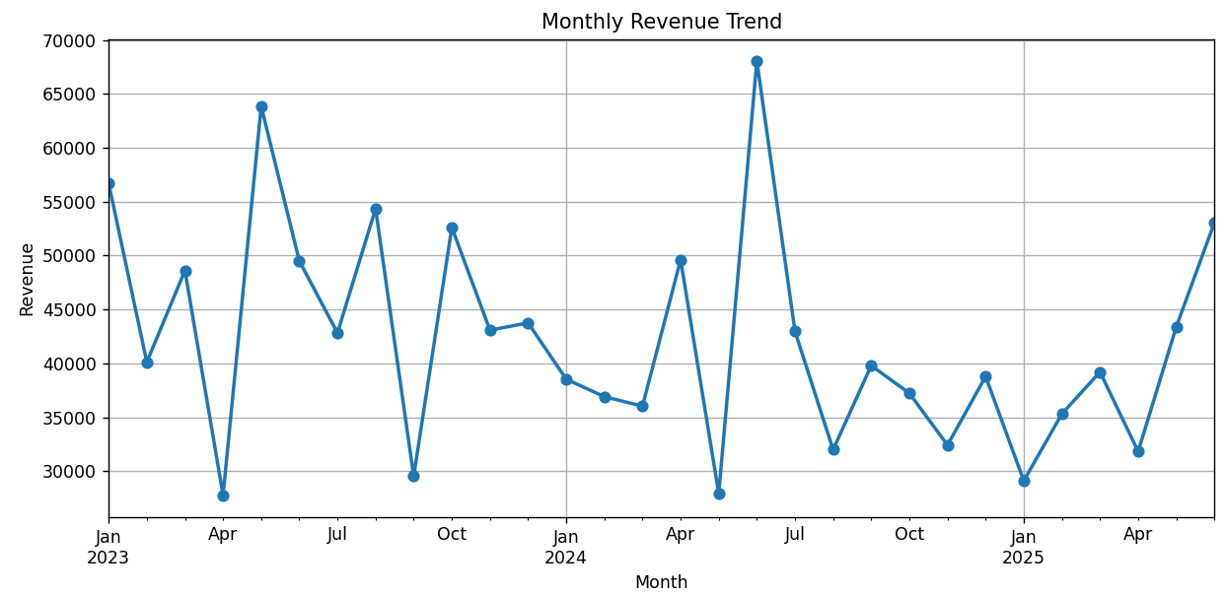Revenue Distribution
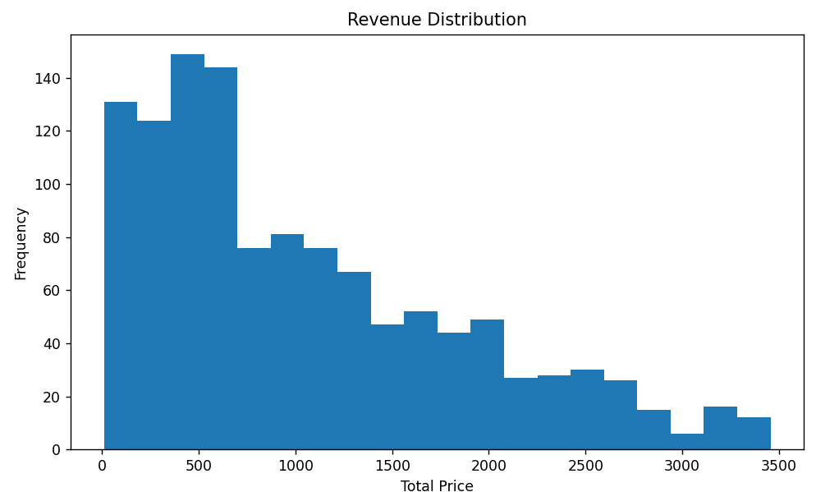

5. Dashboard Development
A Power BI–style dashboard was developed using Python and Matplotlib to provide an interactive business overview.
Dashboard KPIs
- Total Revenue
- Total Orders
- Average Order Value
- Top Product
Dashboard Components
- Monthly Revenue Trend
- Product Order Analysis
- Payment Method Distribution
(Insert pro_dashboard.png here)

6. Key Business Insights
- Revenue exceeded ₹1.26 million across 1200 orders.
- Printer was the highest-selling product.
- Online payments were the most preferred payment method.
- Monthly sales displayed seasonal fluctuations.
- Average order value remained above ₹1000.
- Only a small number of sales outliers were detected.

7. Conclusion
The Exploratory Data Analysis successfully identified important sales patterns, customer preferences, and revenue trends within the e-commerce dataset.
The dashboard provides a concise business overview that can support decision-making and performance monitoring. This project demonstrates practical skills in data analysis, visualization, dashboard development, and business insight generation using Python.

Skills Demonstrated
- Exploratory Data Analysis (EDA)
- Data Visualization
- Statistical Analysis
- Dashboard Development
- Business Reporting
- Python Programming
- Pandas
- Matplotlib
- Git & GitHub

Final Dashboard
