**proc** **iml**;

a = {**10** **3** **6** **8** **9** **4** **3**};

max_diff = **0**;

do i =**2** to ncol(a);

diff = a[i] - a[i-**1**];

if diff<**0** then

do;

diff = -**1**\*diff;

end;

if diff>=max_diff then

do;

max_diff = diff;

end;

end;

print max_diff;

quit;



**data** Vitals;

input ID Age Pulse SBP DBP;

datalines;

001 23 68 120 80

002 55 72 188 96

003 78 82 200 100

004 18 58 110 70

005 43 52 120 82

006 37 74 150 98

007 762 82 140 100

;

data NewVitals;

set Vitals;

if Age<**50** then

do;

if Pulse<**70** then PulseGroup = 'Low';

else PulseGroup = 'High';

if SBP<**130** then SBPGroup = 'Low';

else SBPGroup = 'High';

end;

else

do;

if Pulse<**74** then PulseGroup = 'Low';

else PulseGroup = 'High';

if SBP<**140** then SBPGroup = 'Low';

else SBPGroup = 'High';

end;

**run**;

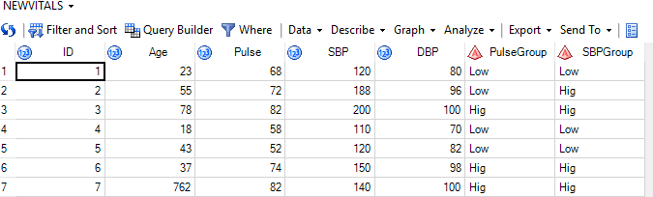

Libname mylib1 'E:\16IM10032\27-02-2019';

**proc** **fcmp**

outlib = mylib1.dataset.package1Math;

function MySelectionSort(a[*]) vargs;

outargs a;

put a = ;

do i=**1** to **10**;

do j = i+**1** to **10**;

if a[i]>a[j] then

do;

temp = a[i];

a[i] = a[j];

a[j] = temp;

end;

end;

end;

rc = write_array('mylib1.SortedData', a);

endsub;

options cmplib = mylib1.dataset1;

**run**;

**proc** **print** data=mylib1.SortedData;

**run**;

**data** mylib1.DataToSort;

input a1 a2 a3 a4;

datalines;

8 3 22 15

2 12 27 17

5 23 3 11

1 61 16 8

7 7 13 4

4 21 17 7

3 13 9 9

9 15 11 12

12 17 13 21

16 19 2 12

;

data mylib1.SortedData;

set mylib1.DataToSort;

array a a1 a2 a3 a4;

MySelectionSort(a1);

MySelectionSort(a2);

MySelectionSort(a3);

MySelectionSort(a4);

end;

**run**;

**quit**;

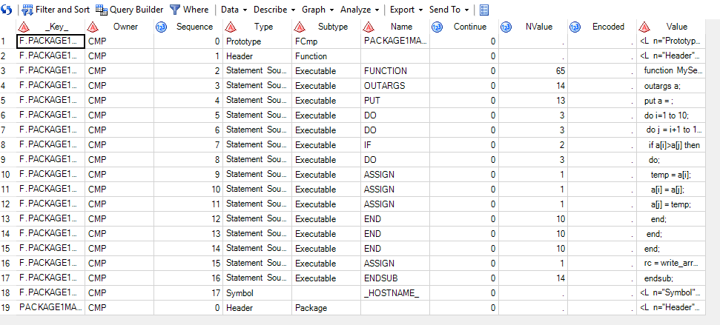

**proc** **optmodel**;

set mines = {"L1","L2","L3"};

set consumers = {"K1","K2","K3","K4","K5"};

number c{mines,consumers} = [**3** **2** **3** **4** **1** **4** **1** **2** **4** **2** **1** **0** **5** **3** **2**];

number max_production{mines} = [**75** **150** **75**];

number min_demand{consumers} = [**100** **60** **40** **75** **25**];

var x{mines,consumers} >=**0**;

min f = sum{i in mines, j in consumers}c[i,j]*x[i,j];

con supply{i in mines}: sum{j in consumers}x[i,j] <= max_production[i];

con demand{j in consumers}: sum{i in mines}x[i,j] >= min_demand[j];

solve;

print x f;

**quit**;

