Course: High Performance Computing Lab

Practical No 1

PRN:22510029

Name:Anjali Kumbhar

Batch:B1

Title: Introduction to OpenMP

Problem Statement 1 – Demonstrate Installation and Running of OpenMP code in C

*#include* <stdio.h>

*#include* <omp.h>

*int* main(*void*)

{

*#pragma* *omp* *parallel*

    printf("Hello, world.\n");

*return* 0;

}

gcc -fopenmp test.c -o hello

.\hello.exe

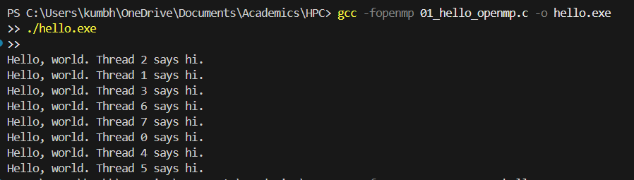

Problem Statement 2 – Print ‘Hello, World’ in Sequential and Parallel in OpenMP

We first ask the user for number of threads – OpenMP allows to set the threads at runtime. Then, we print the Hello, World in sequential – number of times of threads count and then run the code in parallel in each thread.

Code snapshot:

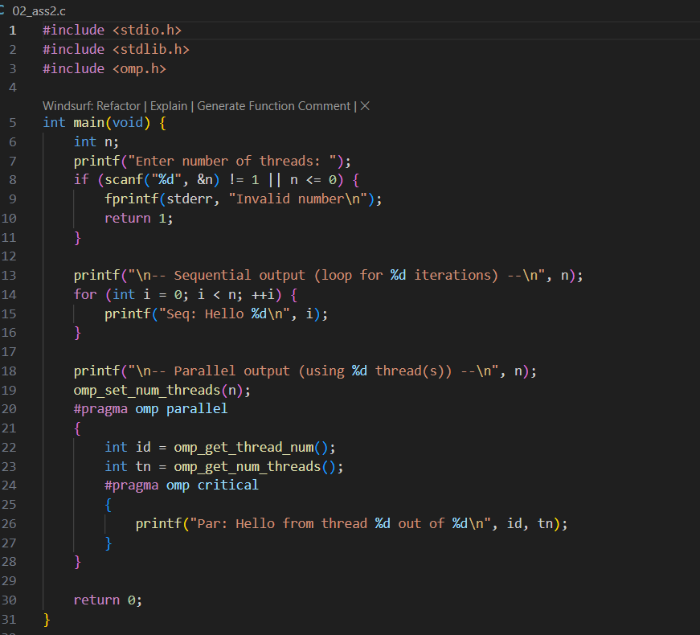

Output snapshot:

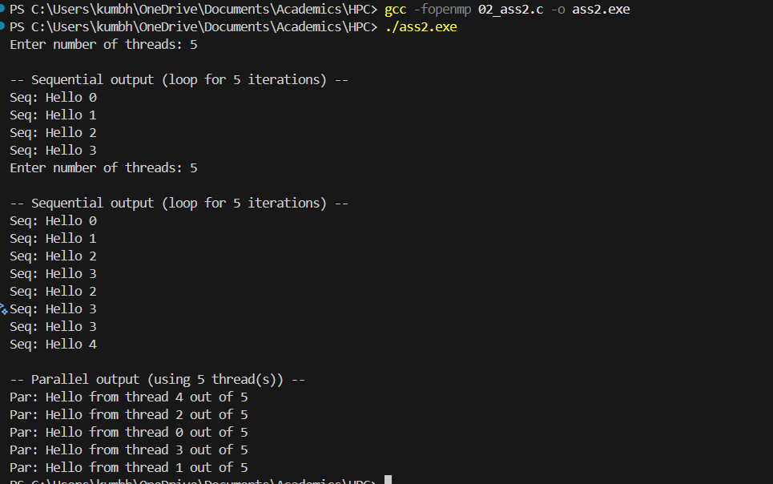

Analysis:

The experiment demonstrates the difference between sequential and parallel execution using OpenMP. In sequential execution, output order is strictly increasing as per loop iteration. In parallel execution, thread scheduling by the OpenMP runtime results in non-deterministic output order, but all requested threads execute. This verifies correct OpenMP installation and functionality on the system.

Problem statement 3: Calculate theoretical FLOPS of your system on which you are running the above codes.

|  |  |  |
| --- | --- | --- |
| Parameter | Symbol | Significance |
| Clock Speed | $$f$$ | The number of CPU cycles per second (in Hz). Higher clock speed means more operations per second. |
| Number of Cores | $$N$$ | The number of **physical CPU cores**. More cores enable more operations to be executed in parallel. |
| SIMD Width / Factor | $$V$$ | Number of floating-point values processed simultaneously by one vector instruction (based on SIMD register width). |
| FMA Factor | $$F$$ | Accounts for **Fused Multiply-Add** instructions. If supported, each instruction counts as **2 FLOPs** (1 multiply + 1 add). |
| Superscalar Factor | $$S$$ | Indicates how many SIMD instructions a core can issue per clock cycle (instruction throughput). Modern CPUs may issue 1-2 per cycle. |

$$Therotical FLOPS=f ×N ×V ×F ×S$$

$$∴Therotical FLOPS=1.2×109×6×8×2×1=115.2 GFLOPS$$

Github Link : https://github.com/Anjali1874/HPC-Lab

.